**From:** Keith Sappenfield <[Keith.Sappenfield@cheniere.com](mailto:Keith.Sappenfield@cheniere.com)>   
**Sent:** Thursday, July 11, 2019 2:39 PM  
**To:** Jarvis, Jeff <[Jeffery.Jarvis@encana.com](mailto:Jeffery.Jarvis@encana.com)>  
**Cc:** [JHB@8760.com](mailto:JHB@8760.com); Jonathan Booe <[jbooe@naesb.org](mailto:jbooe@naesb.org)>; Elizabeth Mallett <[emallett@naesb.org](mailto:emallett@naesb.org)>; [bredd@southwest-energy.com](mailto:bredd@southwest-energy.com)  
**Subject:** FW: NAESB R19009 - Money Rates

Jeff:

Thanks for looking into this and providing this information on “Wall Street Journal” Prime Rate publication.

By this note I am asking NAESB Office to post this email including your note as a work paper to support my withdrawal of the request.

Thus we can remove discussion from the agenda and the work paper will be referenced in the meeting minute records to support the withdrawal of the request.

Thanks

Keith

**Keith M. Sappenfield, II**

**Principal, Project Strategy**

**Cheniere Energy, Inc**.

700 Milam, Suite 1900

Houston, TX 77002

Office: +1 713-375-5050

Cell: +1 832-627-0851

[Keith.sappenfield@cheniere.com](mailto:Keith.sappenfield@cheniere.com)



**From:** Jarvis, Jeff <[Jeffery.Jarvis@encana.com](mailto:Jeffery.Jarvis@encana.com)>   
**Sent:** Thursday, July 11, 2019 2:28 PM  
**To:** Keith Sappenfield <[Keith.Sappenfield@cheniere.com](mailto:Keith.Sappenfield@cheniere.com)>  
**Subject:** NAESB R19009 - Money Rates

|  |
| --- |
| **EXTERNAL EMAIL: Do not click on any links or open any attachments unless you trust the sender and know the content is safe.** |

Keith

Further to our call, I looked into the recent request regarding the publishing of the prime rate of interest as published by the WSJ.  I reached out to the WSJ and the newsletter that was attached to R19009 has in fact been discontinued, but the rate is still published and available on-line.  If you type “money rates” into the WSJ search engine it will take you to a page where the WSJ continues to publish the prime rate.  The NAESB does not reference the newsletter, so I do not believe any changes are necessary.  I have pasted an image of what I found on-line today at the WSJ.  I hope this helps.  Talk to you tomorrow at the NAESB meeting.

Regards,

Jeff

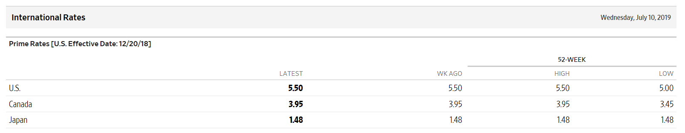

**Jeff Jarvis**

Associate General Counsel

Phone    720-876-3737  
Cell         303-517-0881

**Encana Services Company Ltd.**

**encana.com**

Encana Services Company Ltd. provides

operational, corporate, administrative and

advisory services to Encana Corporation

and its subsidiaries

This e-mail and any attachments are for the sole use of the intended recipient(s) and may contain information that is legally privileged and/or confidential information. If you are not the intended recipient(s) and have received this e-mail in error, please immediately notify the sender by return e-mail and delete this e-mail from your computer. Any distribution, disclosure or the taking of any other action by anyone other than the named recipient is strictly prohibited.