Modification of Service Reference Tracking

NAESB WEQ 20201 Annual Plan
3 | Develop business practices standards to improve the current operation of the wholesale electric market and develop and maintain business practice and communication standards for OASIS and Electronic Scheduling

3c) | Develop of industry business practice standards, as applicable, for identification of all modifications of service made to an original reservation in one location within OASIS
Background

OASIS Business Standards allow for the modification of service. Such modifications include request types of Original, Resale, Renewal, Deferral, Redirect, Relinquish, Full_Transfer, Part_Transfer, and Recall. In addition, the Request Type templates for each type of modification contain a data element that refers to the reservation being modified – the Parent/Child relationship. However, this link only exists for one generation – identifying one generation of modification (the Child/Parent link).

There are certain restrictions on the types of modifications that may be made to certain existing confirmed reservations, i.e a Resale reservation cannot be transferred. Valid modifications to the standard request types are noted below:

Request Type | Redirect? | Resale? | Part_Transfer? | Full_Transfer? | Parent Ref
Original | Y | Y | Y | Y | N/A
Redirect | Y | Y | Y | Y | RELATED_REF
Resale | Y | Y | N | N | REASSIGNED_REF
Recall | N | N | N | N | RELATED_REF
Part_Transfer | Y | Y | Y | N | REASSIGNED_REF
Full Transfer | Y | Y | Y | Y | REASSIGNED_REF
Renewal | Y | Y | Y | Y | RELATED_REF
Relinquish | N | N | N | N | RELATED_REF
Deferral | N | N | N | N | RELATED_REF

The purpose of 2021 API 3c is to provide visibility into the “family tree” of a given, confirmed reservation in a single display. It is important to note that this information currently exists and readily available, but only for one generation back in the current displays.

Simple transaction flow involving an Original and 2 modifications of service

Trans # | ARef | Request_Type | Start | Stop | Comments
1 | 696725 | Original | ?? | 2009-06-01 | Could not retrieve from OASIS Archive
2 | 1597755 | Renewal | 2009-06-01 | 2021-06-01 | Renewal w/Rollover Rights
3 | 16006725 | Redirect | 2010-06-01 | 2021-06-01 | Redirect to End-of-Term

Transaction #1 - ARef 696725
This was an Original Request that started the transaction flow. As an Original Request, no Related or Reassigned ARef was needed. Once Confirmed, it became a long term reservation with Rollover Rights. Note that I could not retrieve this reservation from the OASIS Archive

Transaction #2 ARef 1597755
This was a Renewal of ARef 696725. Note that it carries a Related reference of the parent reservation:

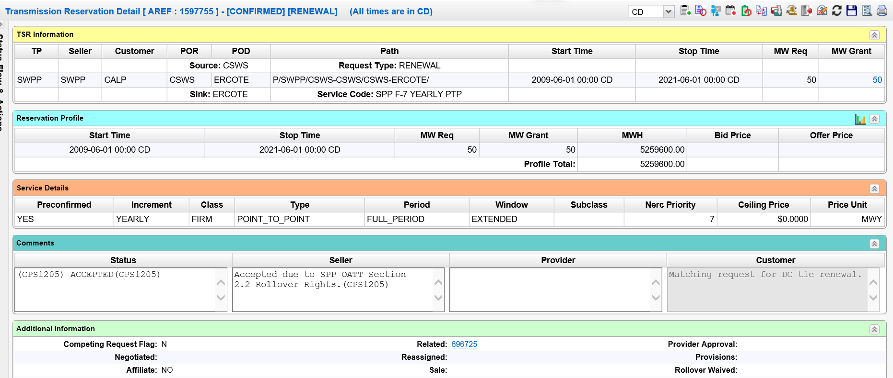

Transaction #3 ARef 1600613
This is a Redirect of the Renewal reservation after it had run for one year – this Redirect going to the end of term. Note that this Redirect carries a Related reference to its parent – the Renewal, not the original.

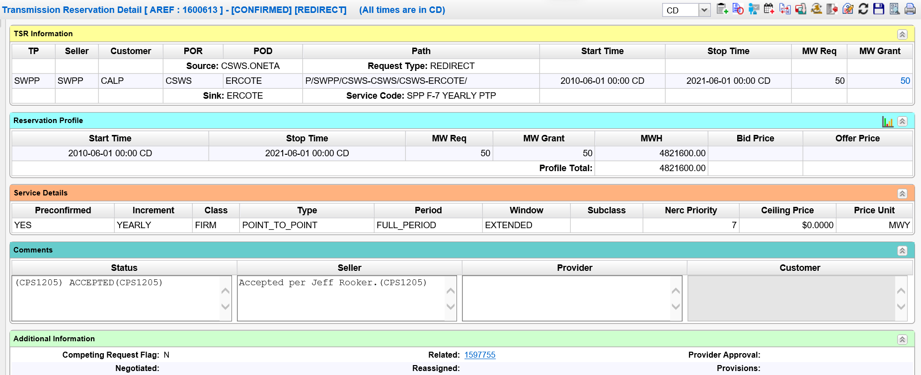

While this is a very simple transaction flow, the options available to a Transmission Customer can continue to “daisy-chain” for sometime (aka the Zerfing Effect).

The goal of this request is to allow visibility of the multi-generational relationships between related/reassigned reservations. Ideally, one could submit a given reservation and the system would return it’s “Multi-Generational Family Tree.”

Reservation in Question | Type | Predecessor | Predecessor Type
1600613 | Redirect | 1597755 | Renewal
1597755 | Renewal | 696725 | Original
696725 | Original | None

