Meeting
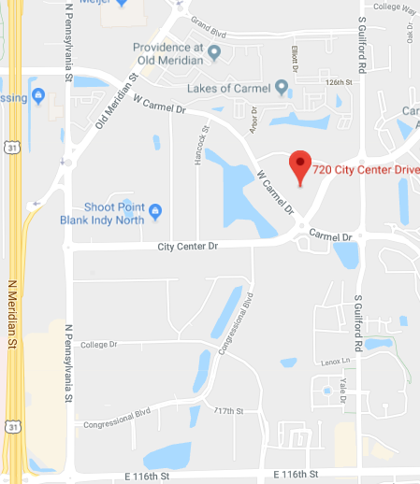
WEQ OASIS
July 23 - 25, 2019

LOCATION:
720 City Center Dr
Carmel, IN 46032

MISO 720 Building
Catlin C Conference Room

Hotels:
https://www.misoenergy.org/about/contact-us/locations/

Additional Information:
- Sign in at the front desk. You will be directed to the lower level where the conference room is located.
- Escorts are not required in the lower level.
- Photo ID is required for sign in.
- Please RSVP to NAESB so that meal arrangements can be made.

