NAESB WEQ OASIS Subcommittee Meeting Arrangements
May 2019
Hosted by Southwest Power Pool at Tenaska Power Services Offices
Arlington, TX
May 21, 2019 (9:00 am-4:00 pm)
May 22, 2019 (9:00 am-4:00 pm)
May 23, 2019 (9:00 am-12:00 pm)
Location: Tenaska Power Services Co., South 1 Conference Room
Address: 1707 East Lamar Boulevard, Suite 100, Arlington, TX 76006
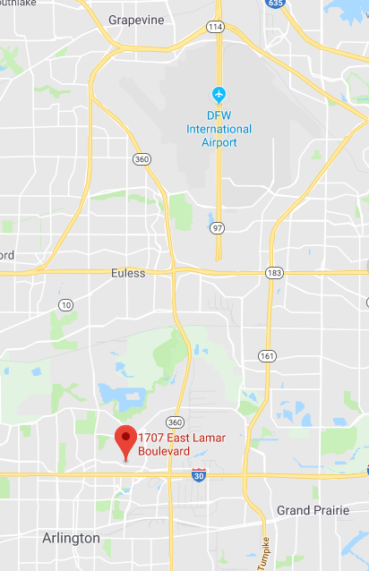
Hotel Options: See next page

Tenaska Power Services Co.
Hotel Rates – Arlington, TX
(Revised 4/16/19)

Arlington Hilton Hotel $155* per Night (Tenaska Rate)
2401 E. Lamar Blvd.
Arlington, Texas 76006
Phone: (817) 640-3322
Full service hotel with complimentary shuttle service to/from DFW Airport and Tenaska
(based on availability so it is best if the traveler lets them know of their need in advance)
Contact: Scott Veillon
(817) 640-4715 E-mail: Scott.Veillon@interstatehotels.com

Sheraton Hotel 25% off best available rate per Night
Link: Book your corporate rate for Tenaska or use “TSK” in the corporate code section under “Special Rates”.
1500 Convention Center Drive
Arlington, Texas 76011
Phone: (817) 261-8200
Full service hotel with complimentary shuttle service to/from DFW Airport and Tenaska
(based on availability so it is best if the traveler lets them know of their need in advance)
Contact: Khrystyn Henry
(817) 548-2813 E-mail: Khrystyn.Henry@sheratonarlingtonhotel.com

Towneplace Suites by Marriott Dallas Arlington North $99 per Night (Tenaska Rate)
1709 E. Lamar Blvd.
Arlington, TX 76006
Phone: (817) 861-8728
Next door to office, walking distance
Contact: Donna Johnson E-mail: donna.johnson@whitestonehm.com

SpringHill Suites Dallas Arlington North $99 per Night (Tenaska Rate)
1975 E. Lamar Blvd. Link: Book your corporate rate for Tenaska
Arlington, TX 76006
Phone: (817) 860-2737
Contact: Mallory Clark E-mail: Mallory.Clark@hhg-hotels.com

Hilton Garden Inn $139* per Night (Tenaska Rate)
2190 E. Lamar Blvd.
Arlington, Texas 76006
Phone: (817) 274-6644
Contact: Chanell Taylor
(817) 274-6644 E-mail: Chanell.Taylor@concordhotels.com

* When making hotel reservations, ask for the Tenaska Rate. All rates are subject to change.

