NAESB WEQ OASIS Subcommittee Meeting Arrangements
April 2019 Face-to-Face
Meeting Dates, Times & Room:
Date | Time | Room
April 16, 2019 | 10:00 am - 5:00 pm EDT | Caucus A (Leadership Development Training)
April 17, 2019 | 10:00 am - 5:00 pm EDT | Caucus A (Leadership Development Training)
April 18, 2019 | 10:00 am - 1:00 pm EDT | Caucus A (Leadership Development Training)

Meeting location: | Duke Energy Host:
Duke Energy  526 South Church Street  Room: Phase I, 3rd floor, Caucus A  (Leadership Development Training Area)  Charlotte, NC  (entry possible from both Church Street and  Mint Street sides of the building) | Alan Pritchard  Office: 704-382-7463  Cell: 704-957-9951  E-mail: alan.pritchard@duke-energy.com
Attendee Registration:
In order to facilitate Duke security clearance everyone planning to attend in person should notify NAESB (naesb@naesb.org) and Duke Energy (alan.pritchard@duke-energy.com) at least one week prior to the meeting and provide name, company, email address and phone number.

Hotels:
See the attached map for a view of the meeting location and nearby hotels.
Here are some hotels that are within 1/2 mile of Duke Energy’s 400 S. Tryon Street office, sorted by distance. The rates shown are for Duke but many times these rates are honored by the hotels for people attending meetings hosted at Duke Energy.
$185 Courtyard by Marriott Charlotte City Center (704) 926-5800
$164 Residence Inn by Marriott Uptown Charlotte 704-340-4000
$239 Omni Charlotte Hotel 704-377-0400
$182 Aloft Charlotte Uptown at the EpiCenter (704) 333-1999
$189 Embassy Suites by Hilton Charlotte Uptown 704-940-2517
$162 Hilton Garden Inn Charlotte Uptown 704-347-5972
$153 Hampton Inn – Charlotte Uptown 704-373-0917
$144 Holiday Inn Charlotte City Center 704-335-5400
$164 The Dunhill Hotel 704-332-4141
$156 Hyatt House Charlotte/Center City 704-373-9700

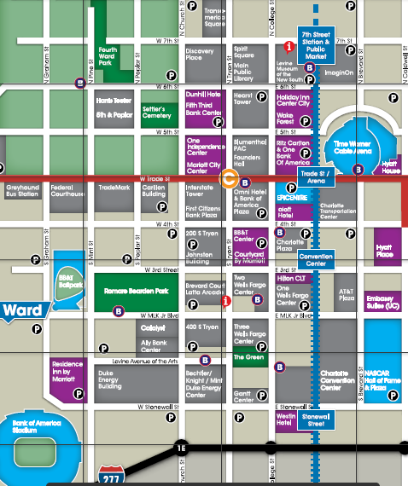
Meeting Location

