2018 API 3a Assigned to OASIS Subcommittee
3. Develop business practices standards to improve the current operation of the wholesale electric market and develop and maintain business practice and communication standards for OASIS and Electronic Scheduling.
a. Requirements for OASIS to use data in the Electric Industry Registry (EIR)
Individual Assignment: Refine the scope for Requirements for OASIS to use data in the Electric Industry Registry (R12001) as it relates to tagging (per OS discussion in February 2018/Phoenix)

February 2018 OS discussion introduced the OS to the data elements for certain information currently held and used by OASIS and the EIR. Differences in data elements for the same entry were discussed.

RFI Data elements:
- Tag Information Section
Source BA Entity Code - GCA
PSE Entity Code (e-tag Author PSE)
Unique transaction identifier (e-tag code) alpha-numeric
Sink BA Entity Code - LCS
Example
SWPP_FPLPSECMRN08T_TVA
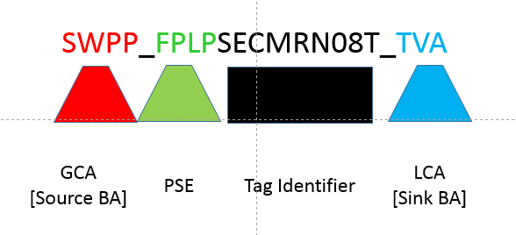
Contact Information Section
PSE Code
PSE Contct
PSE Phone
PSE FAX
Gen Contact
Gen Phone
Gen FAX
Load Contact
Load Phone
Load Fax
Comment

Request Section
Req #
Type (creation/adjustment/curtailment
Author PSE
Time
Status
2. Market Path Section
PSE
Product

Market Information Section

- Physical Path Section
Source BA
PSE
Source

TSP
PSE
POR
POD

Sink BA
MO
PSE
Sink
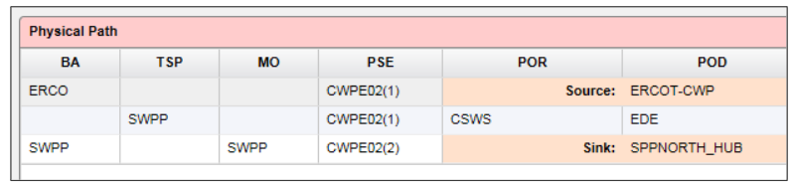

- Energy and Transmission Profiles Section
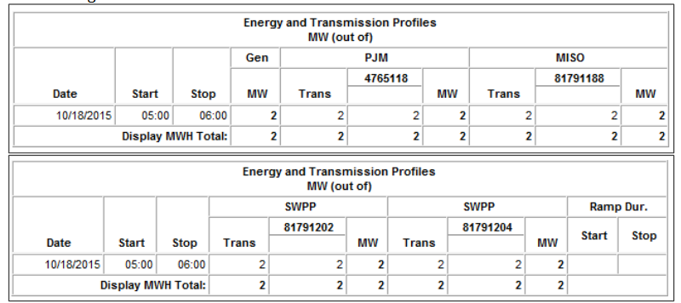
- Transmission Allocation Section
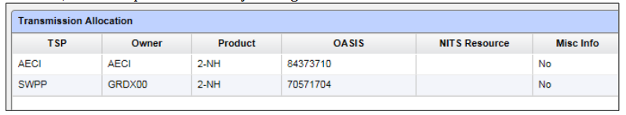
- Carbon Copy List Section
- Loss Accounting Section
