NAESB WEQ Coordinated Interchange Scheduling Subcommittee
Request:
Consider modifications to existing tagging functional specifications to incorporate battery, pumped storage or other future bi-directional (generation and load) type resources. Changes to the WEQ Electronic Tagging Specifications have been infrequent and minor over the last several years. However, storage type resources have come online at a rapid pace and there is a growing desire to have a Transaction Product Type that can support a single resource that has ability to go in both directions. The request is to develop a Transaction Product Type that can support batteries and future similar technology.

New England’s Energy Storage Resources
ISO New England has relied on pumped storage resources providing more than 1,700 MW of capacity since the mid-1970s. Over the years, pumped storage has played a significant role in New England’s grid reliability, flexibility, and resilience. Traditionally, these resources would generate electricity during the peak hours of the day, and pump, serving as a load, when demand is low, typically in the overnight hours. However, with the rapid penetration of renewable energy resources, the traditional behavior of pumped storage has evolved.
New England has more than 7,000 MW of behind the meter PV resources and over 1,500 MW of wind resources. Due to the high volume of solar generation in the region, mid-day net electricity demand is now falling below the traditional overnight lows. Additionally, offshore wind is projected to grow significantly in the upcoming years. Rather than pumping in the overnight hours, pumped storage facilities are now helping to balance the fluctuations in generation during the middle of the day.
In more recent years, New England has experienced an increase in batteries to support grid reliability. While New England’s battery fleet is small in both number and capacity compared to traditional thermal and existing pumped storage generation, the need for more dispatchable limited energy resources has become increasingly evident. As the region shifts away from traditional generation and moves toward renewables, batteries will likely become a significant player in New England’s fleet.
Energy Storage Operations
Pumped storage facilities operate similarly to traditional thermal generators in New England. These resources are dispatchable and bid into ISO New England’s Day Ahead Markets (DAM) and/or Real Time Markets (RTM). Unlike traditional fossil fuel generators, pumped storage can ramp up and down very quickly, providing frequency regulation. Similarly, batteries also can ramp quickly. However, most batteries in New England today are small and therefore operate on regulation following frequency deviations rather than participating in either DAMs or RTMs.

New England’s External Transactions
New England currently has six interfaces with an additional DC-tie projected to be in service by Fall of 2025. All transactions must submit offers in ISO New England’s External Transaction Tool (NEXTT), a software application developed by ISO New England to facilitate the submission, management, and evaluation of external transactions in the wholesale electricity market.
The New York North interface is the interconnection between New York and New England, comprised of 7 free-flowing AC transmission lines. The interface schedules utilize Coordinated Transaction Scheduling (CTS), a process where optimized energy transactions occur every 15 minutes. Market Participants submit bids based on expected price spreads between control areas. The frequent scheduling ensures energy flows efficiently based on real-time market conditions and system needs. Market Participants that submit CTS transactions must submit transactions in both NYISO’s Joint Energy Scheduling System (JESS) as well as NEXTT (ISO-NE).
While most interfaces are pooled transmission services, Phase II and Cross Sound Cable (CSC) serve as Transmission Service Providers (TSP) that can flow energy into, out of, or through New England. Market Participants that wish to schedule transactions on these facilities must create reservations in Open Access Same-Time Information System (OASIS) prior to submitting transactions in ISO New England’s DA or RT markets.

New England’s Current Tagging and Transaction Processes
ISO New England’s NEXTT application allows market participants to manage imports, exports, and wheeling transactions efficiently through the New England Control Area. Transactions are scheduled in NEXTT for both DA and RT markets. While all RT transactions require eTags, which are created and managed in Open Access Technology International (OATI) web-based software, NEXTT is the official platform in which tracking, approving, and curtailing transactions occurs for ISO New England.

REX
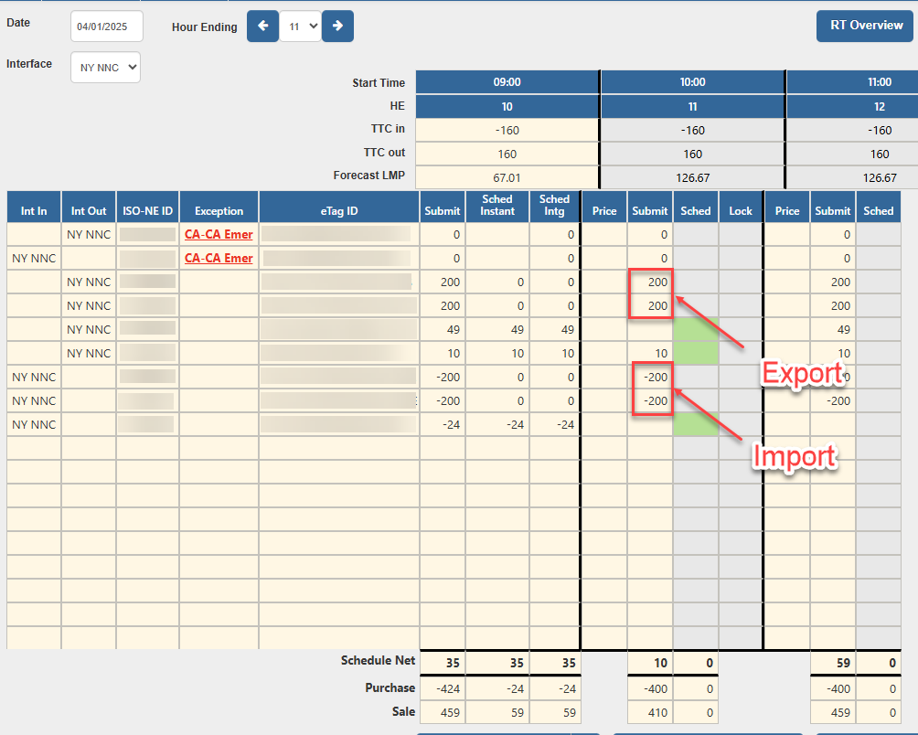
Transactions created in NEXTT, are entered into ISO New England’s Real-Time Energy Transaction (REX) software for RT scheduling, monitoring and settlement purposes. Within REX, operators can view tag details, direction of flow, priority and price. In RT, operators run scheduling algorithms for every interval to determine the most economic dispatch of resources based on Real-Time Unit Commitment (RTUC) calculations. System Operators may revise individual transactions within an interface to support revised transmission constraints, the needs for reserves in the region, or for other reasons deemed necessary to support grid reliability.

OATI Tagging
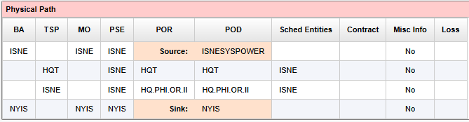
eTags are created on OATI’s WebSmartTag platform and requires the Market Participant to identify the physical path in which the energy will flow.
Current Tag Construct
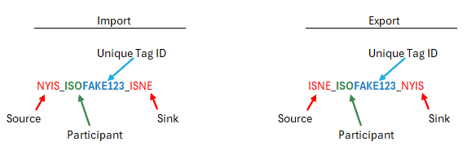
In the example below, the Market Participant (ISO) has identified that their import transaction will flow from NYISO to ISO-NE, using the etag ID FAKE123. To create a transaction in the opposite direction, the Market Participant cannot use the same etag. They will need to create a new etag, switching the source and sink to indicate the change in direction.

