Example 1:

Below is an example #1 where there are different TSP’s (A,B,C,D,E,F) and constraints 1 and 2 are in different TSP’s either B or E.   Transaction uses A-E-C-D Path . if RC issues WELR on the constraint 2 which is owned by TSP E then the process would treat the transaction as non-firm hourly since the leg on TSP E has non-firm priority even though they utilize firm on TSP C.

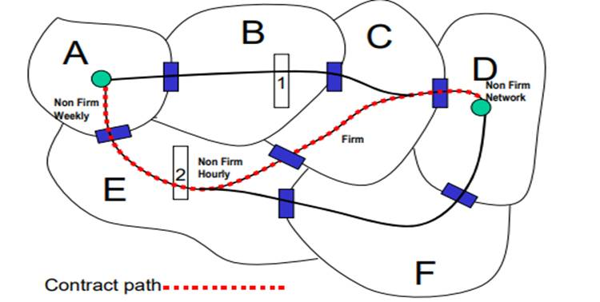

Example 2:

Example #2 Same transaction but it has firm priority on TSP E rather than non-firm in this case if RC issues WELR on constraint 2 the transaction would be treated as Firm.

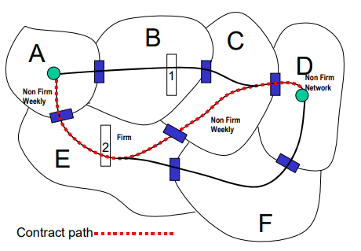

For the example #2 if RC issues curtailment on constraint 1 which is owned by TSP B , the transaction would be treated as non-firm since it is not scheduled on B and some leg of transaction has non-firm priority.

Example 3:

Constraint 3 is a Joint owned line between TSP E and TSP C.  so Transaction has non firm priority on TSP E and firm priority on TSP C. since it is a Joint owned equipment the on path rule applies for both TSP E and TSP C and then from the transaction we could utilize Highest Priority and treat the transaction as firm priority from WELR curtailments