State of Common Grid Services Definitions
Public Review Draft – Do not cite or quote
June 2022
Jingjing Liu Steve Widergren
Jaime Kolln Ted Bohn
Sonny Xue Rich Brown
Bruce Nordman
Disclaimer:

This document was prepared as an account of work sponsored by the United States Government.
While this document is believed to contain correct information, neither the United States
Government nor any agency thereof, nor the Regents of the University of California, nor any of their employees, makes any warranty, express or implied, or assumes any legal responsibility for the accuracy, completeness, or usefulness of any information, apparatus, product, or process disclosed, or represents that its use would not infringe privately owned rights. Reference herein to any specific commercial product, process, or service by its trade name, trademark, manufacturer, or otherwise, does not necessarily constitute or imply its endorsement, recommendation, or favoring by the United States Government or any agency thereof, or the Regents of the University of California. The views and opinions of authors expressed herein do not necessarily state or reflect those of the United States Government or any agency thereof or the Regents of the University of California.

State of Common Grid Services Definitions

GMLC 2.5.2 project report

Jingjing Liu¹ Steve Widergren²
Jaime Kolln² Bruce Nordman¹
Sonny Xue³ Ted Bohn⁴
Rich Brown¹

June 2022

Public Review Draft – Do not cite or quote

Abstract

This document is prepared as part of the Department of Energy’s Grid Modernization Laboratory Consortium (GMLC) 2.5.2 project, whose goal is to develop and socialize a common set of grid service definitions relevant to grid-related interactions with distributed energy resources (DER: responsive generation, storage, and loads), and to advance the concept and requirements of the Energy Services Interface (ESI) to the point of launching related interface standards and guides that can be implemented in communication protocols and business process definitions. The notion of “grid services” is integral to the definition of an ESI because a key principle of the ESI is that it permits coordination between grid operators and DER facilities in a way that is service-oriented, with an understanding of performance expectations.

This document reviews the current state of grid service definitions, including those actively used in the market today as well as new services that have been proposed for future implementation. The document describes grid services used in transmission as well as distribution systems. In defining grid services, this document also distinguishes between two fundamental concepts: an “operational objective” and a “grid service,” which describes a generator’s or consumer’s expected physical performance in delivering power to or consuming power from the grid.
Acknowledgments

This research was supported by the Grid Modernization Initiative of the U.S. Department of Energy (DOE) as part of its Grid Modernization Laboratory Consortium, a strategic partnership between DOE and the national laboratories to bring together leading experts, technologies, and resources to collaborate on the goal of modernizing the nation’s grid. The authors acknowledge the help and guidance received from the DOE manager, Christopher Irwin, in developing the plan for this document and encouraging outreach to relevant stakeholders.
Acronyms and Abbreviations

The following terms are described for their use in the GMLC 2.5.2 Project.

DER | Distributed energy resources (DER) include responsive generation, storage, or load connected at the distribution system level. Responsive means that the operation of the assets can be managed to provide one or more grid service.
DER facility | A site that includes one or more DER and has a single point of connection with the electric distribution system.
DER interconnection agreement | A legal contract between the electric utility and customer establishing all terms and conditions associated with operating DER in parallel with the utility’s electric power system.
ESI | An energy services interface (ESI) is a bi-directional, service-oriented, logical interface that supports the secure communication of information between entities inside and entities outside of a customer boundary to facilitate various energy interactions between electrical loads, storage, and generation within customer facilities and external entities.
facility management function | Manages the operation of the electrical devices and systems at a customer site (a facility). In the ESI concept, this function interacts with outside parties through the ESI.
grid-DER service | A service provided between a DER Facility and an external interacting party (usually a grid entity) as coordinated by ESI interactions. The service definition describes what is expected to be provided but does not specify how it is accomplished or how it will be used. Managing the quantity of energy consumption over a period is an example of a grid-DER service.
grid service agreement | Specifies what a service provider will accomplish for a service requester, how it will be measured, and any compensation (monetary or otherwise) from the service requester for performing that service.
grid-side entity | An external interacting party that interacts with a DER facility using the ESI.
layered decomposition | Hierarchical disaggregation of a complex problem into a series of simpler subproblems with clear and relatively simple interfaces between them. These subproblems are solved locally with interaction links to larger coordination domains and internally to subdomains.
service-oriented | A style of a software interface where services are provided to other system components (service requesters) by service provider components, through a network communication protocol. Its principles are independent of vendors and other technologies.

Contents
1.0 Background and Purpose 1
2.0 Common Grid Services Definitions in the Literature 2
2.1 Transmission Grid Services 2
2.2 Distribution Grid Services 9
3.0 Characterizing Grid Services 12
3.1 Performance Expectation Versus Operational Objective 12
3.2 Method for Categorizing Grid Services 13
3.3 Mapping Operational Objectives to Grid Services 14
4.0 Grid Service Stakeholder Engagement 15
References: 16

Figures
Figure 1. Map of Seven Regional Transmission Organizations in the U.S. (Source: FERC) [US GAO 2017] 3
Figure 2. Main Services Procured in the U.S. Power System [Denholm et al. 2019] 4
Figure 3. Timescales of Operating Reserve Requirements [Denholm et al. 2019] 6

Tables
Table 1. Transmission System Grid Service Categories with Examples from Grid Entities and Regulators 8
Table 2. Distribution System Operational Objective Categories 11
Table 3. Mapping Transmission System Grid Service Categories and Distribution System Operational Objective Categories onto the Proposed Common Grid Services 14

Background and Purpose
This document is prepared as part of the Department of Energy’s Grid Modernization Laboratory Consortium (GMLC) 2.5.2 project, whose goal is to develop and socialize a common set of grid service definitions relevant to grid-related interactions with distributed energy resources (DER: responsive generation, storage, and loads), and to advance the concept and requirements of the Energy Services Interface (ESI) to the point of launching related interface standards and guides that can be implemented in communication protocols and business process definitions. The notion of “grid services” is integral to the definition of an ESI because a key principle of the ESI is that it permits coordination between grid operators and DER facilities in a way that is service-oriented, with performance expectations.

In a service-oriented interaction, rather than turning devices off and on or otherwise having direct control of a DER, the grid service requestor (grid-side entity) makes a request of the DER facility for a particular physical performance, such as scheduling its energy use, and the DER facility’s management function then determines how to meet those performance expectations. This method has the advantage that it allows the DER facility to retain control of its assets to serve their intended function for the customer, while the grid-side entity requires little or no information about the type or nature of DER connected and other details about the system at the customer’s facility, since there is no need to directly communicate a device-specific control message, only the performance expectation for the service.

The purpose of this document is to review the current state of grid service definitions, to inform development of a simplified, common set of services applicable to DERs and also help to standardize interactions with the electricity grid more broadly. This builds upon the body of work in three previous GMLC projects including GMLC 1.2.1: Grid Architecture; 1.4.2: Definitions, Standards and Test Procedures for Grid Services from Devices; and 1.2.2: Interoperability. The GMLC 1.2.1 project produced a Grid Services Master List that compiled grid operation support functions [Samaan et al. 2017]. The GMLC 1.4.2 and 1.2.2 projects identified eight grid services that can be provided by a variety of DER devices [Pratt et al. 2020; Widergren et al. 2018].

For the purposes of defining grid services, it is useful to distinguish between two fundamental concepts: an “operational objective” and a “grid service.” As described by Pratt et al. [2020], an operational objective refers to “the fundamental underlying physical needs, stated as objectives, of the grid for safe, reliable, robust, and economically efficient operation. These are often in the form of balancing supply and demand at various time scales and for various purposes.” Operational objectives may include things like peak load management, operating reserves, or frequency regulation. A grid service, on the other hand, describes a generator’s or consumer’s expected physical performance in delivering power to or consuming power from the grid, in a way that can be clearly defined and measured; it describes what is needed, but not why, which is described separately in the grid’s operational objectives. Section 3 of this report provides more details about these definitions.

Grid operators generally fall into two categories – transmission and distribution – depending on the scope of their operations. Distribution utilities (also known as load-serving entities) provide local distribution to end-use customers, whereas transmission operators balance operation of generators to meet the demand of these load-serving entities. Because of their different scopes, responsibilities and regulatory environments, transmission and distribution operators require different types of grid services and tend to describe these services in different ways. DERs, by their distributed nature, are generally connected to distribution grids and provide services at that level of the grid. However, DERs can be coordinated to provide services of a greater magnitude to meet the needs of transmission grid operators. Section 4 of this report provides a preliminary description of common grid services at the bulk system operating level that can facilitate discussions with industry and may eventually be refined into a more comprehensive, common set of grid service terms and definitions.

Common Grid Services Definitions in the Literature
To support the purpose stated above, the project conducted a literature review of typical transmission and distribution system level grid services that currently exist in the electrical grid systems and/or are being developed/conceptualized in the US and other countries. The sources of literature covered in this initial review include relevant technical reports by research institutes, publications by regulatory bodies, independent system operator (ISO) or regional transmission organization (RTO) operation documents, utility published materials, and academic papers. We segment these services into those provided at the transmission versus the distribution level of the grid.

As mentioned above, earlier GMLC projects have compiled a common set of grid services that spanned both transmission and distribution levels. These include: peak capacity management, autonomous frequency response, capacity market dispatch, traditional frequency regulation, spinning reserve, dynamic frequency regulation, autonomous distribution voltage response, and wholesale market price response [Pratt et al. 2020; Widergren et al. 2018]. The majority of these grid services exist in today’s US wholesale electricity markets but some are emerging grid service concepts.

Transmission Grid Services

Traditionally, the power grid was designed for carrying a one-way flow of electricity from the generators to the electricity end users (i.e., utility customers) through transmission and distribution systems. In different parts of the United States, the arrangement and procurement of transmission and distribution system grid services are different, which impact how DERs provide these grid services. In much of the western, and southeastern United States, the grid operator role is carried out by vertically integrated utilities that also act as electricity distribution suppliers. These integrated utilities operate the grid and provide generation, transmission, and distribution services to all retail customers in a specified area.

In other parts of the United States, an independent system operator (ISO) or regional transmission organization (RTO) acts as a transmission grid operator and manages regional networks of electric transmission lines. Seven RTOs operate across the United States: the California ISO (CAISO), Southwest Power Pool (SPP), Electric Reliability Council of Texas (ERCOT), Midcontinent ISO (MISO), PJM Interconnection (PJM), New York ISO (NYISO), and ISO New England (ISO-NE), as illustrated in Figure 1. These RTOs cover part or all of 38 states and the District of Columbia. In addition to their grid operator responsibilities, these RTOs operate wholesale electricity markets to buy and sell services needed to maintain a reliable grid, such as capacity, energy, and ancillary services [US GAO 2017].

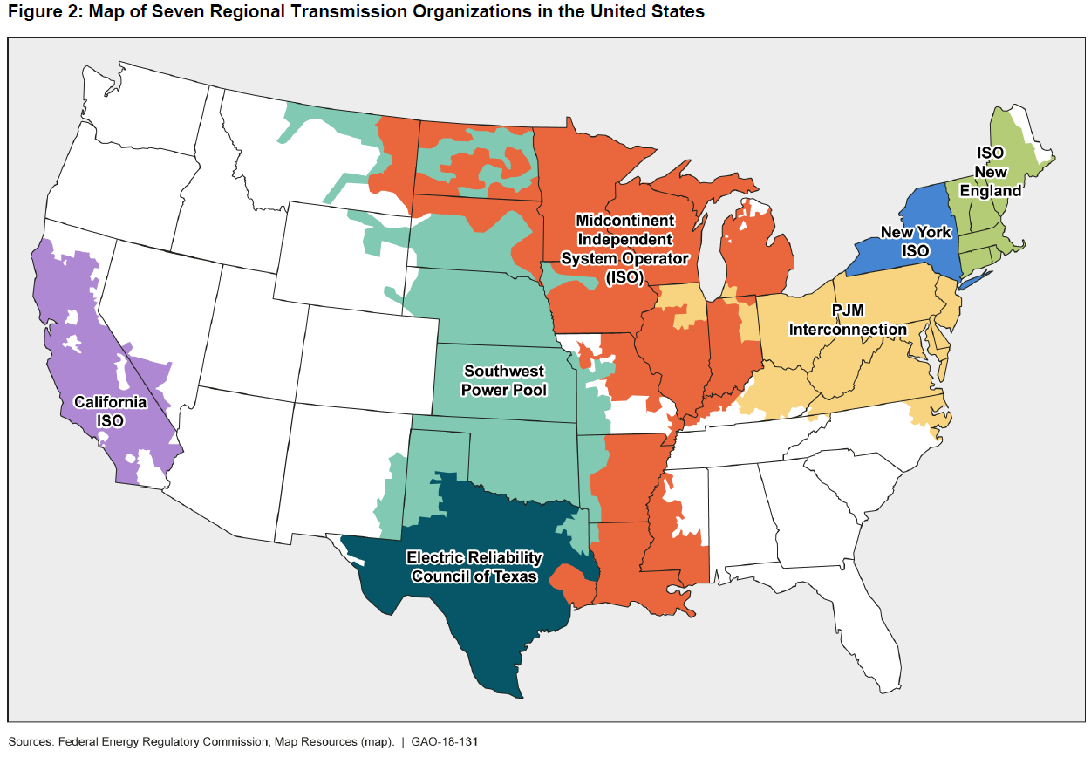
Figure 1. Map of Seven Regional Transmission Organizations in the U.S. (Source: FERC) [US GAO 2017]

The transmission system level grid services have historically been supplied by large scale generators for the purpose of providing secure and reliable electricity services for distribution to end users. These services have been developed and matured over the last several decades and can be broadly categorized into “energy and capacity services” (containing both energy service and capacity service) and “essential reliability services” (ERS). ERS can be further categorized as “operating reserves” and “other ERS.” Each of these subcategories also include multiple distinct grid services as shown in Figure 2 [Denholm et al. 2019].

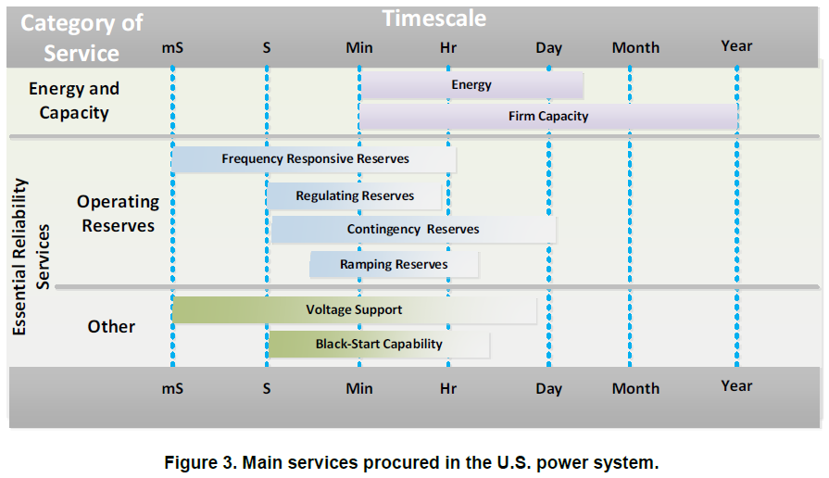
Figure 2. Main Services Procured in the U.S. Power System [Denholm et al. 2019]

Energy service is a fundamental grid service because the modern power system is built for the purpose of providing energy, in the form of electricity, from centralized power plants to end users. Grid operators schedule which power plants will generate electricity throughout the day to maintain the balance of generation and consumption while minimizing costs through sophisticated optimization. As a general rule, grid operators use “economic dispatch” to schedule the least costly power plants to run first and the longest, while scheduling the costliest power plants to run only as needed to meet higher loads [GAO 2017]. Each ISO/RTO operates multiple markets including two wholesale electricity or “energy” markets, namely:
- a day-ahead market, in which participants commit to buy or sell electricity at various times over the next twenty-four hours, based on forecast load; and
- a real-time market, in which participants buy and sell electricity a short time before it is needed to balance differences between the day ahead commitments and actual load and generation [Gundlach & Webb 2018].

Capacity service is used to ensure that, in the long term, there are power plants and other resources with adequate capacity, measured in MW, to reliably meet customers’ expected future electricity needs. Among the seven ISO/RTOs, four of them—ISO-NE, MISO, NYISO, and PJM—utilize capacity markets as a component of their approaches to ensuring resource adequacy. They administer periodic auctions to acquire capacity resources cost-effectively [GAO 2017]. We focus on these regions for capacity service because the open markets offer opportunities for DERs to participate. Owners of power plants and other resources can earn revenue in capacity auctions in exchange for making a “capacity commitment” (in MW)—an agreement that their power plants or other resources will be available, if needed, to meet customers’ electricity needs during a specific future period, called the “delivery period.” ISO/RTOs generally require owners of power plants to participate in energy auctions that the RTO operates to meet energy needs throughout the delivery period for the capacity auction [GAO 2017].

Essential Reliability Services (ERS) is a modern term used by the North American Electric Reliability Corporation (NERC) to refer to the necessary operating characteristics needed to reliably operate the North American electric grid. ERS concepts borrow from the definitions of interconnected operations services (IOSs) that the NERC IOS Subcommittee created in the early 2000s. An IOS is “a service (exclusive of basic energy and transmission services) that is required to support the reliable operation of interconnected bulk electric systems” [NERC 2002]. This NERC IOS Reference Document identified six basic IOSs supplied by generation (and sometimes load) that must be used to ensure transmission system reliability, regardless of regulatory environment, market structure, or organizational framework [NERC 2014].

- Frequency Response is the provision of capacity from IOS resources that deploys automatically to stabilize frequency following a significant and sustained frequency deviation on the interconnection. Frequency response is typically divided into three time phases: primary, secondary, and tertiary.
  - Inertial Response has been provided as an inherent physical characteristic of synchronous generators, not as a procured service. It immediately responds to arrest frequency decline by injecting kinetic energy stored in rotating generators into the system to resist frequency deviation on the time scale of a few AC cycles [Denholm et al. 2019, NERC 2014].
  - Primary Frequency Response (PFR, sometimes known as governor response) detects changes in frequency and adjusts operations of synchronous generators to maintain frequency range without a system operators’ signal [Denholm et al. 2019].
  - Fast Frequency Response (FFR), also referred to as synthetic inertia in the literature, describes the general capability of any resource that can detect and rapidly respond to changes in frequency, supplementing or replacing some amount of inertial response and primary frequency response (which are legacy terms applicable to synchronous generators). Inverter based resources (IBR) equipped with an energy storage system have the ability to measure system frequency and can be programmed to rapidly increase or decrease output in response to frequency deviation, faster than PFR and in a manner similar to a conventional generator’s inertial response [Denholm et al. 2019; NERC 2014; Demoulias et al. 2020].
- Regulation, or “regulating reserves,” is used to meet short-term variability (seconds to a few minutes) during both normal operations and grid events. The economic dispatch used for energy scheduling, which typically only balances the system as frequently as every 5 minutes, is too slow to respond to normal variability and uncertainty in load and variable generation supply, thus additional reserves may need to be committed to meet intra-hour variability [Denholm et al. 2019].
- Load Following, or “ramping reserves,” is the provision of generation and load‐response capability that is dispatched within a scheduling period (e.g., every 5 or 15 minutes) by the operating authority, including capacity, energy, and maneuverability.
- Contingency Reserve is the provision of capacity deployed by the balancing authority (e.g., the ISO or RTO) to reduce area control error (ACE) to meet the Disturbance Control Standard and other NERC and Regional Reliability Council contingency requirements. Contingency reserves are composed of (1) spinning and non-spinning, and (2) supplemental reserves.
- Reactive Power Supply from Generation Sources is the provision of reactive capacity, reactive energy, and responsiveness from IOS resources, available to control voltage and support operation of the transmission system. This is described further in the Other ERS section below.
- System Black-start Capability is the provision of generating equipment that, following a system blackout, is able to: (1) start with an independent electrical supply, and (2) energize a defined portion of the transmission system. System black-start capability serves to provide an initial start‐up energy supply source for other system resources, as one part of a broader restoration process to re‐energize the transmission system.

More recently, the NERC ERS Task Force created a new grouping of these ERSs, which include “Frequency Support” and “Voltage Support,” while system black-start capability was determined not in their immediate scope. This categorization method is consistent with Figure 2, since the general category of Operating Reserves serves to maintain system frequency by increasing or decreasing generator output [Denholm et al. 2019]. In other words, four of the above six NERC essential reliability services are part of the Operating Reserves category: Frequency Response, Regulation, Contingency Reserve, and Load Following (called Ramping Reserves in Figure 2).

The above four general classes of operating reserve services can be further broken down by subcategory as illustrated in Figure 3 [Denholm et al. 2019]. The distinctions between different operating reserve services can be illustrated using three characteristics: how much, how fast, and how long. For each of these reserve services, the bars in Figure 3 indicate approximately the timescale over which the service is required. The left-hand side of the bar represents the time between the request and the time the reserve must start responding (“how fast”), while the length of the bar represents the duration the service may be needed (“how long”). The required duration will depend somewhat on grid conditions, represented by the fade in color on the right-hand side of the bar.

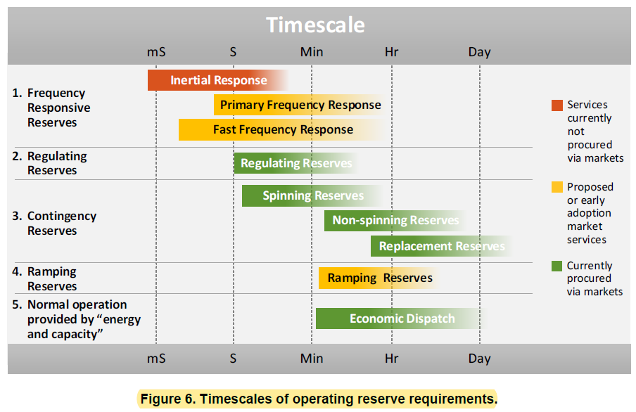
Figure 3. Timescales of Operating Reserve Requirements [Denholm et al. 2019]

Other ERS: as shown in Figure 2, major subcategories of ERS aside from operating reserves include “Voltage Support” and “Black-Start Capability” services.

- Voltage Support: The primary objective of this service is to maintain the voltage in the transmission system within a secure, stable range. Voltage Support is location-specific and requires reactive power control from reactive resources distributed throughout the power system [NERC 2014]. Voltage control is performed at each of the three major parts of the grid, including at the point of generation, at various points in the transmission system, and in the distribution network. Devices that provide voltage control maintain appropriate voltage on the grid during both normal operating conditions and fault conditions [Denholm et al. 2019]. The characteristics of the Voltage Support service are as follows [NERC 2014]:
  - Reactive Power/Power Factor Control: The ability to control leading and lagging reactive power on the system to maintain appropriate voltage levels and acceptable voltage bandwidths, to maximize efficient transfer of real power to the load across the bulk power system under normal and contingency conditions, and provide for operational flexibility under normal and abnormal conditions.
  - Voltage Control: The ability of the system to maintain adequate levels of voltage in local and regional areas to support system loads and maintain transfers and devices connected to the system.
  - Voltage Disturbance Performance: The ability of the system to maintain voltage support during and after a disturbance in order to avoid voltage collapse.
- Black-Start Capability: As defined above in the NERC ERS section, black-start represents capacity that can be used to re-energize the transmission system from a blackout.

The above described energy service, capacity service, and essential reliability services categories are consistently referenced by the US electrical system regulatory authorities, FERC and NERC, and the ISO/RTO transmission grid service definitions. Table 1 shows how FERC, NERC and selected other grid entity’s services can be mapped into the general transmission grid service categories described above. These grid entity examples include both ISO/RTOs and a vertically integrated utility.

“Ancillary services” is a commonly used term among grid entities and the NERC ERS Task Force considers them a subset of ERSs. FERC defines ancillary services as, “Those services necessary to support the transmission of electric power from seller to purchaser, given the obligations of control areas and transmitting utilities within those control areas, to maintain reliable operations of the interconnected transmission system” [NERC 2014]. Grid operators procure several ancillary services needed to ensure that supply and demand remain in balance from moment to moment so that they can deliver electricity within technical and regulatory standards—for example, at the right voltage and frequency. Ancillary services generally involve resources of scale—such as power plants—being available on short notice to increase or decrease their generation or consumption [GAO 2017]. Some ERSs are already well‐defined ancillary services, while others may become new services provided by market mechanisms of a balancing area or an ISO/RTO. Existing ancillary services were defined for a traditional system with conventional generating plants, however, with changing transmission system characteristics, these services can be provided by a variety of technologies that meet certain performance requirements [NERC 2014].

Table 1. Transmission System Grid Service Categories with Examples from Grid Entities and Regulators
Grid service categories |  | FERC 888  (1996) | NERC IOS (2002) | NERC ERS  (2014) | CAISO | PJM | Hawaiian Electric
Energy service |  | Scheduling, System Control and Dispatch |  |  | Day-Ahead & Real-Time energy | Energy | Energy
Capacity service |  |  |  |  | (no capacity market) | Reliability Pricing Model Capacity Performance | Transmission Capacity; Energy Reserve Margin
ERS | Frequency Response | Regulation and Frequency Response | Frequency Response | Inertia;  Frequency Disturbance Performance;  Frequency Control |  |  | Inertia; Primary Frequency Response; Fast Frequency Response
 | Regulation |  | Regulation | Regulation | Regulation Up; Regulation Down | Regulation (Traditional and Dynamic) | Regulating Reserves
 | Contingency Reserve | Operating Reserve - Spinning Reserve and Supplemental Reserve | Contingency Reserve | Contingency Reserves (spinning, non‐spinning and  supplemental) | Spinning Reserve; Non-Spinning Reserve | Synchronized Reserve; Non-Synchronized Reserve; Secondary Reserve
 | Load Following (Ramping Reserve) | Energy Imbalance | Load Following | Load Following;  Ramping Capability | Flexible Ramping (in Real-time Market) |  | Load Reduce; Load Build
 | Reactive Power Supply from Gen. Sources | Reactive Supply and Voltage Control from Generation Sources | Reactive Power Supply from Generation Sources | Reactive Power/PF Control; Voltage Control; Voltage Disturb. Perf. | Voltage Support | Voltage Control | Voltage Support
 | System Blackstart Capability |  | System Blackstart Capability |  |  | Black Start Service
*ERS: Essential Reliability Services

Distribution Grid Services
While the various types of transmission system grid services procured in wholesale markets have existed for decades, open procurement of distribution-level grid services from distributed or customer-side resources is nascent and actively evolving. Customer-side resources have been included in many utilities’ distribution grid portfolios to improve reliability or reduce system costs, most commonly through distributed renewable generation, energy storage, or emergency and economic Demand Response (DR) programs. Demand Response is defined by FERC as "a reduction in the consumption of electric energy by customers from their expected consumption in response to an increase in the price of electric energy or to incentive payments designed to induce lower consumption of electric energy" [FERC 2010]. Traditionally, DR is provided by customer load resources but some utilities also allow other DERs such as inverter-based resources to participate.

New concepts are being developed by academia and utilities in recognition of the challenges that distribution system operators (DSO) face from operating distribution grids with high renewables penetration. These concepts often involve voluntarily calling on the unique capabilities of inverter-based resources for measurable and compensated ancillary services rather than requiring such functionalities in interconnection standards and other regulations as it is today in the US and some other countries. The current state of development of distribution-level grid services in the US and Europe is best illustrated in the three reports described below.

First, researchers at Lawrence Berkeley National Laboratory (LBNL) have identified six categories of system requirements needed for ensuring reliable operation of the distribution grid [Cappers et al. 2016]. The report discusses the current practices of distribution grid operators, challenges they face in light of deeper DER penetration, potential active management strategies, and characteristics of real-time response services needed to address each of these system requirements for the evolving grid.

Second, the California investor-owned utilities (IOUs) and the Association of Edison Illuminating Companies (AEIC) member utilities published a whitepaper in 2018 to discuss learnings through pilot projects involving smart inverter enabled DERs [AEIC 2018]. One of the key conclusions from this whitepaper is that capabilities provided by grid modernization technology deployments will enable such DERs to provide “active” distribution grid services beyond “autonomous” smart inverter functions. To this end, the whitepaper has identified four key grid objectives identified by utilities during their distribution planning process, including “distribution capacity,” “voltage support and/or reactive power support,” “reliability (back-tie),” and “resiliency (microgrid).” These four capabilities are also covered in the LBNL report.

Third, the European Union-funded project “EASY-RES,” supporting 100% renewable energy sources in the European energy system, has identified six types of ancillary services that inverter-based resources, including renewable generation and battery energy storage systems, can provide to the grid. These services are inertial response, primary frequency response, power smoothing (power ramp-rate control), reactive power support for voltage regulation, harmonic mitigation, and fault-ride-through capability and fault clearing contribution [Demoulias et al. 2020]. Some of these autonomous functionalities are mandated in today’s codes and standards (e.g., CA Rule 21 and IEEE 1547-2018) in the form of “system support functions,” which are not attractive to inverter-based resource owners because they impose direct or indirect costs. EASY-RES presents an opportunity to make these compensated ancillary services instead. Among the above six services, power smoothing and reactive power services are relevant to both the transmission and distribution systems; inertial response and primary frequency response are provided to the upstream grid, i.e. transmission system; harmonic mitigation and fault ride-through/ fault clearing are only relevant to the distribution system. The same paper also makes an important contribution in defining the metrics and measurement methods that can be used to quantify inverter-based resources’ contribution to the various ancillary services identified earlier.

In summary, based on the above three key studies, distribution-level operational objectives can be categorized and described as follows. Some of these examples are used by distribution utilities today while the majority have been proposed for future implementation to take advantage of unique capabilities offered by inverter-based resources.

- Distribution capacity: Some conditions, such as high outdoor temperatures that lead to overloaded or peak conditions, can be predicted the day before [Cappers et al. 2016]. Load-modifying or energy supply services can be provided via the dispatch of generators or reduction in load, which can reliably and consistently reduce net loading on desired distribution infrastructure in response to a control signal from the utility, aggregator or autonomously [AEIC 2018]. This is an existing distribution grid service.
- Emergency load transfer (a.k.a. “back-tie reliability”): Unexpected peak conditions may occur spontaneously or be caused by faults, requiring immediate mitigation [Cappers et al. 2016]. Qualifying services include load-modifying or supply services capable of reducing the frequency and duration of outages. Specifically, the back-tie reliability service provides a fast (likely automated) reconnection from one feeder with an identified operational need to one or more feeders that have excess capacity reserves (including those provided by DERs) to restore customers during an outage [AEIC 2018]. The California investors owned utilities (IOUs) have identified that this is a potential grid service which could be provided by autonomously or actively-controlled DERs.
- Outage recovery (resiliency): This service includes load-modifying or supply services capable of improving a local distribution system’s ability to quickly recover from an outage [AEIC 2018]. During the reconnection process from power outages, one challenge is that the reconnection can result in abnormally high loading in the part of the system affected by the outage due to the coincidence of previously non-coincident load and thereby prolong the outage [Cappers et al. 2016]. Actively-controlled DERs can potentially respond to a control signal to provide power to intentionally-islanded end-use customers through an ad-hoc microgrid when central power is not supplied, reducing the duration of outages [AEIC 2018]. The California IOUs have identified that this is a potential grid service which could be provided by actively-controlled DERs.
- Power smoothing (ramp rate control): Higher penetration of renewables can cause large load variations at the system level on different time scales. There is concern about extreme ramp rates at both transmission and distribution system levels and therefore the power smoothing service as a mitigation strategy is relevant for both system levels. Power smoothing can be provided by some smart inverter-based renewable generators as well as complementary energy storage systems. Energy storage systems with quick response capabilities can enable power smoothing on the time scales of milliseconds to few seconds; slower energy storage systems are suitable for power smoothing on the timescale of seconds to several minutes [Demoulias et al. 2020]. This is a future grid service concept.
- Phase balancing: Voltage levels on the multiple AC distribution phases are balanced during system planning and periodically during grid operation through grid reconfigurations, but this tends to be an imprecise process because voltage phase is usually only measured at the substation level. Large changes in single-phase customer loads over time, either increases or decreases, may result in voltage phases becoming significantly out of balance [Cappers et al. 2016]. To develop phase balancing as a dynamic grid service will require more real-time monitoring and automated capability to reduce or increase phase loading from DERs. This is a future grid service concept.
- Voltage management: The grid is designed to maintain consistent voltage at each level of the distribution system. However, traditional monitoring at the substation level may be insufficient to identify brief load changes arising from large loads with rapidly changing active and reactive power demands [Cappers et al. 2016]. To meet the operational objective of consistent voltage within the grid, it is possible to coordinate the reactive power of inverter-based resources to regulate voltage levels in the distribution network as well as the exchange of reactive power with the transmission system [Demoulias et al. 2020]. Voltage management services could be provided by autonomously or actively-controlled DERs capable of dynamically correcting excursions outside of voltage limits. For example, a Smart Inverter can support this capability by absorbing or injecting reactive power (Volt-VAr) as well as by controlling real power output (Volt-Watt) [AEIC 2018]. This is an existing distribution grid service.
- Fault ride-through/ fault clearing: A valuable function is fault ride-through and inject controllable currents during a fault as a function of the IBR’s location and the short-circuit capacity of the upstream grid. Adjustable fault ride-through capability and the injection of active currents when the primary source is not available can be achieved by the implementation and proper control of an energy storage system at the DC link of the IBR. Such ability in inverters is important because it would allow legacy protection systems to remain functional under high IBR penetration; the alternative would be to pursue expensive, more advanced protection systems and methods [Demoulias et al. 2020]. This is a future grid service concept that would most likely be implemented on an autonomous basis by inverter-based resources.
- Harmonic mitigation: The increasing penetration of non-linear loads (e.g. power electronics) and inverter-based resources greatly increases the potential for harmonic (i.e., high frequency) currents flowing in the feeders, which in turn causes harmonic distortion of the AC voltage waveform. Smart inverters can act as active harmonic filters to assist in the mitigation of these voltage harmonics with no additional equipment required, and can even provide this service when the primary energy source is not available. These inverters could control their currents so that in addition to the fundamental-frequency current component they inject harmonic currents with magnitude and spectrum determined by the harmonic content of the voltage at their terminals [Demoulias et al. 2020]. This is a future grid service concept that would most likely be implemented on an autonomous basis by inverter-based resources.

Similar to the Table 1 mapping for the transmission grid service categories, Table 2 shows examples of mapping the grid services from several sources found in the literature into the above proposed distribution operational objectives. Hawaiian Electric and Portland General Electric (PGE) are used as DSO examples. As mentioned earlier, the distribution grid services are not as mature as the transmission grid services and are evolving as more inverter-based resources are interconnected to distribution systems. Therefore, DSOs will likely innovate in using DERs for distribution grid services in the future, and the proposed categories will be refined as more examples become available.

Table 2. Distribution System Operational Objective Categories
Operational Objective Category | CA IOUs & AEIC | Hawaiian Electric | PGE | EASY-RES (EU) | LBNL Report
Distribution capacity | Distribution capacity | Distribution Capacity | Localized Demand Response (for distribution congestion relief) |  | Maximum capacity relief
Emergency load transfer (a.k.a “back-tie reliability”) | Reliability (back-tie) |  |  |  | Emergency load transfer
Outage recovery | Resiliency (microgrid) | Distribution Reliability |  |  | Outage recovery
Power smoothing |  |  |  | Power smoothing (active power ramp rate control)
Phase balancing |  |  |  |  | Phase balancing
Voltage support and/or reactive power support | Voltage support and/or reactive power support |  | Autonomous Volt/VAr Support | Reactive power support for voltage regulation | Steady state voltage management
Fault-ride-through/ fault clearing |  | Short-circuit Current |  | Fault ride-through capability & fault clearing contribution
Harmonic mitigation |  |  |  | Voltage harmonic mitigation | Power quality

Characterizing Grid Services
As described in the introductory section, to facilitate service-oriented coordination of DERs, grid services need to be defined in a way that describes the expected performance requirements of the DER without specifying the technology type of the DER and the purpose the grid has in requesting the service. The grid services described in Section 2 tend to be defined using at least some of the grid’s operational objectives, thus a more generalized set of service definitions are needed to enable the service-oriented ESI. The following material is presented to facilitate the identification of a set of common grid services that can accommodate the diverse grid needs in different regions and territories while minimizing the information that must be communicated for interactions between grid operating entities and DER facility operators.

Performance Expectation Versus Operational Objective
Common grid service terms used by grid entities tend to be more descriptive of the goal or objective of the service. While an operational objective descriptor might be something like “peak load management” or “frequency regulation,” performance characteristics are related to the physical and temporal aspects of the service and the capabilities of the DER. The service-oriented paradigm means that the service provider (e.g., the DER facility) should not need to know why the service is invoked and the service requestor (e.g., the grid entity) should not need to know how the service is provided. Examples of performance characteristics include the service provider’s capacity to provide real or reactive power, response time, duration, or signal types. These characteristics can be used to quantify the capability of a provider to meet a performance expectation required by a service. For example, a service defined by a performance expectation might be defined as the ability of a service provider to respond in less than a minute to supply a certain magnitude of real power according to an agreed upon schedule.
Performance characteristics and expectations are measurable and, to accurately be communicated, must have defined units such as seconds and kWh. The types of schedules also must be defined, whether a reservation of capacity to be called upon with a signal, or the following of an arranged energy schedule. These measurement units and schedules could be bidirectional, in other words, provided by either the service requester or the service provider, as required for agreement and validation.

Method for Categorizing Grid Services
While the terms and concepts for each grid service should be common, the definitions must accommodate the need for specializing the performance expectations and characteristics to meet operational jurisdiction requirements. That is, aspects related to qualification, performance expectations, monitoring, reconciliation, and settlement will need to vary based on the operational policy of the region. With these diverse requirements in mind, the project reviewed the existing grid services described above and categorized them based on their associated performance expectations and performance characteristics.
A review of current grid services indicates that existing grid service names often more accurately describe the operational objectives rather than the services being provided and very few are descriptive of the interaction between the grid service requestor and the provider. Localized demand response, energy imbalance, and capacity market dispatch have the objective of securing energy supply to meet demand. Maximum capacity relief ensures that loads do not exceed the rated capacity of distribution equipment. Ramping has a similar objective of balancing supply and demand but requires that supplied power continually increase or decrease over some period of time. Despite the differences among these operational objectives, these services all have a common performance expectation that the grid service provider changes real power supply or load following a committed schedule.
The project hypothesizes that by classifying operational objectives of existing “grid services” by their associated performance expectation rather than the objective, many existing “grid services” could fit under a common set of required performance characteristics to meet this expectation. These performance characteristics include response time requirements, duration requirements, units of measure for the service and measurement and validation requirements. Additionally, some operational objectives, such as those that manage frequency, require either autonomous response, feedback, or a continuous signal such as Automatic Generation Control (AGC). This exercise led to categorizing the operational objective based on performance expectation and characteristics of the resources fulfilling the service. For example, the operational objectives (originally described as services) for maximum capacity relief, localized demand response, energy imbalance, and capacity market dispatch are different in their details, but all have the same general performance expectation of injecting real power following a committed schedule. The performance characteristics for requesting or validating the service are similar in response times, type of signal, units, and metrics for measurement and validation.
Rather than redefining the existing “grid service” terminology used by ISO/RTOs and DSOs and adding to confusion for stakeholders, we propose that the broader categories addressing multiple operational objectives be described as common grid services for communicating between a grid entity and a service provider. For example, in the operational objectives discussed above, the grid’s needs would be achieved by scheduling energy supply and demand, thus the multiple grid objectives could be subsumed into a single, generalized “Energy Schedule Service.” This method leads to a preliminary consolidation of the “grid services” to address the identified operational objectives for invoking these services. Hence, our initially proposed common grid services include:
- Energy Schedule Service: consume or produce a specified amount of energy over a scheduled period of operation (e.g., over minutes or hours);
- Reserve Service: reserve a specified capacity for consuming or producing energy and deliver the requested amount of energy upon the service requestor’s signal within a specified timeframe (e.g., 10 or 30 minutes) and duration (e.g., 1 or 4 hours);
- Regulation Service: increase or decrease real power generation or demand against a predefined real-power base point following the grid operator’s automatic signal (e.g., every 2 or 4 seconds);
- Emergency Service: start without grid electrical supply and then energize part of the electrical power system, and can include procedures used to help prevent outage or restore power following blackouts;
- Voltage Management Service: inject or absorb active or reactive power (or increase/decrease active/reactive loads) to manage voltage at a location over very short time periods (e.g., ms); and
- Frequency Response Service: detect frequency deviation and near instantaneously inject (or absorb) active power to help arrest the frequency drop (or increase).
This list of grid services will be refined and further developed with inputs from industry stakeholders as a next step in the project. It is envisioned that in practical application, the terms of these agreements could be codified in a contract between the grid service requestor and the service provider.

Mapping Operational Objectives to Grid Services
To ensure that the list of grid services adequately covers the performance characteristics that will be expected of service providers, Table 3 maps the operational objectives listed in Section 2 to the grid services defined above. This has the added advantage of identifying the performance expectation and measurable performance characteristics required to achieve the operational objectives, thus making the “service-oriented” communication concept more tangible to industry participants who are assisting the GMLC team to refine the common grid service concept.
Table 3. Mapping Transmission System Grid Service Categories and Distribution System Operational Objective Categories onto the Proposed Common Grid Services
Proposed Common Grid Services | Transmission System Grid Service Categories | Distribution System Operational Objectives
Energy Schedule Service | Energy service, Capacity service, Load following | Distribution capacity, Emergency load transfer, Phase balancing
Reserve Service | Contingency reserve
Regulation Service | Regulation
Emergency Service | System Black-start Capability | Outage recovery
Voltage Management Service | Reactive Power Supply from Generation Sources | Voltage support and/or reactive power support
Frequency Response Service | Frequency response
In addition to mapping the general operational objectives in Table 3, we also reviewed a small sample of the current methods used to engage DER, to help prioritize grid services for greater attention. Some existing DER programs, such as those often referred to as “bring your own device” (see for example Green Mountain Power [2020]), offer bill credits for the use of a customer’s device. The operational objective of these programs could be to achieve balance between supply and demand or to have a reserve available to match supply and demand. This is achieved by using a customer device, like a water heater, to defer a load or perhaps manage the charge/discharge schedule of an energy storage system. The performance expectation is to supply power or reduce load following a committed schedule or to reserve energy capacity in case it is needed. The existence and adoption of these programs and the capabilities of controllable loads (DER) suggest that energy schedule service and reserve service would be two categories of priority for standardization for the ESI.
Other grid services require more dynamic controls and involve harmonization with other requirements. For example, inverters have existing interconnection requirements in many locales which require autonomous behaviors relating to voltage and reactive power. These interconnection mandates and codes will obviate a service-oriented communication approach for managing those services. Also, the response-time requirements of some operational objectives may be too short (e.g., ms) to allow for reliable two-way communications and negotiation between grid service requester and the DER facility.
Services involving frequency, voltage, and balance between real and reactive power are currently essential reliability services provided by transmission and distribution assets. The rules that govern these kinds of services typically exist in code or mandate, such as California Rule 21 or Hawaiian Electric Rule No. 14, or commonly adopted standards such as IEEE Std 1547-2018. These require complex calculation and communication and are often performed autonomously. This suggests that these capabilities might not currently be well suited for a service-oriented, two-way communication scheme.

Grid Service Stakeholder Engagement
To ensure that the grid services defined in this project are consistent with current market practices and will be helpful to the future evolution of electricity markets, the GMLC team is working with a diverse group of stakeholders to advise and review research products. The group represents RTO/ISO regions, vertically integrated utilities, distribution system operators, and other market actors involved in transmission and distribution planning and operation. Important input we have received from the advisory group includes information about RTO/ISOs’ timeline and plans for implementing FERC Order 2222, references to plans in CA and NY for integration of DERs, updates on standard IEEE 2030.11 (IEEE Draft Guide for Distributed Energy Resources Management Systems (DERMS) Functional Specification) balloting, and Southern California Edison’s DERMS project. In addition, we learned that the NAESB Wholesale Electricity Quadrant Business Process Standards Battery Storage Task Force is working on addressing DER/battery integration into wholesale markets.

References:

Association of Edison Illuminating Companies (AEIC). 2018. Joint IOU White Paper Series - Enabling Smart Inverters for Distribution Grid Services. https://aeic.org/wp-content/uploads/2018/11/Joint-IOU-SI-White-Paper-Final-10-26-18.pdf (accessed on January 27, 2021)

Cappers, P., et al. 2016. Future Opportunities and Challenges with Using Demand Response as a Resource in Distribution System Operation and Planning Activities. Lawrence Berkeley National Laboratory. LBNL-1003951. https://escholarship.org/content/qt2bp9s0vp/qt2bp9s0vp.pdf (accessed on January 27, 2021)

Demoulias, C. et al. 2020. Ancillary Services Offered by Distributed Renewable Energy Sources at the Distribution Grid Level: An Attempt at Proper Definition and Quantification. Applied Science, 10, 7106. doi:10.3390/app10207106.

Denholm, Paul, Yinong Sun, and Trieu Mai. 2019. An Introduction to Grid Services: Concepts, Technical Requirements, and Provision from Wind. Golden, CO: National Renewable Energy Laboratory. NREL/TP-6A20-72578. https://www.nrel.gov/docs/fy19osti/72578.pdf (accessed on January 20, 2021).

FERC (Federal Energy Regulatory Commission). 2010. Electronic Code of Federal Regulations: §35.28 Non-discriminatory open access transmission tariff (b)(4). https://www.ecfr.gov/cgi-bin/text-idx?node=18:1.0.1.2.23#se18.1.35_128 (accessed on April 9, 2021)

FERC. 2020. Order No. 2222: Final Rule re Participation of Distributed Energy Resource Aggregations in Markets Operated by Regional Transmission Organizations etc. under RM18-9. https://www.ferc.gov/sites/default/files/2020-09/E-1_0.pdf (accessed on February 12, 2021)

FERC. 2021. Order No. 2222-A: Order Addressing Arguments Raised on Rehearing, Setting Aside Prior Order in Part, and Clarifying Prior Order in Part under RM18-9. https://elibrary.ferc.gov/eLibrary/filedownload?fileid=15738993 (accessed on April 30, 2021).

Green Mountain Power. 2020. Bring Your Own Device. Report to Congressional Committees (GAO-18-131). https://greenmountainpower.com/rebates-programs/home-energy-storage/bring-your-own-device/ (Accessed on March 30, 2021)

Gundlach, J. and Webb, R. 2018. Distributed Energy Resource Participation in Wholesale Markets: Lessons from the California ISO. Energy Law Journal, 39:1, 47-77. http://columbiaclimatelaw.com/files/2018/05/Gundlach-and-Webb-2018-05-DER-in-Wholesale-Markets.pdf (accessed on January 30, 2021)

North American Electric Reliability Corporation (NERC). 2002. Reference Document: Interconnected Operations Services, Prepared by the Interconnected Operations Services Subcommittee (Draft, February 2002). Docket No. RM01-12-000. https://www.nerc.com/FilingsOrders/us/Archives/NERCFilingsToFERC/IOS_CoverRef_Doc_022502.pdf

NERC. 2014. Essential Reliability Services Task Force - A Concept Paper on Essential Reliability Services That Characterizes Bulk Power System Reliability (October 2014). https://www.nerc.com/comm/Other/essntlrlbltysrvcstskfrcDL/ERSTF%20Concept%20Paper.pdf (accessed on January 20, 2021)

Pratt, R. et al. 2020. Grid Services from DER Device Fleets: Volume 2 - Trial Analysis (June 2020). Grid Modernization Laboratory Consortium. PNNL-31007. https://gmlc.doe.gov/sites/default/files/resources/PNNL-31007%20Grid%20Services%20from%20Devices%20-%20Vol%202%20Trial%20Analysis.pdf (accessed on March 19, 2021)

Samaan, N. et al. 2017. Grid Services Master List [Microsoft Excel File] (June 2017). Grid Modernization Laboratory Consortium. PNNL-26599. https://gmlc.doe.gov/resources/gmlc-grid-services-master-list.

Widergren, S. et al. 2018. Interoperability Strategic Vision - A GMLC White Paper (March 2018). Grid Modernization Laboratory Consortium. PNNL-27320. https://gmlc.doe.gov/sites/default/files/resources/InteropStrategicVisionPaper2018-03-29.pdf (accessed on March 19, 2021)

United States Government Accountability Office (GAO). 2017. Electricity Markets - Four Regions Use Capacity Markets to Help Ensure Adequate Resources, but FERC Has Not Fully Assessed Their Performance. Report to Congressional Committees (GAO-18-131). https://www.gao.gov/assets/690/688811.pdf (Accessed on Jan 23, 2021)

Lawrence Berkeley National Laboratory
1 Cyclotron Road
Berkeley, CA 94720
(510) 486-4000
https://gmlc.doe.gov

Augmented from “An Introduction to Interconnection Policy in the United States,” NARUC, accessed June 2021 at https://pubs.naruc.org/pub.cfm?id=5375FAA8-2354-D714-51DB-01C5769A4007
“Interoperability Strategic Vision, a GMLC White Paper,” PNNL-27320, March 2018, accessed February 2022 at, https://gmlc.doe.gov/sites/default/files/resources/InteropStrategicVisionPaper2018-03-29.pdf
“DER facilities” are sites connected to the electric system that have one or more operationally-flexible assets.

