Via email and posting
June 13, 2012
TO: NAESB Board of Directors
FROM: NAESB Board Committee – Gas Electric Harmonization
RE: GEH Status Report
Dear Board Members,
The following outline summarizes what lead NAESB to initiate the GEH Board Committee and progress since the committee’s kick-off in January.
- September 2011 – National Petroleum Council issues “Prudent Development – Realizing the Potential of North America’s Abundant Natural Gas and Oil Resources” report. (See links under documents 10 &11 on page 5.)
- January 2012 – NAESB named Board Committee kicks off
- Reference documents gathered and summarized
- Observations were made by GEH committee members from reference materials
  - Observations were scrubbed to organize around similar Issues of;
- Scheduling
- Capacity
- Curtailment
- Communications
- Issues were surveyed among GEH members to poll which category the issue fell into;
- Standards
- Commercial
- Policy
- Comments
  - All but one member responded to the survey.
  - Survey responses were organized into Primary and Secondary responses by category.
- Draft committee recommendations addressing areas with observations categorized for policy, commercial and standards, and comments:
- http://www.naesb.org/pdf4/geh060812a3.docx (Commercial Observations),
- http://www.naesb.org/pdf4/geh042612_survey_comments.docx (Comments),
- http://www.naesb.org/pdf4/geh060812a2.docx (Policy Observations), and
- http://www.naesb.org/pdf4/geh060812a1.docx (Standards Observations)
- Status Report for the June 21 Board meeting
- Upcoming / remaining meeting scheduled
- September 2012 – Final Recommendation presented for full board approval. All votes to be simple majority as no governance or standards development is untaken.
- Add any approved recommendations to the appropriate 2013 Annual Plan(s)
- Submit work product(s) as status/informational reports to the Federal Energy Regulatory Commission as normal for NAESB work

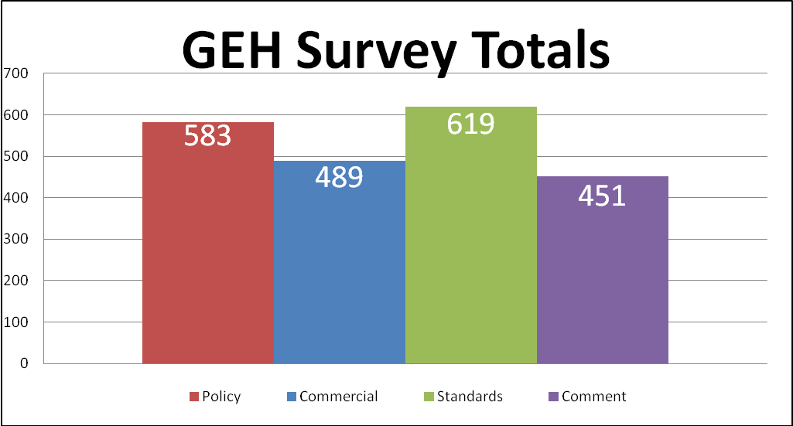

Thirty five of the thirty six committee members prepared and submitted surveys for inclusion in the overall results.

Gas-Electric Harmonization Committee Timeline -- Schedule of Meetings and Deliverables
 | Date/Time | Meeting | Deliverables
 | January 27, 1:00 pm to 4:00 pm | Conference Call & Web Cast  Full Committee - Organizational | Introduction to the Committee
 | February 15, 1:00 pm to 4:00 pm | Conference Call & Web Cast  Full Committee | Review Work Plan and Assignments
 | March 1, 10:00 am to 1:00 pm C | Conference Call & Web Cast  Team 2 | Work on core issues for coordination of transactions
 | March 1, 1:30 to 4:30 pm C | Conference Call & Web Cast  Team 1 | Work on core issues for transparency of information
 | March 2, 1:30 to 4:30 pm C | Conference Call & Web Cast  Team 3 | Work on core issues on commercial/operational issues
 | March 5, 1:30 to 2:30 pm C | Conference Call & Web Cast  Leadership Team | Review work of the teams and determine direction
 | March 16, 9:00 am to 10:00 am C | Conference Call & Web Cast  Full Committee | Review work of the teams, revise and prepare for NAESB Board meetings
 | March 20, 1:00 pm to 4:00 pm | Conference Call & Web Cast  Full Committee | Review work of the teams, revise and prepare for NAESB Board meetings
 | March 22 – 9:00 am to 1:00 pm | NAESB Board Meeting, Houston | Review of Progress of Committee
X | April 4, 1:00 pm to 4:00 pm (Cancelled) | Conference Call & Web Cast  Full Committee | Review Work Plan and Assignments and Progress Made to date regarding formation of recommendation
 | April 24, 10:00 am to 4:00 pm E | Meeting, Conference Call & Web Cast, Baltimore, MD  Full Committee | Review Work Plan and Assignments and Progress Made to date regarding formation of recommendation, Discuss categories and prepare survey
 | May 16, 1:00 pm to 4:00 pm C | Conference Call & Web Cast  Full Committee | Review Work Plan and Assignments and Progress Made to date regarding formation of recommendations based on survey responses
 | June 8, 10:00 am to 4:00 pm E | Meeting, Conference Call & Web Cast, Baltimore, MD  Full Committee | Review Work Plan and Assignments and Progress Made to date regarding formation of recommendation
 | June 19, 1:00 pm to 4:00 pm C | Conference Call & Web Cast  Full Committee | Review Work Plan and Assignments and Progress Made to date regarding formation of recommendation
 | June 21 – 9:00 am to 1:00 pm C | NAESB Board Meeting, Houston | Review of Progress of Committee with Possible Board Vote to Approve Recommendations
 | September 20, 9:00 am to 1:00 pm C | NAESB Board Meeting, Houston | Review of Progress of Committee with Possible Board Vote to Approve Recommendations

NAESB Gas-Electric Harmonization Committee – Reference Documents
# | Document | Link
1 | MIT Study, The Future of the Electric Grid | http://web.mit.edu/mitei/research/studies/documents/electric-grid-2011/Electric_Grid_Full_Report.pdf
2 | MIT Study, The Future of Natural Gas | http://web.mit.edu/mitei/research/studies/documents/natural-gas-2011/NaturalGas_Report.pdf
3 | FERC-NERC Joint Task Force Report on Outages and curtailments During the Southwest Weather Event on February 1-5, 2011 | http://www.ferc.gov/legal/staff-reports/08-16-11-report.pdf
4 | North American Natural Gas Midstream Infrastructure Through 2035: A Secure Energy Future Executive Summary Prepared by the INGAA Foundation | http://www.ingaa.org/File.aspx?id=14911
5 | Implications of Greater Reliance on Natural Gas For Electricity Generation Prepared For the American Public Power Association | http://www.publicpower.org/files/PDFs/ImplicationsOfGreaterRelianceOnNGforElectricityGeneration.pdf
6 | NAESB current Gas Nomination Standards and Gas-electric Coordination Standards | http://www.naesb.org/misc/geh_related_standards.docx
7 | Electricity Advisory Committee Interdependence of Electricity System Infrastructure and Natural Gas Infrastructure | http://www.naesb.org/misc/electric_infrastructure_gas_infrastructure_oct2011.pdf
8 | NERC 2011 Special Reliability Assessment: A Primer of the Natural Gas and Electric Power Interdependency in the United States – DUPLICATE OF ITEM 13 | http://www.naesb.org/misc/nerc_primer_gas_electric_interdependency_nov2011.pdf
9 | NERC Gas/Electricity Interdependencies and Recommendations, 2004 | http://www.naesb.org/misc/nerc_gas_electricity_interdependencies_2004.pdf
10 | NPC Prudent Development – Executive Summary (may be replaced by the published version – Ken Yeasting) | http://www.naesb.org/misc/npc_north_american_resource_dev_exec_summ_volume_dec2011.pdf
11 | NPC Prudent Development – Ch. 3 – Natural Gas Demand (may be replaced by the published version – Ken Yeasting) | http://www.naesb.org/misc/npc_demand_chapter_091511.pdf
12 | Excerpt of NAESB Bylaws | http://www.naesb.org/misc/naesb_bylaws_section2.2_best_practices.pptx
13 | NERC December 2011 Special Assessment - DUPLICATE OF ITEM 8 | http://www.nerc.com/files/Gas_Electric_Interdependencies_Phase_I.pdf
14 | Natural Gas in a Smart Energy Future – American Gas Foundation, APGA Research Foundation, Canadian Gas Foundation, INGAA Foundation, Natural Gas Supply Foundation and their members | http://media.godashboard.com/gti/Natural_Gas_in_a_Smart_Energy_Future_01-26-2011.pdf
15 | Summary of the North American Energy Standards Board Gas and Electric Interdependency Final Report to the Federal Energy Regulatory Commission in Docket No. RM05-28-000 “NAESB Report on the Efforts of the Gas-Electric Interdependency Committee” – U.S. DoE and NARUC | http://www.naesb.org/misc/icf_geic_primer062206.pdf
16 | Nuclear Plant Interface Coordination – Standard NUC-001-2, NERC, April 2010 | http://www.nerc.com/files/NUC-001-2.pdf
17 | Natural Gas year in Review – EIA, December 9, 2011 | http://205.254.135.7/naturalgas/review/, and http://205.254.135.7/naturalgas/review/print_version.cfm (print version)
18 | ERCOT Nodal Protocols | http://www2.econ.iastate.edu/tesfatsi/ERCOT.DefinitionsAcronyms.Oct2011.pdf
19 | Commission Role Regarding Environmental Protection Agency’s Mercury and Air Toxics Standards | http://www.ferc.gov/media/news-releases/2012/2012-1/01-30-12-notice.pdf
20 | How does the natural gas delivery system work – AGA web site | http://www.aga.org/Kc/aboutnaturalgas/consumerinfo/Pages/NGDeliverySystem.aspx
21 | Request for Comments of Commissioner Moeller, on Coordination between the Natural Gas and Electricity Markets, February 3, 2011 | http://www.ferc.gov/about/com-mem/moeller/moellergaselectricletter.pdf
22 | Gas and Electric Infrastructure Interdependency Analysis, prepared for the Midwest ISO, February 22, 2012 | https://www.midwestiso.org/Library/Repository/Communication%20Material/Key%20Presentations%20and%20Whitepapers/Natural%20Gas-Electric%20Infrastructure%20Interdependency%20Analysis_022212_Final%20Public.pdf
23 | Power Plants Likely Covered by the EPA Mercury and Air Toxics Rule, EPA, December 2011 | http://www.epa.gov/mats/pdfs/20111221PowerPlantsLikelyCoveredbyMATS.pdf
24 | NARUC Inventory on Gas Curtailment Planning, Institute of Public Utilities and the US Department of Energy, April 2005 | http://www.naruc.org/Publications/CIP_GasCurtailmentInventoryReport_8.pdf
25 | Federal Engagement in Standards Setting; Executive Office of the President Office of Science and Technology, Executive Office of the President Office of Management and Budget & Executive Office of the President United States Trade Representative, January 2012 | http://www.naesb.org/pdf4/geh051612w3.docx

NAESB Gas-Electric Harmonization Committee Named Members (35)
Member | Company/Organization
Vicky Bailey | BHMM Energy Services, LLC
Jim Buccigross | 8760 Inc.
Ralph Cleveland | AGL Resources, Inc.
Craig Colombo | Dominion Resources
Valerie Crockett (Co-Chair) | Tennessee Valley Authority
Alex DeBoissiere | The United Illuminating Company
Michael Desselle | Southwest Power Pool
Katie Elder | Aspen Environmental Group
Bruce Ellsworth | New York State Reliability Council
Lisa Epifani | Van Ness Feldman
Christopher Freitas | US Department of Energy
Arthur Fusco | Central Electric Power Cooperative Inc.
William Gallagher | Vermont Public Power Supply Authority
Bob Gee | Gee Strategies Group, LLC
Michehl Gent | Open Access Technology International, Inc.
Michael Goldenberg | FERC
Joseph Hartsoe | American Electric Power Service Corp.
Jesse D. Hurley | Shift Research, LLC
Kevin Kirby | ISO New England, Inc.
Richard Kruse | Spectra Energy Transmission
Gregory Lander | Capacity Center
Wayne Moore | Southern Company
Rana Mukerji | New York Independent System Operator, Inc. (NYISO)
Lou Oberski | Dominion Resources Services, Inc.
Joelle Ogg | DC Energy
Randy E. Parker | ExxonMobil Gas and Power Marketing Company
Marty Patterson | American Midstream Partners, LP
Andrew Rodriquez | North American Electric Reliability Corporation
Keith Sappenfield | Encana Oil & Gas (USA), Inc.
Pam Silberstein | FERC
Commissioner Timothy Simon | California Public Utility Commission
Rick Smead | Navigant Consulting, Inc.
Terence (Terry) Thorn | KEMA Gas Consulting Services
Sue Tierney (Co-Chair) | Analysis Group, Inc.
Kenneth L. Yeasting | Cambridge Energy Research Associates

