**North American Energy Standards Board**

**Request for Initiation of a NAESB Business Practice Standard, Model Business Practice or Electronic Transaction**

**or**

**Enhancement of an Existing NAESB Business Practice Standard, Model Business Practice or Electronic Transaction**

**Instructions:**

**1. Please fill out as much of the requested information as possible. It is mandatory to provide a contact name, phone number and fax number to which questions can be directed. If you have an electronic mailing address, please make that available as well.**

**2. Attach any information you believe is related to the request. The more complete your request is, the less time is required to review it.**

**3. Once completed, send your request to:**

**Rae McQuade**

**NAESB, President**

**1415 Louisiana, Suite 3460**

**Houston, TX 77002**

**Phone: 713‑356‑0060**

**Fax: 713‑356‑0067**

**by either mail, fax, or to NAESB’s email address, naesb@naesb.org.**

**Once received, the request will be routed to the appropriate subcommittees for review.**

**North American Energy Standards Board**

**Request for Initiation of a NAESB Business Practice Standard, Model Business Practice or Electronic Transaction**

**or**

**Enhancement of an Existing NAESB Business Practice Standard, Model Business Practice or Electronic Transaction**

Date of Request: September 5, 2024

1. Submitting Entity & Address:

TC Energy Corporation

700 Louisiana, Suite 700

Houston, Texas 77002

2. Contact Person, Phone #, Fax #, Electronic Mailing Address:

Name : Steven McCord

Title : NAESB Coordinator

Phone : (713) 252-7848

Fax :

E‑mail : steven_mccord@tcenergy.com

1. Title and Description of Proposed Standard or Enhancement:

Title:

Modify the Transportation/Sales Invoice dataset (NAESB WGQ Standard 3.4.1) to accommodate Distance Based Rate charges on paper and EDI Invoices.

Description:

Add Data Elements to the NAESB WGQ Standard 3.4.1 Transportation / Sales Invoice to accommodate the practice of charging Distance Based Rates for transportation services. These charges use a combination of the distance between the receipt and delivery locations along with daily or monthly charges to calculate the amount due for transportation. Sample calculations include:

* 100 Dth-Mile Calculation
  + (Dth) * (100-Miles) * (Monthly Rate) = Amount Due
  + Where “100-Miles” represents the total miles between the receipt and delivery location, divided by 100.
* GJ-Kilometer Calculation
  + (GJ) * (Kilometers) * (Monthly Rate) = Amount Due
  + Pipeline in Canada that connects to US pipelines.

Proposed Data Elements:

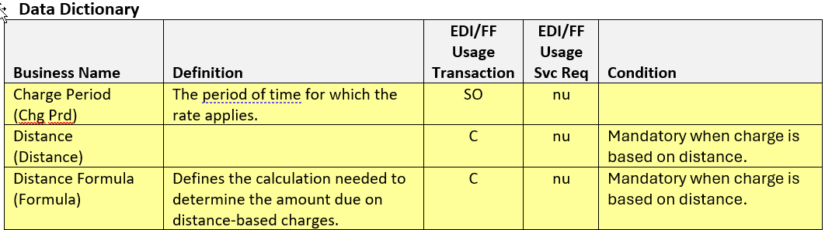

4. Use of Proposed Standard or Enhancement (include how the standard will be used, documentation on the description of the proposed standard, any existing documentation of the proposed standard, and required communication protocols):

These modifications will incorporate new data elements that will allow the pipeline to convey additional information to the shippers to fully describe the applicable distance-based invoice charges.

5. Description of Any Tangible or Intangible Benefits to the Use of the Proposed Standard or Enhancement:

Allows the pipeline to convey, via EDI and “paper” invoices, all information needed to manually verify or calculate a Distance Based Rate charge.

6. Estimate of Incremental Specific Costs to Implement Proposed Standard or Enhancement:

The requested data elements are Business Conditional, and not required. Cost impacts would only exist for Transportation Service Providers who choose to implement.

7. Description of Any Specific Legal or Other Considerations:

None

8. If This Proposed Standard or Enhancement Is Not Tested Yet, List Trading Partners Willing to Test Standard or Enhancement (Corporations and contacts):

N/A

9. If This Proposed Standard or Enhancement Is In Use, Who are the Trading Partners :

N/A

10. Attachments (such as : further detailed proposals, transaction data descriptions, information flows, implementation guides, business process descriptions, examples of ASC ANSI X12 mapped transactions):

None.