June 1, 2017
TO: Parliamentary Committee Members: Bill Boswell(*), Jim Buccigross, Cade Burks, James Cargas, Valerie Crockett, Michael Desselle, Bruce Ellsworth, Joe Hartsoe, Richard Kruse, Greg Lander, Debbie McKeever, Rae McQuade (*), Randy Parker, Timothy Simon

FROM: Bill Boswell and Jonathan Booe
RE: Parliamentary Committee Draft Process Flows – Weighted Voting Bylaw – May 19, 2017
Dear NAESB Parliamentary Committee Members:
Please find attached three process flow diagrams of the Bylaw proposals offered by Bill Boswell and Richard Kruse during our May 19, 2017 meeting in different formats. Currently, all action by the NAESB Board of Directors, outside of actions related to Certificate of Incorporation and Bylaw modifications described in the governance documents, requires simple majority support of the Board of Directors as a whole, regardless of the quadrant or segment affiliation of those voting. In response to concerns that a minority position of a single quadrant may be overridden by a majority position of the entire Board of Directors, a modification to the NAESB Certificate of Incorporation was proposed to create a structure for weighted voting by quadrant. The proposed modification to the NAESB Certificate was agreed upon in principle during the February 16, 2017 committee meeting, contingent on the development of a supportive NAESB Bylaw that would create a process by which consensus could be strengthened on a voting item that is not supported by a majority of each of the existing quadrants. The following process flows reflect the proposed NAESB Bylaw modifications offered by Bill Boswell and Richard Kruse.

PROCESS FLOW DIAGRAMS
Diagram 1 |  | Page
 | W. P. Boswell | 2
 | R. Kruse | 3
Diagram 2
 | W. P. Boswell | 4-5
 | R. Kruse | 6-7
Diagram 3
 | W. P. Boswell | 8-9
 | R. Kruse | 10-12

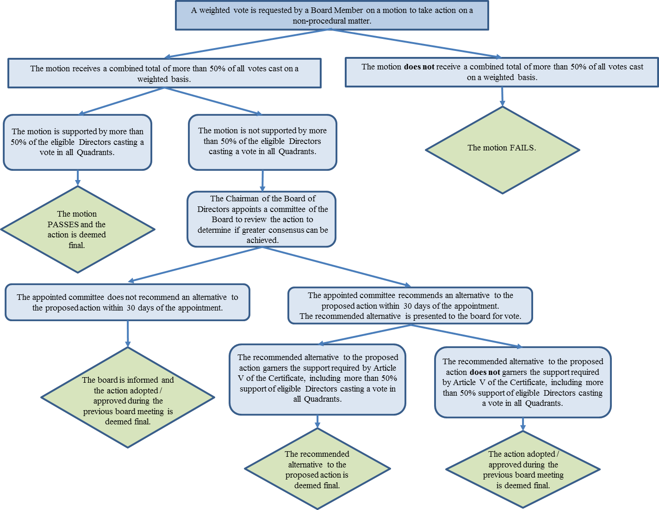
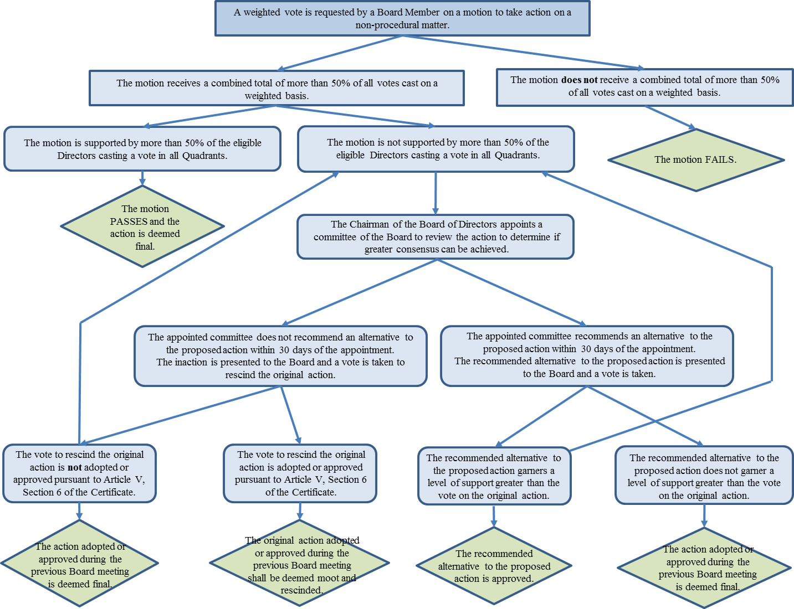
A weighted vote is requested by a board member on a motion made during a board meeting for motions not applicable to super-majority voting.
The motion receives a combined total of more than 50% of all votes cast on a weighted basis.
The motion is supported by more than 50% of the eligible directors casting a vote in each quadrant.
The motion PASSES and the action is deemed final.
The motion is not supported by more than 50% of all eligible directors casting a vote in each quadrant.
2a2
The Chairman of the Board of Directors appoints a committee of the Board to review the action to determine if greater consensus can be achieved.
The appointed committee does not recommend an alternative to the proposed action within 30 days of the appointment.
The board is informed and the action adopted /approved during the previous board meeting is deemed final.
The appointed committee recommends an alternative to the proposed action within 30 days of the appointment. The recommended alternative is presented to the board for a vote.
The recommended alternative to the proposed action garners the support required by Article V of the Certificate, including more than 50% support of eligible directors cast a vote in each quadrant.
The recommended alternative to the proposed action is deemed final.
The recommended alternative to the proposed action does not garner the support required by Article V of the Certificate, including more than 50% support of eligible directors cast a vote in each quadrant.
The action adopted /approved during the previous board meeting is deemed final.
The motion does not receive a combined total of more than 50% of all votes cast on a weighted basis.
The motion FAILS.

A weighted vote is requested by a board member on a motion made during a board meeting for motions not applicable to super-majority voting.
The motion receives a combined total of more than 50% of all votes cast on a weighted basis.
The motion is supported by more than 50% of the eligible directors casting a vote in each quadrant.
The motion PASSES and the action is deemed final.
The motion is not supported by more than 50% of all eligible directors casting a vote in each quadrant.
The Chairman of the Board of Directors appoints a committee of the Board to review the action to determine if greater consensus can
be achieved.
2a2
The appointed committee does not recommend an alternative to the proposed action within 30 days of the appointment.
The inaction is presented to the Board and a vote is taken to rescind the original action.
The vote to rescind the original action is not adopted or approved pursuant to Article V, Section 6 of the Certificate.
The action adopted or approved during the previous Board meeting is deemed final.
The vote to rescind the original action is adopted or approved pursuant to Article V, Section 6 of the Certificate.
The original action adopted or approved during the previous Board meeting shall be deemed moot and
rescinded.
The appointed committee recommends an alternative to the proposed action within 30 days of the appointment. The
recommended alternative is presented to the board for a vote.
The recommended alternative to the proposed action garners a level of support greater than the vote on the original
action.
The recommended alternative to the proposed action is approved.
The recommended alternative to the proposed action does not garner a level of support greater than the vote on the
original action.
The action adopted or approved during the previous board meeting is deemed final.
The motion does not receive a combined total of more than 50% of all votes cast on a weighted basis.
The motion FAILS.

A weighted vote is requested by a board member on a motion made during a board meeting for motions not applicable to super-majority voting.
 | A | B | C | D | E | End Result
Case 1 | The motion receives a combined total of more than 50% of all votes cast on a weighted basis. | The motion is supported by more than 50% of the eligible directors casting a vote in each quadrant. |  |  |  | The motion PASSES and the action is deemed final
Case 2 | The motion receives a combined total of more than 50% of all votes cast on a weighted basis | The motion is not supported by more than 50% of all eligible directors casting a vote in each quadrant. | The Chairman of the Board of Directors appoints a committee of the Board to review the action to determine if greater consensus can be achieved. | The appointed committee does not recommend an alternative to the proposed action within 30 days of the appointment. |  | The board is informed and the action adopted /approved during the previous board meeting is deemed final.
Case 3 | The motion receives a combined total of more than 50% of all votes cast on a weighted basis | The motion is not supported by more than 50% of all eligible directors casting a vote in each quadrant. | The Chairman of the Board of Directors appoints a committee of the Board to review the action to determine if greater consensus can be achieved. | The appointed committee recommends an alternative to the proposed action within 30 days of the appointment. The recommended alternative is presented to the board for a vote. | The recommended alternative to the proposed action garners the support required by Article V of the Certificate, including more than 50% support of eligible directors cast a vote in each quadrant. | The recommended alternative to the proposed action is deemed final
Case 4 | The motion receives a combined total of more than 50% of all votes cast on a weighted basis | The motion is not supported by more than 50% of all eligible directors casting a vote in each quadrant. | The Chairman of the Board of Directors appoints a committee of the Board to review the action to determine if greater consensus can be achieved. | The appointed committee recommends an alternative to the proposed action within 30 days of the appointment. The recommended alternative is presented to the board for a vote. | The recommended alternative to the proposed action does not garner the support required by Article V of the Certificate, including more than 50% support of eligible directors cast a vote in each quadrant. | The action adopted /approved during the previous board meeting is deemed final.
Case 5 | The motion does not receive a combined total of more than 50% of all votes cast on a weighted basis. |  |  |  |  | The motion FAILS.

A weighted vote is requested by a board member on a motion made during a board meeting for motions not applicable to super-majority voting.
 | A | B | C | D | E | End Result
Case 1 | The motion receives a combined total of more than 50% of all votes cast on a weighted basis. | The motion is supported by more than 50% of the eligible directors casting a vote in each quadrant. |  |  |  | The motion PASSES and the action is deemed final.
Case 2 | The motion receives a combined total of more than 50% of all votes cast on a weighted basis. | The motion is not supported by more than 50% of all eligible directors casting a vote in each quadrant. | The Chairman of the Board of Directors appoints a committee of the Board to review the action to determine if greater consensus can be achieved. | The appointed committee does not recommend an alternative to the proposed action within 30 days of the appointment. The inaction is presented to the Board and a vote is taken to rescind the original action. | The vote to rescind the original action is not adopted or approved pursuant to Article V, Section 6 of the Certificate. | The action adopted or approved during the previous Board meeting is deemed final.
 |  |  |  |  | (or) back to Column B
Case 3 | The motion receives a combined total of more than 50% of all votes cast on a weighted basis. | The motion is not supported by more than 50% of all eligible directors casting a vote in each quadrant. | The Chairman of the Board of Directors appoints a committee of the Board to review the action to determine if greater consensus can be achieved. | The appointed committee does not recommend an alternative to the proposed action within 30 days of the appointment. The inaction is presented to the Board and a vote is taken to rescind the original action. | The vote to rescind the original action is not adopted or approved pursuant to Article V, Section 6 of the Certificate. | The original action adopted or approved during the previous Board meeting shall be deemed moot and rescinded.
Case 4 | The motion receives a combined total of more than 50% of all votes cast on a weighted basis. | The motion is not supported by more than 50% of all eligible directors casting a vote in each quadrant. | The Chairman of the Board of Directors appoints a committee of the Board to review the action to determine if greater consensus can be achieved. | The appointed committee recommends an alternative to the proposed action within 30 days of the appointment. The recommended alternative is presented to the board for a vote. | The recommended alternative to the proposed action garners a level of support greater than the vote on the original action. | The recommended alternative to the proposed action is approved.
 |  |  |  |  | (or) back to Column B
Case 5 | The motion receives a combined total of more than 50% of all votes cast on a weighted basis. | The motion is not supported by more than 50% of all eligible directors casting a vote in each quadrant. | The Chairman of the Board of Directors appoints a committee of the Board to review the action to determine if greater consensus can be achieved. | The appointed committee recommends an alternative to the proposed action within 30 days of the appointment. The recommended alternative is presented to the board for a vote. | The recommended alternative to the proposed action does not garner a level of support greater than the vote on the original action. | The action adopted or approved during the previous Board meeting is deemed final.
Case 6 | The motion does not receive a combined total of more than 50% of all votes cast on a weighted basis. |  |  |  |  | The motion FAILS.

