Via email and posting

September 16, 2022

**TO:** NAESB Gas-Electric Forum and Interested Parties

**cc:** NAESB Board of Directors, Executive Committee (EC) Members, EC Alternates, Members, and Advisory Council

**FROM:** Rae McQuade, NAESB President & Jonathan Booe, NAESB Executive Vice President & COO

**RE:** NAESB Gas-Electric Forum Survey Responses – September 14, 2022 - Revised with additional comments related to Items 3.a, 3.a.i, 3.b., and 3.c in response to the October 3, 2022 request

Dear NAESB Members, GEH Forum Participants and Interested Parties,

Please find below the comment received by the NAESB Office in response to the survey/request for comments that was distributed on September 7, 2022 related to Items 3.a, 3.a.i, 3.b, 3.c from Recommendation 7: <https://www.naesb.org/pdf4/geh092322w1.docx>.

| **Responses Submitted by September 14, 2022 – 3a** | | | | |
| --- | --- | --- | --- | --- |
| **Question/Topic** | | 3a. Please provide comments and any specific recommendations for the forum attendees to consider regarding “Which entity has authority to require certain natural gas-fired generating units to obtain either firm supply and/or transportation or dual fuel capability, under what circumstances such requirements would be cost-effective, and how such requirements could be structured, including associated compensation mechanisms, whether additional infrastructure buildout would be needed, and the consumer cost impacts of such a buildout.” | | |
| **#** | **Organization** | **Representative** | **Market/Segment** | **Comment & Specific Recommendation** |
| 1 | LS Power | Marji Phillips | WEQ – Generator | It is important to distinguish between RTO and non-RTO regions, which are structured in vastly different ways to assure generation performance and adequate fuel supply and ensure that any recommendations respect this. Any additional requirements that result in additional investment must ensure guaranteed cost recovery; ideally it would be through a market mechanism in the RTO regions. In terms of authority, at least with respect to the RTOs, it would be the RTO that would make a tariff fling with FERC to reflect any mandates. Hopefully whatever mandates are produced would be the result of thoughtful consideration of stakeholder concerns, including state and federal regulators.  Obviously pipeline infrastructure build out would be the easiest way to solve many problems, but that is not an alternative in many states that have limited, and plan to eliminate the use of natural gas in their state. From a reliability perspective, this alternative would probably be less expensive. Additionally, it would be ideal if the pipelines could offer more flexible call options at lower costs than exist today.  There are balances to be considered in mandating firm supply or dual fuel capability. First, it may be an unnecessarily broad action. For example, LS Power owns a natural gas peaking plant in New England that because of its location on the pipeline system it does not need firm fuel to perform (as it has, with excellence). To so require firm fuel would unnecessarily increase consumer costs (as that requirement would have to be passed through) with zero incremental reliability gains. So it is important to be very precise on identifying the problem (e.g. where a plant is in relationship to the pipeline). Ensuring the right balance between carrot and stick: incentives and severe penalties for non-performance, is probably the ideal approach.  Finally, we need to consider if the 1 in 10 standard used is appropriate: are we trying to change that standard to a 1 in 20; is it necessary to have a seasonal approach to be more efficient, etc.  These are just some of the issues that need to be considered |
| 2 | Aspen Environmental Group | Catherine Elder | Other/Observer | I recommend FERC direct the independent system operators and RTOs to require evidence of firm supply and transportation or dual fuel capability in order to for that electric generation capacity to count towards resource adequacy – or vehicles such as the proposed Western Resource Adequacy Program submitted to FERC by the Western Power Pool (which may need modification to capture these gas-related issues). From work on a plant near Warner Robbins, I had thought SERC or Georgia had such a requirement but cannot quickly find a reference to it. If confirmed, the SERC requirement could be a potential model for other planning pools. Notably, in states such as California, the PUC has no jurisdiction over generators’ fuel and transportation arrangements. Accordingly, the action must come through FERC’s oversight of electricity markets.  Having worked on fuel arrangements for many merchant generators, I notice it is often over-looked that the reason they rely on interruptible arrangements is that they only have to operate enough to make their debt service payments and they have no obligation to operate. Just as important, those costs cannot be recovered in a marginal-cost bid market. As such, they do not want to commit to paying the reservation charge associated with firm transportation capacity. Capacity payments would be a huge help to solve this problem and it would be comforting to see FERC stop sticking its head in the sand on the symbiotic relationship between gas system reservation charges and electricity marginal cost markets.  In some locations (New England comes to mind) infrastructure buildout would be needed. Those costs should go to electric customers unless the additional capacity benefits all ratepayers but perhaps as a reliability surcharge rather than blending into existing rates. It would be interesting to explore recovery of such costs and any potential premium for firm supply (and maybe even the pipeline reservation charges) as an electricity security charge. FERC could also consider creation of an emergency at-risk provision under which all generators must be prepared to operate under emergency conditions (and governors and/or the President would declare that emergency similar disaster emergency declarations and/or the EEA stages) and impose a negative surcharge on those that fail to certify having made the appropriate arrangements to so operate. |
| 3 | Natural Gas Supply Association | Pat Jagtiani | WGQ Producer | NGSA has a strong preference for relying on competitive market solutions to improve the functioning of the market prior to resorting to out-of-market solutions or government mandates. Therefore, before examining who should mandate fuel procurement practices by generators, NGSA encourages the forum to consider market improvements that will fairly incentivize proper service procurement.  Current market design in organized markets often results in a disincentive for advance contracting and purchases of natural gas, which runs counter to what is required to ensure reliability. In organized power markets, generators face uncertainty about whether they will run until regional operators dispatch them. Consequently, generators in those markets often find it difficult to take on the financial risk of procuring their fuel in advance when they are unsure about how much fuel they need and whether they will be able to recover fuel-related costs. In many instances, generators continue to rely on interruptible transportation and supply contracts (that are typically only available when the gas system is not constrained), and day-of gas purchases that arise to meet electric system balancing requirements that expose generators to more volatility associated with spot market purchases.[1]  Recently, ISO-NE’s problem statement emphasized this point: “Specifically, the electricity markets are not designed to spur investments in supporting infrastructure needed to ensure a reliable clean energy transition. While the region is in the process of developing a plan and cost allocation methodology for assuring investments in the transmission infrastructure required to integrate renewable resources, there is no comparable plan to ensure the region has sufficiently robust, long duration, sources of balancing energy (including for the meantime, sufficient supplies of natural gas). In essence, the prevailing assumption is that the fuel markets will ensure sufficient fuel supply in response to high prices in the electricity markets. For a variety of reasons, this assumption is proving to be flawed.”[2]  NGSA believes that this forum should recommend that FERC and regional operators work with regional stakeholders to develop market design changes that mitigate the financial risk associated with advance fuel procurement and contracting by gas generators by placing more value on reliability. Also, we should explore other ways to encourage improved contracting and fuel procurement practices such as considering greater awareness of generator contractual commitments, power market capacity accreditation enhancements, the timing of day-ahead awards, and new flexible pipeline services. Given that the scope of this forum is not limited to serving power customers that operate only in organized markets, we would also be interested in gaining a better understanding about whether integrated utilities are also experiencing similar issues.  (1) Consideration of Design Changes in Organized Markets.  At a meeting last year, PJM presented a problem statement, which precipitated the creation of Senior Task Force on Gas-Electric Coordination. According to the problem statement, one of the primary problems with market design issues is as follows:  “Under the current wholesale electric market design, the risk/reward that Market Participants with gas generators face discourages fuel procurement at the very time generation is most needed. As need and gas costs rise, the profit margins of Market Participants with gas generators fall, often going negative. At extreme prices, there may even be corporate limitations that prevent fuel purchases altogether (authorization protocols, cashflow requirements, etc.). Also, market design limitations can create perverse generator behavior with respect to the way they use their dual fuel capability. Generators that can maximize profits (or limit losses) will have incentive to burn limited backup fuel resources as gas procurement risk/reward falls. Often this results in backup fuel consumption well in advance of peak weather or need.”[3]  Not only does current market design in organized markets discourage fuel procurement “at the very time” it is most needed, but it also discourages procurement “in advance” of when it is needed, which is ideally when fuel procurement should take place.  Notably, vertically integrated utilities and local distribution companies do not experience the same disincentive to procure fuel and, as a result, do not face the same level of reliability risk that we see in organized markets. Specifically, vertical utilities and LDCs (that have obligation to serve) do not face the same level of exposure because they have cost recovery mechanisms that allow them to actively manage their gas supply and capacity needs and invest in an expansive portfolio of long-term firm contracts and storage that support the level of reliability they require. Not only do advance contractual arrangements support a high level of reliability, but they also help to avoid or minimize the need to purchase large amounts of natural gas in the more volatile spot market, thereby mitigating their cost exposure. Organized markets should strive to replicate these practices to the extent possible through market design changes that value reliability and provide market signals that incentivize enhanced generator procurement practices. While this may appear to be a difficult or expensive undertaking when viewed in isolation, it should be evaluated in the broader context of the benefits derived from avoiding costly, damaging, and life-threatening power outages, as well as supporting the energy transition.  (2) Greater Awareness of Contractual Information and Improved Capacity Accreditation Practices.  NGSA supports recommendations in the FERC-NERC Final Report, such as Recommendations 1.G and 8, that give regional operators greater insight into the types of contracts gas generators have so they have a more accurate understanding of potential vulnerabilities that may exist due to contracting practices. Similarly, ensuring that capacity accreditation is in line with the actual expected availability of generation units for all resources could be a valuable tool for more appropriately valuing advance arrangements for reliable fuel delivery.  (3) Timing of Day-ahead Awards.  To the extent possible, region operators may want to consider whether changing the timing of day-ahead generator awards would assist gas generators in their region by giving them more timely notice about the amount of fuel they will need to purchase during the morning period when the gas market is most liquid. Late day award notifications force generators into the market when most gas has already been sold for the day (generally by 9am ET). This risks gas availability as well as higher priced purchases during illiquid periods. The gas industry does not “set” a time for purchases. Many gas customers purchase on a monthly basis and the percentage sold in the daily market is generally completed in the early morning hours. This also holds true for gas pipeline scheduling where most capacity is scheduled during the timely gas cycle and later cycles are used more for balancing.  (4) Facilitated Discussions to Find Mutually Agreeable Service Options.  A recent ISO-NE study found that, as more renewables are added to the grid and electrification efforts accelerate, natural gas demand will actually increase during cold weather periods when wind and solar resources underperform.[4] When pipeline systems are operationally constrained, whether by higher utilization by firm shippers or increased hourly takes, a gas generator’s ability to attain services and accommodations become more limited. In those instances, there may be (1) insufficient spare capacity to offer firm transportation and storage services to generators if there is an increased demand for those services (as recommended in FERC-NERC report on Uri), (2) less ability to rely on “spare” interruptible capacity, and (3) more limited operational intra-day flexibility to accommodate best efforts swings.  As these new patterns of electricity usage create a need for greater hourly swings by generators to balance the variability of renewable resources, it will be important to assess whether pipeline systems will also have the operational capability to manage the need for increased hourly flows. A pipeline’s ability to provide customers with intra-day flexibility (non-ratable takes) is contingent upon how much physical capacity is actually available in the existing pipe, which is limited by the finite size of the pipeline and its operational parameters. It also depends on how much line pack is available at a certain location in the pipe and how much the pipeline can let certain shippers draw on that line pack without causing an operational issue on the pipeline. During peak weather events, however, sudden unexpected takes can literally drain a pipeline system and impact its pressure – harming system operations and service to all shippers.  If a pipeline has insufficient capacity to provide the level of intra-day flexibility a customer requires, no level of coordination can change that fact.[5] However, given that most pipeline customers currently receive such “services” without additional costs on a best-efforts basis for much of the year, it may be difficult for gas generators to justify paying for flexible services that provides guaranteed hourly flexibility. If generators are compensated for purchasing this needed level of intra-day flexibility, pipelines will have the proper compensation to stand ready to serve through, for example, expanding capacity, increasing line pack in locations of the pipe where it is most needed, calling on increased supplies through OBAs with interconnecting pipelines and pulling on system storage. The costs of providing these services should be properly allocated to ensure that they are not borne by other customers.  While there are a variety of flexible market options available to generators in the gas market today, NGSA believes it would be helpful for this forum to recommend discussions between providers of natural gas services and their power customers to find mutually agreeable service options for flexible pipeline firm transportation and storage services or third-party services that provide the flexibility generators require. While these types of conversations typically occur between a company and its customer, the time may be ripe for a fuller discussion of what prevents such flexible services from coming to fruition and ways to encourage customers to invest in these services rather than relying on pipelines to accommodate those needs on a best-efforts basis. |
| 4 | Process Gas Consumers Group & American Forest Paper Association | Andrea Chambers | WGQ End User | Commenters assert that the FERC is the federal entity that has the authority to require natural gas-fired generators to obtain either firm supply and/or transportation or dual fuel capability to participate in wholesale electricity markets. Indeed, FERC has exercised this authority in the past in response to the Polar Vortex winter event when it approved ISO-NE’s and PJM’s pay-for-performance incentives aimed at ensuring energy resources are ready and able to fulfill their obligations to provide electricity or reduce demand during times of stress on the power system. The New England ISO’s incentive payments have increased over time and are being phased in over the next several years. Because FERC approves tariffs that provide for the payment to electric generators for their supply of electricity and capacity in wholesale markets, FERC is the proper authority to require such generating entities to acquire the necessary firm interstate pipeline transportation or natural gas storage in order to ensure the reliability of the electric grid as a condition to qualify to receive wholesale electric capacity or energy payments.  The FERC has also approved payments to generators, through reliability must run agreements, in cases where a region, like the California ISO, has experienced inadequate reliable generation to serve electric load. As noted in the NERC’s Report on the February 2021 Cold Weather Outages in Texas and South Central United States (the “Report”) discussing the outages during the Uri Storm, natural gas pipeline capacity is certificated to accommodate firm transportation commitments, while many natural gas-fired units rely on non-firm commodity and/or transportation contracts. Commenters believe the answer to electric service reliability issues is to make electric service more reliable by fixing compensation issues in the wholesale electric markets that discourage generators from signing contracts for firm natural gas transportation or storage to serve gas-fired generators. The Commenters believe the resolution is not to make the electric system more reliable by leaning on the existing firm pipeline infrastructure that is built to serve natural gas demand in a way that harms reliability of natural gas service to customers of interstate pipelines who pay for firm transportation service.  Requiring electric generators to purchase firm pipeline transportation to ensure reliability will provide the pipelines with the market demand to support their construction of additional interstate pipeline capacity where it is needed to serve both electric power generation load and natural gas demand for home heating, commercial and industrial load. Without the requirement that natural-gas-fired generators purchase firm transportation, consumers will suffer in the reduction of both reliable electric and reliable natural gas services, which could result in damage to property and health in extreme weather events, as was witnessed with the Uri Storm. Moreover, regions could also see economic and job loss due to industry moving from a region with less reliable electricity and natural gas supplies to another region with more reliable energy resources.  In terms of cost-effectiveness, the cost for natural gas supply to local utilities in Texas in the wake of the Uri storm for a week was more than some utilities budgeted for the year. According to the Report, analyst with the Federal Reserve Bank of Dallas estimate the outages caused direct and indirect losses to the Texas economy of between $80-$130 billion. On top of that, there is the cost of loss of life which is immeasurable. According to the Report, 210 people died during Storm Uri, with most of the deaths connected to the power outages. While the loss of life is more significant than economic losses, manufacturers suffered economic losses from shutting down production and, in cases where replacement gas was available, from the high cost of replacement gas. These additional costs are sometimes recoverable from increasing the cost of manufactured products, but many manufacturers and industrial companies, such as PGC and AF&PA members operate in highly competitive, trade exposed markets and must absorb these increased costs |
| 5 | Enchanted Rock | Joel Yu | WEQ Technology or Service | The challenge with respect to the costs of firm deliveries to electric generation is in the fact that benefits of firm service accrue to electric customers while costs are borne by gas companies. The most cost-effective solution would allow these costs to be reflected in competitive electric markets through requirements on electric generation. Relevant state commissions or FERC should develop rules to require firm natural gas supply and transportation for generation and allow those costs to be recovered through the electric markets without handicapping natural gas generation with respect to other technologies that may not have the same level of flexibility and dispatchability without duration limits. Texas has taken steps to do this through the development of a Firm Fuel Supply Service product. Revenues generated from the electric markets will pass through to the gas companies to deploy for expanded capacity and resiliency investments. Recommendations for electric generation must be paired with recommendations for improving gas facility reliability under topic 2, including potential requirements for gas facilities, like electric compressor stations, to deploy on-site gas-fired generation that can provide backup during grid emergencies and provide support to the electric grid when operating in parallel. |
| 6 | Interstate Natural Gas Association of America | Christopher Smith | WGQ Pipeline | Before reaching the question of authority to impose requirements, there is a threshold question: Why shouldn’t the organized wholesale electric market develop market incentives, products, or services to promote reliable fuel supplies in the first place? In organized power markets, however, uncertainty over whether a generator will be called upon leads to short notice fuel procurement practices that are no longer sustainable given the increased demand for natural gas. Current market design in organized markets often results in a disincentive for advance contracting and purchases of natural gas, which runs counter to what is required to ensure reliability. Market clearing times force gas generators into the gas market to purchase gas after most gas is already sold during the more illiquid times if they wait to know if they clear. Gas generators are most hesitant to purchase gas during tight market conditions, when gas is most needed, because it is more expensive during those times, and they lack confidence in whether they will be compensated for taking an untenable financial risk.  The concern is that calls for more “gas-electric coordination” skirt addressing the fundamental disconnect between electric reliability and organized power markets which dispatch on least cost. While this structure may work well for creating competitive bidding in organized markets, it does not give generators certainty of how often they will be needed; making gas generators hesitant to make advance longer-term arrangements for their fuel supply. Regional operators must be able to provide greater confidence to gas generators so that they are not at risk when contracting for the proper level of commodity, transportation, and storage.  Changes to RTO market structures must be made to instill greater confidence to generators to secure their fuel supply. Organized markets should develop mechanisms that properly value reliability and facilitate power generator investment in the gas services they require, including supporting new gas infrastructure investment when needed. Nonetheless, cost recovery for infrastructure will be difficult when the electricity market structure drives electricity suppliers to short-run marginal costs. One such recommendation to address these concerns, proposed by ISO New England, is to create an energy “reserve.” Such a reserve could be achieved through some or all of the following:  1) State regulated cost-of-service infrastructure investments coupled with contracting for the necessary energy.  2) FERC regulated cost-of-service rates for recovering investments in infrastructure and forward energy supply chain arrangements.  3) FERC regulated wholesale electric market tariffs that rely on uniform clearing price mechanisms to incentivize investments in infrastructure and forward energy supply chain arrangements. |

| **Responses Submitted by September 14, 2022 – 3a(i)** | | | | |
| --- | --- | --- | --- | --- |
| **Question/Topic** | | 3a(i). Please provide comments and any specific recommendations for the forum attendees to consider regarding [Recommendation 24] “Federal and state entities with jurisdiction over natural gas infrastructure should cooperate to further study and enact measures to address natural gas supply shortfalls during extreme cold weather events, including market/public funding for generators to have firm transportation and supply and invest in storage contracts. Such funding may need to finance infrastructure necessary to provide additional firm transportation capacity, because many existing pipelines were financed and constructed to serve LDCs and may not have sufficient additional firm capacity.” | | |
| **#** | **Organization** | **Representative** | **Market/Segment** | **Comment & Specific Recommendation** |
| 1 | LS Power | Marji Phillips | WEQ – Generator | See Response to 3a |
| 2 | Aspen Environmental Group | Catherine Elder | Other/Observer | We’ve assumed these last decades that the market will decide how much capacity to build. What FERC can conclude from the Uri example is that the market did not properly value capacity and the need to operate under extreme conditions. Many of us recognize that the public, and by extension, the market is not good at valuing low probability, extreme events. Analytic exercises that evaluate the supply(capacity)/demand balance under extreme conditions are enormously important in getting that story out and give our planners and policy makers a forum and context in which to think. My staff and I contributed analysis of this kind to the 20201 Integrated Energy Policy Report of the California Energy Commission as I also did after the Aliso Canyon gas well leak. As for financing, see answer 3a above. Along with doing the supply(capacity)/demand balance work, the study should identify which generating units must operate. Alternatively, under the kinds of conditions that occurred with Uri, it may be that almost all generators become critical. The study should also describe and explore the risk of extreme events and recognize that the “standard” 1-in-10 criterion often applied does not begin to capture the intense suffering citizens will experience during extreme conditions or that extreme conditions are likely to occur more often than in the past, due to climate change. We must re-think reliability and willingness to pay to avoid extreme outcomes. The study might also rank both the cost and effectiveness of solutions as it sure seems (but should be confirmed) that winterizing wells may be a least-expensive option for making supply more secure and then compare the cost of adding underground storage and some LNG needle peakers versus new pipeline capacity. |
| 3 | Natural Gas Supply Association | Pat Jagtiani | WGQ Producer | First and foremost, NGSA believes that market solutions provide the best means to address the need for more resources in the most efficient manner that reduces costs to consumers.  At FERC’s conference in Burlington, Vermont last week, a number of panelists and FERC commissioners questioned ISO-NE’s current market construct that is not procuring sufficient resources to ensure reliable operations. ISO-NE has been trying to solve gas supply issues with market design enhancements, but imperfections exist because generators do not have a mechanism to recover costs for investment in services that would support new gas infrastructure, such as pipeline capacity and storage, on-site storage and LNG imports, or dual fuel capabilities. In these instances, in which there are near-term risks and limited options, it may be necessary for states, the regional operator and stakeholders to work together to expeditiously develop and implement additional market-based products, at least on a temporary basis. |
| 4 | Process Gas Consumers Group & American Forest Paper Association | Andrea Chambers | WGQ End User | Commenters agree with 3.a.i. are believe that local entities with jurisdiction over natural gas infrastructure at the distribution level and service to retail consumers are also the proper authorities to require firm transportation for gas-fired generators serving those utilities in cases where they are not purchasing wholesale electric generation. These local entities are best positioned to require firm transportation because they are most aware of the existing infrastructure constraints in their locality as well as what capacity is needed to meet the region’s demand. These local entities should also coordinate with the FERC as discussed in 3a. |
| 5 | Interstate Natural Gas Association of America | Christopher Smith | WGQ Pipeline | A survey of interstate pipelines found that from 2006-2016 pipelines delivered 99.79% of “firm” contractual commitments to transportation customers at the primary delivery points specified in their contract. Traditionally, gas-fired power generators have had the benefit of using existing pipeline capacity that was funded by other shippers. Generators might not be able to rely on this benefit in the future as pipelines become constrained through higher utilization by firm shippers and increasing numbers of dispatchable power generators that will be needed to complement renewable generation and that rely on natural gas.  A pipeline’s ability to provide extra contractual flexibility beyond what is in its tariff is contingent upon how much physical capacity is available in the existing pipe, which is limited by the finite size of the pipeline, certificated maximum pressures to ensure safety, and how firm shippers are using their contractual commitments. It also depends on how much line pack is available at a certain location in the pipe and how much the pipeline can let certain shippers draw on that line pack without causing an operational issue on the pipeline. Gas generators cannot continue to rely on interruptible capacity and pipeline operators’ best efforts to support flexibility, particularly during coincident peak periods, when the pipeline’s firm shippers are using their capacity, and additional pipeline capacity is not available. Relying on best efforts to accommodate flexible scheduling is simply not a sustainable approach. In these instances, it is additional capacity that is required, and no level of coordination can change that fact.  In addition to extreme cold weather events, the electric industry’s needs stand to change dramatically in the coming years as the grid integrates more renewable resources and increasingly relies on gas generators, which can be dispatched quickly and ramp up easily, to play an integral role in balancing the system. An ISO New England study found that even in a deep decarbonization scenario, demand for natural gas during the peak hour in 2040 was only 14% lower than in 2021 as electrification efforts shifted consumption patterns. This indicates that today’s level of pipeline capacity is roughly the minimum necessary to reliably run the grid even as the generation mix changes dramatically. Gas is not a “just in time” fuel, as some characterize it, because the bulk of pipeline customers make advance arrangements to ensure it arrives on time.  Looking forward, very little analysis has been done looking at whether existing gas infrastructure can accommodate steeper and more frequent ramping requirements, without impacting gas industry operations and service to other shippers (and ultimately retail customers), and whether the electric industry should rely on pipeline flexibility, which isn’t always available, for their own electric reliability.  The availability of natural gas for power rests on the existence of sufficient gas infrastructure to serve power market needs. But there simply isn’t enough pipeline infrastructure to meet the demand for natural gas. Pipeline infrastructure, including storage, takes years to certificate and build, and there must be foresight into what the electric grid needs to reliably meet power demand as well as the flexibility required to accommodate changing gas consumption patterns. It may also take time for power market customers and regional operators to craft solutions that make it possible for power market stakeholders to financially commit to needed gas capacity additions that make such projects economically viable. Additionally, permitting reform at the federal, state, and local levels is essential to remove obstacles to natural gas infrastructure development. By removing barriers to infrastructure development, FERC will not need to identify “zones” with insufficient pipeline capacity. Markets will make that determination and pipeline companies will develop the infrastructure needed to address the constraint. |
| 6 | Kansas Corporation Commission | Justin Grady | Retail – End User / Public Agency | One idea that I think should get more discussion and consideration would be an addition to the current NAESB certification criteria to include a designation for NAESB Certified Winterized Gas. Much of the conversation to date in this forum has been about limitations of available gas transportation during extreme events, but there was adequate transportation capacity (although it was admittedly very tight) for natural gas throughout much of the event in the Central part of the United States. What was lacking was available molecules of natural gas to be transported. The reasons for this are multifaceted as detailed in the FERC/NERC report, but one major contributing factor was the lack of winterization of natural gas supply infrastructure. While some States are making progress in requiring certain natural gas infrastructure to winterize, these efforts are likely to be piecemeal and incomplete when viewed through the lens of regional reliability. There's also the very real concern that these mandated winterization efforts will not come with a guarantee of cost recovery for producers given the status of wholesale natural gas as a deregulated commodity. This idea (a NAESB Certified Winterization Seal) would allow the market to differentiate between winterized molecules of gas and non-winterized molecules of gas. Market participants could then value those molecules appropriately, and compensate the producers who made the necessary investments to winterize their facilities. Additionally, if State Regulators found that it was necessary for retail utilities under their jurisdiction to secure these winterized gas supplies in order to meet their legal requirement to provide efficient and sufficient service, that would provide additional demand and liquidity to the market for Winterized Natural Gas. I'm sure there are flaws to this approach that I'm looking forward to hearing, but this solution would appear to be a market driven solution that would first identify, then certify, natural gas production that came from fully-winterized natural gas production facilities. Then, the market could value that reliability trait, thereby providing compensation for the producers who made the winterization investments. |

| **Responses Submitted by September 14, 2022 – 3b** | | | | |
| --- | --- | --- | --- | --- |
| **Question/Topic** | | 3b. Please provide comments and any specific recommendations for the forum attendees to consider regarding [Recommendation 24] “Possible options for increased regasification of liquid natural gas (including possible Jones Act Waivers).” | | |
| **#** | **Organization** | **Representative** | **Market/Segment** | **Comment & Specific Recommendation** |
| 1 | LS Power | Marji Phillips | WEQ – Generator | It is likely that it will take more than Jones Act Waivers. It is about reserving the ships, competing with Europe and other countries willing to pay more for LNG than US counterparts. |
| 2 | Aspen Environmental Group | Catherine Elder | Other/Observer | It isn’t clear to me how the Jones Act waiver helps when we are exporting so much gas as LNG. Rather, simply reduce the export, though that has international geopolitical repercussions as well as potential contract interference issues. I suppose suspending the Jones Act would help those that are able to find a cargo in transit but cannot take delivery because the carrier is not US-flagged. But even then, several days could pass by the time the carrier reaches a US import terminal and the gas enters our pipeline system, making its usefulness in an emergency less than clear. Instead, I think it makes more sense to encourage more LNG needle peaking units astride existing pipelines (that have capacity available during winter) or located near generators. These units, of course, cost more than pipeline capacity so we get back to the question of how to pay for them – perhaps a reliability surcharge ultimately makes sense. More underground gas storage could help, too, but clearly the merchant/option pricing approach has not resulted in large amounts of gas storage being added in recent decades. Should the ultimate approach be to create emergency declaration with associated intervention powers, though, I don’t see a reason not to include temporary waiver of the Jones Act for purchase and delivery of spot cargos. |
| 3 | Natural Gas Supply Association | Pat Jagtiani | WGQ Producer | As noted above, the primary obstacle hampering adequate LNG options is the inability of gas generators to recover the fixed costs associated with such investments and significant market design improvements must be made to reflect the value of reliability so that generators will be motivated to contract for such services. If the market does not provide the proper signals to attract sufficient resources required for grid reliability, additional market-based products should be considered.  Recently, in an August 18 letter to Massachusetts Governor Baker, Energy Secretary Granholm stated that the Department of Homeland Security will consider waivers to the Jones Act on a case-by-case basis.[6] Absent any additional legislation, we will continue to rely on individual determinations, which may not provide the level of fuel security required to ensure that sufficient resources are available to maintain reliability. |
| 4 | Process Gas Consumers Group & American Forest Paper Association | Andrea Chambers | WGQ End User | The increased regasification of liquified natural gas (“LNG”) in capacity constrained regions is not without infrastructure components. For example, both options will require some amount of storage infrastructure to be built as well as local pipelines to deliver the commodity to the end user. The storage component of this option will not completely negate the capacity constraints because there is a limited amount of storage capacity in these regions as well. Moreover, importing LNG and foreign gas will also expose consumers to increased price volatility because the imports will subject to macroeconomic pricing as well as any foreign and domestic tariffs. However, other regions, like the Pacific Northwest, rely on market-area storage to supply winter supply needs and LNG for peak-shaving events to avoid curtailment of load in peak seasons without the need to build additional pipeline capacity from the production areas. It is critical that each region plan ahead and have in place adequate infrastructure to serve their loads. |

| **Responses Submitted by September 14, 2022 – 3c** | | | | |
| --- | --- | --- | --- | --- |
| **Question/Topic** | | 3c. Please provide comments and any specific recommendations for the forum attendees to consider regarding “Which entity has authority, and under what circumstances, to take emergency actions to give critical electric generating units pipeline transportation priority second only to residential heating load, during cold weather events in which natural gas supply and transportation is limited but demand is high.” | | |
| **#** | **Organization** | **Representative** | **Market/Segment** | **Comment & Specific Recommendation** |
| 1 | Aspen Environmental Group | Catherine Elder | Other/Observer | As for interstate pipeline capacity, it would be only FERC. Emergency powers could be authorized under a disaster declaration or such. Rather than take gas from industrial customers I expect it makes more sense to require those southwest and midcontinent wells be winterized. Intrastate pipelines would be state jurisdictional; perhaps each state with such a pipeline could designate its office of emergency services and public utilities commission to coordinate with FERC to issue the emergency orders for actions needed to preserve gas supply for critical services. |
| 2 | Natural Gas Supply Association | Pat Jagtiani | WGQ Producer | NGSA is not aware of any federal government authority to unilaterally abrogate private contracts in the interstate market. Such authority may exist in some states for intrastate market transactions but that is likely to vary state-by-state, and state authority would not be applicable to any interstate transactions. While it is possible that parties may want to explore the idea of agreeing to reduce contracted levels on a voluntary basis in advance of disruptive events, customer contracts cannot be altered legally by any governmental authority without the parties’ consent.  Furthermore, reprioritizing natural gas use during cold winter events runs counter to one of the key objectives of this forum: exploring ways to encourage generator contracting that is more aligned with the level of reliability they require. Redirecting other shippers’ gas in the interstate market to generators will actually reduce the incentive for generators to contract for firm fuel supplies if they know they will be prioritized in emergencies. Therefore, before pursuing this concept, we must explore how it would be possible that a “critical electric generating unit” would not have procured reliable gas supply and transportation to ensure their own priority status in the first instance.  Re-directed gas cannot be relied upon as a solution given that it disregards the potential irreparable harm caused to other customers that rely on gas supplies for essential human needs services. Further, abrogation of any energy contracts sets a bad precedent across the energy industry for gas and power, undermines confidence in the energy marketplace, and is inconsistent with judicial precedent. Redirecting a customer’s supply, when that customer has paid large sums of money for reliable uninterrupted service, to another customer that has not invested in the same level of priority of service would not only be disruptive to that customer but also to our industry’s stability, which is underpinned by contracts. Under the Commission’s Order No. 636, which was issued over three decades ago, priority end-use has been replaced in the interstate market by a competitive framework in which contracts and the sanctity of those contracts are fundamental components contributing to the successful of the wholesale natural gas markets we have today. Why would these shippers and customers continue to sign contracts if they are subject to abrogation at a time when their fuel purchases are needed the most?  Moreover, NGSA’s member companies draw on their large portfolios of assets during peak weather events to ensure as many customers get gas supplies as possible. They pull not only on their storage and transport capacity in the region, but also bring gas from other regions using their storage and transport assets across the country. In addition, NGSA members have been able to redirect LNG cargoes to regions in need during peak weather events. Inserting a new authority that can cut NGSA members’ firm capacity and redirect it to generators will disrupt NGSA member’s ability to move additional supply resources to markets in need. |
| 3 | Process Gas Consumers Group & American Forest Paper Association | Andrea Chambers | WGQ End User | Manufactures plan ahead and sign up to pay for firm pipeline capacity to ensure that their plants can operate in a reliable and safe manner even in cold weather events when pipeline capacity is constrained and demand is high and they strongly believe that electric generators should be required to do the same. The Commenters represent industrial consumers who have contracted for firm transportation and natural gas supplies, and who are reliant on the firm delivery of such natural gas to run their plants. Because Commenters are in a private contractual relationship with the respective pipelines for the transportation of their natural gas supply, the Commenters do not believe that any authority may strip their firm rights without following the pro-ration requirements of the FERC-approved tariffs.  Moreover, these companies pay for the natural gas supply that is shipped through the pipeline and believe that the government may not take away their property rights in such supply without compensation. However, in certain scenarios, manufactures or industrials may be willing to offer excess gas supply or transportation back to the market when they are able to reduce demand. In such cases, manufactures should be compensated not only for the reservation demand credits, but more importantly for replacement supply which in supply shortage situations can cost significantly more than their original contract price or not be available.  Commenters also note that many local distribution companies (“LDCs”) have voluntary curtailment plans in place, and the Commenters believe that the local authorities should require any such entity curtailing natural gas customers be required to have curtailment plans in place and have them approved either by the PUC or FERC under their tariff. Such tariffs should provide manufactures the ability to be included as priority facilities when curtailment of natural gas supply will result in cuts to the manufacturers and with adequate compensation when service is cut. However, in no event should curtailment of firm shippers who pay for pipeline service be viewed as the solution to inadequate planning on the part of electric generators or as a fix to flaws in the wholesale electricity market design.  However, it is also key to focus on the other root causes of the outages identified in the report as well, many of which are related to lack of weatherization of the natural gas infrastructure system and electric generators. As explained in the Report, unplanned outages of natural gas wellheads due to freeze-related issues, loss of power and facility shut-ins to prevent freezing as well as unplanned outages of natural gathering and processing, resulted in a 28% decrease in total natural gas production in the lower 48 states and a 50% reduction in natural gas production when compared to average production in January of 2021. The report finds that of the generators that experienced outages, 58% of were natural gas-fired generators. Of the outages, 75% were due to freezing issues or fuel issues. Natural gas fuel supply issues caused the majority, 87%, of the 31.4% of outages due to fuel issues. ERCOT has adopted winterization requirements for generators located in ERCOT and, according to ERCOT’s recent audits, most generators are in compliance with such requirements. However, Texas has not adopted similar requirements for natural gas infrastructure. Given the impact of these natural gas infrastructure freezing issues, FERC must work with Texas to ensure that that they take steps to protect the reliability of the electric system by requiring weatherization of natural gas facilities as is standard practice in northern regions. These steps are critical in recognition of the increasing frequency of these extreme weather events in Texas, SPP and MISO South. Additionally, FERC and Texas regulators should address issues related to dissuade pipelines from being overly dependent on electric natural gas compression stations to avoid compression station failures like those that occurred in Texas during the Uri Storm. |
| 4 | Dominion Energy | Michael Oberleitner | WEQ Generator | When addressing firm transportation priority (gas generators second to residential heating load), does this conflict with any concerns or FERC standards around allowing different levels of firm service within the same pipeline transportation rate schedule? |
| 5 | Enchanted Rock | Joel Yu | WEQ Technology or Service | With respect to the topic 3 questions for the upcoming forum, we note that for distributed technologies or other bulk-system generation located behind the Local Distribution Company’s city-gates, the most direct authority for transportation prioritization is the state-level utility commission overseeing gas distribution. In Texas, the Railroad Commission recently went through a process to revise its curtailment prioritization policy to rank electric generation just below deliveries to LDCs and their firm load. See the Railroad Commission’s Adopted Rule 16 TAC §7.455 and §7.305, April 2022. [<https://www.sos.texas.gov/texreg/archive/April292022/Adopted%20Rules/16.ECONOMIC%20REGULATION.html#95>]. In other regions, LDCs sometimes do not have tariffs in place to provide firm service to electric generation on the gas distribution system, usually due to some combination of lack of adequate capacity and lack of policy support to deploy more gas. For example, in the NYC area, LDC-connected electric generation is required to have dual fuel and placed on interruptible gas service. In California, core gas service is not allowed for LDC-connected electric generation unless it is de minimis in size. |
| 6 | Interstate Natural Gas Association of America | Christopher Smith | WGQ Pipeline | Section 215A(b) of the Federal Power Act (FPA) and the subsequent Grid Security Emergency Final Rule, 10 CFR Part 205, (January 2018), permits the Secretary of Energy to issue an order for emergency measures following a Presidential declaration of a grid security emergency (GSE). The applicability of a GSE states that “An order for emergency measures under this subsection may apply to-(A) the Electric Reliability Organization; (B) a regional entity; or (C) any owner, user, or operator of critical electric infrastructure or of defense critical electric infrastructure within the United States.” “Critical electric infrastructure” is defined as “a system or asset of the bulk-power system, whether physical or virtual, the incapacity or destruction of which would negatively affect national security, economic security, public health or safety, or any combination of such matters.” Natural gas pipelines do not fall into this category.  Over three decades ago, priority end-use on interstate pipelines was replaced by a framework in which contracts and the sanctity of those contracts became the fundamental components that have contributed to the successful natural gas markets we have today. The contracts, however, are entered into by shippers, such as utilities, that are legally required to maintain service. Therefore, if the sanctity of contracts is undermined, shippers may not be able to provide service to their customers or operate their businesses. In addition, if the sanctity of contracts is undermined, it provides a continued incentive for generators to continue to rely on less than firm services if an entity could take emergency action to provide generator units pipeline priority ahead of those who chose to contract for pipeline firm capacity.  Shippers enter into firm contracts to ensure that heating services can be provided on peak demand days. During emergency situations, some policymakers may feel pressure to disregard a gas customer’s contract so that gas supplies can be redirected to generating units that do not hold firm pipeline transportation or storage capacity when such generators may be critical to maintaining electric reliability. Attempts to re-direct gas disregards the potential irreparable harm caused to other customers that rely on gas supplies for essential human needs services beyond residential heating and would be a violation of the pipeline tariff and FERC policies. Pipelines do whatever they are able within the tariff to support emergency recovery, but since pipelines do not own the gas that they transport, diversion of the gas puts pipelines at risk of serious liability. Prior to pursuing such extreme confiscation measures that take other customers’ gas and disregard the sanctity of contracts, we must in the first instance address how it would be possible that a “critical electric generating unit” would not be holding a firm contract for both gas supply and transportation to ensure their own reliability. |
| 7 | California Public Utilities Commission | Jean Spencer | Retail – End User / Public Agency | The CPUC has approved a curtailment order for the SoCalGas service territory that was developed via settlement agreement. In it, a percentage of electric generation takes the first cut--in part because it is quick to offload--but the remainder is among the last noncore load to be curtailed, with some exceptions for hospitals and refineries, etc. While this particular order of curtailment might not be applicable everywhere, the broader idea of establishing a curtailment order could be used by other state utility commissions.  As a side note, the WECC's Gas-Electric Interface Study pointed to this curtailment order as the reason why California's gas-fired electric generators don't hold long-term gas contracts. We asked stakeholders to comment on this in our Long-Term Gas Planning Rulemaking, and their general response was that the primary reason that they don't hold long-term contracts is because they can't bid them into the CAISO market. The curtailment order was far less of an issue. |

| **Responses Submitted by September 14, 2022 – General Comments Related to Agenda Topics for the September 23 Meeting** | | | | |
| --- | --- | --- | --- | --- |
| **Question/Topic** | | **General Comments Related to Agenda Topics for the September 23 Meeting** | | |
| **#** | **Organization** | **Representative** | **Market/Segment** | **Comment & Specific Recommendation** |
| 1 | LS Power | Marji Phillips | WEQ – Generator | It might be helpful to have representatives from the various sectors lay out their perspective of the issue, for example, LS's point that not every generator has to have a firm fuel contract to perform reliably and with excellence. Pipelines may have particular viewpoints. Of course, state and federal regulators, investor utilities and RTOs each have their concerns, too. One way to facilitate such a basic discussion is to utilize a tool employed by PJM: develop an issues matrix whereby stakeholders identify their concerns and preferred goals. |
| 2 | Aspen Environmental Group | Catherine Elder | Other/Observer | We today see increasing pressure to not build new gas infrastructure. As a result, we have to balance the impact of any infrastructure additions with the idea that they may or may not be in service for 50 to 70 years. Again, winterizing the wells seems like the least-cost option for maintaining existing gas supply under emergency conditions. |
| 3 | Natural Gas Supply Association | Pat Jagtiani | WGQ Producer | NGSA is committed to working with all stakeholders in this forum to ensure the resilience and reliability of both the natural gas and power sectors.  The electric industry’s needs are changing and are expected to change dramatically in the coming years as more intermittent resources are integrated into the grid. Through this transition, gas generators will be increasingly relied upon to play an integral role in balancing the system.[7] With the expected evolution of the resource mix, we can no longer ignore the central disconnect between the gas and power markets: generators are going to look to the natural gas industry for more flexibility as steeper ramping is demanded to balance greater levels of intermittent resources. Yet, the inability of gas generators to fully recover their fixed costs through existing products in organized power markets hampers their ability to invest in and support the development of gas infrastructure and services that may be needed to provide that level of flexibility.  The availability of natural gas fuel supply for power rests on three fundamental pillars:  1. The mitigation and management of physical/operational disruptions that could affect the ability of the natural gas industry to honor its contractual commitments.  2. Ensuring sufficient natural gas infrastructure to meet a growing gas generator demand and increased flexibility to accommodate greater integration of increasing variable resources.  3. Ensuring contractual arrangements and procurement practices are aligned with the level of reliability they require.  Our expectation is that this forum at NAESB will provide a venue for discussion of these real, crucial, issues that must be addressed to ensure that sufficient gas infrastructure and services are available to meet the needs of our power as well as our other gas customers. Given the critical importance of having sufficient infrastructure in place to reliably meet growing power demand as well as the flexibility required to accommodate the way many gas generators use gas, we are pleased to see that gas infrastructure has been raised as a priority issue in this forum rather than simply recommended for further study as was originally suggested in the FERC-NERC Report.[8] |
| 4 | Dominion Energy | Michael Oberleitner | WEQ Generator | To the overarching issue addressed in Item 3, natural gas-fired generators must be properly incentivized to procure sufficient fuel, in advance of any cold-weather event. Much of the NAESB Gas Electric Forum Work Plan addresses assurances around sufficient firm pipeline capacity and firm natural gas supply, with no mention of the current misalignment between the ‘daily’ electric market and weekend “multi-day” natural gas market. To focus efforts solely on an adequate level of firm pipeline capacity and firm natural gas supply, without asking if the gas generator procured enough fuel in advance of a cold-weather event, does not address the entire gas generation availability issue.  The ERCOT load shed event occurred on a Monday morning, which was the third day of a four-day holiday weekend. However, the vast majority of gas supplies were procured prior to the first day, of this holiday weekend, as the natural gas market predominantly traded four-day packages on that Friday before. Consequently, gas fired generators may not have purchased sufficient fuel because the next day electric market signal did not support the cost of the weekend gas supply package. By Monday morning, not only were incremental gas supplies not available, but the timing was outside the final pipeline nomination cycle, within that Gas Day. Further support for our hypothesis that gas-fired generators may not have purchased sufficient fuel in advance of the load shed event is supported by the considerable gas supply volumes consumed by non-generator market participants (e.g., gas exports to Mexico, gas volumes for LNG Feedstock, and industrials) who presumably did. Lastly, as the ERCOT event demonstrated, it is important to address the misalignment of the electric and natural gas markets to enhance bulk power system reliability in extreme weather conditions. |
| 5 | American Gas Association | Matthew Agen | WGQ Distributor | See Below |
| 6 | American Public Gas Association | Dave Schryver | WGQ Distribution | See Below |



*Filed Via Email (naesb@naesb.org)*

September 14, 2022

North American Energy Standards Board 1415 Louisiana Street, Suite 3460

Houston, Texas 77002

# RE: AGA’s Response to the Survey Issued on the Second Gas-Electric Forum

North American Energy Standards Board:

The American Gas Association (“AGA”) appreciates the opportunity to comment on the agenda of the second Gas-Electric Harmonization Forum (“GEH Forum”) meeting scheduled on September 23, 2022, requested by the North American Energy Standards Board (“NAESB”).

# Introduction

AGA, founded in 1918, represents more than 200 local energy companies that deliver clean natural gas throughout the United States. There are more than 77 million residential, commercial and industrial natural gas customers in the U.S., of which 95 percent — more than 73 million customers — receive their gas from AGA members. AGA is an advocate for natural gas utility companies and their customers and provides a broad range of programs and services for member natural gas pipelines, marketers, gatherers, international natural gas companies, and industry associates. Today, natural gas meets more than one-third of the United States’ energy needs. AGA is an active member of NAESB and has participated in the various prior gas-electric coordination and harmonization efforts at NAESB and in other forums.

# Comments

NAESB has recently scheduled several GEH Forum meetings. The initial meeting occurred on August 30, 2022. The GEH Forum was convened because the Chairman of the Federal Energy Regulatory Commission (“FERC”), Richard Glick, and the President and CEO of the North American Electric Reliability Corporation (“NERC”), Jim Robb, submitted a letter to NAESB leadership on July 29, 2022, requesting a forum be convened. Specifically, the letter requested that NAESB take steps to convene the forum discussed in Key Recommendation 7 of the FERC/NERC Report on the February 2021 Cold Weather Outages in Texas and the South Central United States (“Winter Storm Uri Report”) issued in November 2021.1 During the initial meeting, FERC and NERC staff members presented the findings of the Winter Storm Uri Report that led to Key Recommendation 7 in the report. Key Recommendation 7 provides, among other things, that

1 *See* [https://www.ferc.gov/](http://www.ferc.gov/news-events/news/final-report-february-2021-freeze-underscores-winterization-)news-eve[nts/news/final-report-february-2021-freeze-underscores-winterization-](http://www.ferc.gov/news-events/news/final-report-february-2021-freeze-underscores-winterization-) recommendations.

**Matthew J. Agen,** Assistant General Counsel, Office of General Counsel

400 N. Capitol St. NW 4th Floor, Washington, DC, 20001 **P** 202-824-7090 **F** 202-824-9144 **E** [magen@aga.org](mailto:magen@aga.org) [**www.aga.org**](http://www.aga.org/)

FERC should consider establishing a forum to identify actions to improve the reliability of the natural gas infrastructure system necessary to support the Bulk Electric System.

On September 7, 2022, NAESB issued a survey/request for comments (“September 7 Notice”) that will be utilized to shape the agenda of the second forum meeting on September 23, 2022. In the September 7 Notice, NAESB indicated that the agenda for the September 23, 2022 meeting would include “Item 3 from Recommendation 7. Measures to improve the ability of generators to obtain fuel during extreme cold weather events when natural gas heating load and natural gas-fired generators are both in high demand for natural gas, at the same time that natural gas production may have decreased.” NAESB requested comments on four specific areas related to Item 3 from Key Recommendation 7.

AGA believes that reliability of service for customers is an overarching priority for both the gas and electric industries. Below are a few preliminary recommendations and concerns about the GEH Forum.2

* The overall goal should be to preserve and enhance reliability for all customers, both gas and electric.
* Reliability efforts should be coordinated so that the reliability of one system is not achieved at the expense of the other system’s customers.
* Addressing reliability will require a better understanding of both the day-to-day operations of both systems and the longer-term impacts on operations, planning, and cost to consumers.
* The gas system, particularly natural gas utility service, is reliable and resilient. This is because natural gas utilities plan for the peak demand day (or winter peak) and use a portfolio of mechanisms to ensure that customers receive gas. This planning model helps ensure reliability.
* Harmonization should not focus narrowly on whether changes should be made to the gas industry as a solution for electric reliability concerns.
* Any harmonization effort must preserve the historical quality of service received by all firm pipeline customers.
* Natural gas utilities support the electric industry by providing service to generators.
* Electric generator planning processes should assess whether there is an over- reliance on interruptible or insecure fuel services, without back-up, to meet electric reliability needs.
* Any harmonization effort should draw on regional experience and expertise, stakeholders, including all relevant gas and electric interests, state commissions and agencies, *etc*.

2 NAESB should also clarify the impact of the unanimous “No Action” determination that the Joint Gas-Electric Business Practice Subcommittee recently submitted to the Joint Gas-Electric Executive Committee, which is currently pending, that included recommendations (R21006) similar to Key Recommendation 7. As it currently stands, that “No Action” determination suggests there is not support from those that worked for several months on R21006, and it is unclear how such opposition will be overcome.

Regarding the four specific questions NAESB raised in the September 7 Notice, each raises important issues for the GEH Forum to discuss; however, Question 3c is the most concerning to AGA. Specifically, Question 3c states:

Please provide comments and any specific recommendations for the forum attendees to consider regarding “Which entity has authority, and under what circumstances, to take emergency actions to give critical electric generating units pipeline transportation priority second only to residential heating load, during cold weather events in which natural gas supply and transportation is limited but demand is high.”3

AGA appreciates NAESB’s desire to foster gas-electric harmonization even in the midst of difficult operational circumstances. AGA recommends that the GEH Forum and NAESB refrain from taking any actions that would reduce services that natural gas utilities need to serve customers. The ability of local natural gas utilities (“LDCs”) to serve customers safely and reliably cannot be frustrated. The highest priority for a natural gas utility is the ability to deliver natural gas to its customers safely,4 reliably, responsibly, and at just and reasonable rates.5 Furthermore, LDCs are obligated, in accordance with applicable state law and regulatory requirements, to distribute the natural gas transported by interstate pipelines to retail residential, commercial, governmental, and industrial customers.6 Due to this obligation to serve, LDCs develop detailed long-term supply and transportation plans to ensure that they can reliably meet the physical demand for service on peak days both today and in the future. Acquiring and maintaining pipeline capacity and natural gas supply is an integral part of this planning process. Interstate pipelines play a critical part in the supply chain because the natural gas flowing through those pipelines is ultimately used by LDCs to serve customers that use natural gas in their homes, businesses, or industrial facilities (including electric generators). Ignoring natural gas utilities’ need for natural gas and pipeline capacity ignores the industry’s obligation to serve customers.

More broadly, redirecting natural gas supply and transportation capacity away from utilities, that have paid for the commodity and the transportation service, would threaten to undermine planning by LDCs to maintain reliable service to their customers. Residential and business customers expect and demand uninterrupted service for human need purposes, such as home heating, and business purposes. As an essential predicate to providing natural gas

3 The September 7 Notice quotes a section of Winter Storm Uri Report Key Recommendation 7.

4 Regarding safety, natural gas distribution pipeline systems are regulated by the Pipeline & Hazardous Materials Safety Administration, and its state partners, under 49 CFR Part 192.

5 Elements of a utility’s retail services are regulated at the state level.

6 Most laws or regulations that govern utility service include the concept of the “obligation to serve.” In short, this duty stems from the reality that when a franchise service territory is granted by a state or regulatory entity a public interest is established in maintaining reliable service. *See, e.g.,* 66 Pa. Cons. Stat. § 2207 (stating that “the natural gas distribution company shall serve as the supplier of last resort for residential, small commercial, small industrial and essential human needs customers and any other customer classes determined by the commission”); Nev. Admin. Code § 704.499 (stating that each utility shall exercise reasonable diligence and care to provide customers with natural gas and to the extent possible, should avoid any shortage or interruption).

distribution services, LDCs develop and implement detailed long-term supply plans7 that are subject to periodic update, review and approval processes, as applicable. 8 Guided by past experience and regulatory oversight, LDCs plan natural gas deliveries on a daily, weekly, monthly, and seasonal basis by matching supply resources to forecasted demand and preparing for “design day” conditions (or a historic “peak day” load). During the winter, LDCs typically use a full suite of supply assets and tools to fulfill the obligation to serve customers reliably and safely, both on an average day as well as a peak demand day. The goal of these gas supply plans is to ensure that natural gas utilities can reliably meet their projected physical demand for service on peak days. This process requires building and managing portfolios of physical natural gas supply, and building or contracting for storage and pipeline transportation services in order to meet anticipated peak day customer needs. NAESB and the GEH Forum should therefore not ignore the reliability consequences related to attempting to redirect gas away from LDCs and customers.

Current state and local energy service prioritization requirements are premised on the need to provide service for health and safety reasons, and such requirements are factored into how LDCs plan for peak day conditions. Prioritization of local service must remain subject to state and local jurisdiction and should not be revised by NAESB, FERC, or NERC. The forgoing entities do not have authority to redirect natural gas away from LDCs or utility customers and that authority should remain with state and local authorities.

Furthermore, interstate pipeline prioritization should remain subject to FERC’s authority under Commission approved tariffs and its non-discrimination policy.9 FERC policy since Order No. 436 has been to mandate non-discriminatory transportation of natural gas.10 Additionally, since Order No. 636, FERC has required that pipelines establish a level playing field for all shippers on the interstate pipeline system so that “no gas seller has an advantage over another gas seller,” and to “ensure that the benefits of [wellhead] decontrol redound to the consumers of natural

7 As one state court succinctly explained, “[n]ecessarily encompassed within a utility’s obligation to serve is an attendant obligation to plan and make reasonable provision for the continuing availability of its products or services in order to meet reasonably expected future demand, given the information which the utility possesses and the options open to it.” *People’s Org. for Wash. Energy Res. v. Utils. & Transp. Comm’n*, 104 Wn.2d 798 (Supreme Court of Washington, 1985).

8 This update, review, and approval process relates to both internal company practices and, where applicable, regulatory review. *See, e.g.*, Mass. G.L. c. 164, § 69I (the Massachusetts Department of Public Utilities shall approve or reject utility company long-range plans).

9 Notably, interstate and intrastate pipelines may have different prioritization mechanisms due to differing regulatory requirements. Even if local rules permit different prioritization, this should not impact interstate pipelines. Natural gas supply being transported via an interstate pipeline to an LDC in one state should not be adversely affected by local rules in another state.

10 *Regulation of Natural Gas Pipelines After Partial Wellhead Decontrol,* FERC Stats. & Regs. ¶ 30,665 (1985)*, vacated and remanded*, *Associated Gas Distribs. v. FERC,* 824 F.2d 981 (D.C. Cir. 1987), *readopted on an interim basis*, Order No. 500, FERC Stats. & Regs. ¶ 30,761 (1987), *remanded*, *Am. Gas Ass’n v. FERC*, 888 F.2d 136 (D.C. Cir. 1989), *readopted*, Order No. 500-H, FERC Stats. & Regs. ¶ 30,867 (1989), *reh’g granted in part and denied in part*, Order No. 500-I, FERC Stats. & Regs. ¶ 30,880 (1990), *aff’d in part and remanded in part*, *Am. Gas Ass’n v. FERC*, 912 F.2d 1496 (D.C. Cir. 1990), *order on remand*, Order No. 500-J, FERC Stats. & Regs. ¶ 30,915, *order on remand*, Order No. 500-K, FERC Stats. & Regs. ¶ 30,917, *reh’g denied*, Order No. 500-L (1991).

gas to the maximum extent as envisioned by the NGPA and the Decontrol Act.”11 This goal has been manifested in various ways, including FERC’s specific requirement that capacity be allocated to those that value it the most, thus serving the policy of maximizing economic efficiency through the use of “allocative efficiency.” 12 Having NAESB attempt to alter pipeline capacity allocations to what it might deem as “better” or “less worthy” end-uses invites – rather than resolve – controversy, and would be completely inconsistent with the entire policy of non-discrimination and economic efficiency that FERC has consistently followed for decades. Additionally, AGA is concerned that any attempt by NAESB to redirect or reallocate pipeline capacity and supply would not only run afoul of state and federal requirements, it may also be inconsistent with any applicable contract terms and general contract law. AGA requests that any NAESB action or proposal not be contrary to state and federal laws/policies and not be inconsistent with contract law.

While AGA appreciates the fact that the September 7 Notice and Key Recommendation 7 references the importance of residential heating load, focusing on this single aspect of an LDCs service ignores various critical aspects of utility service. First, focusing only on residential heating, while appropriate in a cold weather event, ignores an LDCs general obligation to serve, as discussed above. Concerning the idea of maintaining supply for residential customers by controlling or limiting supply to other customer classes, many LDCs generally do not have the ability to selectively control curtailments to specific customers or groups of customers. The objective is to provide safe and reliable service to the entire distribution system. That includes support to all firm customers - picking and choosing is not an option. To the extent that an LDC could call for the interruption of service for certain customers, this would be subject to any applicable local regulations, tariffs, and the terms of service. For example, if a commercial customer only has contracted for interruptible service from the utility, then interruption in a weather event is an option. However, not all utilities have interruptible service schedules. Second, such a limited focus ignores the needs of LDCs to serve commercial customers that have a right to firm service and/or provide essential services such as hospitals, grocery stores, any place that might be a shelter during a weather event, entities with a natural gas generator, restaurants, and gas stations, *etc*. By limiting the focus to residential services only, NAESB and FERC/NERC disregard local requirements and the critical role that commercial and industrial customers may play during and after a weather event. AGA believes that this was an oversight on FERC and NERC’s part and one that must be remedied in the GEH Forum. NAESB should not devalue a LDC’s requirement to serve customers and the critical role that commercial and industrial users of natural gas provide to those in need.

11 *Pipeline Service Obligations and Revisions to Regulations Governing Self-Implementing Transportation; and Regulation of Natural Gas Pipelines After Partial Wellhead Decontrol*, Order No. 636**,** FERC Stats. & Regs. ¶ 30,939, at 393, *order on reh’g*, Order No. 636-A, FERC Stats. & Regs. ¶ 30,950, *order on reh’g*, Order No. 636**-**B, 61 FERC ¶ 61,272 (1992), *order on reh’g*, 62 FERC ¶ 61,007 (1993), a*ff’d in part and remanded in part sub nom. United Dist. Cos. v. FERC*, 88 F.3d 1105 (D.C. Cir. 1996), *order on remand*, Order No. 636-C, 78 FERC ¶ 61,186 (1997).

12 *See, e.g*., Order No. 636-A at 30,555.

# Conclusion

The American Gas Association respectfully requests that NAESB consider these comments in response to its September 7 Notice. AGA looks forward to working with NAESB as part of the GEH Forum.

Respectfully submitted,

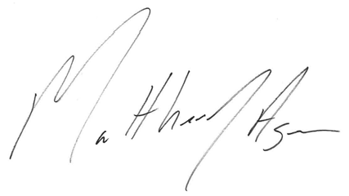

Matthew J. Agen

Assistant General Counsel American Gas Association

400 N. Capitol Street, NW Washington, DC 20001

202-824 7090

[magen@aga.org](mailto:magen@aga.org)

September 14, 2022



September 14, 2022

North American Energy Standards Board:

The American Public Gas Association (APGA) respectfully submits these comments in response to the North American Energy Standards Board’s (NAESB) request for comments ahead of the NASEB Gas-Electric Harmonization (GEH) Forum’s September 23, 2022, meeting focused on items 3.a, 3.a.i, 3.b, and 3.b of the GEH Forum Work Plan.

# Introduction

APGA is the trade association representing more than 730 communities across the U.S. that own and operate their retail natural gas distribution entities. These include not-for-profit gas distribution systems owned by municipalities and other local government entities, all accountable to the citizens they serve. Public gas systems provide safe, reliable, and affordable energy to their customers and support their communities by delivering fuel to be used for cooking, clothes drying, and space and water heating, as well as for various commercial and industrial applications, including electricity generation.

NAESB serves as an industry forum for the development and promotion of standards which intend to lead to a seamless marketplace for wholesale and retail natural gas and electricity. Specifically, NAESB proposes and adopts voluntary standards and model business practices designed to promote more competitive and efficient natural gas and electric service. APGA has been exceedingly engaged in NAESB GEH efforts and offers the below comments for the committee’s consideration.

# Comments

During President’s Day weekend in February 2021, Winter Storm Uri brought extreme cold temperatures to much of the country, including areas not typically accustomed to such weather in the south, disrupting many aspects of natural gas and electricity markets. Electricity generation sources, including fuel-burning plants and wind turbines, were shuttered by both the freezing temperatures and scarce access to fuel, forcing electric curtailments and blackouts in parts of the southern United States. Some of these curtailments also resulted in loss of power to critical natural gas production facilities and compressor stations, which further strained natural gas deliveries that were already impacted by freeze offs and other equipment failure perpetuated by the severe weather.

Collectively, these circumstances created scarcity conditions that caused at least one interstate pipeline to use its human needs curtailment plan for the first time. However, actual customer curtailments for natural gas were quite limited. Few, if any, human needs customers lost service for any length of time. Still, record-setting natural gas prices spiked, impacting APGA’s members by imposing a severe economic burden on gas utilities that had no choice but to purchase natural gas fuel to keep the heat on in their communities. The price of natural gas reaching unimaginable levels and fatalities occurring due to

complications from the severe weather conditions over that weekend have necessitated appropriate action to prevent another such event.

In response to Winter Storm Uri, the Federal Energy Regulatory Commission (FERC) and North American Electric Reliability Corporation (NERC) initiated an investigation into the events of the weekend, culminating in the FERC/NERC Report on the February 2021 Cold Weather Outages in Texas and the South Central United States that was issued on November 16, 2021.1 The report outlined several recommendations, including one that suggests “establishing a forum in which representatives of state legislatures and/or regulators with jurisdiction over natural gas infrastructure, in cooperation with FERC, NERC and the Regional Entities (which collectively oversee the reliability of the Bulk Electric System), and with input from the Balancing Authorities (which are responsible for balancing load and available generation) and natural gas infrastructure entities, identify concrete actions (consistent with the forum participants’ jurisdiction) to improve the reliability of the natural gas infrastructure system necessary to support the Bulk Electric System.” 2

On July 25, 2022, FERC and NERC leadership sent a letter asking NAESB to convene such a forum,3 in response to which NAESB agreed to host the GEH Forum. NAESB held an initial meeting on August 30, 2022, and has subsequently scheduled several additional meetings. On September 7, 2022, NAESB provided notice of and requested comments on the agenda for the second forum meeting on September 23, 2022, which will focus discussion on items from the GEH Forum Work Plan. While each agenda item raises important issues for the GEH Forum to consider, APGA is most concerned with Work Plan Item 3.c:

Which entity has authority, and under what circumstances, to take emergency actions to give critical electric generating units pipeline transportation priority second only to residential heating load, during cold weather events in which natural gas supply and transportation is limited but demand is high.

Reliability and affordability are critical to public gas utilities, as well as the natural gas and power sectors more broadly. Accordingly, APGA members have invested significant resources into infrastructure, as well as fuel procurement, and are committed to working with stakeholders to further these efforts. As policies make the electric grid more reliant on intermittent resources, natural gas will have an important role to play as a generation balancing fuel at times when the sun is not shining and the wind is not blowing. At the same time, natural gas will continue to play an effective and critical role through direct use, as the production and delivery of natural gas into homes and buildings is three times more efficient than grid- delivered electricity.4 Due to the developing role of natural gas as a quickly dispatchable fuel to meet electric generation needs while still meeting traditional direct use needs, a central disconnect currently exists between the gas and power markets - something the GEH Forum has been created to address.

APGA, however, is concerned that Question 3.c runs counter to both public gas utilities’ obligation to serve their customers and the underlying contracts that facilitate such services. As local distribution companies (LDCs), APGA members are responsible for maintaining safe and reliable service to the customers in their communities, which include residential, commercial, and industrial end-users. To ensure availability of

1 Available at [https://www.ferc.gov/media/february-2021-cold-weather-outages-texas-and-south-central-united-](https://www.ferc.gov/media/february-2021-cold-weather-outages-texas-and-south-central-united-states-ferc-nerc-and) [states-ferc-nerc-and.](https://www.ferc.gov/media/february-2021-cold-weather-outages-texas-and-south-central-united-states-ferc-nerc-and)

2 *Id.* at 196.

3 [https://www.ferc.gov/media/joint-ferc-nerc-letter-naesb.](https://www.ferc.gov/media/joint-ferc-nerc-letter-naesb)

4 [https://playbook.aga.org/reliable.](https://playbook.aga.org/reliable)

fuel for delivery, public gas utilities and other LDCs have developed robust fuel procurement procedures to ensure long-term supply can be met for their customers. Such planning takes into account anticipated peak loads based on weather and a number of other conditions. Significant deviation is likely to result in costs that will ultimately be borne by the end consumers.

Any type of pipeline prioritization should remain squarely in FERC’s jurisdiction, through its approved tariffs and non-discrimination policy. Furthermore, APGA is not aware of any overarching entity that has authority to abrogate contractual agreements. In fact, granting such authority could undermine goals of ensuring electric generation plants are sufficiently incentivized to proactively procure adequate quantities of fuel in preparation for emergency situations. To ensure necessary supply for their customers, APGA members purchase gas under firm contracts, which are intended to guarantee delivery in all but the most extreme instances and are priced accordingly. Redirecting contractually obtained natural gas supply and capacity away from public gas utilities will place a significant burden on their communities that rely on the fuel for a number of end uses and should be avoided.

Instead of redirecting natural gas away from public gas utilities and other LDCs that have expended significant resources to meet their customers’ needs, the GEH Forum should explore other ways to incentivize ensuring that necessary amounts of fuel can be procured ahead of emergency situations. Potential solutions could include the development of additional infrastructure or new market structures. APGA looks forward to exploring such options through discussions with other participants in the GEH Forum.

Finally, since Winter Storm Uri, many legislators, regulators, and private entities have taken action to improve the resilience and reliability of both the natural gas and power sectors. Accordingly, it is important for NAESB and participants of the GEH Forum to understand this new landscape of requirements and voluntary actions before taking actions that may be duplicative or counterproductive.

* * *

Thank you for your review and consideration of these comments in response to NAESB’s September 7, 2022 notice. APGA and its members look forward to further engaging with NAESB and the GEH Forum moving forward. If you have any questions regarding this submission, please do not hesitate to contact me.

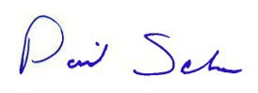Respectfully submitted,

David Schryver

President & CEO

American Public Gas Association

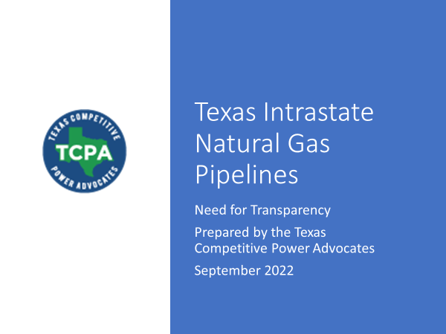

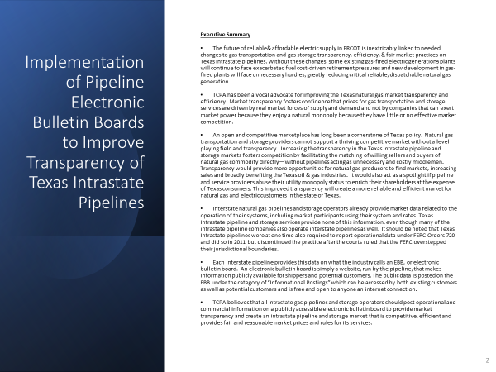

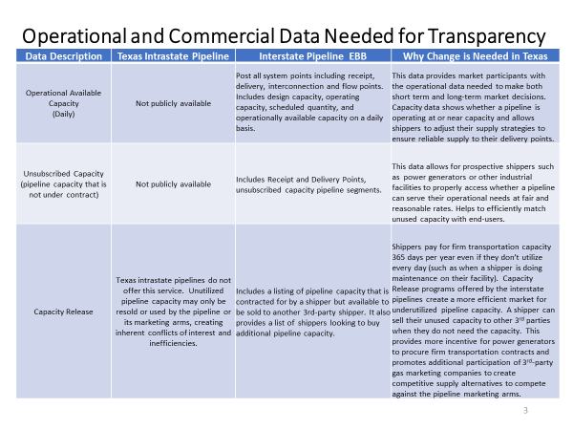

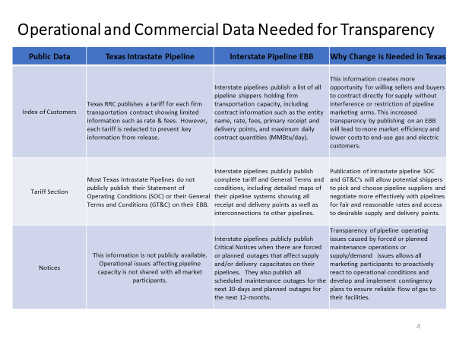

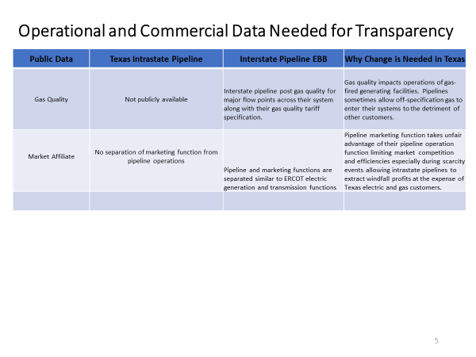

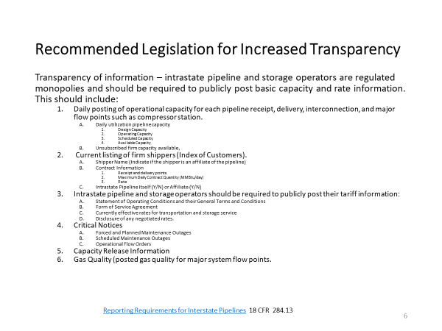

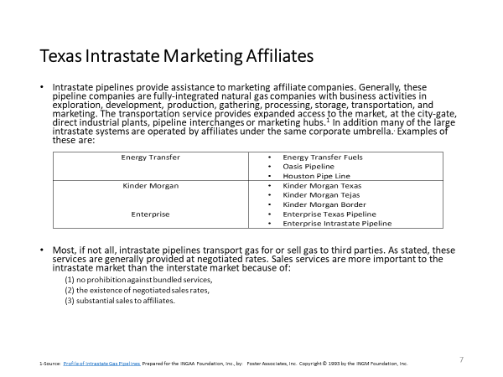

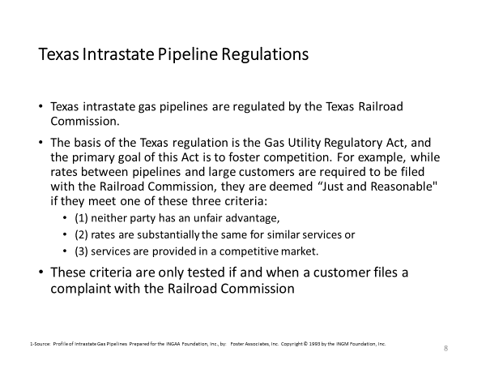

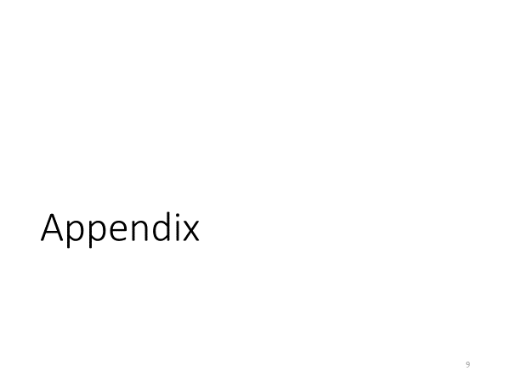

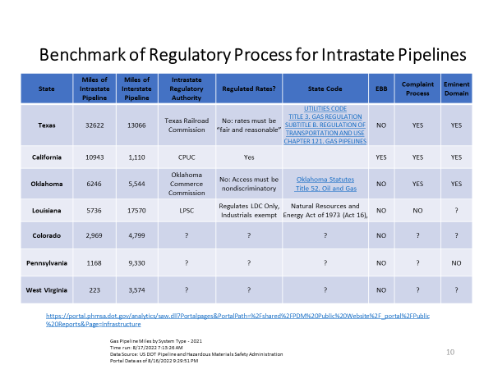

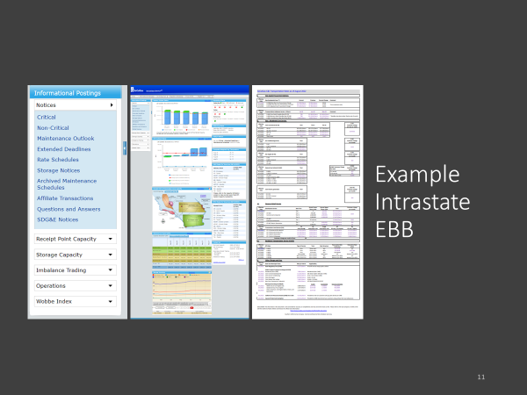

1. There are a variety of ways that generators, utilities, and industrial users can choose to purchase their natural gas. Generally, natural gas customers purchase their natural gas through a portfolio of products including prearranged contracts set at a pre-determined fixed price or indexed to an agreed variable, along with buying some supply in the daily spot market, where availability and prices fluctuate in response to weather and the availability of infrastructure capacity and storage. Many transactions are made in advance on a monthly. Depending on the location and the relative options available to a generator, relying on interruptible service may not pose issues during peak load conditions. Therefore, it is not always essential for generators to acquire firm capacity to ensure reliable fuel.
2. Draft ISO/EDC/LDC Problem Statement and Call to Action on LNG and Energy Adequacy Federal Energy Regulatory Commission New England Winter Gas-Electric Forum, September 8, 2022.
3. PJM Markets & Reliability Committee Meeting, Aug. 25, 2021. https://pjm.com/-/media/committees-groups/committees/mrc/2021/20210825/20210825-item-05-2-natural-gas-and-electric-markets-problem-statement.ashx.
4. ISO-NE “2021 Economic Study: Future Grid Reliability Study Phase 1, July 29, 2022.
5. There are tools in place today that are available to generators that are not often dispatched such as purchasing delivered gas or entering into OBAs or park and loans agreements with pipelines to provide flexibility to the extent that a pipeline system can operationally allow it.
6. Granholm, Jennifer. The Secretary of Energy. August 18, 2022. Letter to the Honorable Charles D. Baker, Governor of the Commonwealth of Massachusetts. “With regard to the Jones Act, the Department of Homeland Security (DHS), which reviews waiver requests under the Jones Act, has a process in place to expeditiously review any requests for waivers, and the Secretary of Homeland Security will make a determination for each request consistent with the requirements of 46 U.S.C. § 501. While the law does not enable DHS to issue pre-emptive blanket waivers, DHS will expeditiously consider each individual waiver request to determine if the waiver is necessary in the interest of national defense. DOE is a consulting agency for Jones Act waiver requests related to energy, and the Department works closely with DHS to provide input into how energy supplies impact national defense interests, as appropriate.”
7. Very little analysis has been performed to analyze (1) whether, during peak conditions, existing gas infrastructure can adequately accommodate the anticipated steeper and more frequent ramping requirements of gas generators, without impacting gas industry operations and service to other shippers (and ultimately retail customers), and (2) how the electric industry could rely on pipeline flexibility to accommodate hourly flows beyond what the tariff provides, which is not always available, for their own electric reliability.
8. Federal Energy Regulatory Commission et al., FERC – NERC - Regional Entity Staff Report: The February 2021 Cold Weather Outages in Texas and the South- Central United States (FERC, November 2021): 233.