North American Energy Standards Board

Board Strategic Plan Task Force Report & Recommendations

*Adopted by the NAESB Board of Directors on September 11, 2014*

|  |  |  |  |  |
| --- | --- | --- | --- | --- |
| **NORTH AMERICAN ENERGY STANDARDS BOARD**  **BOARD STRATEGIC PLAN TASK FORCE REPORT AND RECOMMENDATIONS**  **TABLE OF CONTENTS** | | | | |
|  | | | | Page |
| I. | Background & Charge of the Task Force | | | 3 |
| II. | Executive Summary | | | 4 |
| III. | Vision and Mission of NAESB | | | 5 |
| IV. | Procedural Considerations and Procedural Recommendations to the Board of Directors | | | 6 |
| V. | Strengths, Cautions and Risks of NAESB and Areas to be Developed | | | 7 |
| VI. | Standards Development Directions and Recommendations | | | 9 |
| VII. | Other Considerations and Recommendations | | | 11 |
| VIII. | Conclusions | | | 12 |
| Appendices | | A. | NAESB Strategic Plan 2015-2017 | 15 |
|  | | B. | Board Strategic Plan Ad Hoc Task Force Mission Statement | 19 |
|  | | C. | NAESB Standards Development Survey Results | 20 |
|  | | D. | NAESB Communications Strategy | 55 |
|  | | E. | NAESB Standards Development Survey Tables | 56 |
|  | | F. | List of Task Force Members | 72 |
|  | | G. | Task Force Meeting Dates | 73 |
|  | | H. | Listing of Working Documents | 74 |

**I. Background & Charge of the Task Force**

During the September 5, 2013 NAESB Board of Directors meeting, NAESB held a special strategic session to discuss the current and future state of the energy markets and ways that NAESB could best serve the markets moving forward. To facilitate the discussion, a panel of industry leaders was assembled, including Pat Wood, Timothy Simon, Marc Spitzer, Bob Gee, Terry Thorn, Gerry Cauley, Ravi Anne, Emil Peña, Christine Tezak, Sheila Hollis and Annie McIntyre. The panel participants identified a number of emerging market activities that NAESB may want to consider supporting through potential standards development, as well as activities that the organization should monitor over the next one to two years. A commonality in the remarks given by the panelists was the recognition of the transformative state of the energy industry and the opportunities and risks that are presented by the production of shale gas and its movement to the market, the vast influx in the amount of data gathered and managed as a result of the smart meter integration, and the most efficient and effective use of the nation’s abundant natural gas resources. Discussion focused on how these developments may impact NAESB’s work plans, structure and resources in the next several years and the ways that organizations strengths, weaknesses, opportunities and threats may play into the organization’s involvement in new development areas.

To continue discussions and ensure that the valuable recommendations and guidance provided by the panelists were effectively pursued by the organization, Chairman of the Board, Michael Desselle, created the Board Strategic Plan Task Force to address the information provided and map out the strategies and supporting structures for the future. Mr. Desselle noted his observations from the strategic session in a correspondence to the Board of Directors and Advisory Council on September 23, 2013 and specifically charged the task force with identifying NAESB strategies and reviewing NAESB’s segment structure to determine if it is currently relevant and effectively serving the markets, or if modifications should be considered in light of the results of the strategic session. Additionally, he requested that the task force consider a contingent framework for organizational change if non-traditional standards requests begin to materialize or if market participants not represented in the organization begin to seek membership or heavily participate in NAESB activities.

The task force is composed of Board of Directors and Advisory Council members; however, as with all NAESB meetings, participation is open to all interested parties. The task force held seven meetings beginning in October 2013 to discuss the observations and guidance provided during the September Board meeting and to develop recommendations concerning the strategic direction and structure of the organization. Over the course of the seven meetings the task force developed four recommendations for consideration by the Board of Directors. These recommendations are the direct result of the discussions and activities of the task force, including the distribution of the NAESB Standards Development Survey issued to the industry on March 10, 2014.

**II. Executive Summary of Recommendations of Task Force**

Included in this report are four sets of recommendations of the Board Strategic Plan Task Force for consideration by the Board of Directors.

Strategic Plan:

The task force recommends that the Board of Directors adopt of the NAESB Strategic Plan for 2015-2017 included in Appendix A.

Strategic Plan Ad Hoc Task Force:

The task force recommends that the Board of Directors approve the creation of the NAESB Board Strategic Ad Hoc Plan Task Force as described in the mission statement in Appendix B.

Standards Development and Quadrant/Segment Structure:

The task force recommends that the Board of Directors approve the direction of the organization to continue to consider standards development in the existing nine areas identified in the survey as noted in Appendix C.

The task force recommends that the Board of Directors approve the direction of the organization to not pursue standards development in the twelve potential areas identified as noted in Appendix C. As requests are received to pursue any of these areas, the organization can determine the best course of action. When considering such requests, the task force recommends that NAESB consider the level of interest of the industry, the availability of subject matter experts for participation, other standards development priorities that may be affected, the level of interest of the regulatory and other government agencies in the development of standards, and the availability of NAESB resources to pursue the requested development.

The task force recommends that the Board of Directors take no action regarding modifications to the current quadrant and segment structure, as the results of the survey indicate that it is unnecessary at this time. The results of the survey are included in Appendix C. Again, should NAESB receive any requests for standards development that would impact sectors of the industry that are not currently represented within NAESB as a segment, the organization may consider further action, including modifications to the quadrant/segment structure of NAESB. This determination would depend on a number of factors including the interest level and sustainability of any changes.

Communications Strategy:

The task force recommends that the Board of Directors adopt the NAESB Communications Strategy described in Appendix D.

**III. Vision and Mission of NAESB**

NAESB serves as an industry forum for the development and promotion of standards which will lead to a seamless marketplace for wholesale and retail natural gas and electricity, as recognized by its customers, business community, participants, and regulatory entities. The purpose of NAESB is defined in the Article II Section 1 of the organization’s Certificate of Incorporation: “The objects and purposes of NAESB are to propose and adopt voluntary standards and model business practices designed to promote more competitive and efficient natural gas and electric service, as such standards apply to electronic data interchange (“EDI”) record formats and communications protocols and related business practices that streamline the transactional processes of the natural gas and electric industries.”

As a threshold question, the task force reviewed the mission statement of NAESB and asked if the current activities of the organization are within the scope of work set by the governing documents of the organization and if the activities are in furtherance of the defined mission and purpose of NAESB. The task force also reviewed the potential standards development activities identified by the September 2013 Board panelists, and refined by the task force, to determine if they would be within the scope and further the purpose of the organization. Through discussion it was agreed that the potential standards development areas are within the organization’s purview, should NAESB opt to pursue any related standards development.

To ensure that the current activities of the organization and any future activities of NAESB remain consistent with the goals and purposes of the organization, the task force recommended the development of a three year strategic plan that would serve as a guidepost for activities moving forward. The proposed strategic plan models that of the North American Electric Reliability Corporation (NERC) and captures the high level goals that the activities should meet in order to ensure mission success. Specifically, the proposed plan identifies and defines the goals of four activities engaged by the organization; these activities are standards development, certification administration, tool management and industry coordination. Each goal is supported by specific objectives and deliverables that should be pursued to ensure that the objectives and overarching goals are satisfied. As recommended by the task force, the proposed strategic plan would be reviewed on a three year basis for consistency with the mission statement and purpose of the organization.

**Recommendation**: The task force recommends that the Board of Directors adopt of the NAESB Strategic Plan for 2015-2017 included in Appendix A.

**IV. Procedural Considerations and Procedural Recommendations to the Board of Directors**

Given the transformative state of the energy industry, as noted by the September 2013 strategic panel, it is the recommendation of the task force that an ad hoc task force of the Board of Directors be created to periodically review developing trends in the industry and identify areas where NAESB could provide support through standards development and related activities. In addition, the ad hoc task force would review the structure of the organization and the NAESB work products to ensure that the organization is effectively supporting the NAESB membership and the industry through its activities. As a result of the ad hoc task force’s periodic reviews, recommendations would be provided to the Board of Directors for board consideration. The board may address the recommendations through the management of the annual plan(s), modifications to the structure of the organization or adjustments to the work products adopted by the organization.

**Recommendation**: The task force proposes the creation of the NAESB Board Strategic Plan Ad Hoc Task Force as defined below and with the following provisions.

* Statement of Purpose – to provide assistance to the Board of Directors by (a) developing and maintaining a strategic plan, (b) appraising NAESB work products to ensure that NAESB is addressing member needs, (c) assessing NAESB structure to ensure that market segments that take part in development of NAESB work products are adequately and fairly represented, and (d) reviewing market trends to ensure that NAESB remains relevant.
* Relationship to the Board of Directors – all non-administrative decisions and work products of the ad hoc task force are subject to the approval of the Board of Directors.
* Relationship to other committees – The ad hoc task force will work as needed with other board committees, such as the Parliamentary Committee for governance issues, and the Revenue Committee for communications outreach. The work of the Board Strategic Plan Ad Hoc Task Force as it pertains to standards development will be provided to the Annual Plan Subcommittee for discussion and consideration for inclusion in the Annual Plan(s) under development. The Board of Directors, if it so chooses, may add standards development items to the existing annual plan(s) that the ad hoc task force has recommended.
* Membership and Qualifications – NAESB Board of Director members and NAESB Advisory Council members as named by the chairman may serve on the committee. The membership will be reviewed by the chairman periodically to determine if roster changes are needed to support the activities of the ad hoc task force and ensure a balance of interests representative of the Board of the Directors is maintained. As with the responsibilities of membership on the Board of Directors, members of the ad hoc task force will serve and make decisions in the best interests of the NAESB organization as a whole.
* Meetings – the ad hoc task force will meet as needed to complete tasks, and the meetings will be administered by an officer of the Board of Directors. The meetings will be open to all interested parties, however only named members may make motions and vote.

**V. Strengths, Cautions and Risks of NAESB and Areas to be Developed**

To evaluate the likelihood of success in areas of current and future standards development and related activities, the task force reviewed the organizations strengths, cautions the organizations should consider in pursuing new endeavors and the risks that would be inherent to those pursuits. These considerations resulted from the strategic session of the September 2013 Board meeting and were further refined and amended through the discussions of the task force. It was agreed that these threshold considerations should serve as essential criteria when evaluating any new or evolving standards development area. All considerations should be analyzed individually and potential standards development and related activities should be pursued when they are aligned or support the organizations strengths or development of strengths and the benefits of standards development to the NAESB membership and the industry outweigh the cautions and risks identified by the task force.

**Strengths**

Strengths of the organization and strengths to be developed by the organization, as identified by the task force include the following.

* NAESB’s flexibility and agility to allow new business standards development needs to be incorporated without lengthy procedural effort
* NAESB’s goodwill in the industry
* NAESB’s diversity, open process and adaptability
* NAESB’s procedural transparency in all activities
* NAESB’s ability to support the convergence of interests when industry segment's activities overlap or converge and improved alignment is necessary
* NAESB’s ability to provide for the interaction of both state and federal unregulated and regulated activities (i.e. demand response and similar activities)
* NAESB’s accommodation of the introduction of new technologies that redefine the competitive landscape in the energy markets (i.e. smart grid, cybersecurity and similar activities)
* NAESB’s ability to support activities requested by market participants, in addition to regulatory driven activities, that provide a level of uniformity and efficiency which would provide lower transaction costs and ease of entry into new areas.
* NAESB’s participation in activities that support the justification of the existing organizational structure

**Cautions**

Cautions that should be considered before engaging in standards development activities, as identified by the task force include the following.

* NAESB should focus on a few key development areas that can be accomplished in a three to five year time frame
* NAESB should continue to be member driven with a focus on value to the consumers and to the energy markets
* NAESB’s strategic directions should keep pace with the evolution of market rules
* NAESB should ensure that appropriate resources are available before undertaking new development
* NAESB should ensure that areas of new interest for development provided by trade associations and energy organizations expand beyond the association or organization itself to external companies and provide for a longer term sustainability
* NAESB should ensure access to subject matter experts in addition to policy and political efforts when determining whether standards development efforts should be undertaken
* NAESB should provide a structure that supports all stakeholders having an opportunity to have a seat at the table
* NAESB should continue to rise above self-interest to support the long term health of the markets
* NAESB should consider whether standards development in a given area is necessary, as other organizations might be more appropriate places to address the need
* NAESB should focus on the customers who benefit from the products developed
* NAESB should be forward looking as directed by its members and the market; NAESB should not employee the “build it and they will come” approach to standards development activities

**Risks**

Risks that should be considered before engaging in standards development activities, as identified by the task force include the following.

* Expanding the organization too quickly can impact effectiveness
* The organizations resources can be strained when new development by non-members is undertaken
* Rapid evolution of markets require quick response to remain relevant
* For new standards development that is based on regulatory policy, if the policy is controversial or ambiguous and does not have support of industry executives, the ability to achieve consensus on the development can become difficult
* As NAESB develops standards in new areas, the process of reflecting the complexity of the new areas aligned with standards development, may include market participants at the table, but not specifically represented in the organization.
* The unknown unknowns
* Specific to the natural gas market, geographical shifts in natural gas production puts stress on existing infrastructure and could impact NAESB – both from an organizational structure perspective and from a standards development perspective
* Specific to the retail energy markets, the interests are not as aligned as the wholesale markets, which can make the development more difficult, but development focused and led by a few states or regions can be seen as templates for other regions or states as they consider standards development

**VI. Standards Development Directions and Recommendations**

During the first five meetings held by task force, the participants reviewed and discussed the observations from the strategic session identified by Mr. Desselle in his correspondence to the Board of Directors and Advisory Council on September 23, 2013. Through discussion, the task force expanded and refined the areas of potential engagement by NAESB and cultivated a list of areas that NAESB currently maintains standards, or has standards development underway, and areas that the organization could consider for future standards development. To broaden the discussion and receive feedback from the industry, it was recommended that NAESB conduct a survey of the NAESB membership and the industry at large to gauge interest in the identified areas. The language of the survey was crafted by the task force and distributed on March 10, 2014. Responses to the survey were requested by April 10, 2014. The responses to the survey directly guided the recommendations of the task force and the development of the present report.

The survey was divided into three distinct sections providing opportunities for respondents to provide (1) their contact and membership information, (2) their positions concerning existing standards development projects, and (3) their positions concerning possible standards development projects. The participants were requested to rate their preference for continued engagement in nine existing areas of standards development and their preference for engagement in twelve possible areas of standards development in the future (18-24 months). Participants were asked to rate their preference on a five point scale through options of strongly agree, agree, no opinion, disagree and strongly disagree. Those responding were also given the opportunity to provide comments on each of the questions and/or answer not applicable.

In total, the NAESB office received a total of 99 responses from representatives from 89 different organizations. Of the 99 responses, 75 were received from representatives of member companies and 17 responses were submitted by representatives of non-member companies. Two tables providing a graphical representation of the responses are provided in Appendix E. Table 1 represents the responses concerning existing areas of standards development and Table 2 represents responses concerning future (18-24 months) standards development. Also included in Appendix E are tables 3-8, created to demonstrate interest in areas by quadrant. As a majority of the respondents represent companies that participate in multiple markets, participants were given an opportunity to indicate affiliation in multiple market segments. To graphically demonstrate the level of interest by quadrant, survey responses from companies with business interests in multiple segments were counted in each of the quadrants in which they indicated participation. This resulted in a total of 189 responses when totaled by quadrant.

Table 3 represent the *positive* responses concerning existing areas of standards development by quadrant and Table 4 represents responses concerning future (18-24 months) standards development by quadrant. Table 5 represents the *negative* responses concerning existing areas of standards development by quadrant and Table 6 represents responses concerning future (18-24 months) standards development by quadrant. Table 7 represents the *non-committal* responses concerning existing areas of standards development by quadrant and Table 8 represents responses concerning future (18-24 months) standards development by quadrant.

As demonstrated by the data, conclusions can be drawn that NAESB is currently focusing on standards development in appropriate areas, as significant positive support was found for the continued engagement in the nine areas identified by the task force, with exception of social engineering. Of the nine areas considered, each garnered 60% or greater positive support for continued activity, the most support given to the NAESB Gas-Electric Coordination efforts, and none of the existing efforts received a majority sentiment that they should not be considered for standards development. This includes the outlier regarding social engineering, which was largely non-committal.

**Recommendation**: As a result, it is the recommendation of the task force that the organization continue to consider standards development in the existing nine areas identified.

While the level for support of existing standards development areas was largely positive, the level of support for potential areas of future standards development is less dispositive. However, significantly less support was provided for engagement in any of the twelve areas for potential standards development. The only areas receiving greater than 50% support for potential standards engagement was distributed generation and smart grid. While there was support in these areas, the support was not overwhelming, and did not elicit further investigation by the task force.

**Recommendation**: As a result, it is the recommendation of the task force that the organization not pursue standards development in the twelve potential areas identified at this time, and as requests are received to pursue any of these areas, the organization can determine the best course of action. Factors that would weigh in on the decisions would include level of interest in the industry, availability of subject matter experts to participate, other standards development priorities that could be affected, level of interest of the regulatory and other government agencies in pursuit of requested development, and the availability of NAESB resources to pursue the requested development.

**Recommendation**: Based upon the results of the survey and the discussions of the participants, the task force recommends that the Board of Directors take no action regarding modifications to the current quadrant and segment structure, as the results of the survey indicate that they are unnecessary at this time. The results of the survey are included in Appendix C. Again, should NAESB receive any requests for standards development that would impact sectors of the industry that are not currently represented within NAESB as a segment, the organization may consider further action, including modifications to the quadrant/segment structure of NAESB. This determination would depend on a number of factors including the interest level and sustainability of any changes.

**VII. Other Considerations and Recommendations**

Through the discussions of the task force, it was highlighted that an effective and documented communications strategy may be supportive of NAESB by bringing attention to the organization’s accomplishments, plans and efforts underway. To support this objective the task force developed the following proposed strategy.

* The goal of the NAESB communications strategy is informing the industry of NAESB accomplishments, plans, and development activities underway and fostering dialogs with the industry thus providing the organization with guidance from the industry on directions that NAESB should take in the development of standards.
* The communications strategy should be effective, supporting NAESB’s key strategic priorities – supporting and aligning the vision, mission and reputation of the organization.
* The communications strategy supports the achievement of NAESB’s objectives, engaging effectively with members and interested participants, demonstrating the success of NAESB’s work products, ensuring the industry understands what NAESB does, and attracting of volunteers to develop NAESB standards.
* “Discipline of Repetition” – the messages of the communications strategy are threefold -- (a) define the issue or activity, (b) describe the problem raised by the issue or the reason for the activity, and (c) explain the result of the activity or the solution to the problem. For NAESB with standards development – the communications would take the form of (a) defining the standard(s) to be developed, (b) identifying the business function(s) the standard(s) support, and (c) the benefits of the standard(s) – basically a description of the benefits that would be achieved when the standards are used.
* Without additional staffing, the communications strategy will be carried out internally by NAESB staff . Actions include:
  + Newsletters are to be provided three times per year to coincide with NAESB board meetings.
  + Press releases are to be provided to the trade press upon the beginning of major development, conclusion of major development, and the adoption of standards by regulatory agencies.
  + Seven to eight update calls are to be held per year to update state and federal agencies and any other company interested in a one hour review of standards development activities underway by NAESB.
  + Speeches are to be provided by NAESB staff and NAESB members on behalf of NAESB, reviewing NAESB standards and plans. Speaking on behalf of NAESB requires Managing Committee approval.
  + Publications by staff in trade literature are to be developed dependent on NAESB development.
* Reviews of communications activities undertaken by NAESB staff or on behalf of NAESB should be addressed through the Revenue Committee in a standing agenda item for that committee.

**Recommendation**: The task force proposes the adoption of the NAESB Communications Strategy described above.

**VIII. Conclusions**

For the reasons described in this report, the task force fully supports the approval of its recommendations by the NAESB Board of Directors. The communications strategy, a standing Board Strategic Plan Ad Hoc Task Force, and a high level 3 year strategic plan are appropriate for an organization of our size and maturity, and ensure the strong voice of the Board of Directors.  The development activities of our organization and the plans for future development do not, at this time, indicate the need for any structural changes to the quadrants and segments, but should requests be received that would indicate such, the organization will evaluate and make necessary changes to continue to support a broad based, balanced and equitable voice for all participants. Should the Board adopt the recommendation of the task force to create a permanent Board Strategic Plan Ad Hoc Task Force, the ad hoc task force will meet and take action as needed to make recommendations to the Board of Directors that ensure the strategic direction of NAESB is being followed and further the goals of the organization as defined by the mission statement. The members of the task force thank the Board of Directors for providing this opportunity to serve NAESB and look forward to supporting the organization in the future, and it goes without saying, that many thanks go out to all who helped to reach the decisions made in this report.

North American Energy Standards Board

Board Strategic Plan Task Force Report & Recommendations

*Adopted by the NAESB Board of Directors on September 11, 2014*

*Appendices:*

*A. NAESB Strategic Plan 2015-2017 15*

*B. Board Strategic Plan Ad Hoc Task Force Mission Statement 19*

*C. NAESB Standards Development Survey Results 20*

*D. NAESB Communications Strategy 55*

*E. NAESB Standards Development Survey Tables 56*

*F. List of Task Force Members 72*

*G. Task Force Meeting Dates 73*

*H. List of Working Documents 74*

**NAESB Strategic Plan 2015 - 2017**

The North American Energy Standards Board (NAESB) serves as an industry forum for the development and promotion of standards which will lead to a seamless marketplace for wholesale and retail natural gas and electricity, as recognized by its customers, business community, participants, and regulatory entities.

**Mission**

To propose and adopt voluntary standards and model business practices designed to promote more competitive and efficient natural gas and electric service; as such standards apply to electronic data interchange (“EDI”) record formats and communications protocols and related business practices that streamline the transactional processes of the natural gas and electric industries.

**Vision**

To be a standards development organization that utilizes subject matter experts from the energy industries to develop voluntary business practice standards and model business practices that improve market transactions.

**Core Values and Guiding Principles**

The following core values and guiding principles serve as guidelines for all NAESB activities.

***Independence*** – NAESB is an independent body. While it may have informal liaisons to trade associations, other standards organizations and government agencies, it should be a separately incorporated, fully independent, organization.

***Openness*** – NAESB should conduct its activities in the open. Openness should apply to all aspects of its organizational governance, elections and Standards or Model Business Practices development processes, including work products and related meetings. The meetings, agendas and items set for discussion and/or possible vote should be publicly noticed, and interested parties, regardless of membership should have the opportunity to participate.

***Voluntary*** – Participation in NAESB should be voluntary and adherence to its Standards and Model Business Practices should, from NAESB's perspective, also be voluntary. Membership should not be dependent upon whether the company seeking membership implements the Standards and Model Business Practices. NAESB will not maintain any type of enforcement activity.

***Balance of Interests*** – The voting with respect to governance, Standards, Model Business Practices, and Operating Practices should provide for balance among industry Segments and Quadrants participating in NAESB so as to avoid any one interest group or group of interests having the ability to exert undue influence over any decision.

***Inclusivity*** – All interested parties have the opportunity to participate in the activities of the standards organization and to join NAESB. All participants should be identified and associated with a Segment and Quadrant.

***Consensus-Based Decisions*** – The voting rules should be constructed so that decisions based upon consensus are encouraged. In addition, with respect to voting upon the Standards or Model Business Practices issued or to be issued by NAESB, energy Quadrants and their Segments should be assured that each energy Quadrant and its Segments can protect its interests by requiring both super-majorities and a minimum per Segment, and that a per Quadrant threshold be achieved for passage of such Standards and Model Business Practices by NAESB.

***No Advocacy*** – NAESB should be prohibited from taking advocacy positions on its Standards or Model Business Practices as a party to any proceeding before a governmental agency. This is not intended to preclude NAESB’s duly authorized representatives from educating or communicating with any group as to NAESB’s procedures and/or work product(s).

***Membership Driven*** – NAESB should be membership driven. The paid staff should perform administrative functions to support NAESB's activities. Requests for Standard(s) or Model Business Practices should be proposed by identified persons and not by NAESB or its committees and subcommittees. NAESB’s staff should neither have a vote nor a role with respect to conducting the affairs of NAESB other than to provide ministerial functions.

***Develop Practices, Not Policy*** – The committees, subcommittees and task forces of NAESB should endeavor not to create policy in their Standards or Model Business Practices development activities absent being requested to do so by the Board.

***Incorporate Best Practices*** – To the extent reasonable, the Standards and Model Business Practices to be established should reflect standardization and streamlining of activities chosen as best practices from among existing and reasonably anticipated policies and practices.

***Broad Applicability*** – To the extent reasonable, the Standards and Model Business Practices to be established should be structured such that they can be applicable to both the electric and natural gas industries. The two industries should work together to develop Standards and Model Business Practices when joint Standards and Model Business Practices are appropriate. However, where operating requirements dictate the need for different approaches, discrete Standards and Model Business Practices will be established separately by Quadrant(s).

***ANSI Accreditation*** – NAESB is an American National Standards Institute Standards Development Organization.

**Strategic Goals 2015 – 2017**

NAESB has identified four goals in the following strategic areas: standards; certification; tool management; and coordination and collaboration.

**Standards**

**Goal 1**: To develop relevant and effective business practice standards and model business practices through wide industry participation that supports the commercial needs of the wholesale and retail natural gas and electric markets.

**Objective 1**: Business practice standards and model business practices will be clear and concise.

**Key Deliverables**:

* When possible and appropriate, all business practice standards and model business practices will be distributed for an informal industry wide comment period by subcommittees and/or task forces during the standards drafting process.
* All draft business practice standards and model business practices will be distributed for a formal industry wide thirty-day comment period before being reviewed by the appropriate Executive Committee(s).
* All draft business practice standards and model business practices and industry comments will be reviewed by the appropriate Executive Committee(s) with the authority to make any necessary edits prior to adoption and distribution for quadrant ratification.

**Objective 2**: Business practice standards and model business practices will reflect a wide range of industry participation and interests.

**Key Deliverables**:

* Membership in NAESB is open to all interested parties.
* The submission of standards development requests and participation in the standards development process is open to all interested parties despite membership status.

**Objective 3**: Business practice standards and model business practices will be developed in a timely and efficient manner.

**Key Deliverables**:

* Resource availability and deadlines for the development of all business practice standards and model business practices will be established and managed by the NAESB Board of Directors through the quadrant annual plans.
* Open discussion and responses to questions concerning the standards development process of individual business practice standards and model business practices will be facilitated by NAESB staff.

**Certification**

**Goal 2**: To successfully maintain a certification process that fosters market confidence in products and/or services that support the existing and future NAESB business practice standards and model business practices for adoption by interested industry parties.

**Objective 1**: Certification will provide transparency into the relevant products and/or services offered by parties claiming NAESB certification.

**Key Deliverables**:

* Require and make available any documentation that supports compliance with the requirements for individual certification programs.
* All requests for the development of certification programs will be considered by the Board of Directors.
* The development and maintenance of NAESB certification programs will be the responsibility of the Board Certification Program Committee.

**Tool Management**

**Goal 3**: To successfully manage tools that efficiently supports industry commercial functions.

**Objective 1**: NAESB will be responsive to the needs of the industry in the management of commercially related tools.

**Key Deliverables**:

* Maintenance of a process whereby enhancements to the NAESB managed tool can be implemented when supported by industry.
* NAESB staff, with support of the Board of Directors, will establish and maintain relationships with any vendors or service providers engaged in the implementation of NAESB managed tool.
* All requests for the adoption or development of commercially related tools will be considered by the Board of Directors.

**Coordination and Collaboration**

**Goal 4**: To successfully coordinate and collaborate with industry participants, both member and non-member parties, and external organizations in support of the goals of the industry and of NAESB.

**Objective 1**: NAESB will maintain strong relationships with industry stakeholders and ensure that the organization is inclusive and responsive to all interested parties.

**Key Deliverables**:

* Participate in industry activities including conferences, seminars, forums and other industry gatherings that are supportive of industry and the organization.
* Offer courses to interested parties, both members and non-members, related to the business practice standards and model business practices and other NAESB work products.
* Execute of the NAESB Communications Strategy.

**Objective 2**: NAESB will maintain strong working relationships with external industry organizations and regulators.

**Key Deliverables**:

* NAESB staff will continue to maintain an open dialog and hold regular meetings with the staff and leadership of external organizations and regulators relevant to the goals of NAESB and supportive of the industry.
  + These organizations include, but are not limited to, the Department of Energy, the Department of Commerce, the National Petroleum Council, the Federal Energy Regulatory Commission, the National Association of Regulatory Utility Commissioners, individual state commissions, the North American Electric Reliability Corporation, the National Institute of Standards and Technology, the American National Standards Institute, the White House Office of Science and Technology Policy, trade organizations, and other various industry organizations, forums, coalitions, councils and collaborations.

**Mission Statement of the Board Strategic Plan Ad Hoc** **Task Force**

* Statement of Purpose – to provide assistance to the Board of Directors by (a) developing and maintaining a multi-year strategic plan, (b) appraising NAESB work products to ensure that NAESB is addressing member needs, (c) assessing NAESB structure to ensure that market segments that take part in development of NAESB work products are adequately and fairly represented, and (d) reviewing market trends to ensure that NAESB remains relevant.
* Relationship to the Board of Directors – all non-administrative decisions and work products of the ad hoc task force are subject to the approval of the Board of Directors.
* Relationship to other committees – The ad hoc task force will work as needed with other board committees, such as the Parliamentary Committee for governance issues, and the Revenue Committee for communications outreach. The work of the Board Strategic Plan Ad Hoc Task Force as it pertains to standards development will be provided to the Annual Plan Subcommittee for discussion and consideration for inclusion in the Annual Plan(s) under development. The Board of Directors, if it so chooses, may add standards development items to the existing annual plan(s) that the ad hoc task force has recommended.
* Membership and Qualifications – NAESB Board of Director members and NAESB Advisory Council members as named by the chairman may serve on the ad hoc task force. The membership will be reviewed by the chairman periodically to determine if roster changes are needed *to support the activities of the ad hoc task force e and ensure a balance of interests representative of the Board of the Directors is maintained*. As with the responsibilities of membership on the Board of Directors, members of the ad hoc task force will serve and make decisions in the best interests of the NAESB organization as a whole.
* Meetings – the ad hoc task force will meet as needed to complete tasks, and the meetings will be administered by an officer of the Board of Directors. The meetings will be open to all interested parties, however only named members may make motions and vote.

North American Energy Standards Board

Survey Results on Standards Development Projects

**Background:** On September 5, 2013, NAESB held a strategic session as part of its September Board of Directors meeting to discuss the current and future state of the energy markets and how NAESB can best serve those markets moving forward. During the meeting several areas for potential standards development were identified by the participants, and questions were raised concerning the organizations current structure and whether it is supportive of the standards development work underway today and the standards development work we expect to address in the future. Specifically, does the current structure of NAESB through its quadrants and segments provide adequate representation to all factions of the existing energy markets seeking participation in standards development both now and in the near future. To continue the discussion from the strategic session and conduct a deeper analysis of the questions presented related to potential areas for standards development and the structure of the organization, Michael Desselle, Chairman of the Board, created the Board Strategic Planning Task Force of the Board of Directors. Since its creation, the Task Force has held seven conference calls to discuss the issues presented and make a recommendation to the Board of Directors concerning the structure and future strategic direction of the organization. As part of the investigation into the current and future status of the energy markets, the task force recommended the distribution of an industry wide survey for both member companies and non-member companies to seek input regarding areas of interest for current and future standards development.

**Survey Summary:** The survey was distributed on March 10, 2014 and closed on April 10, 2014. It was broken into three parts asking questions concerning (1) contact and membership information, (2) existing standards development projects, and (3) possible standards development projects. The participants were requested to rate their preference for continued engagement in nine existing areas of standards development and their preference for engagement in twelve possible areas of standards development in the future (18-24 months). Participants were asked to rate their preference on a five point scale through options of strongly agree, agree, no opinion, disagree and strongly disagree. Those responding were also given the opportunity to provide comments on each of the questions and/or answer not applicable.

**Survey Results Summary:** In total, the NAESB office received a total of 99 responses from representatives from 89 different organizations. Of the 99 responses, 75 were received from representatives of member companies, 17 responses were submitted by representatives of non-member companies, and 7 respondents (non-members) did not indicate their membership status. Roughly 75% of the responses were submitted by representatives from the wholesale natural gas and electric markets, split nearly evenly, and roughly 25% were submitted by respondents from the retail markets. In general, a positive response was received for all areas of existing standards development with the exception of social engineering. More varied responses were provided when the focus was on possible standard development areas over the next 18 to 24 months. The responses aggregated by development area can be seen below:

Continued standards development in existing areas

*(Strongly Agree & Agree / No Opinion / Disagree & Strongly Disagree)

1. Energy Efficiency: (65/16/12)
2. Demand Side Management: (63/21/9)
3. Variable Energy Resources, Renewables: (65/17/11)
4. Gas-Electric Coordination: (79/8/9)
5. Cybersecurity: (73/13/11)
6. Social Engineering: (19/51/21)
7. Data Privacy: (67/19/9)
8. Smart Grid Applications: (63/19/10)
9. Telecommunications and Electronic Communication of Data for Standard Transactions: (77/11/7)

Possible standards development areas in 18-24 months

*(Strongly Agree & Agree / No Opinion / Disagree & Strongly Disagree)

1. Distributed Generation: (55/25/12)
2. Additional Smart Grid Interoperability: (49/30/12)
3. Clean Water/Energy Nexus: (16/53/21)
4. Fracking and Shale Gas, Movement from production to market: (35/34/23)
5. Additional Gas Quality Issues: (39/43/8)
6. Greenhouse Gas: (30/32/31)
7. Energy Exports: (22/41/26)
8. Environmental Regulations and Reporting: (32/30/33)
9. Ancillary Services: (42/33/17)
10. Midstream Interests (such as processing and gathering): (26/49/17)
11. Natural Gas Liquids, Liquefied Natural Gas and Compressed Natural Gas: (42/35/13)
12. Frequency Response: (33/45/13)

The aggregated responses can be seen in Attachment A to this report.

**Survey Results Conclusions:** Based upon the results, conclusions can be drawn that we are currently focusing on the right areas for existing standards development; however, the picture moving forward may be less clear. While the responses related to distributed generation, smart grid, and ancillary services are positive, there was either noncommittal or split responses for other potential standards development areas that could be undertaken in the next 18 to 24 months -- clean water, energy exports, midstream services, frequency response, shale gas & fracking, environmental reporting, NGL, LNG, and CNG. For the positive areas, we have already laid a base of work for all but distributed generation – so they were probably well understood by the respondents. As we currently maintain standards in the positive areas, with the exception of distributed generation, it is unlikely that modifications to the current structure of the organization or larger variations to the current direction of the annual plans will be necessary.

Dear NAESB Members[1]/Advisory Council Members and Interested Parties --

The North American Energy Standards Board requested your help in completing the NAESB Standards Development Projects Survey. The survey responses will be used by the NAESB Board Strategic Plan Task Force to evaluate and prepare a recommendation to the NAESB Board of Directors regarding the overall direction the organization should follow for standards development, including the structure that we may need in the future. Armed with our mission statement, the commitment to provide industry balance and equitable representation in decision making, and your survey responses – we hope to provide a recommendation to our Board of Directors that will provide a strong platform for strategic planning for the future for NAESB.

Our mission statement is provided in our governance documents:

*The North American Energy Standards Board (NAESB) serves as an industry forum for the development and promotion of standards which will lead to a seamless marketplace for wholesale and retail natural gas and electricity, as recognized by its customers, business community, participants, and regulatory entities.*

With this mission statement, NAESB can develop standards and supporting work products and tools that support commercial transactions of the marketplace, as requested by the industry. Over the last twenty years we have done just that. We have developed several thousand standards, in published versions, through the efforts of subject matter industry experts.

The market interests impacted by NAESB standards for wholesale and retail natural gas and electricity transactions drive the structure of NAESB. As we address new development we should either have those market interests already represented equitably in decision making roles at NAESB, or we should ensure that mechanisms are in place so they can be accomodated and provide an equitable voice as decisions are made. The information provided from your responses will form the foundation from which we can determine where the areas of standards development are likely to be and whether we have the structure to support them.

For those concerned that we may be overstepping our bounds as a standards organization, we certainly do not want to take the position of “build it and they will come” for development, nor do we want to develop standards that other standards development organizations have underway, but neither do we want to be caught unaware of industry needs that should be met by NAESB, thus being placed in the position of rushing to catch up, and not being responsive.

As you can see, this survey is important to the overall strategic health of our organization. The online survey was active for aggregation until April 10, 2014. For background on NAESB and its work products, please access the following link: <http://www.naesb.org/misc/naesb_work_products.docx>. You can follow the efforts of the Board Strategic Plan Task Force responsible for this survey on the Board of Directors web page.

Thank you for your time and for your commitment to our organization --

**1.** Please provide your contact information.

|  |  |
| --- | --- |
| Company or Organization: | Representative: |
| **89** Companies/Organizations | **99** Representatives |

**2.** Do you participate in (check as many as are applicable):

**68** Wholesale Natural Gas Market as a **7** Producer

**20** Pipeline

**13** Distributor

**10** Services or Technology Company

**14** Marketer

**25** End User

**5** Other Participant

**66** Wholesale Electric Market as a **22** Transmission Company

**30** Generator

**22** Distributor/Load Serving Entity

**16** Merchant or Marketer

**9** Independent Grid Operators and Planners

**13** Marketers/Brokers

**16** Technology and Services Companies

**9** Other Participant

**48** Retail Energy Market as a **18** Retail Electric Service Providers/Suppliers

**14** End Users/Public Agencies

**17** Retail Gas Market Interests

**18** Retail Electric Utilities

**11** Other Participant

**12** None of the above, please describe your market function:

|  |  |
| --- | --- |
| 1. | Gas LDC |
| 2. | NCEMC is a user of the transmission system and as such, interested in the business practice standards that affect transmission providers. |
| 3. | None, Transmission Provider |
| 4. | Consultant |
| 5. | Xanthus helps to develop standards through the IEC TC57 and TC8 for market-related functions, particularly for DER and cybersecurity.  Ms Cleveland is also an net metering end user with a PV system |
| 6. | The OpenADR Alliance is a member-based association enabling industry adoption of the Open automated demand response (OpenADR) standard. |
| 7. | PNNL performs research and development that includes considerations of wholesale and retail electricity markets. PNNL also administers the GridWise Architecture Council that also considers topics related to electricity and energy markets. |
| 8. | We operate a market for our members. |
| 9. | Regulatory Affairs |
| 10. | Retail Natural Gas Marketer / Retail Electric Broker |
| 11. | We also use the Liquids NAESB as a startup for 2014 to market ethane in the Utica Shale |
| 12. | No longer active in the industry or NAESB but interested in seeing that it continues in its work. |

3. Are you a member of NAESB?

**75** Yes

**17** No

**7** Don’t Know

4. Please indicate whether NAESB should continue to engage in standards development for each of the development projects planned, underway or completed with a possibility of enhancements. Comments may be provided for each development effort.

| **Standards Development Projects:** | **Strongly  Agree** | **Agree** | | | **No  Opinion** | **Disagree** | **Strongly Disagree** | | **N/A** | | **Total** | |
| --- | --- | --- | --- | --- | --- | --- | --- | --- | --- | --- | --- | --- |
| 1. Energy Efficiency | **18** | **47** | | | **16** | **7** | **5** | | **4** | | **97** | |
| **8 Comments:**   1. It is not clear to us to what extent NAESB is involved in EE standards other than at Retail. 2. Only if the focus can be limited to business practices 3. Monitor and Enhance when needed. Follow-up with ANSI Energy Efficiency Standards Coordination Council (EESCC) 4. NAESB has developed standards in this area that meet the need of the industry. Due to the varied utilization of this area it is unclear if it is for wholesale, retail, or gas. From our WEQ perspective no further action is needed regarding this area. 5. This seems more naturally to be a state regulatory issue 6. Any NAESB efforts should be coordinated with existing standards and with on-going IEEE and IEC standards developments 7. Efficiency is handled by other venues and is not within NAESB's purview of the "development and promotion of standards which will lead to a seamless marketplace for wholesale and retail natural gas and electricity". 8. NAESB is the best organization to integrate Energy Efficiency Standards in with market standards so that an integrated market sending effective price signals can continue to develop | | | | | | | | | | | |  |
| 1. Demand Side Management | **18** | | | **45** | **21** | **3** | | **6** | | **4** | | **97** |
| **14 Comments:**   1. It is not clear to us to what extent NAESB is involved in EE standards other than at Retail. 2. The primary focus should be on Distribution/Retail. 3. The primary focus should be on Distribution/Retail. 4. Only from a business practice standpoint 5. The primary focus should be on Distribution/Retail. 6. Monitor and Enhance when needed. Continue certification efforts with demand response products and services 7. NAESB has developed standards in this area that meet the need of the industry. Due to the varied utilization of this area it is unclear if it is for wholesale, retail, or gas. From our WEQ perspective no further action is needed regarding this area. 8. Similarly, this seems to be a state regulatory issue, not federal. 9. IEC has already developed standards for this area and is working to develop additional standards based on the Common Information Model in IEC TC57 WG21. 10. If coordinated with other standards organizations. We do not need new standards, but can enhance existing ones. 11. Caveat - there are jurisdictional issues associated with demand side management. If NAESB can engage in this work from a neutral position relative to federal vs. state vs. local jurisdictional issues then they should continue work in this area. Otherwise they should only work on aspects that have no jurisdictional contention. 12. The IEC SDO is actively working in this area and what we do not need is competing standards that the industry needs to implement. The US is well represented in this organization and we do not need to split our resources and develop competing standards. 13. Only to the extent needed to provide standards for development of a set of nationwide policies and practices which in the long run will reduce implementation costs for the industry. 14. NAESB is the best organization to integrate Demand Side Management Standards in with market standards so that an integrated market sending effective price signals can continue to develop | | | | | | | | | | | |  |
| 1. Variable Energy Resources, Renewables | **30** | | | **35** | **17** | **6** | | **5** | | **4** | | **97** |
| **11 Comments:**   1. We assume that this is response to Order 764 2. Only from a business practice standpoint 3. Support REQ efforts on net metering model business practices, continue provisional item in WEQ/RXQ on renewable portfolio standards 4. It is unclear what quadrant or aspects of this area is being considered. 5. Only as it relates to the wholesale grid, not consumer related resources 6. The IEC has already developed standards for Energy Resources, specifically IEC 61850-7-420, IEC 61400-25-x. In addition the IEEE is updating 1547 to cover additional interconnection requirements. 7. See comment for demand side management. Similar concern applies here - especially for distributed energy resource integration aspects. 8. The IEC SDO is actively working in this area and what we do not need is competing standards that the industry needs to implement. The US is well represented in this organization and we should put all of our resource into this channel. 9. NAESB should develop these standards in conjunction with specific FERC direction. NAESB should not initiate any such standards that promote or incentivize any specific energy resource. 10. NAESB is the best organization to integrate Variable Energy Resources' & Renewables' Standards in with market standards so that an integrated market sending effective price signals can continue to develop 11. This is an emerging field and will play a significant role for the market as state based and potential federal "renewable portfolio standards" come into effect and expand the ratio of VERS in the supply composite makeup of delivered electricity. This will put market pressure on utilities to use market based resources for VERS supply, and in turn, necessitate the creation of standards to properly track, record, and regularize transactions involving VERS assets. | | | | | | | | | | | |  |
| 1. Gas-Electric Coordination | **45** | | | **34** | **8** | **4** | | **5** | | **0** | | **96** |
| **14 Comments:**   1. This should be a top priority for NAESB 2. This should be a top priority. The gas day and electric day must line up as must as possible to eliminate business conflicts that may spill over to create potential system reliability issues. 3. SPP will support the development NAESB gas electric harmonization as needed. 4. NAESB should be involved only after any changes are finalized 5. Standards must be consistent with and limited to FERC requirements for industry 6. Boardwalk supports gas/electric coordination efforts to facilitate improved efficiencies supporting the day-to-day activities between the natural gas and electric industries. We believe that standardization activities related to this effort should be contingent upon Commission guidance regarding policy issues, as required. 7. Looks like FERC agrees! 8. So long as existing electric standards developed by the IEC and IEEE are respected, coordinated gas standards are very welcome 9. NO. NASB should take no action until FERC provides specific direction and guidance. 10. This involved complex policy issues that should be left to the FERC and its regulatory processes. 11. NAESB is the only organization whose members fully understand the issues and potential solutions to implement policies that will be set by either FERC or regional ISO/RTOs. 12. NAESB is the best organization to integrate Gas & Electric Industries respective economic market standards and physical operations standards so that a fully integrated market sending effective price signals can continue to develop and with it a more efficient allocation of resources 13. With such a large portion of the US wholesale electricity market dependent on natural gas as a firm supply of energy, coordination including standardized referencing, transaction support, business practices, security (physical, supply availability, and cyber), and contractual rights are vital to the national interest. 14. We need the gas and electric market days to be more closely aligned to provide more efficiency. | | | | | | | | | | | |  |
| 1. Cybersecurity | **36** | | **37** | | **13** | **7** | | **4** | | **1** | | **98** |
| **16 Comments:**   1. This is primarily a reliability issue and should be left to the NERC standards process. 2. continue to monitor in concert with SGIP 2.0 and any NERC related activity 3. SPP actively participates on the Cyber-security subcommittee. The group has completed the PKI standards and should continue to review and support future standards. NAESB should focus efforts to support current regulatory and industry efforts 4. Standards must be consistent with and limited to FERC requirements for industry 5. I deal with electronic Billing and Payment. The variety of payment options is rapidly changing and when credit/debit cards are used, the rules around PCI DSS are becoming oppressive (while remaining critically important) 6. For non-NERC jurisdictional gas/power commerce areas. 7. Boardwalk believes that NAESB is not the appropriate forum for continued standardization of cybersecurity related topics. 8. let NERC take lead here 9. ISO/IEC JTC 1 SC27 and IEC TC57 WG15 have developed many cybersecurity standards for the electric industry. In addition, NIST (NISTIR 7628) has developed a catalog of cybersecurity requirements, while NERC has the CIPs. These could be reviewed and commented on by NAESB members, and any missing requirements could be identified. Participation by NAESB members in these activities would be more than welcome. 10. Only as the topic relates specifically to market activities and associated standards (which may incorporate cyber security considerations.) NAESB should leave broader cyber security efforts to others. 11. Should coordinate with ISA 12. Yes - as long as the standards are voluntary. 13. NAESB members need to understand the threats to their systems and be a forum to discuss and implement possible responses or solutions to the threats. 14. Becoming one of the most important issues facing the nation. NAESB should be the leader. 15. It’s necessary so that cyber-security standards do not frustrate the operations of the economic market nor become an impediment to physical coordination within, across and among the energy markets 16. As more and more critical infrastructure systems are dependent on real time communications and those communications operate on Internet or network connected environments, market standards concerning cybersecurity are essential to maintaining market integrity and because many of these market systems are interconnected with operating environments, play a vital critical infrastructure reliability role as systems compromise in market side IT systems can cascade to operational assets. Heretofore, the use of an electronic systems perimeter or firewall was sufficient but with the "advanced persistent threats" that are such countermeasures are proven functionally useless to deter coordinated attacks as would be likely for such valuable national assets. | | | | | | | | | | | |  |
| 1. Social engineering | **5** | | **14** | | **51** | **10** | | **11** | | **5** | | **96** |
| **14 Comments:**   1. Not at all sure what this actually involves and how NAESB is involved in this 2. Confusing topic but in context of DSM/EE, behavioral programs are important new products in the market. Issues surrounding data privacy and business practice standards for settling retail market are important. May seek out industry input into needs assessment. Limited impact on wholesale markets as these programs tend to roll up from retail. 3. SPP is not aware of any WEQ projects involving social engineering and proposes that this is one aspect of Cyber-security. 4. This doesn't seem to be an area of expertise for NAESB. 5. Not sure what is meant by this category. NAESB should focus on gas and electric standards in the wholesale markets - nothing more. 6. Do not know what is meant by "social engineering" in this survey or in NAESB oversight. 7. What is Social Engineering in the context of NAESB standardization? 8. There are many general documents on social engineering. It is not clear that any "standard" could help. 9. Need context for this area. Are you talking about social engineering as a component of cyber security attacks or social engineering from an economic policy point of view, or something else altogether? Not clear that NAESB has any business in any of the above. 10. Social engineering is not within NAESB's purview of the "development and promotion of standards which will lead to a seamless marketplace for wholesale and retail natural gas and electricity". 11. You are the first one to ask this question. It is very important that we continue to keep the residential and small business consumer impact in mind as we enhance the gas and electric system. No one else seems to be doing this. 12. I am not sure of how this is being defined. But perhaps that is a reason for some engagement on the part of the organization 13. ??? what is social engineering in the context of NAESB??? 14. Vital as it ties into market integrity, insider trading, and cybersecurity standards... | | | | | | | | | | | |  |
|  | | | | | | | | | | | |  |
| 1. Data Privacy | **24** | | **43** | | **19** | **6** | | **3** | | **3** | | **98** |
| **15 Comments:**   1. Data privacy seems to parallel cyber security. 2. Data privacy seems to parallel cybersecurity. 3. Data privacy seems to parallel cyber security. 4. Given the presence of state and federal policies, NAESB should seek additional guidance fist. It appears to be too soon to start in the next 18-24 months. 5. SPP is not aware of any Data Privacy standards, and feels that current standards are adequate for the WEQ. 6. I have no real opinion other than this causes heartburn for many current NAESB members. 7. Only to the extent it involves information used in the wholesale markets 8. See comments in question 5 9. Boardwalk believes that this topic is not suitable for standardization by NAESB. 10. Significant work on data privacy has been added to the NISTIR 7628, while European countries have many privacy requirements. Taking those into account, NAESB might be able to supplement the privacy requirements, although not as a "standard". 11. As it relates to market data. 12. Yes - as long as the standards are voluntary. 13. For the Energy Industry, NAESB members understand how data privacy rules and regulations can best be implemented for our business practices. 14. Like cyber security, it is necessary that data privacy requirements do not undermine the progress made in competitive transparency of the retail and wholesale natural gas and electric markets 15. Ditto for social engineering. | | | | | | | | | | | |  |
|  | | | | | | | | | | | |  |
| 1. Smart Grid Applications | **16** | | **47** | | **19** | **4** | | **6** | | **5** | | **97** |
| **8 Comments:**   1. Only from a business practice standpoint 2. Continue to monitor SGIP 2.0 and ASHRAE activity (PAP 17). Also follow-up with ANSI EESCC gap analysis to see if opportunities exist 3. Smart Grid Applications is too vague to provide an accurate opinion, however at this time the smart grid standards developed should be put to test in the field before pursuing additional standards. 4. How does NAESB engagement with SmartGrid Applications align with NIST? 5. Smart Grid applications should not be standardized. 6. Generally no. Don't see this as being within NAESB's scope. 7. The IEC SDO is actively working in this area and what we do not need is competing standards that the industry needs to implement. The US is well represented in this organization and we should put all of our resource into this channel. 8. To the extent such application increase the transparency, operations and potential for coordination among markets, yes, to the extent they relate to other than communication and data transfer/access or implementation of standards no. We are not UL. | | | | | | | | | | | |  |
|  | | | | | | | | | | | |  |
| 1. Telecommunications and electronic communication of data for standard transactions | **26** | | **51** | | **11** | **4** | | **3** | | **2** | | **97** |
| **11 Comments:**   1. Only from a business practice standpoint 2. Continue to monitor and update existing business practices as needed. 3. Communications have been developed through stakeholder processes, computer designs, and many other groups to ensure reliable operation of the grid. NAESB should not try to create a standard for this as the regional differences in preference as well as regulatory bodies creates the need for the system that is in place. 4. Reduction of EDI timeframes for quick responses, etc. 15 minute standard is out of date for existing & future technology. 5. I am assuming this refers to power and gas transactions. 6. NAESB has promulgated standards using EDI, where the technology is outpacing the current standards. Many companies want data transfer via other protocols. This is an area where NAESB could refocus some effort. 7. core competency of NAESB 8. Telecommunications have their own standards. However, working with existing transaction standards to enhance those capabilities would be useful. 9. Possibly, though there are probably other organizations better equipped to develop such standards. 10. Only to the extent such standards are required to support or implement NAESB business practice standards. 11. Absolutely. It is imperative to transparency and economic efficiency that there be standard communications protocols and data content and data sufficiency | | | | | | | | | | | |  |
| 1. Other areas of standards development that NAESB should consider: | **5** | | **6** | | **29** | **1** | | **2** | | **16** | | **59** |
| **16 Comments:**   1. See General Comments in response to #4 below 2. Natural Gas Liquids Extraction - standard contract 3. Update standards which may restrict business system design & development. example: 4.3.49 Process Functions (a current frustration). Many current process functions are more intuitive in new web based software & would not need to be defined and located in the upper right section of a page. The current standards restrict design in line with providing a positive user experience. With the world going to smart phones & tablets, users are becoming familiar with functions being available when needed, instead of having a fixed menu of outdated options. A good change from version 2.1 was section 1.3.54 was deleted thereby removing the design limitations for screen layout yet keeping the required elements. Keep changes like this coming. 4. May want to consider whether standards are needed for micro-grids in the future. 5. Transparency standards for pipeline/LDC Loss & Unaccounted Fuel. 6. Boardwalk believes that there are not any additional areas in the Wholesale Gas Quadrant, beyond what has already been standardized, that NAESB should consider for standards development unless there is policy guidance and direction from the Federal Energy Regulatory Commission. 7. NAESB could become more active in IEC and IEEE standards rather than developing their own. 8. Drawing a blank right now 9. I do not believe we should have multiple standards that cover the same area. This makes it difficult to get the standards implemented and supported by the Utilities and the Vendors. We should instead spend our resources to ensure we have a single standard that reduces the confusion within the industry. 10. None 11. New to this field so I can't really say yet 12. "(1) Nuclear Fuel standards from managing and meeting regulatory reporting through the nuclear fuel cycle steps (uranium mining, conversion, enrichment, fabrication, and eventually spent fuel).   (2) Water resource management."   1. machine to machine automated download of transaction report data for wholesale gas 2. Continue to move into the commercial realm. 3. Demand side management for natural gas akin to demand side for electric. Within ten years the hourly nature of the nat gas business will be as important as the hourly/sub-hourly business of electric -- especially as the two industries s become ever more interdependent 4. Carbon capture, offset, and efficiency standards to build a market based solution set to the emerging regulatory driven market of carbon emission reduction should be explored as a new area of standards development for NAESB. | | | | | | | | | | | |  |

**3**. Please indicate whether NAESB should consider development projects in the next 18 to 24 months. Comments may be provided for each development effort.

| **Possible Standards Development Projects:** | **Strongly  Agree** | **Agree** | | **No  Opinion** | | | | **Disagree** | **Strongly Disagree** | | | **N/A** | | | **Total** |
| --- | --- | --- | --- | --- | --- | --- | --- | --- | --- | --- | --- | --- | --- | --- | --- |
| 1. Distributed Generation | **11** | **44** | | **25** | | | | **7** | **5** | | | **4** | | | **96** |
| **17 Comments:**   1. See General Comments in response to #4 below 2. There should be a focus on the interconnection process and metering/accounting of distributed generation 3. There should be a focus on the interconnection process and the metering/accounting needed to accommodate distributed generation. 4. Business practices only, not from a reliability perspective 5. There should be a focus on the interconnection process and metering/accounting of distributed generation. 6. While interconnection is standardized at state and federal levels, significant efforts are underway to promote both CHP and variable generation resource. Interactions with the bulk power system are significant. Monitor activity and potentially seek out needed business requirements for integration into retail markets and continue to develop net metering requirements in REQ space. 7. Distributed Generation will likely be region specific. The various regulatory bodies and renewable standards will create varied regional requirements. Markets and planning process will also have different methods for accounting for Distributed Generation. Creating a standard that would incorporate the various issues related to the regions would not result in a clear standard. A recent article by SNL discussed with PJM and ISO NE how distributed generation could decouple demand (price) from supply which could undermine the markets that are supporting an economic exchange for energy. 8. I believe we need to pace ourselves with the movement of industry in this area. 9. Only as it relates to the wholesale market 10. Standards must remain consistent with and limited to FERC requirements for industry 11. What is Distributed Generation in the context of NAESB standardization? 12. Already being handled by IEEE 1547, UL 1741, and IEC 61850 13. I think others such as IEEE will have this covered. 14. I would like to see NAESB put their resources to work with the IEC to develop these standards. The work has already started within the IEC but it would be very good if NAESB would support that effort. 15. Not at this time. Significant issues need to be resolved at the State level (NARUC) before NAESB can effectively address this issue. 16. In so far as standards for measurement of capacity, reliability, output and ability to be considered on par with demand side management and energy efficiency - yes. Equipment - no model operations tariffs - not economic probably 17. The wholesale transmission capacity in certain markets, e.g. California and the West, is growing increasingly overtaxed. This puts pressure on implementing DG at a retail and ISO/RTO level. Coordination between retail and ISO/RTO activities will become more granular and vastly more frequent as DG resources can impact market integrity and overall regional reliability. | | | | | | | | | | | | | |  | |
|  | | | | | | | | | | | | | |  | |
| 1. Additional Smart Grid Interoperability | **8** | | **41** | | **30** | | **7** | | | **5** | | | **5** | **96** | |
| **13 Comments:**   1. See General Comments in response to #4 below 2. Resources would be better focused in other areas in the near term. 3. Resources would be better focused in other areas during the short term (18-24 months). 4. Business practices only, not from a reliability perspective 5. Resources may be better focused in other areas in the near term (18-24 months). 6. continue to monitor SGIP IMC activity as mechanism to assess needed activity 7. Various standards organizations are working on this subject. It is predominantly a technology standard after what was developed by the WEQ for PAP 3, PAP 4, PAP 9. At this time the smart grid interoperability should be put to test in the field before pursuing additional standards. 8. Only as it relates to the wholesale market 9. NAESB should work with the Smart Grid Interoperability Panel (SGIP) to develop requirements for Smart Grid interoperability which could then be passed to the relevant SDOs (including NAESB if appropriate) 10. Would be nice to coordinate this activity with SGIP. 11. Maybe, but need to stay focused on interoperability for specific purpose. 12. I would like to see NAESB put their resources to work with the Caius to develop these standards and documentation to develop a full compliance and interoperability programs. The work has already started within the Caius but it would be very good if NAESB would support that effort. 13. We should consider implementing supplier controls that require certification of devices that participate in the smart grid to conform to NAESB standards, much in the way this is done for NEMA, ANSI, ASHRAE, or other standards for quality control and interoperability. Vendors of smart grid tools may oppose this at the outset, but with potential support of the regulatory community, the purchasing ability of the regulated utilities will drive market adoption and support the NAESB certification process. | | | | | | | | | | | | | |  | |
|  | | | | | | | | | | | | | |  | |
| 1. Clean Water/Energy Nexus | **4** | | **12** | | **53** | | **8** | | | **13** | | | **5** | **95** | |
| **9 Comments:**   1. See General Comments in response to #4 below 2. This seems to be more of a role for EPA and the individual states. 3. Monitor ANSI EESCC gap analysis to assess the potential opportunities in water/energy space 4. Boardwalk believes that this topic is not suitable for standardization by NAESB. 5. Standards for water should be coordinated with existing energy standards as appropriate. 6. Again, maybe. Is this area mature enough for productive standards development? 7. NO. Clean water is a politically charged issue which is being addressed in other industry venues and is not within NAESB's purview. 8. This is perhaps the most critical area of concern. There needs to be some serious consideration to preserving, and sharing where needed, this nation's water resources, especially drinking water. 9. Unless there is a specific request for development of a business practice for water/energy nexus, I recommend waiting for this discussion until there is sufficient information to have a discussion on the issues/concerns to be resolved by a standard business practice. | | | | | | | | | | | | | |  | |
|  | | | | | | | | | | | | | |  | |
| 1. Fracking and Shale Gas, movement from production to market | **12** | | **23** | | **34** | | **10** | | | **13** | | | **4** | **96** | |
| **11 Comments:**   1. See General Comments in response to #4 below 2. Standards could be beneficial, but do not have a good understanding of what types of standards may be developed. 3. Only in standardizing business practices 4. We believe standards may be beneficial, but do not have a good understanding of what types of standards may be developed. 5. N/A for FMPA 6. Boardwalk believes that this topic is not suitable for standardization by NAESB. 7. If you are talking about markets, yes. If you are talking about environmental and / or technical standards then there are probably others better positioned to develop such standards. 8. NO. Fracking is a politically charged issue which is being addressed in other industry venues and is not within NAESB's purview. 9. This should be regulated by the states, FERC, and other relevant government agencies. 10. Shale gas movement is already active. At this point, there's plenty more to be done, but can't think of specifics right now. 11. Fracking and Shale Gas movement is no different than any other natural gas movement that is already covered by NAESB standards. | | | | | | | | | | | | | |  | |
|  | | | | | | | | | | | | | |  | |
| 1. Additional Gas Quality Issues | **7** | | **32** | | **43** | | **1** | | | **7** | | | **6** | **96** | |
| **9 Comments:**   1. See General Comments in response to #4 below 2. Only as it relates to business practices or equity in the markets 3. We have an entire regulatory and market system built on the premise that "gas is gas" but that is not true. Eventually we will need common standards on gas quality if gas is truly to be interchangeable across the country. FERC should probably do this, but it hasn't had the appetite to do so yet. 4. N/A for FMPA 5. Boardwalk believes that this topic is not suitable for additional standardization by NAESB. 6. IEC has developed many power equipment conditioning standards many of which could be relevant to gas (pressure, weather, vibration). 7. Not at this time, unless a specific issue is brought to NAESB, which can be addressed at that time. 8. This is a FERC issue and should be handled in a transparent manner. 9. When, if and until, the gas industry requests a specific effort, NAESB should not seek to start any efforts on Gas Quality. | | | | | | | | | | | | | |  | |
|  | | | | | | | | | | | | | |  | |
| 1. Greenhouse Gas | **5** | | **25** | | **32** | | **16** | | | **15** | | | **3** | **96** | |
| **11 Comments:**   1. See General Comments in response to #4 below 2. NAESB should not be involved in terms of regulations 3. The amount of regulation and requirements at the Federal and State levels seem to be adequate. 4. Provisional item under old DSM/EE task from NC, recommend no action as the federal standards are still not in place. 5. With the current regulations for greenhouse gas, NAESB should evaluate the opportunities to minimize the business impacts through standard processes. 6. Boardwalk believes that this topic is not suitable for standardization by NAESB. 7. Perhaps as they may relate to CO2 standards. 8. NO. GHG issues are being addressed in other industry venues and is not within NAESB's purview. It does not require any industry standards development. 9. We must stay on the forefront of the EPA and the governance of the Greenhouse gases. This too is ongoing, but TX has the most refineries, therefore, possibly the biggest impact in numbers & comments. 10. any research here should await EPA rules 11. Only to the extent that this issue interacts with energy efficiency, distributed gen and demand side management | | | | | | | | | | | | | |  | |
|  | | | | | | | | | | | | | |  | |
| 1. Energy Exports | **7** | | **15** | | | **41** | **13** | | | | **13** | | **7** | **96** | |
| **8 Comments:**   1. See General Comments in response to #4 below 2. Boardwalk believes that this topic is not suitable for standardization by NAESB. 3. Perhaps as they relate to markets. 4. LNG community is currently missing from NAESB dialogue. But, this also means pipeline exports to Mexico and from Canada. 5. NO. This is a politically charged issue which is being addressed in other industry venues and is not within NAESB's purview. It does not require any industry standards development. 6. Energy exports are a matter of national policy and should be handled by the appropriate government agencies in a transparent manner. 7. As the US is becoming energy independent, we must use our resources and strategize the best way to add onto and build to allow exports to enhance the US economy for businesses and citizens. 8. Federal authorities are showing an interest in domestic energy supply security so energy exports may play a role in market standards, particularly as it makes a fair and even playing field for domestic consumers. | | | | | | | | | | | | | |  | |
|  | | | | | | | | | | | | | |  | |
| 1. Environmental Regulations and Reporting | **11** | | **21** | | **30** | | **15** | | | **18** | | | **1** | **96** | |
| **12 Comments:**   1. See General Comments in response to #4 below 2. Resources would be better focused in other areas in the near term. 3. Resources would be better focused in other areas during the short term (18-24 months). 4. This should be left to EPA and state agencies. 5. Resources may be better focused in other areas in the near term (18-24 months). 6. Boardwalk believes that this topic is not suitable for standardization by NAESB. 7. Don't see this as an area for NAESB. 8. We have enough - in fact too many regulations now!! 9. NO. This is a politically charged issue which is being addressed in other industry venues and is not within NAESB's purview. 10. This will always be 'very strong." Without scrutiny and regulations and reporting, this industry will suffer greatly. 11. standardized reporting 12. Seems to me this is stretch from the current activities | | | | | | | | | | | | | |  | |
|  | | | | | | | | | | | | | |  | |
| 1. Ancillary Services | **5** | | **37** | | **33** | | **12** | | | **5** | | | **3** | **95** | |
| **15 Comments:**   1. See General Comments in response to #4 below 2. Only in the area of level of service and equity issues 3. Monitor regional activity in wholesale markets, specifically for DSM type products, support updates to wholesale demand response products and services standards as needed. IRC monitors and annually updates DR products database. 4. Varied market types make this a very sensitive subject. If there were aligned market products, market rules, etc. then this could be beneficial, however due to the complexities of each of the markets special care should be given not to cause harm to existing market products. 5. N/A for FMPA 6. Standardizing AS products and AS Markets. 7. Boardwalk believes that this topic is not suitable for standardization by NAESB. 8. by this I assume you mean electric A/S 9. The market for ancillary services will grow significantly with DER systems and controllable loads. Although the markets themselves will be regulated by FERC and the State PUCs, recommendations could be developed by NAESB 10. As they relate to wholesale markets. 11. Perhaps - depending on the specific issue. 12. Add services where the need is greatest in a consensus. 13. Helping some of the wise, and not so wise, political intrusions into the natural gas / electric business will save the nation billions. 14. to the extent these along with demand side and distributed gen are providing complimentary substitutes for one another 15. Faster regulation | | | | | | | | | | | | | |  | |
|  | | | | | | | | | | | | | |  | |
| 1. Midstream Interests (such as processing and gathering) | **5** | | **21** | | **49** | | **8** | | | **9** | | | **4** | **96** | |
| **8 Comments:**   1. See General Comments in response to #4 below 2. N/A for FMPA 3. Boardwalk believes that this topic is not suitable for standardization by NAESB. 4. NO. Midstream issues are being addressed in other industry venues (e.g.: GPA) and is not within NAESB's purview. 5. Unless there is a specific request for development of a business practice for Midstream Interests, I recommend waiting for this discussion until there is sufficient information to have a discussion on the issues/concerns to be resolved by a standard business practice. 6. The most unregulated parts of moving energy in NA. It will be a problem as some operators skirt regs, and safety / environmental problems occur. Normally, increased regulations hamper business, but in this case, regs may be required to head off a major political problem. 7. possibly standard processing contracts 8. More efficiencies in gas... | | | | | | | | | | | | | |  | |
|  | | | | | | | | | | | | | |  | |
| 1. Natural Gas Liquids, Liquefied Natural Gas and Compressed Natural Gas | **15** | | **27** | | **35** | | **8** | | | **5** | | | **6** | **96** | |
| **12 Comments:**   * 1. See General Comments in response to #4 below   2. Natural Gas Liquids Extraction - standardized contract   3. N/A for FMPA   4. Boardwalk believes that this topic is not suitable for standardization by NAESB.   5. Perhaps - depending on the specific issue.   6. To the extent jurisdictional issues are involved, this should be handled by the appropriate regulatory agency.   7. Not new to the US, but the ways to obtain NGLs (i.e., fracking) is newer, generating more product, making more equipment, etc. and more regs to go with it.   8. I can see a place for standards on shipments of NGLs and LNG products.   9. Unless there is a specific request for development of a business practice for NGL, LNG and CNG, I recommend waiting for this discussion until there is sufficient information to have a discussion on the issues/concerns to be resolved by a standard business practice.   10. NGL's -see standard processing contracts   11. As the market moves away from coal and single source large power station models, the standards surrounding different fuel types and their participation in electricity generation may expand as distributed generation activities put a focus on micro grids or VERS induced fluctuations that need the market driven availability smoothing of the supply curve.   12. CNG export business practices... | | | | | | | | | | | | | |  | |
|  | | | | | | | | | | | | | |  | |
| 1. Frequency Response | **6** | | **27** | | **45** | | **9** | | | **4** | | | **2** | **93** | |
| **14 Comments:**   1. See General Comments in response to #4 below 2. Not for reliability; only if the standard relates to business practice or payment for the service 3. NERC is developing Standards in this area. Is NAESB considering updating business practices to accompany these Standards? 4. Varied market types make this a very sensitive subject. If there were aligned market products, market rules, etc. then this could be beneficial, however due to the complexities of each of the markets special care should be given not to cause harm to existing market products. 5. To the extent needed, and only in wholesale areas 6. Don't this as a NAESB issue. It's a NERC issue with respect to reliability. It's an ISO/RTO issue with respect to market development. 7. Support possible engagement, depending upon scope of activity 8. Prob a NERC competency 9. Frequency response by DER systems (in aggregate) is already being studied and ride-through requirements developed, as well as frequency smoothing by DER. Coordination is needed between distribution-based frequency responses and ISO/RTO market-based frequency management. So requirements need to be developed, not standards. 10. This is a technical problem - probably better if a more technical organization tackles this. 11. Perhaps - depending on the specific issue. 12. I will enjoy reading the responses and what the board (and meeting results) have to say. 13. Same as ancillary, distributed gen, and demand side - these should be treated the same to the extent their products are meeting the same market requirements 14. Quicker frequency response | | | | | | | | | | | | | |  | |
|  | | | | | | | | | | | | | |  | |

4. General Comments:

|  |
| --- |
| **22 Comments:**   1. In our opinion, we strongly believe that NAESB should NOT take on any additional responsibilities until they can find a way to clear the backlog of existing work or make it more efficient. NAESB need to continue its liaison efforts with NERC to coordinate business practice standards that do not conflict or counteract with NERC reliability standards that are mandatory, enforceable and auditable by NERC. 2. Xcel Energy values the work done by NAESB to try to reach consensus on a wide variety of issues that affect the energy industry. However, the funding model that supports NAESB, primarily the copyrighting of developed standards, has created difficulty for our use of these standards, in particular standards affecting retail customers, as advocacy tools in the states where we operate. Furthermore, we believe that NAESB should evaluate whether there are any efficiencies that can be created in NAESB’s processes that would reduce costs and reduce the time commitment needed from stakeholders. 3. Thank you for the opportunity to comment. We should also consider the budget and volunteer resource availability to address standards development. Prior to taking on additional work also consider the impact of potential NERC standards being moved to NAESB. 4. "MISO appreciates the opportunity to provide feedback to NAESB regarding its activities and associated priority. As its comments are specific to the Wholesale Electric Quadrant, please accept the below as its response to the entirety of the survey.   MISO recommends that NAESB focus on those activities to which it can apply its skills and experience that are: (1) within its current backlog, and (2) on the near-term horizon. Examples of these activities include:   * 1. Order 890: NAESB continues to address items associated with this Order, which was issued in April 2007. If NAESB has resources available, they should focus their attention on completion of activities associated with this docket and the associated FERC directives.   2. NERC Coordination: The need to stay coordinated with NERC is increasing as a result of NERC revising its standards and requesting NAESB develop standards and address directives that were previously under NERC’s purview. Accordingly, NAESB’s resource allocation to these coordination efforts will need to increase to ensure that this coordination remains efficient, effective, and current. With the modifications to the NERC Interchange Coordination and Scheduling (INT) and the Modeling, Data, and Analysis (MOD) standards, considerable resources, both industry and NAESB, are being applied to these efforts. MISO expects a further increase in the need for resources relative to coordination efforts as NERC revises their Interconnection Reliability Operations and Coordination (IRO) and Resource and Demand Balancing (BAL) standards. Hence, MISO would recommend that NAESB continue to devote available resources to its NERC coordination efforts.   3. Gas Electric Coordination: MISO anticipates that a substantial amount of work will be necessary to respond to the Coordination of the Scheduling Processes of Interstate Natural Gas Pipelines and Public Utilities (RM14-2-00). To ensure that this work occurs effectively, efficiently, and timely, MISO anticipates the need to allocate considerable WEQ resources to this effort, though the impacted standards may only be Wholesale Gas Quadrant Standards. The commission stated they expected the electric industry “to participate in these efforts to help ensure that the resulting consensus reasonably accommodates the interest of both industries.” With this multi-quadrant effort, NAESB should consider how and what resources it allocates to ensure that the deliverables are coordinated and consistent with the existing standards (gas and electric).   4. Parallel Flow Visualization: NAESB has been working on this project since 2009 and will continue to work on this project for a considerable period in the future. MISO would expect that NAESB would continue to devote the resources that are necessary to complete and finalize this long-standing initiative before shifting resources to newer initiatives.   5. Active Annual Plan: There currently are standards requests on the active 2014 WEQ Annual Plan dating back to 2005. NAESB and the industry should focus resources on addressing these requests.   The above comments notwithstanding, it appears the existing channels for the industry to request NAESB develop Wholesale Electric Quadrant standards are sufficient. MISO would request that NAESB consider these comments and its existing projects and initiatives as well as industry requests when evaluating and taking action on the survey results."   1. "PJM appreciates the opportunity to respond to the NAESB survey. As a member of the WEQ Independent Grid Operators/Planners Segment, PJM is supportive of the business standards development process. PJM does have concerns regarding what seems to be, at times, an overly prescriptive approach (i.e. one size fits all approach) regarding development of requirements. PJM has implemented a number of complex and sophisticated automated processes, as well as procedures that support our overall business. Our processes and procedures have been supported and reaffirmed by the FERC and have been vetted through our stakeholder process. Our recent concerns are specific to the NAESB approach for the version 3.0 changes (SAMTs and NITs) and our inability to influence the outcome to include the waiver/relief language in the WEQ Business Practice that allow us to continue with existing processes. Such a continued one size fits all approach could impact a significant number of market participants as PJM operates a very robust market.   Additionally, we have a concern regarding possible conflicts of interest within the OASIS subcommittee. For example, during discussions regarding development of security technologies, PJM offered options to address security but would also allow for advancement in security technologies over time. One of the active members involved in these discussions was not interested in this approach while also benefitting from the more limited outcome as a PKI certificate vendor.  Specific to the standards development projects included in Item 1 above, PJM recommends prior to NAESB initiating further standards development, that a strategic assessment with prioritization of the existing Annual Plan items, be completed to determine how best to proceed. There have been a number of Annual Plan items in the Wholesale Electric Quadrant for which the due dates have been extended. While we recognize resources are integral to this issue, it seems reasonable to assess and prioritize the present workload before moving ahead.  For the development areas included in Item 2 above, background information regarding the purpose, justification and benefit for initiating these items would be helpful to providing support of them to NAESB. At this point in time, PJM does not have sufficient information to provide support.  Overall, PJM recommends that further standard development and business market rule changes should originate from the FERC as demonstrated by issuance of Order 787 specific to Gas-Electric Harmonization."   1. I feel that NAESB should limit its focus to business practice standards that impact equity issues. NAESB should not venture into any issues that are reliability-based since NERC is the organization with clear focus and responsibility for that area. NAESB should continue to coordinate with NERC to ensure that business practice and reliability standards are clearly delineated and not contradictory to one another. 2. We should consider the budget and volunteer resource availability to address the standards development work. Prior to taking on additional work, we should consider the possible impact of potential NERC standards being moved to NAESB. Thank you for the opportunity to comment. 3. "Thank you for the opportunity to provide input to the NAESB Board Strategic Plan Task Force (Task Force) as it evaluates and prepares a recommendation to the NAESB Board regarding the overall direction that the organization should follow for standards development. In addition to the input ISO-NE has provided on the specifically suggested possible Standard development practices, ISO-NE wanted to provide general comments on considerations the Task Force should take into account.   First, the Task Force should look to identify areas in which standards will reduce barriers to commercial transactions. This is a result and impact-oriented approach to Standard drafting and a subject in which NAESB has experience and can fill an important business need. Second, NERC should look at product areas and services that are sufficient mature to warrant standardization. As FERC Commissioners and others noted in the Smart Grid arena, when efforts to Standardization are applied prematurely, that effort can stifle innovation. Likewise, Standardization may be able to create efficiencies where there are mature business practices and Standardization can facilitate understanding across North America.  We look forward to supporting this effort, and please let us know if you have any questions,   1. I would like to thank NAESB and its staff for doing such an excellent job helping our organization engage in the standards development process. I know I can always count on Veronica to help when I call the office, and she is always polite and patient. The professionalism of Caroline Trum and Elizabeth Mallet have greatly aided in the facilitation of the BPS, OASIS, and JESS meetings. While my recent interaction with other NAESB staff isn't as frequent, I know you all provide the same level of excellence. Keep up the good work. 2. Personally, I think NAESB has way more on their plate right now than can be handled. Moving into new areas should be viewed as a staged approach and paced with industry movement. I think NAESB should concentrate on core areas of the gas and power businesses and should leave the environmental regs and associated standards to another agency at this time. To move into new areas, I believe that NAESB will need to see an increase in membership and associated revenue increases so that additional NAESB staff can be added, I don't see how NAESB can handle the vast array of new projects unless additional staff is added. Staff is already overloaded as it is today with the current work load. 3. Focus should remain on areas of direct impact to transmission providers with DOT/PHMSA looking at additional regulation in midstream, we will need to stay active. 4. FMPA strongly opposes NAESB engagement in environmental regulatory issues. 5. NAESB should shadow NERC's standards development and analyze the standard before approval by FERC to determine if business standards should be developed to replace the standard or augment the standard. By interacting in the NERC standards development at this stage, NAESB could help make the entire development of both business and operational standards more efficient. 6. NAESB could become more active in IEC and IEEE standards rather than developing their own. In addition, participation in the SGIP without necessarily developing NAESB standards would be beneficial 7. My understanding is that NAESB is best equipped to deal with markets and related topics, especially at the wholesale level. I think that should remain NAESB's focus. Many of the survey questions seem to relate to NAESB moving into new areas that are already well covered. What is the clear and compelling case for NAESB service as an SDO in those situations? 8. I would like to see NAESB become more of a team player in the international sector and to work with the IEC and ISO SDOs to ensure we have solid standards that are implementable and that are not conflicting. 9. The TLR business practices, etc., are more useful and easier to read than the NERC standards were. 10. NAESB needs to do more to let the industry know what it is working on and is many successes. 11. Work on a number of the areas proposed above would require amendment of NAESB's charter and bylaws. 12. Policy issues should be retained by the applicable government agencies and resolved in an open and transparent manner in the public domain and not on a basis that is open only to NAESB participants who must pay to play. 13. Industry standards and base contracts facilitate business and allow for consistent and uniform practices. Strongly support NAESB's role. 14. I want to thank the NAESB management and the Board for embarking on this survey, it's appropriate given the major shifts in the energy market we are seeing today. |

**NAESB Communications Strategy**

1. The goal of the NAESB communications strategy is informing the industry of NAESB accomplishments, plans, and development activities underway and fostering dialogs with the industry thus providing the organization with guidance from the industry on directions that NAESB should take in the development of standards.
2. The communications strategy should be effective, supporting NAESB’s key strategic priorities – supporting and aligning the vision, mission and reputation of the organization.
3. The communications strategy supports the achievement of NAESB’s objectives, engaging effectively with members and interested participants, demonstrating the success of NAESB’s work products, ensuring the industry understands what NAESB does, and attracting of volunteers to develop NAESB standards.
4. “Discipline of Repetition” – the messages of the communications strategy are threefold -- (a) define the issue or activity, (b) describe the problem raised by the issue or the reason for the activity, and (c) explain the result of the activity or the solution to the problem. For NAESB with standards development – the communications would take the form of (a) defining the standard(s) to be developed, (b) identifying the business function(s) the standard(s) support, and (c) the benefits of the standard(s) – basically a description of the benefits that would be achieved when the standards are used.
5. Without additional staffing, the communications strategy will be carried out internally by NAESB staff – in the development of:
   1. Newsletters to be provided three times per year to coincide with NAESB board meetings
   2. Press releases are to be provided to the trade press upon the beginning of major development, conclusion of major development, and the adoption of standards by regulatory agencies
   3. Seven to eight update calls held per year to update state and federal agencies and any other company interested in a one hour review of standards development activities underway by NAESB
   4. Speeches provided by NAESB staff and NAESB members on behalf of NAESB, reviewing NAESB standards and plans. Speaking on behalf of NAESB requires Managing Committee approval
   5. Publications by staff in trade literature
6. Reviews of communications activities undertaken by NAESB staff or on behalf of NAESB should be addressed through the Revenue Committee in a standing agenda item for that committee.

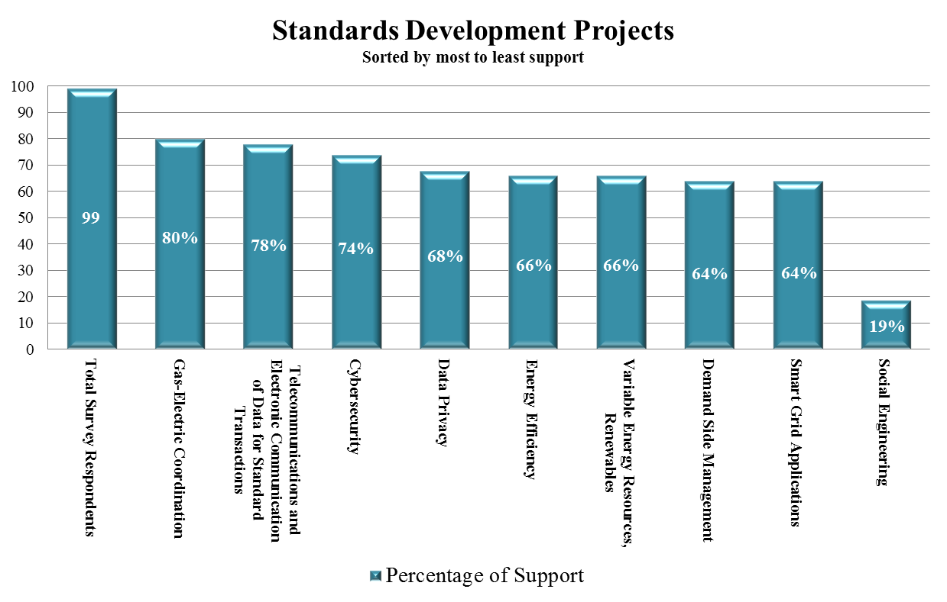

|  |  |
| --- | --- |
| **Percentage of Support** | |
| **Current Staff Development Projects:** | Percentage of Support |
| **Total Number of Survey Respondents - 99** |  |
| Gas-Electric Coordination | **80** |
| Telecommunications and electronic communication of data for standard transactions | **78** |
| Cybersecurity | **74** |
| Demand Side Management | **68** |
| Smart Grid Applications | **66** |
| Energy Efficiency | **66** |
| Data Privacy | **64** |
| Variable Energy Resources, Renewables | **64** |
| Social Engineering | **19** |

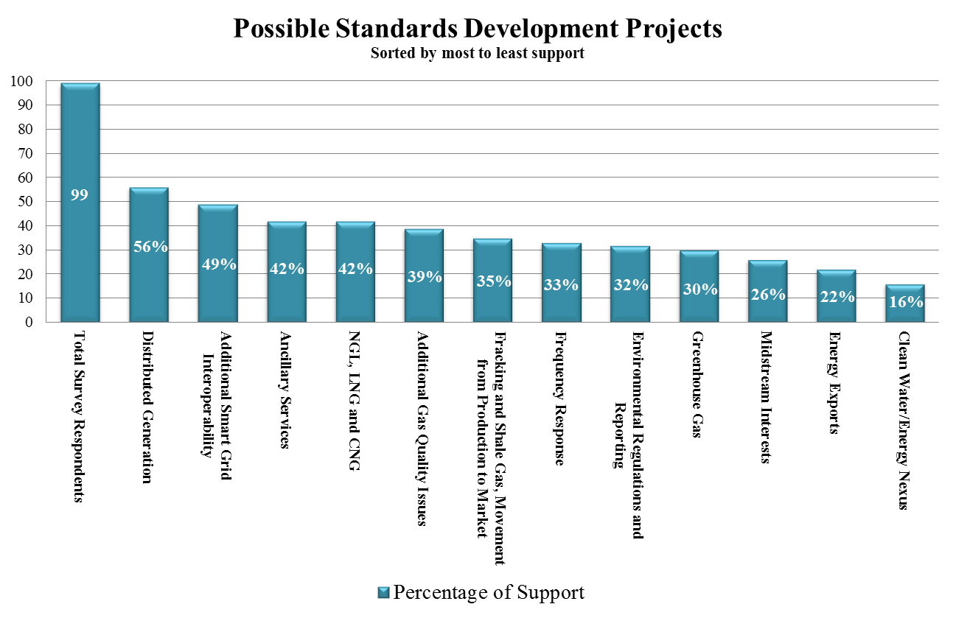

|  |  |
| --- | --- |
| **Percentage of Support** | |
| **Possible Standards Development Projects:** | Percentage of Support |
| **Total Number of Survey Respondents - 99** |  |
| Distributed Generation | **56** |
| Additional Smart Grid Interoperability | **49** |
| Ancillary Services | **42** |
| NGL, LNG and CNG | **42** |
| Additional Gas Quality Issues | **39** |
| Fracking and Shale Gas, Movement from Production to Market | **35** |
| Frequency Response | **33** |
| Greenhouse Gas | **32** |
| Environmental Regulations and Reporting | **30** |
| Midstream Interests | **26** |
| Energy Exports | **22** |
| Clean Water/Energy Nexus | **16** |

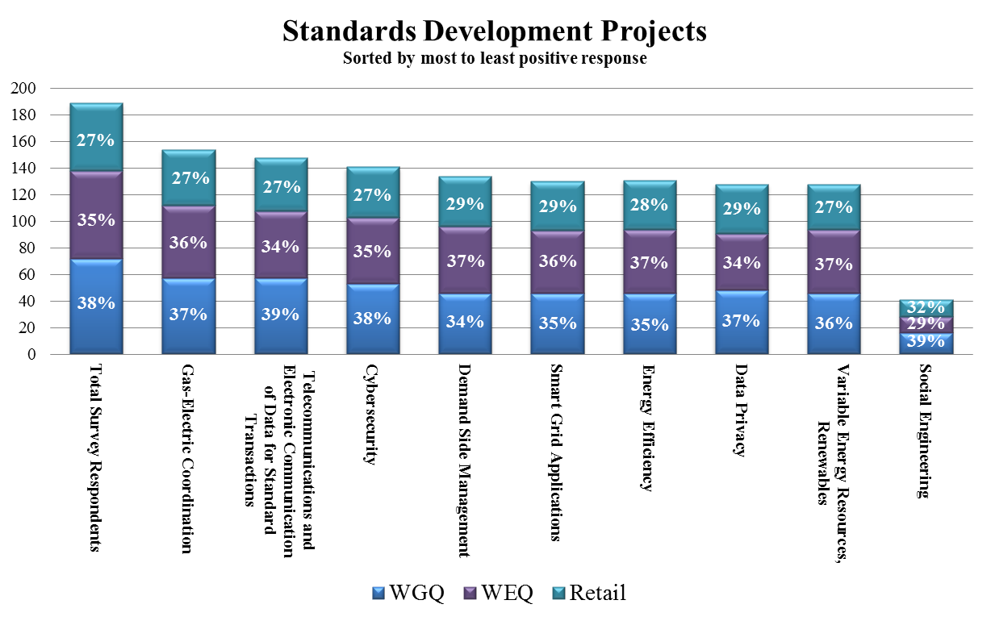

|  |  |  |  |
| --- | --- | --- | --- |
| **Positive Responses by Quadrant** | | | |
| **Current Staff Development Projects:** | WGQ | WEQ | Retail |
| **Total Number of Survey Respondents** | **72** | **66** | **51** |
| Gas-Electric Coordination | **57** | **55** | **42** |
| Telecommunications and electronic communication of data for standard transactions | **57** | **51** | **40** |
| Cybersecurity | **53** | **50** | **38** |
| Demand Side Management | **46** | **50** | **38** |
| Smart Grid Applications | **46** | **47** | **37** |
| Energy Efficiency | **46** | **48** | **37** |
| Data Privacy | **48** | **43** | **37** |
| Variable Energy Resources, Renewables | **46** | **48** | **34** |
| Social Engineering | **16** | **12** | **13** |

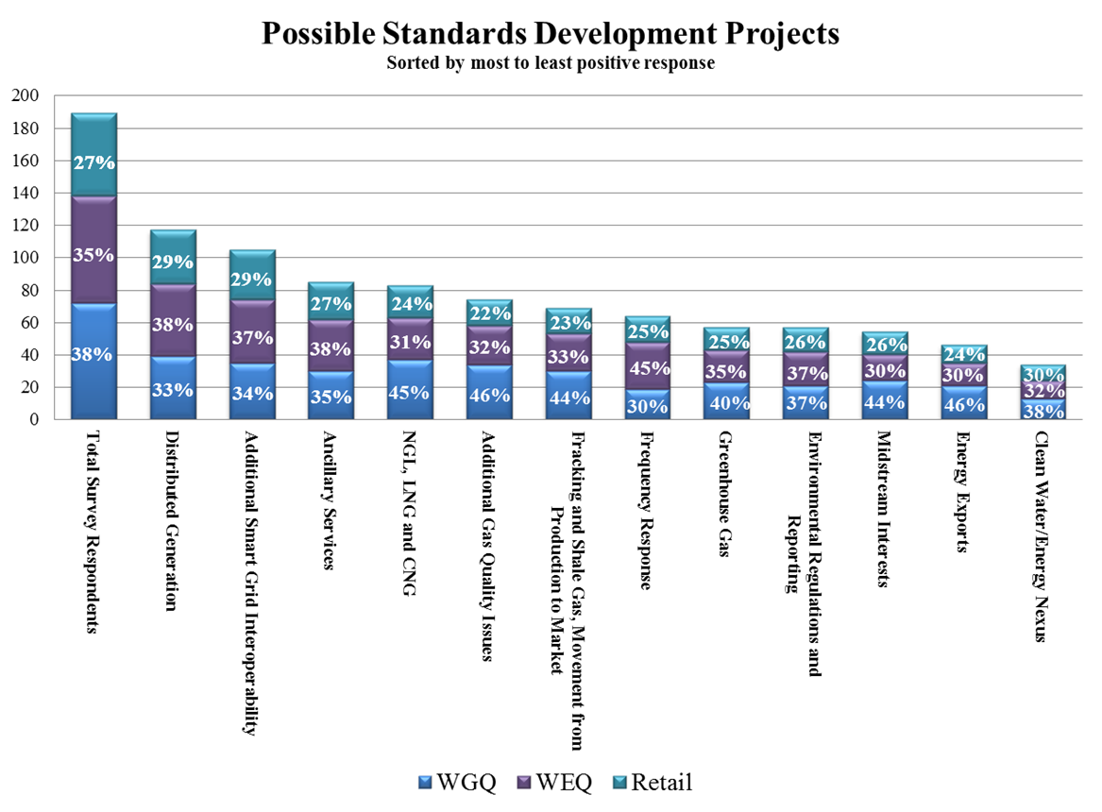

|  |  |  |  |
| --- | --- | --- | --- |
| **Positive Responses by Quadrant** | | | |
| **Possible Standards Development Projects:** | WGQ | WEQ | Retail |
| **Total Number of Survey Respondents** | **72** | **66** | **51** |
| Distributed Generation | **39** | **45** | **33** |
| Additional Smart Grid Interoperability | **35** | **39** | **31** |
| Ancillary Services | **30** | **32** | **23** |
| NGL, LNG and CNG | **37** | **26** | **20** |
| Additional Gas Quality Issues | **34** | **24** | **16** |
| Fracking and Shale Gas, Movement from Production to Market | **30** | **23** | **16** |
| Frequency Response | **19** | **29** | **16** |
| Greenhouse Gas | **23** | **20** | **14** |
| Environmental Regulations and Reporting | **21** | **21** | **15** |
| Midstream Interests | **24** | **16** | **14** |
| Energy Exports | **21** | **14** | **11** |
| Clean Water/Energy Nexus | **13** | **11** | **10** |

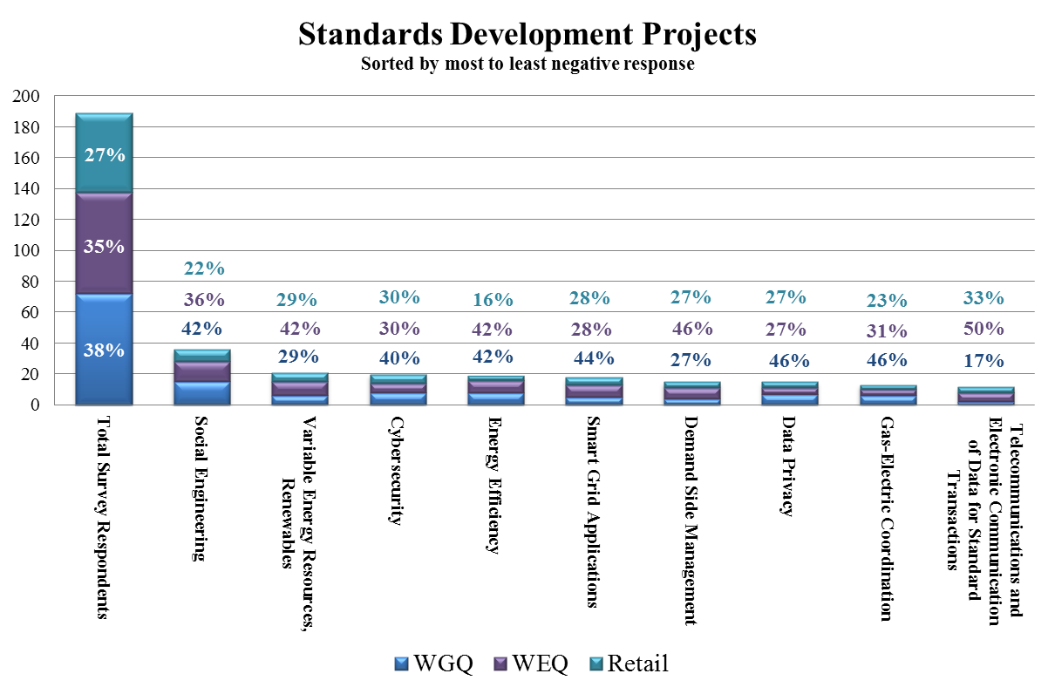

|  |  |  |  |
| --- | --- | --- | --- |
| **Negative Responses by Quadrant** | | | |
| **Current Staff Development Projects:** | WGQ | WEQ | Retail |
| **Total Number of Survey Respondents** | **72** | **66** | **51** |
| Social Engineering | **15** | **13** | **8** |
| Variable Energy Resources, Renewables | **6** | **9** | **6** |
| Cybersecurity | **8** | **6** | **6** |
| Energy Efficiency | **8** | **8** | **3** |
| Smart Grid Applications | **5** | **8** | **5** |
| Demand Side Management | **4** | **7** | **4** |
| Data Privacy | **7** | **4** | **4** |
| Gas-Electric Coordination | **6** | **4** | **3** |
| Telecommunications and Electronic Communication of Data for Standard Transactions | **2** | **6** | **4** |

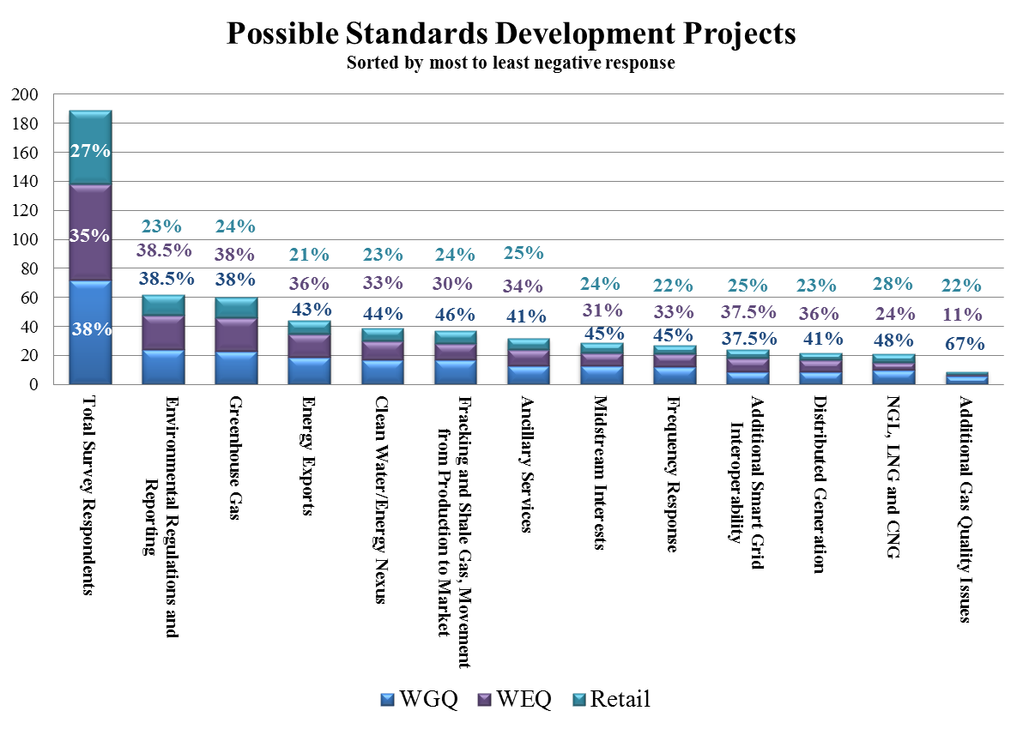

|  |  |  |  |
| --- | --- | --- | --- |
| **Negative Responses by Quadrant** | | | |
| **Possible Standards Development Projects:** | WGQ | WEQ | Retail |
| **Total Number of Survey Respondents** | **72** | **66** | **51** |
| Environmental Regulations and Reporting | **24** | **24** | **14** |
| Greenhouse Gas | **23** | **23** | **14** |
| Energy Exports | **19** | **16** | **9** |
| Clean Water/Energy Nexus | **17** | **13** | **9** |
| Fracking and Shale Gas, Movement from Production to Market | **17** | **11** | **9** |
| Ancillary Services | **13** | **11** | **8** |
| Midstream Interests | **13** | **9** | **7** |
| Frequency Response | **12** | **9** | **6** |
| Additional Smart Grid Interoperability | **9** | **9** | **6** |
| Distributed Generation | **9** | **8** | **5** |
| NGL, LNG and CNG | **10** | **5** | **6** |
| Additional Gas Quality Issues | **6** | **1** | **2** |

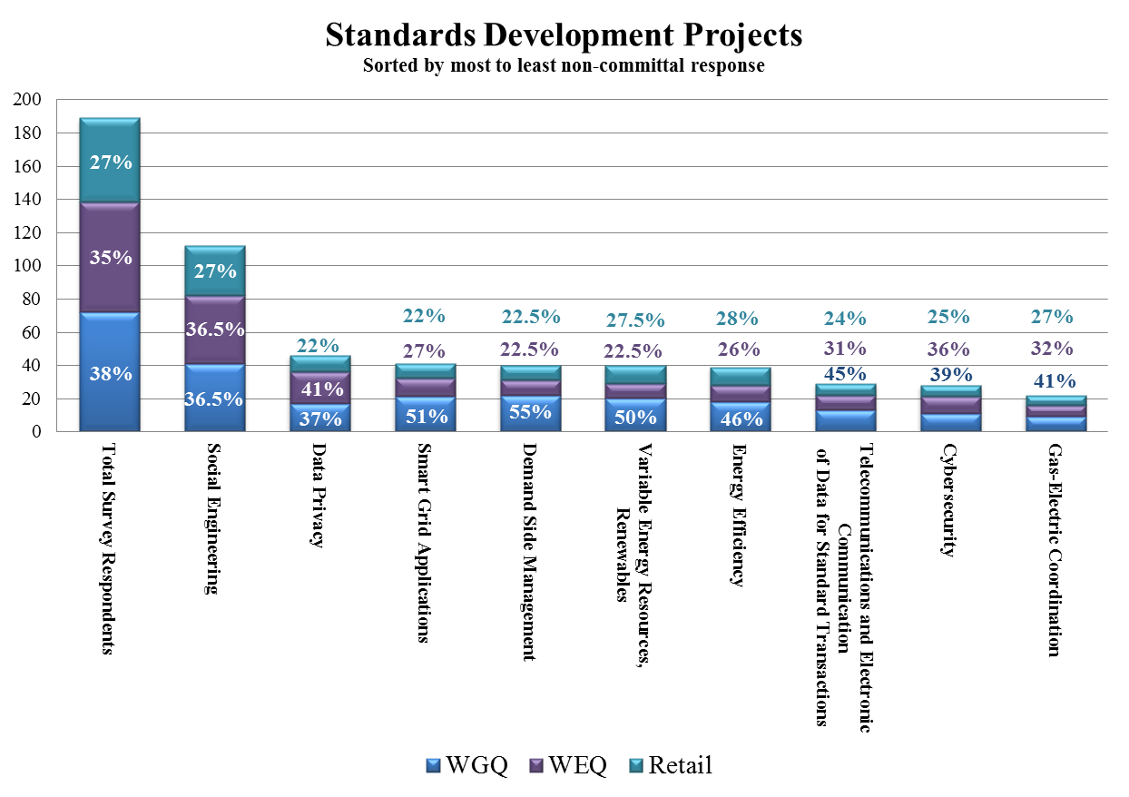

|  |  |  |  |
| --- | --- | --- | --- |
| **Non-committal Responses by Quadrant** | | | |
| **Current Staff Development Projects:** | WGQ | WEQ | Retail |
| **Total Number of Survey Respondents** | **72** | **66** | **51** |
| Social Engineering | **41** | **41** | **30** |
| Data Privacy | **17** | **19** | **10** |
| Smart Grid Applications | **21** | **11** | **9** |
| Demand Side Management | **22** | **9** | **9** |
| Variable Energy Resources, Renewables | **20** | **9** | **11** |
| Energy Efficiency | **18** | **10** | **11** |
| Telecommunications and Electronic Communication of Data for Standard Transactions | **13** | **9** | **7** |
| Cybersecurity | **11** | **10** | **7** |
| Gas-Electric Coordination | **9** | **7** | **6** |

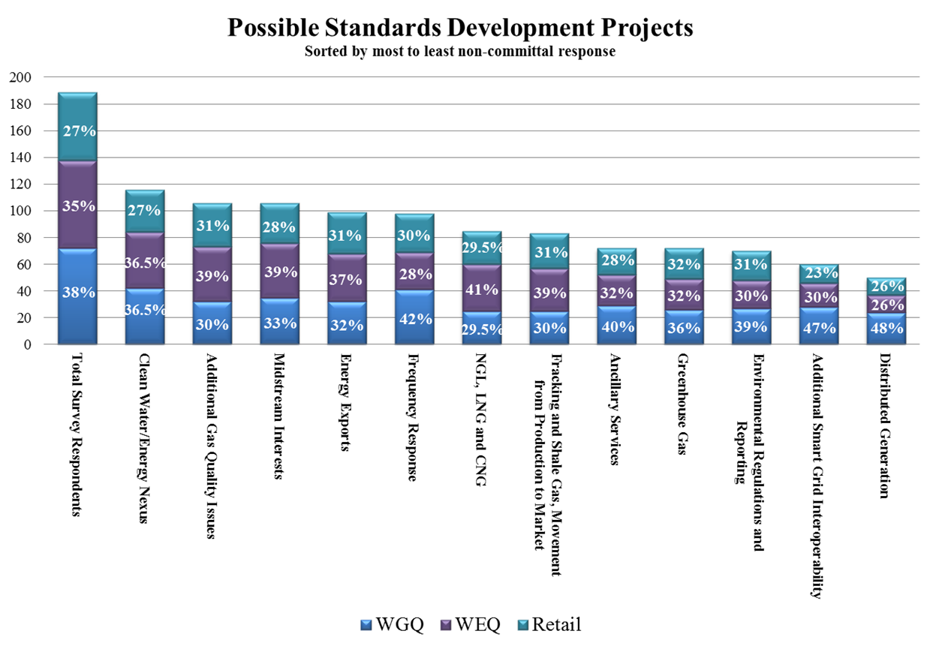

|  |  |  |  |
| --- | --- | --- | --- |
| **Non-committal Responses by Quadrant** | | | |
| **Possible Standards Development Projects:** | WGQ | WEQ | Retail |
| **Total Number of Survey Respondents** | **72** | **66** | **51** |
| Clean Water/Energy Nexus | **42** | **42** | **32** |
| Additional Gas Quality Issues | **32** | **41** | **33** |
| Midstream Interests | **35** | **41** | **30** |
| Energy Exports | **32** | **36** | **31** |
| Frequency Response | **41** | **28** | **29** |
| NGL, LNG and CNG | **25** | **35** | **25** |
| Fracking and Shale Gas, Movement from Production to Market | **25** | **32** | **26** |
| Ancillary Services | **29** | **23** | **20** |
| Greenhouse Gas | **26** | **23** | **23** |
| Environmental Regulations and Reporting | **27** | **21** | **22** |
| Additional Smart Grid Interoperability | **28** | **18** | **14** |
| Distributed Generation | **24** | **13** | **13** |

|  |  |  |  |
| --- | --- | --- | --- |
| **Members of the NAESB Board Strategic Plan Task Force** | | | |
| **Name** | **Company** | **Email** | **Phone** |
| J. Cade Burks | Big Data Energy Services | cade.burks@bigdataenergy.com | 832-661-9127 |
| James P. Cargas | City of Houston | james.cargas@houstontx.gov | 832-393-6255 |
| Valerie Crockett | Tennessee Valley Authority | vjcrockett@tva.gov | 423-751-6096 |
| Lorraine Cross | Cross & Company, P.L.L.C. | cross@co-law.net | 202-609-9862 |
| Dave Darnell | Systrends USA | dave.darnell@systrendsUSA.com | 480-756-6777 |
| *Michael Desselle* | *Southwest Power Pool* ***(Chairman of the Board Strategic Plan Task Force)*** | mdesselle@spp.org | 501-614-3206 |
| Michehl Gent | Open Access Technology International, Inc. | mgent@summitpower.com | 858-450-1005 |
| Richard Kruse | Spectra Energy Corp | rjkruse@spectraenergy.com | 713-627-5368 |
| Mark G. Lauby | North American Electric Reliability Corporation | mark.lauby@nerc.net | 404-446-9723 |
| Debbie McKeever | Oncor Electric Delivery Company LLC | Deborah.mckeever@oncor.com | 214-486-5883 |
| Jim Minneman | PPL Solutions, LLC | [jmminneman@pplweb.com](mailto:jmminneman@pplweb.com) | 610-774-5774 |
| Chris O’Hara | NRG Energy, Inc. | Chris.Ohara@nrgenergy.com | 832-357-5745 |
| Timothy Simon | TAS Strategies | timothyalansimon@gmail.com | 415-505-1723 |
| Mark Stultz | BP Energy | mark.stultz@bp.com | 713-323-1301 |
| James A. Stanzione | National Grid | james.stanzione@us.ngrid.com | 718-403-1010 |
| Terence (Terry) Thorn | KEMA Gas Consulting Services | tthorn@txthorns.net | 713-248-7138 |
| Sue Tierney | Analysis Group, Inc. | stierney@analysisgroup.com | 617-425-8114 |
| Roy True | Alliance for Cooperative Energy Services Power Marketing LLC (ACES) | royt@acespower.com | 317-344-7203 |

|  |  |  |
| --- | --- | --- |
| **Date** | **Committee** | **Notes** |
| Sept 5, 2013 | Board of Directors | [https://www.naesb.org//pdf4/bd090513fm.docx](https://www.naesb.org/pdf4/bd090513fm.docx) |
| Oct 15, 2013 | Strategic Plan Task Force | <http://www.naesb.org/pdf4/bd_strategic_101513mn.docx> |
| Nov 14, 2013 | Strategic Plan Task Force | <http://www.naesb.org/pdf4/bd_strategic_111413mn.docx> |
| Dec 4, 2013 | Strategic Plan Task Force | <http://www.naesb.org/pdf4/bd_strategic_120413mn.docx> |
| Dec 12, 2013 | Board of Directors | [https://www.naesb.org//pdf4/bd121213fm.docx](https://www.naesb.org/pdf4/bd121213fm.docx) |
| Jan 29, 2014 | Strategic Plan Task Force | CANCELLED |
| Feb 27, 2014 | Strategic Plan Task Force | <https://www.naesb.org/pdf4/bd_strategic_022714mn.docx> |
| Mar 25, 2014 | Strategic Plan Task Force | <https://www.naesb.org/pdf4/bd_strategic_032514mn.docx> |
| Apr 3, 2014 | Board of Directors | <https://www.naesb.org/pdf4/bd040314dm.docx> |
| Jul 23, 2014 | Strategic Plan Task Force | <https://www.naesb.org/pdf4/bd_strategic_072314mn.docx> |
| Aug 28, 2014 | Strategic Plan Task Force | <https://www.naesb.org/pdf4/bd_strategic_082814mn.docx> |
|  | | |

|  |
| --- |
| **Strategic Plan Task Force Working Documents** |
| October 15, 2013 Conference Call   * Announcement: <http://www.naesb.org/pdf4/bd_strategic_101513announcement.docx> * Agenda: <https://www.naesb.org/pdf4/bd_strategic_101513a.docx> * Board Minutes: <https://www.naesb.org/pdf4/bd090513fm.docx>   November 14, 2013 Conference Call   * Announcement: <http://www.naesb.org/pdf4/bd_strategic_101513announcement.docx> * Agenda: <https://www.naesb.org/pdf4/bd_strategic_111413a.docx> * Correspondence October 22, 2013: <https://www.naesb.org//pdf4/bd_strategic_111413w1.docx>   December 4, 2013 Conference Call   * Announcement: <https://www.naesb.org//pdf4/bd_strategic_101513announcement.docx> * Agenda: <https://www.naesb.org//pdf4/bd_strategic_120413a.docx> * Outline for Recommendation to the NAESB Board of Directors: <https://www.naesb.org//pdf4/bd_strategic_120413w1.docx> * Member Survey: <https://www.naesb.org//pdf4/bd_strategic_120413w2.docx> * Non-Member Survey: <https://www.naesb.org//pdf4/bd_strategic_120413w3.docx> * Communications Strategy Considerations: <https://www.naesb.org//pdf4/bd_strategic_120413w4.docx> * Certification Programs: <https://www.naesb.org//pdf4/bd_strategic_120413w5.docx>   February 27, 2014 Conference Call   * Agenda: <https://www.naesb.org//pdf4/bd_strategic_022714a.docx> * Survey and Cover Page: <http://www.naesb.org/misc/survey_members.docx> (members), <http://www.naesb.org/misc/survey_non-members.docx> (non-members) * Communications Strategy: <http://www.naesb.org/pdf4/bd_strategic_120413w4.docx> * Recommendation Outline: <http://www.naesb.org/pdf4/bd_strategic_120413w1.docx> * Certification Programs: <http://www.naesb.org/pdf4/bd_strategic_120413w5.docx>   March 25, 2014 Conference Call   * Agenda: <https://www.naesb.org//pdf4/bd_strategic_032514a.docx> * Survey and Cover Page: <http://www.naesb.org/pdf4/bd_strategic_031014survey.pdf> * Communications Strategy: <http://www.naesb.org/pdf4/bd_strategic_120413w4.docx> * NERC reliability risk profile: <http://www.nerc.com/comm/RISC/Agenda%20Highlights%20and%20Minutes/ERO%20Top%20Priority%20Reliability%20Risks%202014.pdf> * Draft points for consideration in creating a standing Board Strategic Plan Ad Hoc Task Force: <http://www.naesb.org/misc/bd_strategic_032514wp.docx> * Certification Programs: <http://www.naesb.org/pdf4/bd_strategic_120413w5.docx> * Recommendation Outline: <http://www.naesb.org/pdf4/bd_strategic_120413w1.docx> (No further changes to the recommendation have been proposed until the survey responses have been collected and analyzed)   July 23, 2014 Conference Call   * Agenda: <https://www.naesb.org//pdf4/bd_strategic_072314a.docx> * Survey Results: results provided under separate cover to task force members, <http://www.naesb.org/pdf4/bd_strategic_031014survey.pdf> * Communications Strategy: <http://www.naesb.org/pdf4/bd_strategic_120413w4.docx> * NERC reliability risk profile: <http://www.nerc.com/comm/RISC/Agenda%20Highlights%20and%20Minutes/ERO%20Top%20Priority%20Reliability%20Risks%202014.pdf> * Draft points for consideration in creating a standing Board Strategic Plan Ad Hoc Task Force: <http://www.naesb.org/misc/bd_strategic_072314w1.docx> * Recommendation Outline: <http://www.naesb.org/pdf4/bd_strategic_120413w1.docx> * Possible inclusions regarding changes to the Quadrant/segment structure and addressing new areas of standards development: <http://www.naesb.org/misc/bd_strategic_072314w2.docx> * Comments Submitted by R. True on the Outline for Addressing New Development and Impact of Quadrant and Segment Structure: <https://www.naesb.org//pdf4/bd_strategic_072314w3.docx> * Comments Submitted by R. True on the Strategic Plan Task Force As a Board Committee: <https://www.naesb.org//pdf4/bd_strategic_072314w4.docx> * NAESB Strategic Plan 2014-2015: <https://www.naesb.org//pdf4/bd_strategic_072314w5.docx> |

1. If you are not sure if you are a member of NAESB, you can go to this link and download the NAESB Membership Roster sorted by Company Name - <http://www.naesb.org/pdf4/members_company.pdf>