North American Energy Standards Board
Board Strategy Committee
2020 NAESB Standards Development Survey Summary Report
Submitted to the NAESB Board of Directors on September 3, 2020

I. Summary Report Recommendations
The purpose of this report is to provide a summary of the data and responses resulting from the 2020 NAESB Standards Development Survey and to offer recommendations based upon the analysis of the Board Strategy Committee for consideration by the Board of Directors. All information collected through the survey has been compiled and organized in an appendix to the summary report, with the exception of individual respondent information to ensure anonymity. Based upon the discussion during the August 27, 2020 conference call, the Board Strategy Committee is recommending the following:
- Continue the development of standards and other activities that support Distributed Ledger Technologies in the wholesale natural gas market,
- Continue and accelerate standards development and other activities that support cybersecurity in the wholesale and retail natural gas and electric markets,
- Explore, identify standards development and other activities to support the integration of battery storage in the wholesale and, where appropriate, retail electric markets, and
- Explore, identify standards development and other activities to support transparency reporting concerning the sustainability of North American natural gas production processes.

II. Survey Background
On June 25, 2020 the NAESB Board Strategy Committee distributed the fourth NAESB Standards Development Survey. This action was taken pursuant to the committee’s mission to provide assistance to the Board of Directors by (a) developing and maintaining a multi-year strategic plan, (b) appraising NAESB work products to ensure that NAESB is addressing member needs, (c) assessing NAESB structure to ensure that market segments that take part in development of NAESB work products are adequately and fairly represented, and (d) reviewing market trends to ensure that NAESB remains relevant. The survey is developed by the committee and distributed to members and non-members on a biennial basis to solicit feedback from the industry-at-large concerning specific areas for potential standards development or other activities that NAESB may pursue in eighteen to twenty-four months. The information obtained through the survey serves as a foundation for the organization’s strategic planning efforts and informs the Board of Directors as it makes decisions on the overall direction of NAESB and appropriate resource allocation. The process also reinforces that the activities of the organization related to standards development, industry tool management, certification and coordination are consistent with and furthering NAESB’s mission of supporting the energy markets’ commercial transactions through standards activities.
This year’s survey was distributed to over two-thousand member and non-member contacts that work in the energy industry for public and private corporations, government agencies, national laboratories, trade press, trade organizations and consulting firms. The year’s survey was developed by the committee during its June 11, 2020 conference call and subsequent email communications. As in the past, this report and the data supporting it will be submitted to the Board of Directors and reviewed during the Strategic Session portion of the September board meeting in support of the organization’s annual plan development process and other activities that become apparent through analysis of the report.
Unlike previous surveys, the 2020 survey focused solely on potential standards development or other supportive activities and provided ten generalized areas for consideration. Participants were encouraged to respond to questions through an open-ended format concerning the ten broad areas by identifying business or use cases that would benefit from standardization by NAESB or by explaining why standardization in the area is unneeded. The change in the question format was intended to solicit more narrowly tailored responses focused on specific actionable items that the committee and, eventually, the Board of Directors could consider for development. The ten areas included in the survey were developed by the committee based primarily on the discussions during the February 8, 2020 NAESB Advisory Council meeting and in response to recommendations made by the Board Digital Committee in the draft Digital Committee Inaugural Report.
Areas for Potential Standards Development or Other Activities in the next 18 to 24 Months
1. | Standards that support Distributed Ledger Technologies | 6. | Standards that support Battery Storage (Retail Market)
2. | Standards that support Distributed Energy Resources | 7. | Standards that support Cybersecurity
3. | Standards that support the Internet of Things | 8. | Standards that support Grid Modernization Activities, included the Department of Energy Grid Modernization Initiative
4. | Standards that support the General Data Protection Regulation (GDPR) | 9. | Standards that support Renewable Natural Gas (such as biogas or biomethane)
5. | Standards that support Battery Storage (Wholesale Market) | 10. | Standards that support Responsibly Produced Natural Gas
In Section 2 (Potential Standards Development Areas) of the survey, respondents were asked to indicate whether they “strongly support,” “support,” or “do not support” NAESB considering standards development or other activities in each of the ten areas identified within the next eighteen to twenty-four months. Respondents were also given an option of providing a “no opinion” response. Participants that selected “strongly support” or “support” were asked to provide more detailed information - specifically, an example of a business practice, process or transaction that would benefit from standardization by NAESB in the given area. If no examples were provided, respondents had the option to provide any open-ended comments. Participants selecting “do not support” were asked to provide more detailed information by selecting one or more of the following: “standardization in the area is not needed,” “standards currently exist that adequately address the area for the energy industry,” “standards development by NAESB would be inappropriate,” or “”standards development by NAESB would inappropriate at this time.” Respondents had the option to provide open-ended comments expanding on their “do not support” selection and/or on the area itself.
III. Respondents
In total, sixty responses were received from fifty-one companies/organizations, with nearly 95% of the surveys coming from member companies. Nearly 20% of the entire NAESB membership participated in the survey, representing a significant increase from the previous survey, as only 74% of the responses to the 2018 NAESB Standards Development Survey were submitted by representatives from member companies. The three respondents from non-member companies were asked to provide a reason why they have declined membership within in NAESB and were given 4 optional responses or an “other” option with a comment box. Two of the respondents cited financial reasons for not becoming NAESB members, and one respondent answered that they represent a U.S. Department of Energy national laboratory without electricity system operational responsibility.
The respondents represented a wide array of market segments from the wholesale gas, wholesale electric and retail energy markets. Each respondent was asked to identify with one or more of the NAESB markets and segments. Those that could not identify with a specific market or segment were asked to describe their market function through an open-ended question. Although seven respondents provided descriptions of their company’s/organization’s market function, only three respondents did not identify with a NAESB market or segment. Of the sixty respondents, 32% identified affiliation with only the wholesale gas market, 25% identified affiliation with only the wholesale electric market, 7% identified affiliation with only the retail markets and 5% did not identify an affiliation. The remaining respondents indicated their companies/organizations participate in multiple markets. A pie chart depicting the make-up of the respondents by market follows.

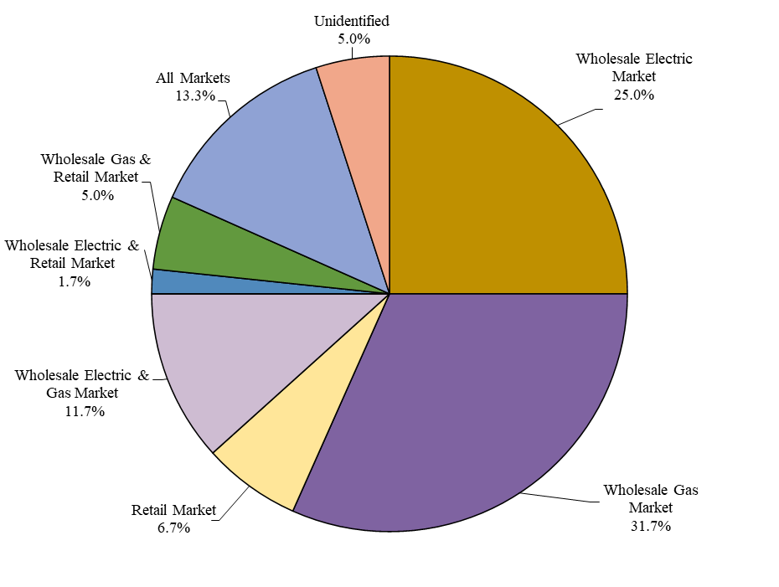
In an effort to gain deeper insight into the data provided, this report will evaluate the data on both a cumulative and market basis. To represent the data on a market basis, surveys submitted by respondents that noted affiliation with multiple markets were included in the results of all markets that were identified. While this approach would have the effect of weighting the responses from surveys provided by respondents affiliated with multiple markets on a cumulative basis, it has no such affect on a market basis and provides a clearer picture of individual market trends. As the standards development and other activities of NAESB is typically undertaken on a market, or quadrant, basis, analyzing the results in this manner will be more valuable for our purposes. Utilizing this method of analysis, the survey responses created eighty-seven data points for evaluation on a market basis consistent with the table below.
Responses by Market Participation
Wholesale Electric Market | 31
Wholesale Gas Market | 37
Retail Market | 16
Unidentified | 3
IV. Response Data
Cumulative
As noted above, respondents were given four optional responses for each of the ten areas identified in the survey. The following graph shows the cumulative (non-market specific) percentages of responses received on each of the areas. The area garnering the highest number of “strongly support” and “support” responses on a cumulative basis is Cybersecurity (77%). Other areas that received a majority, or greater than 50%, “strongly support” or “support” responses are Distributed Energy Resources (65%), Distributed Ledger Technology (62%), Wholesale Battery Storage (55%) and Grid Modernization (54%). The area that garnered the least “strongly support” and “support” responses is Retail Battery Storage (38%), and the areas with the most “do not support” responses are the Internet of Things and General Data Protection Regulation (GDPR) (both receiving 14%).
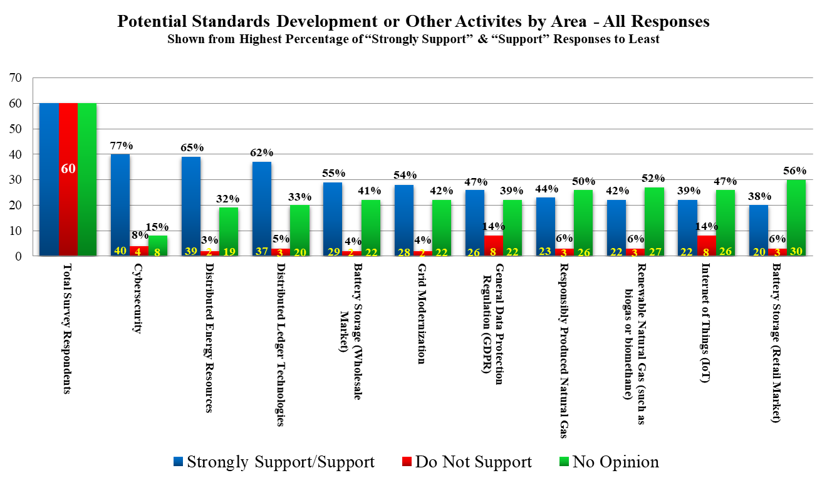

Wholesale Gas
When analyzed on a market basis, the area garnering the highest number of “strongly support” and “support” responses by respondents identifying affiliation with the wholesale gas market is, again, Cybersecurity (72%). Other areas that received a majority, or greater than 50%, “strongly support” or “support” responses are Distributed Ledger Technology (65%), Distributed Energy Resources (57%), Responsibly Produced Natural Gas (56%) and Renewable Natural Gas (53%). The area that garnered the least “strongly support” and “support” responses is the Internet of Things, and the areas with the most “do not support” responses is also the Internet of Things and General Data Protection Regulation (GDPR) (both receiving 20%).

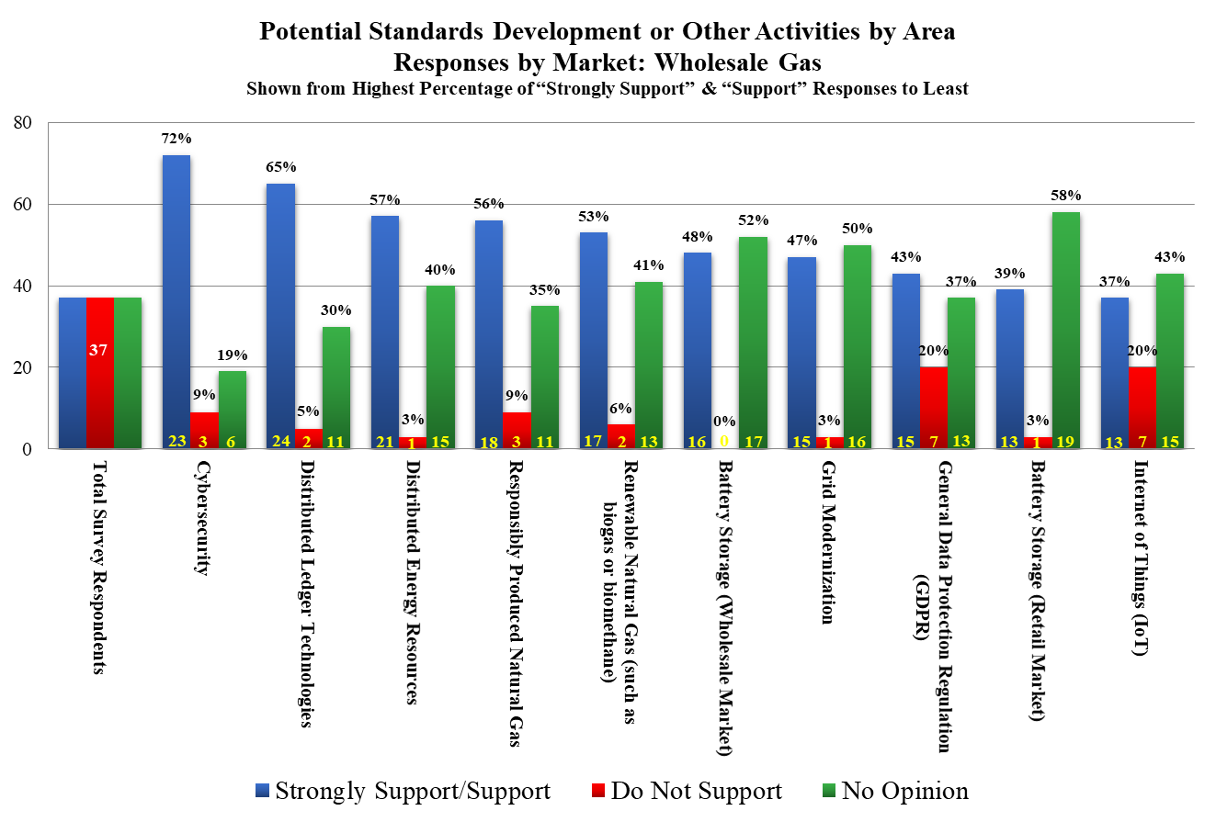

Wholesale Electric
Respondents affiliated with the wholesale electric market basis, also cited Cybersecurity as the area most strongly supported (88%). Other areas that received overwhelming “strongly support” or “support” responses are Distributed Energy Resources (78%) and Wholesale Battery Storage (77%). The area that garnered the least “strongly support” and “support” responses is Responsibly Produced Natural Gas (36%), although most respondents selected “no opinion” concerning the area (64%), and General Data Protection Regulation (GDPR) was the area with the most “do not support” responses (19%).

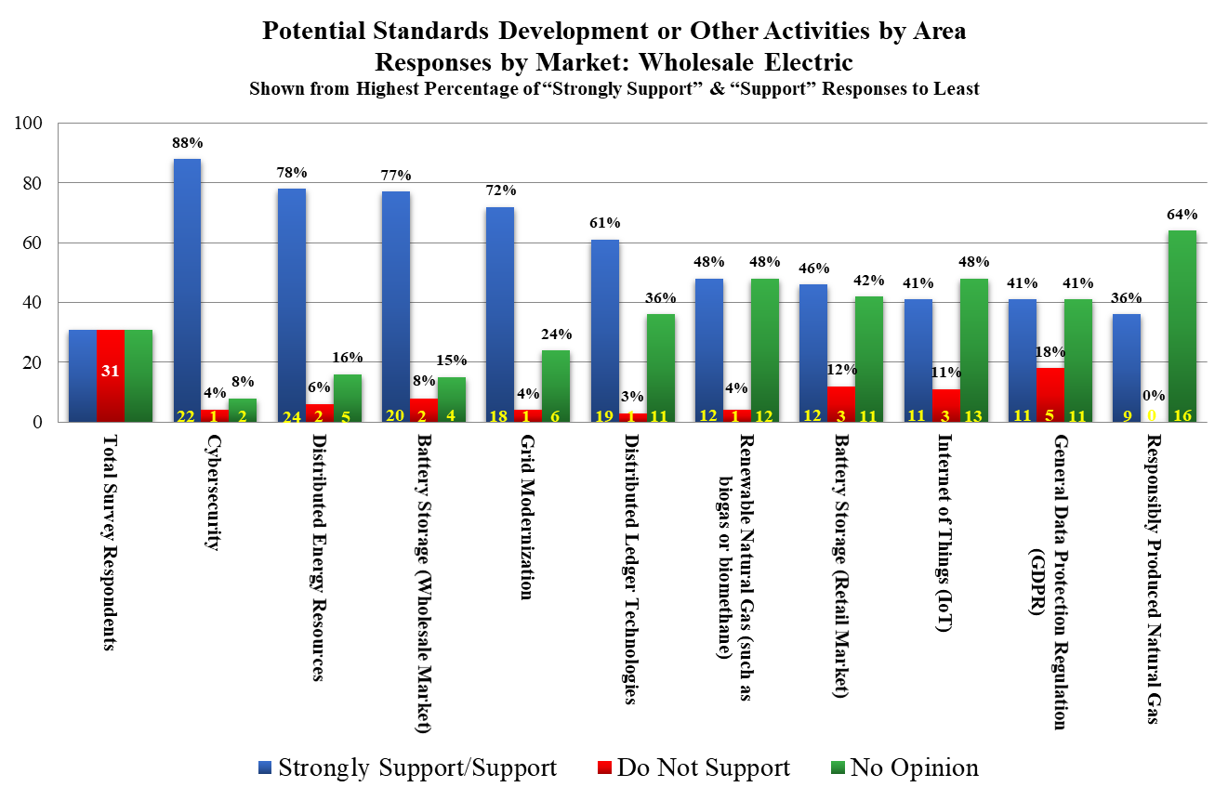

Retail
Unlike the responses from respondents with affiliations in the wholesale gas and electric markets, those identifying participation in the retail market provided the most “strongly support” or “support” responses to Distributed Energy Resources (82%), and no “no support” responses were provided. Other areas that received significant “strongly support” or “support” responses are Cybersecurity (80%), Distributed Ledger Technology (75%) and Wholesale Battery Storage (73%). The area that received the least “strongly support” and “support” responses and the most “do not support” responses was Renewable Natural Gas (40% and 13%, respectively).

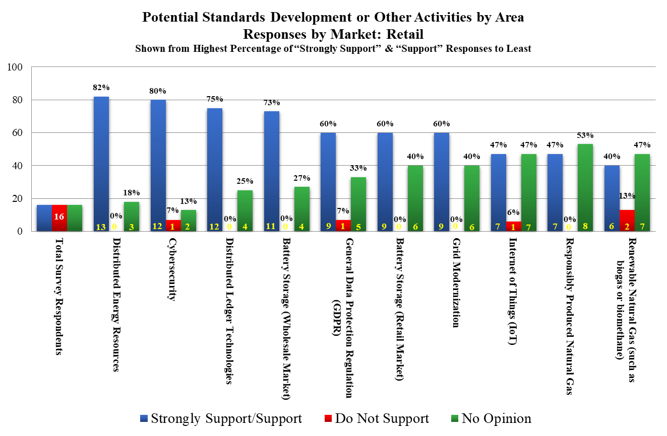

No Opinion
Similar to previous NAESB Standards Development Surveys, a significant number of respondents provided “no opinion” responses to the questions presented in the survey. With these responses removed from the cumulative results, the areas receiving the greatest “strongly support” and “support” vary from representations provided above and offer a different perspective.
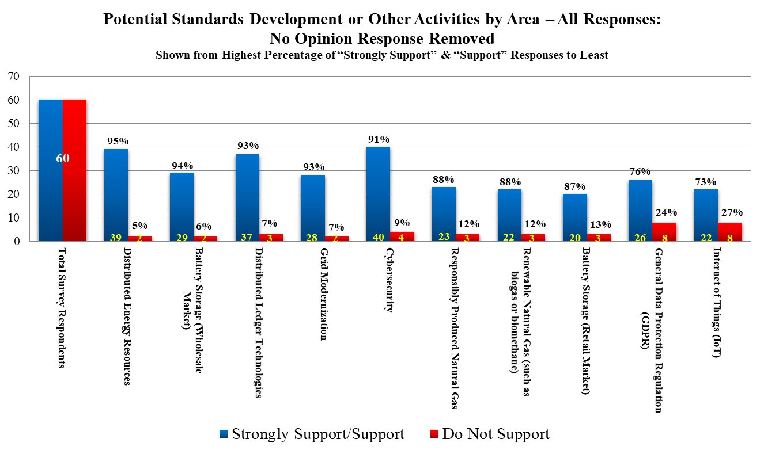
Examples, Explanations and General Comments
As discussed above, respondents were given the opportunity to provide examples of business practices, processes or transactions that would benefit from standardization by NAESB in the given area to expand upon “strongly support” or “support” responses. Additionally, participants providing a “do not support” response were asked to supplement their response with more detailed information. As in the past, respondents had opportunities to provide generalized comments to each of the ten areas identified and to the survey overall. A total of one-hundred fifty-eight comments were provided by respondents in the areas identified in the survey, and six comments were provided in response to the request for any general comments at the conclusion of the survey. These comments are cataloged in the table below and can be found in the appendix to this report.
Potential Areas for Standards Development or Other Activities in the Next 18 to 24 Months |  | Number of Comments
1. | Standards that support Distributed Ledger Technologies
 | Comments Supporting Responses in Support | 13
 | Comments Supporting Responses not in Support | 3
 | Additional Comments | 5
2. | Standards that support Distributed Energy Resources
 | Comments Supporting Responses in Support | 8
 | Comments Supporting Responses not in Support | 2
 | Additional Comments | 8
3. | Standards that support the Internet of Things
 | Comments Supporting Responses in Support | 5
 | Comments Supporting Responses not in Support | 8
 | Additional Comments | 6
4. | Standards that support the General Data Protection Regulation (GDPR)
 | Comments Supporting Responses in Support | 1
 | Comments Supporting Responses not in Support | 8
 | Additional Comments | 6
5. | Standards that support Battery Storage (Wholesale Market)
 | Comments Supporting Responses in Support | 4
 | Comments Supporting Responses not in Support | 2
 | Additional Comments | 8
6. | Standards that support Battery Storage (Retail Market)
 | Comments Supporting Responses in Support | 2
 | Comments Supporting Responses not in Support | 3
 | Additional Comments | 7
7. | Standards that support Cybersecurity
 | Comments Supporting Responses in Support | 7
 | Comments Supporting Responses not in Support | 4
 | Additional Comments | 9
8. | Standards that support Grid Modernization Activities, included the Department of Energy Grid Modernization Initiative
 | Comments Supporting Responses in Support | 3
 | Comments Supporting Responses not in Support | 2
 | Additional Comments | 8
9. | Standards that support Renewable Natural Gas (such as biogas or biomethane)
 | Comments Supporting Responses in Support | 2
 | Comments Supporting Responses not in Support | 3
 | Additional Comments | 9
10. | Standards that support Responsibly Produced Natural Gas
 | Comments Supporting Responses in Support | 4
 | Comments Supporting Responses not in Support | 3
 | Additional Comments | 5
 | General Comments | 6
This table captures the number of written comments submitted outside of the predefined responses
As previously stated in the past, the information gathered through this biennial report has been extremely valuable to the Board of Directors for the purposes of strategic planning, resource allocation and in the development of the NAESB annual plans. The results from the survey solidify the findings contained in the Board Digital Committee Inaugural Report concerning the organization’s appropriate focus on both Cybersecurity and Distributed Ledger Technologies over the last twenty-four months, and further demonstrated support for exploring a new area of activities, distributed energy resources, and more specifically, battery storage. The Board Strategy Committee deeply appreciates the time commitment made to NAESB by completing the survey and looks forward to supporting the Board of Directors in the analysis of the data contained in this report.
Results of Survey Distributed on June 25, 2020

Section 1 – Respondent Profiles
1. Please provide your contact information.
Total Responses | 60
Companies and/or Organizations | 51
Individual Representatives | 59
2. Do you participate in (check as many as are applicable):
37 Wholesale Natural Gas Market 4 Producer
10 Pipeline
6 Distributor
6 Services or Technology Company
12 End User
5 Other Participant
3. 31 Wholesale Electric Market as a 14 Transmission Company
12 Generator
9 Distributor/Load Serving Entity
5 End User
6 Independent Grid Operators and Planners
10 Marketers/Brokers
2 Technology and Services Companies
4 Other Participant
4. 16 Retail Energy Market as a 7 Retail Electric Service Providers/Suppliers
3 End Users/Public Agencies
4 Retail Gas Market Interests
7 Retail Electric Utilities
4 Other Participant
5. 3 If you do not fit into any of the market functions described in questions 2 through 4, or if one of your market functions has not been provided in questions 2 through 4, please describe your market function.:
1. | We are an LDC for natural gas, but there are subsidiaries under our parent company that have electric utilities (Participant in All Markets)
2. | Consultant (Market Participation Not Provided)
3. | Retail electric broker - NAESB Groupie (Participate in All Markets)
4. | Wholesale transmission (Participant in Wholesale Electric Market)
5. | Regulator for Bulk Electric System Reliability in North America (Participant in Wholesale Electric Market)
6. | PNNL is a US DOE national laboratory, we do research and facilitate activities in the electric power industry consistent with the federal role of enhancing the economic and social welfare of the nation. (Market Participation Not Provided)
7. | Regulator (Market Participation Not Provided)

Individual Respondent Identification of Market Participation - Single/Multi Market (60 Data Points)
Single Market
Wholesale Electric Market | 15
Wholesale Gas Market | 19
Retail Market | 4
Multi Market
Wholesale Electric & Gas Market | 7
Wholesale Electric & Retail Market | 1
Wholesale Gas & Retail Market | 3
All Markets | 8
Unidentified | 3

Responses by Market Participation - (87 Data Points)
Wholesale Electric Market | 31
Wholesale Gas Market | 37
Retail Market | 16
Unidentified | 3

6. Are you a member of NAESB?
57 Yes
3 No
7. If you are not a member, why have you not joined NAESB?
2 Financial reasons
0 My organization is an affiliate of a member company
0 NAESB’s activities are not currently relevant to my organization
0 My organization’s interests are represented by another entity
1 Other
Other:
US DOE national laboratory without electricity system operational responsibility.

Section 2 – Potential Standards Development Areas

Please indicate whether NAESB should consider standards development or other activities in the following areas within the next 18 to 24 months. Comments may be provided for each development effort.
- Standards or Other Activities that Support Distributed Ledger Technologies |  | Strongly  Support | Support | Do Not Support | No Opinion | Total
All Respondents |  | 13 | 24 | 3 | 20 | 60
By Market
Wholesale Gas Market |  | 5 | 19 | 2 | 11 | 37
Wholesale Electric Market |  | 7 | 12 | 1 | 11 | 31
Retail Energy Markets |  | 5 | 7 | 0 | 4 | 16
No Market Identified |  | 1 | 0 | 0 | 2 | 3
Responses in Support
Examples of specific business practices, process or transactions that would benefit from standardization by those supportive of standards development or other activity
1. | Potential opportunities include the EIR, e-Tagging systems, and OASIS systems. Additional opportunities also include Transmission and Market Transaction Settlements.
2. | Marketplace settlement transactions
3. | I believe while the WGQ is at the forefront of DLT, there should be a standardize business process for the industry if implemented.
4. | Gas Purchase and Sale Agreements are examples but not Gas Transportation Contracts
5. | Invoicing
6. | DLT could be used to enhance high availability and resiliency of EIR and/or other functions, i.e. e-tagging
7. | Settlement, Billing - back office functions. Collateral Management
8. | As cybersecurity has come to the forefront have standards addressing digital exposures is critical
9. | Power trading through accounting, Rec contract through attestation & retirement, and Gas Pipeline Transportation
10. | Standards on Redirect, Preemption & Competition, Consolidation etc
11. | Natural Gas Supply Chain (active), REC Voluntary (active), Wholesale Electricity
12. | Cheniere's current NAESB request at R19014
13. | Natural Gas Trading, Scheduling & Invoicing activities
Responses not in Support
Detailed information concerning responses by those not supportive of standards development or other activity
1 | Standardization in the area is not needed (comments below)
 | No comments provided
0 | Standards currently exist that adequately address the area for the energy industry
1 | Standards development by NAESB would be inappropriate (comments below)
 | Distributed Ledger is a technology choice that might have application in many areas that are not subject to NAESB regulations. NAESB members may not be in the best position to develop standards for this technology. Instead, NAESB should focus its efforts on standards that are more aligned with its core area of responsibility/oversight.
1 | Standards development by NAESB would be inappropriate at this time (comments below)
 | Do not see as a priority at this time.
Additional Comments
1. | A standard tracking system outside of WECC and a standard contract for voluntary environmental attribute transactions would be useful.
2. | Much effort has been put into creation of digital datasets for the NAESB Base Contract and related datasets over the past several years. Those datasets have the potential to greatly improve the related processes; however, I anticipate additional work will be needed to improve the datasets and move the processes into the Distributed Ledger realm.
3. | DLT can be a great efficiency tool. As new vendors spool up to provide the Purchase and Sales process electronically there will be updates and enhancements to the newly developed NAESB DLT documentation.
4. | No opinion on the continued development of electronic versions of NAESB Base Contract and related Transaction Confirmation and Invoice. At this time, no opinion is based on that there is no actual industry experience with current proposed standards that could be used in an analysis of benefits versus cost of implementation and impacts to a company’s existing commercial systems, accounting, and operations.
5. | Distributed ledger aka block chain is a more secure method than email. email is the primary method for wholesale markets.

- Standards or Other Activities that Support Distributed Energy Resources |  | Strongly  Support | Support | Do Not Support | No Opinion | Total
All Respondents |  | 15 | 24 | 2 | 19 | 60
By Market
Wholesale Gas Market |  | 7 | 14 | 1 | 15 | 37
Wholesale Electric Market |  | 7 | 17 | 2 | 5 | 31
Retail Energy Markets |  | 6 | 7 | 0 | 3 | 16
No Market Identified |  | 2 | 1 | 0 | 0 | 3
Responses in Support
Examples of specific business practices, process or transactions that would benefit from standardization by those supportive of standards development or other activity
1. | NC, SC, and FL have many solar and battery storage deployments. Indiana has several battery storage projects in the wholesale market.
2. | Continue support of electronic metering reporting standards, such as “Green Button “standard for retail electric meters.
3. | Community Solar
4. | Digitalization between nat gas and electric systems to achieve harmonization and thus reliability and resiliancy would be nice
5. | This might already exist but a standard interconnection agreement should exist and a documented process flow for the agreement, business process standards should also be developed.
6. | Communication with Utilities/ISOs (similar to NERC BES standards but for smaller load) Cybersecurity
7. | The retail electricity space for expanding the integration distributed energy resources with system operations is being hampered because terminology and related concepts are confusing and make for an inefficient dialogue, especially when discussing the nature of a service to be exchanged at the boundary between the electric power system infrastructure and customer premises. Understanding and separating operational objectives from the performance expectations of a service agreement are needed to make the business value propositions and related interactions between grid-related and customer-related parties become more effective and efficient.
8. | Trading, Scheduling & Invoicing activities under the NAESB Wholesale Gas Contract
Responses not in Support
Detailed information concerning responses by those not supportive of standards development or other activity
0 | Standardization in the area is not needed
1 | Standards currently exist that adequately address the area for the energy industry (comments below)
 | IEEE Standard 1547 provides requirements relevant to the performance, operation, testing, safety considerations, and maintenance of DER.
0 | Standards development by NAESB would be inappropriate
1 | Standards development by NAESB would be inappropriate at this time (comments below)
 | No comments provided.
Additional Comments
1. | Also, market standards needed to complement the NERC reliability standards for variable energy resources.
2. | Standardization in this area would likely not affect the WGQ Pipelines.
3. | There appears to be an opportunity for future standards, NAESB should monitor and remain engaged to develop Business Practices when the technology matures.
4. | With Solar, Wind, Batteries being added to the energy mix, NEASB may wish to revisit WEQ-023 Modeling Standard for transparency.
5. | DER is growing at such a rapid pace that NAESB should continue to closely monitor the penetration and market activity of DER.
6. | Not Applicable to WGQ
7. | Integration of batteries is a challenge for regulators and market participants. If NAESB showed them how batteries can be used in multiple ways to maximize efficiencies, perhaps they will deploy faster.
8. | DER overtook Coal in ERCOT last year

- Standards or Other Activities that Support Internet of Things (IoT) |  | Strongly  Support | Support | Do Not Support | No Opinion | Total
All Respondents |  | 6 | 16 | 8 | 26 | 56
By Market
Wholesale Gas Market |  | 3 | 10 | 7 | 15 | 35
Wholesale Electric Market |  | 3 | 8 | 3 | 13 | 27
Retail Energy Markets |  | 2 | 5 | 1 | 7 | 15
No Market Identified |  | 1 | 1 | 0 | 1 | 3
Responses in Support
Examples of specific business practices, process or transactions that would benefit from standardization by those supportive of standards development or other activity
1. | Retail markets - Distribution circuits and behind-the-meter customers
2. | North America- if cross border digital standards could be achieved interconnection issues including reliability could be solved
3. | supply chain
4. | Industrial Internet of Things - Sensor communication and cybersecurity
5. | To the extent that IoT standards support the integration of DER on the customer-side with electric system operations, as described in the previous question's response, this area is relevant.
Responses not in Support
Detailed information concerning responses by those not supportive of standards development or other activity
0 | Standardization in the area is not needed
1 | Standards currently exist that adequately address the area for the energy industry (comments below)
 | We address our internet systems at an enterprise level and don't feel the need for standards
0 | Standards development by NAESB would be inappropriate
6 | Standards development by NAESB would be inappropriate at this time (comments below)
 | Not a priority at this time. NAESB should not have this focus.
 | It is unclear what part of IOT the NAESB standards would address. Perhaps with more definition of the proposal there could be an opportunity.
 | Technology is still to vague for standardization
1 | Other (comments below)
 | Not applicable to any of the NAESB Quadrants
Additional Comments
1. | From our perspective, IoT devices and related communications would be back office processes used with our SCADA and/or measurement systems. Not sure how this might affect other segments and/or quadrants.
2. | At this time, no opinion is based on need to review specific proposed standards to analyze whether to support or not support a proposed standard.
3. | With the explosion of "smart devices" for homes, business, and industry, this seems like another great area to monitor to ensure standards are sufficient. This seems especially true in areas of privacy and security.
4. | Standards could be as simple as cross referencing standards already developed by other organizations. Thus, incorporating by reference an incorporation by reference ;)
5. | As I understand what is associated with the iot arena, i don't think there is a lot of commonalities in the needs of energy markets..
6. | I'd like to see standards apply to all intrastate natural gas pipelines and not only to interstate natural gas pipelines, public electronic bulletin boards

- Standards or Other Activities that Support General Data Protection Regulation (GDPR) |  | Strongly  Support | Support | Do Not Support | No Opinion | Total
All Respondents |  | 5 | 21 | 8 | 22 | 56
By Market
Wholesale Gas Market |  | 2 | 13 | 7 | 13 | 35
Wholesale Electric Market |  | 3 | 8 | 5 | 11 | 27
Retail Energy Markets |  | 1 | 8 | 1 | 5 | 15
No Market Identified |  | 2 | 0 | 0 | 1 | 3
Responses in Support
Examples of specific business practices, process or transactions that would benefit from standardization by those supportive of standards development or other activity
1. | In the WEQ, OASIS and other standards provide guidance on the treatment of some data. Developing a common set of standards to manage what data is shareable and with whom would benefit industry. This could include OASIS, EIR, e-Tag, retail meter data, Gas pipeline data, etc.
Responses not in Support
Detailed information concerning responses by those not supportive of standards development or other activity
2 | Standardization in the area is not needed (comments below)
 | This is an EU only initiative.
1 | Standards currently exist that adequately address the area for the energy industry (comments below)
 | No comments provided.
3 | Standards development by NAESB would be inappropriate (comments below)
 | These standards are well defined for companies that must comply with this regulation.
 | I am interpreting this to refer to the European General Data Protection Regulation, which is not related to the North American energy industry. Some North American companies may be required to comply with it, but I don't believe NAESB has a role to play in setting standards.
2 | Standards development by NAESB would be inappropriate at this time (comments below)
 | GDPR is an EU regulation and would seemingly be outside the scope of NAESB. NAESB members and NAESB Standards are North America centric. As we understand GDPR, it applies to international organizations based outside of the EU that have activity on European soil. None of our entities fit that description nor do we believe other U.S. marketing entities would either. Prior to supporting any standard, we would need to review specific proposed standards to determine the impact on our U.S. commercial activities. Finally, similar to NAESB Contract Standards, any standards adopted by NAESB should be completely voluntary and not mandated by FERC or other federal agency without enabling legislation.
Additional Comments
1. | From our perspective, we do not generally gather or use personal information for individuals.
2. | Need More Information
3. | Our company has been asked to support GDPR security standards for some of the global companies we work with.
4. | under cyber concern
5. | As i currently understand this is a uk regulation. in the event the us does not have something then european activities around this regulation could be monitored maybe under the cybersecurity subcommittee work.
6. | The handling of customer information with privacy rights is important for integrating an customer-side resources with electric system operations.

- Standards or Other Activities that Support Battery Storage (Wholesale Market) |  | Strongly  Support | Support | Do Not Support | No Opinion | Total
All Respondents |  | 7 | 22 | 2 | 22 | 53
By Market
Wholesale Gas Market |  | 3 | 13 | 0 | 17 | 33
Wholesale Electric Market |  | 3 | 17 | 2 | 4 | 26
Retail Energy Markets |  | 5 | 6 | 0 | 4 | 15
No Market Identified |  | 1 | 0 | 0 | 2 | 3
Responses in Support
Examples of specific business practices, process or transactions that would benefit from standardization by those supportive of standards development or other activity
1. | Many regulated battery storage projects in NC, SC, FL, and IN
2. | Standards that communicate operating status of Battery Storage Facility and their ability to provide services to regional transmission authorities responsible for grid reliability. Standards development should only be undertaken after receipt of request by NAESB,
3. | Community Solar
4. | Communication and cybersecurity Bulk Electric Communication and cybersecurity Retail Electric
Responses not in Support
Detailed information concerning responses by those not supportive of standards development or other activity
0 | Standardization in the area is not needed
1 | Standards currently exist that adequately address the area for the energy industry (comments below)
 | There are already existing business rules and testing requirements for battery storage resources to participate in the wholesale market. We do not believe additional standards are necessary.
0 | Standards development by NAESB would be inappropriate
1 | Standards development by NAESB would be inappropriate at this time (comments below)
 | There appears to be an opportunity for future standards, NAESB should monitor and remain engaged to develop Business Practices when the technology matures.
Additional Comments
1. | Also, market standards needed to complement the NERC reliability standards for variable energy resources.
2. | Standardization in this area would likely not affect the WGQ Pipelines.
3. | We support developing standards on this topic when it has matured.
4. | Many utilities such as TVA are encouraging the development and expansion of battery technology via request for proposals from third party developers so this is an area that would be great to monitor to ensure standards are being updated accordingly.
5. | Not Applicable to WGQ
6. | Given that many states require 10% or more renewable energy in the transmission grid and given that there are times when there isn't wind or sun, battery storage is a key piece in minimizing brown outs. given that grids can only hold so much energy, until there is a more cost-effective solution battery storage is here to stay.
7. | At this point, our company has only one battery storage pilot project underway, which is for generation purposes. I do not believe we will be seeking to use for firming wholesale marketing reasons for the foreseeable future.
8. | Integration of batteries is a challenge for regulators and market participants. If NAESB showed them how batteries can be used in multiple ways to maximize efficiencies, perhaps they will deploy faster.

- Standards or Other Activities that Support Battery Storage (Retail Market) |  | Strongly  Support | Support | Do Not Support | No Opinion | Total
All Respondents |  | 3 | 17 | 3 | 30 | 53
By Market
Wholesale Gas Market |  | 0 | 13 | 1 | 19 | 33
Wholesale Electric Market |  | 1 | 11 | 3 | 11 | 26
Retail Energy Markets |  | 1 | 8 | 0 | 6 | 15
No Market Identified |  | 1 | 1 | 0 | 1 | 3
Responses in Support
Examples of specific business practices, process or transactions that would benefit from standardization by those supportive of standards development or other activity
1. | Many distribution connected Batteries in NC, SC, and FL
2. | Communication and cybersecurity Retail Electric
Responses not in Support
Detailed information concerning responses by those not supportive of standards development or other activity
1 | Standardization in the area is not needed (comments below)
 | Not applicable to PJM at the Retail Level. Retail Energy Storage Incentive Program is typically operated under a state program with specific state participation and incentive requirements.
0 | Standards currently exist that adequately address the area for the energy industry
0 | Standards development by NAESB would be inappropriate
1 | Standards development by NAESB would be inappropriate at this time (comments below)
 | There appears to be an opportunity for future standards, NAESB should monitor and remain engaged to develop Business Practices when the technology matures.
1 | Other (comments below)
 | It is inapplicable to our company, as we do not have a retail electricity or energy market in our region of the U.S.
Additional Comments
1. | Yes (e.g. significant battery storage to support demand response on the distribution system)
2. | Standardization in this area would likely not affect the WGQ Pipelines.
3. | We support developing standards for battery storage, however development is not needed at this time.
4. | Not Applicable to WGQ
5. | Integration of batteries is a challenge for regulators and market participants. If NAESB showed them how batteries can be used in multiple ways to maximize efficiencies, perhaps they will deploy faster.
6. | I don't see how battery storage links into retail market processes.
7. | Battery storage is part of the DER, customer-side resources whose management can be coordinated for electric system operation.

- Standards or Other Activities that Support Cybersecurity |  | Strongly  Support | Support | Do Not Support | No Opinion | Total
All Respondents |  | 16 | 24 | 4 | 8 | 52
By Market
Wholesale Gas Market |  | 7 | 16 | 3 | 6 | 32
Wholesale Electric Market |  | 10 | 12 | 1 | 2 | 25
Retail Energy Markets |  | 6 | 6 | 1 | 2 | 15
No Market Identified |  | 1 | 1 | 0 | 1 | 3
Responses in Support
Examples of specific business practices, process or transactions that would benefit from standardization by those supportive of standards development or other activity
1. | Enhancement and evolution of existing standards. Standards to address appropriate security for cloud utilization with in the industry.
2. | NERC CIP assets, Distribution grid assets, and wide area telecom infrastructure
3. | Various security items
4. | Focus on enhancing security technologies for data exchange.
5. | The department of Commerce National Telecommunication and Information Administration is working on standards for "Software Bill of Materials"(SBOM), which would help energy companies know what inside a software object before installing. An SBOM is akin to the labeling of ingredients on a food product so that people with allergies don't take something that could cause death. An SBOM will help detect malware, before any attempt at installation in energy cyber asset ecosystem.
6. | Wholesale Gas Infrastructure Reporting to DOE and/or DHS for Situational Awareness. Wholesale Electric Infrastructure Reporting incorporation with NERC
7. | Cybersecurity policies that are standardized of set up as guides for interactions between customer-side flexibility resources with electric system infrastructure operation would help the integration of these resources.
Responses not in Support
Detailed information concerning responses by those not supportive of standards development or other activity
0 | Standardization in the area is not needed
2 | Standards currently exist that adequately address the area for the energy industry (comments below)
 | NERC CIP, NIST CSF, ISO 27001, PCI, SOX
1 | Standards development by NAESB would be inappropriate (comments below)
 | Other industry groups are already adequately supporting this initiative. NAESB should continue to focus on ensuring its standards development compliments those efforts.
1 | Standards development by NAESB would be inappropriate at this time (comments below)
 | No comment provided.
Additional Comments
1. | Standards are needed as requested by the Department of Energy and/or other regulatory entities.
2. | The topic “Cybersecurity” is too broad to provide better comments. Consider narrowing this topic to a specific area within cybersecurity.
3. | For the WGQ, extensive work has been performed over the past year to incorporate cybersecurity improvements in the Standards, where needed, based on recommendations of Sandia National Labs. However, we are always supportive of any Standardization needed to strengthen our cybersecurity efforts.
4. | The latest standards and manual updates for WGQ V3.2 addressed cybersecurity concerns raised by Sandia National Laboratory in their latest review. This area will always be pertinent and changing as more and more devices are connected and sharing data.
5. | Support high level guidance allowing each company to determine their best implementation
6. | One of the issues with setting standards for CyberSecurity is the inherent visibility this gives to those who would do harm. This needs to be taken into consideration.
7. | process to quickly address changes in a rapidly changing field.
8. | All non third world countries rely on electronic communications for their business. successful hacking is at an all time high and many have been successful. given that the hackers hold data for ransom should put everyone on alert.
9. | There will presumably be a role for NAESB to complement NERC's mandatory reliability standards, but I do not have specific comments at this time.

- Standards or Other Activities that Support Grid Modernization Activities, including the Department of Energy Grid Modernization Initiative |  | Strongly  Support | Support | Do Not Support | No Opinion | Total
All Respondents |  | 13 | 15 | 2 | 22 | 52
By Market
Wholesale Gas Market |  | 4 | 11 | 1 | 16 | 32
Wholesale Electric Market |  | 8 | 10 | 1 | 6 | 25
Retail Energy Markets |  | 3 | 6 | 0 | 6 | 15
No Market Identified |  | 2 | 0 | 0 | 1 | 3
Responses in Support
Examples of specific business practices, process or transactions that would benefit from standardization by those supportive of standards development or other activity
1. | Utility partner in multiple Grid Modernization Laboratory Consortium (GLMC) projects
2. | Should strongly support standards starting with safety supporting the us third world grid
3. | The first example in this survey is a part of the DOE-GMLC 2.5.2 project on Grid Services and Energy Services Interface that is a part of this program.
Responses not in Support
Detailed information concerning responses by those not supportive of standards development or other activity
0 | Standardization in the area is not needed
1 | Standards currently exist that adequately address the area for the energy industry (comments below)
 | The Department of Energy and NERC are already working on these areas.
1 | Standards development by NAESB would be inappropriate (comments below)
 | Need clear direction from Regulators and Congress prior to taking on these initiatives.
0 | Standards development by NAESB would be inappropriate at this time
Additional Comments
1. | Standards are needed as requested by the Department of Energy and/or other regulatory entities. Also, market standards needed to complement the NERC reliability standards for variable energy resources.
2. | Standardization in this area would likely not affect the WGQ Pipelines.
3. | NAESB should be engaged with the developments of this effort at the DOE. While it is unclear at this time how NAESB can initiate standards activity, it is very likely there will be opportunity in the future.
4. | Ensuring the standards are aligned to the advancement of grid technologies is important.
5. | Need more details on NAESB Role
6. | Always a good idea to support a federal mandate and assist with implementation so that it goes smoothly.
7. | Fully support DOE initiatives.
8. | The GMI ties into several other standards initiatives listed in the survey.

- Standards or Other Activities that Support Renewable Natural Gas (such as biogas or biomethane) |  | Strongly  Support | Support | Do Not Support | No Opinion | Total
All Respondents |  | 5 | 17 | 3 | 27 | 52
By Market
Wholesale Gas Market |  | 2 | 15 | 2 | 13 | 32
Wholesale Electric Market |  | 4 | 8 | 1 | 12 | 25
Retail Energy Markets |  | 2 | 4 | 2 | 7 | 15
No Market Identified |  | 1 | 0 | 0 | 2 | 3
Responses in Support
Examples of specific business practices, process or transactions that would benefit from standardization by those supportive of standards development or other activity
1. | Capturing further characteristics regarding gas quality, BTU content standardization, etc. will further enhance gas markets. Verification of these characteristics is an additional opportunity.
2. | Hydrogen technologies are becoming more relevant
Responses not in Support
Detailed information concerning responses by those not supportive of standards development or other activity
2 | Standardization in the area is not needed (comments below)
 | No comments provided.
1 | Standards currently exist that adequately address the area for the energy industry (comments below)
 | No comments provided.
0 | Standards development by NAESB would be inappropriate
0 | Standards development by NAESB would be inappropriate at this time
Additional Comments
1. | As biogas and/or biomethane fits into the distributed resource category, market standards needed to complement the NERC reliability standards for variable energy resources.
2. | Would need additional information to determine how this might affect the WGQ Standards.
3. | This appears to be an area NAESB can incorporate into its gas contract processes.
4. | We support the movement and proposed methodologies for Renewable Natural Gas and believe NAESB should in response to specific requests work on standards since Renewable Natural Gas efforts would benefit from standardization.
5. | With the expansion of natural gas to meet power demand, the standards in the area should be monitored accordingly.
6. | More Information Needed
7. | Could be interesting, but I don't know standardization would fit into this market
8. | I would need more information on how this would differ from current wholesale gas standards.
9. | RNG is fairly small, but would benefit from using some of our WNG standards.

- Standards or Other Activities that Support Responsibly Produced Natural Gas |  | Strongly  Support | Support | Do Not Support | No Opinion | Total
All Respondents |  | 5 | 18 | 3 | 26 | 52
By Market
Wholesale Gas Market |  | 3 | 15 | 3 | 11 | 32
Wholesale Electric Market |  | 2 | 7 | 0 | 16 | 25
Retail Energy Markets |  | 0 | 7 | 0 | 8 | 15
No Market Identified |  | 1 | 0 | 0 | 2 | 3
Responses in Support
Examples of specific business practices, process or transactions that would benefit from standardization by those supportive of standards development or other activity
1. | SWN is a leader in Responsibly Produced Methane and has been involved in this movement for some time.
2. | Distribution Ledger/Blockchain to certify origin
3. | Where do I start?
4. | The words, “responsibly produced" indicate that some gas production activities or processes are currently irresponsible. if that's the case then a best practice document should be developed and following the development, the current naesb standards for gas production should be "challenged" against the document to see if there are areas in those processes where they need to be strengthened to help the party be more responsible.
Responses not in Support
Detailed information concerning responses by those not supportive of standards development or other activity
2 | Standardization in the area is not needed (comments below)
 | Not relevant area for NAESB.
0 | Standards currently exist that adequately address the area for the energy industry
1 | Standards development by NAESB would be inappropriate (comments below)
 | This market is still at the conceptual stage. It may be appropriate for NAESB to have a role once the market structure is defined and ready for implementation.
0 | Standards development by NAESB would be inappropriate at this time (comments below)
Additional Comments
1. | Would need additional information to determine how this might affect the WGQ Standards.
2. | This appears to be an area NAESB can incorporate into its gas contracts process.
3. | We support the efforts related to Responsibly Produced Natural Gas and believe NAESB should, in response to specific requests, work on standards since Responsibly Produced Natural Gas efforts would benefit from standardization.
4. | More information needed to determine if current standards suffice
5. | This could support a new market in responsibly produced natural gas as well as provide origin certification for customs purposes

Additional Comments
1. | We would like to see standards development that addresses a need for alternatives for the G846UPRD in NAESB Standard 5.4.14. Specifically, there are currently no standards addressing the amount and frequency of inbound UPRDs that reflect industry participants who utilize a pay per-file contract and would prefer to send data to parties on a more timely basis outside the G846UPRD request for download. Frequently, there are non-customer users of this data and the data request could better be addressed through a timely automated push rather than the inbound request at significant cost savings.
2. | We proposed the standard for scheduling/allocation previously submitted at WGQ R19014 and encourage the Board of Directors to find such standard within Scope for the WGQ to develop.
3. | Forgive me if this is a stupid question but with the growth of teleworking, I am curious if this will have an impact on any NAESB standards?
4. | Looking forward to continue working with the NAESB team and members.
5. | Keep up the good work.
6. | Transparency and security in markets will help us remain on the forefront of sustainable energy

The February 8, 2020 Advisory Council Notes can be found through the following hyperlink: https://naesb.org/pdf4/advisory020820notes.docx
The draft Digital Committee Inaugural Report can be found through the following hyperlink: https://naesb.org/pdf4/bd_digital061120w2.docx
One respondent provided two sets of responses representing two separate entities resulting in sixty responses from fifty-nine companies.
Detailed data concerning the segment affiliation can be found in the appendix to this report.

