

DATE: August 26, 2013,

TO: NAESB OS

FROM: Robin H Cross

SUBJECT: September 17-19 NAESB OS Meeting location and Hotel Accomodations

Seattle City Light – Hosting September 17- 19 NAESB OASIS Subcommittee

Please contact Robin H. Cross (206) 684-3392 or robin.cross@seattle.gov if you have any questions regarding accommodations/directions/restaurants/tourist activities.

Meeting Location – September 17-19th
901 5th Ave, Seattle WA 98104
Floor 19 Conference Room No. 1903

Seattle City Light has two floors in the building located at 901 5th Ave. Seattle City Light’s primary administrative offices are located at 700 5th Ave, Seattle WA 98104 which is ~ one block south of our meeting location (901 5th Ave building).

Lunch Locations
There are many nearby restaurants. For quickest service it is recommended that meeting attendees go to:
(a) the small café located inside 901 5th Ave building (it is near the main entrance on the 5th ave side of the building).
(b) the food court located in the Columbia Tower -1 block south of our meeting location. If you enter the Columbia Tower from 5th Avenue, take the escalators down 3 levels to the food court. The building entrance(s) on 4th Avenue (1 block west of 5th Avenue) takes you directly to the food court area.

Columbia Tower – 701 5th Ave, Seattle WA 98104
http://goo.gl/maps/4VjuK

Primary Airport
Sea-Tac

http://www.portseattle.org/Sea-Tac/Maps-and-Directions/Pages/Terminal-Overview.aspx

Nearby Hotels
Here is a list of some hotels that are within walking distance of the meeting location (901 5th Ave, Seattle WA 98104).

They are listed in order of proximity and are walking blocks, not miles. Distance is approximate.
Some hotels may charge an extra fee if there is more than 1 adult

Arctic Club Hotel (2 blocks)
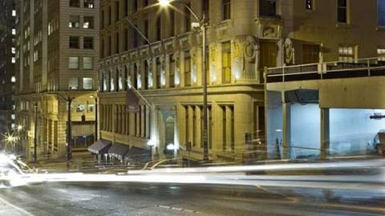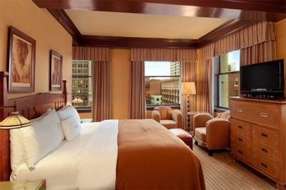
700 3rd Avenue at Cherry, Seattle, WA 98104
(206) 340-0340
http://thearcticclubseattle.com/

Renaissance Seattle Hotel (3 blocks)
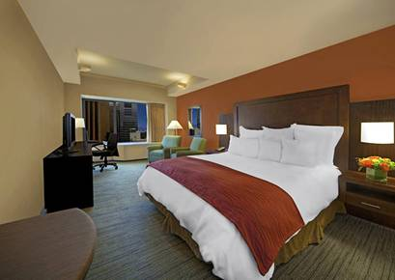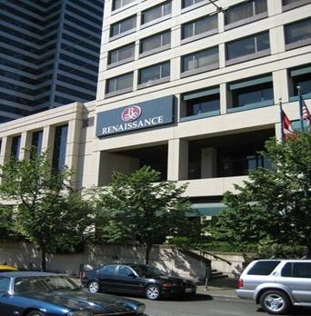

515 Madison Street, Seattle, WA 98104
(206) 583-0300 – (800) 546-9184 – (206) 447-0992 (Fax) ‎
marriott.com

Courtyard by Marriott Seattle Downtown/Pioneer Square (3 blocks) 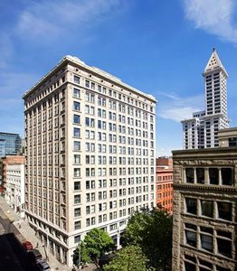 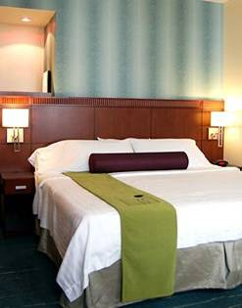
612 2nd Avenue, Seattle, WA 98104
(206) 625-1111
courtyardpioneersquare.com

Hotel Vintage Park (4 blocks) 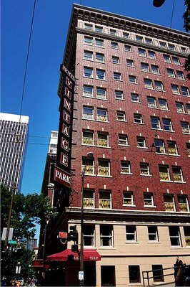 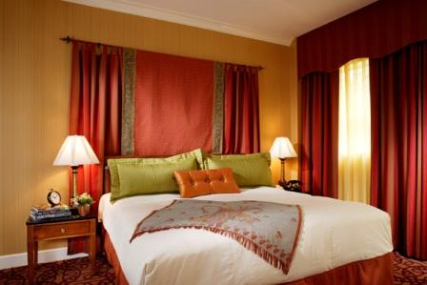
1100 Fifth Avenue, Seattle, WA 98101
(206) 624-8000 ‎
hotelvintagepark.com

The W Seattle Hotel (4 blocks) 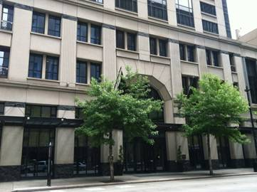 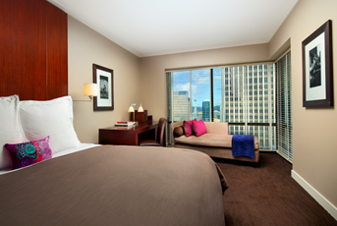
1112 Fourth Avenue, Seattle, WA 98101
(206) 264-6000 ‎
starwoodhotels.com

Hotel Monaco Seattle (5 blocks)
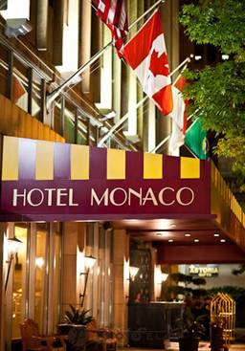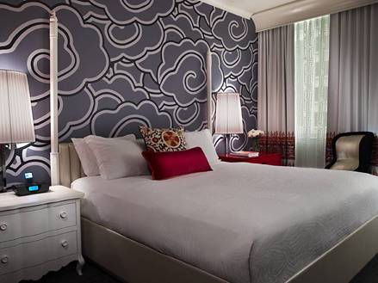
1101 4th Ave, Seattle, WA 98101
(206) 621-1770
monaco-seattle.com

Crowne Plaza Hotel Seattle (5 blocks) 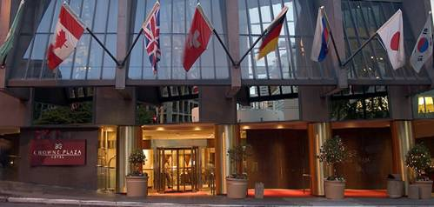 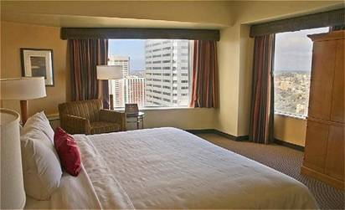
1113 Sixth Avenue, Seattle, WA 98101
(206) 464-1980 ‎
cphotelseattle.com

Hilton Seattle Hotel (6 blocks) 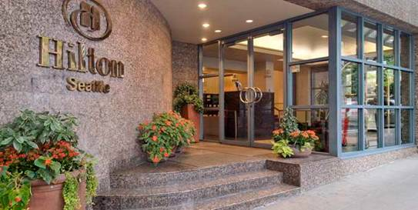 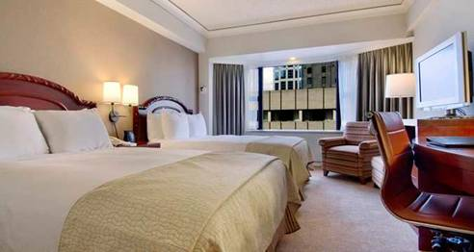
1301 6th Avenue, Seattle, WA 98101
(206) 624-0500 ‎
hilton.com

Fairmount Olympic Hotel (7 blocks)
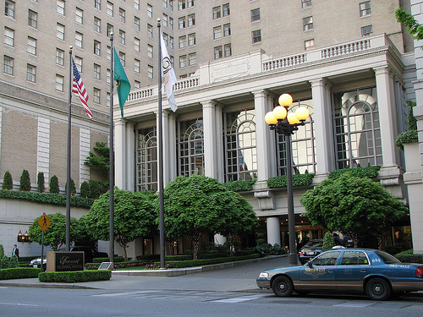
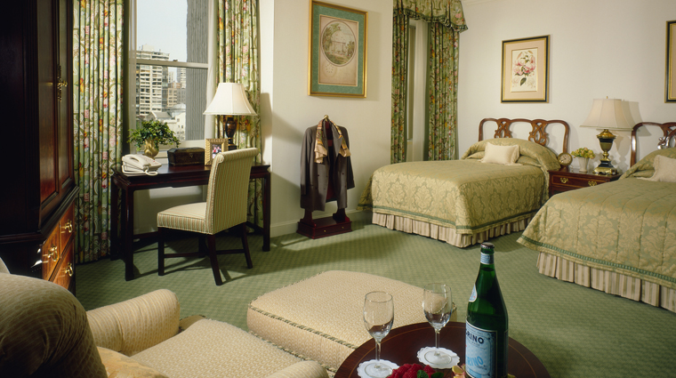
411 University St, Seattle, WA 98101
(206) 621-1700
http://www.fairmont.com/seattle/

Red Lion Hotel (7 blocks) 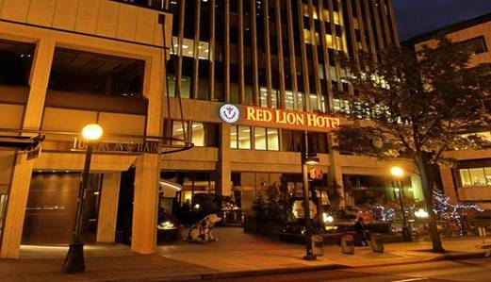 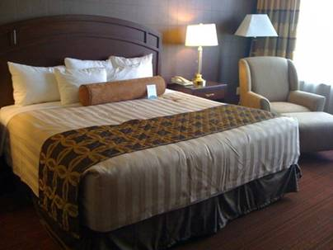
1415 5th Avenue, Seattle, WA 98101
(206) 971-8000 ‎
seattleredlionfifthavenue.com

Hotel 1000 (7 blocks)
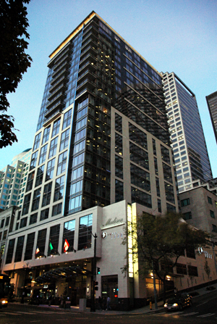
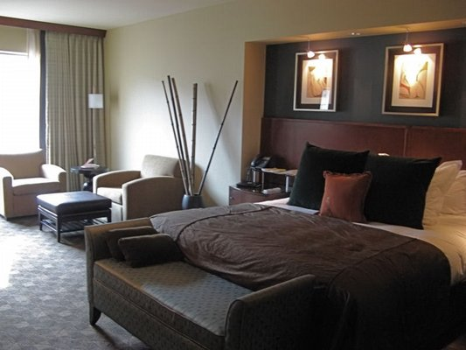
1000 1st Ave Seattle, WA 98104
(206) 957-1000
http://www.hotel1000seattle.com/

Alexis Hotel (7 blocks)
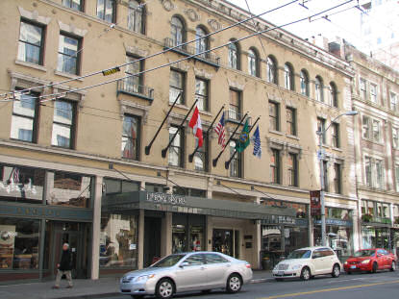
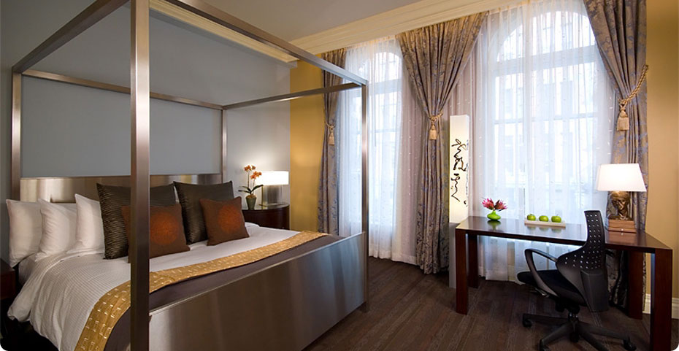

1007 1st Ave Seattle, WA 98104
(206) 624-4844
http://www.alexishotel.com/

Sheraton Seattle Hotel (8 blocks)
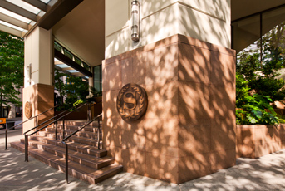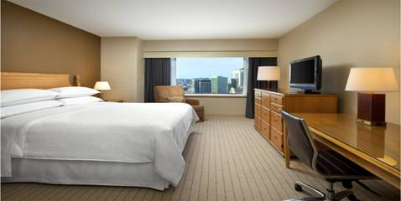
1400 Sixth Avenue, Seattle, WA 98101
(206) 621-9000 ‎
starwoodhotels.com

Sorrento Hotel (8 blocks)
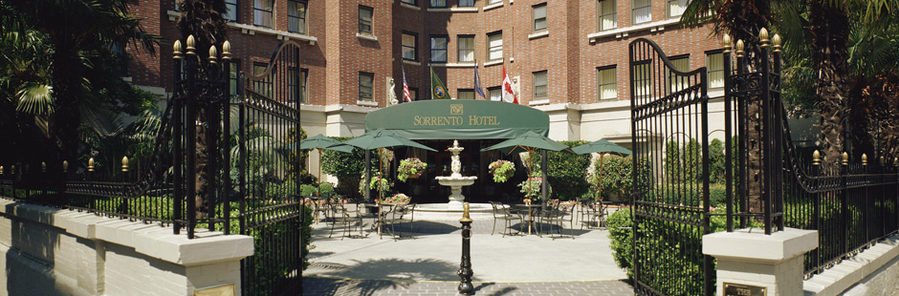
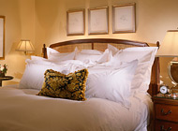
900 Madison St Seattle, WA 98104
(206) 622-6400
http://www.hotelsorrento.com/

Panama Hotel (9 blocks)
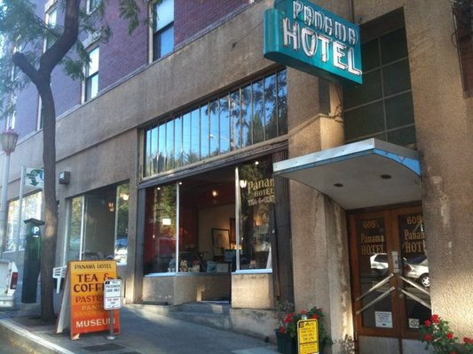
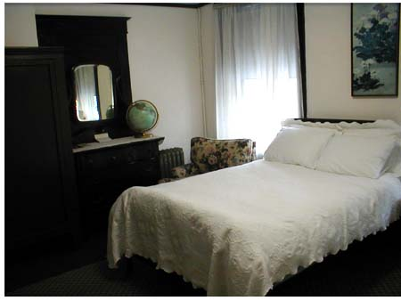

605 1/2 S Main St Seattle, WA 98104
(206) 223-9242
http://www.panamahotelseattle.com/

Roosevelt Hotel (10 blocks)
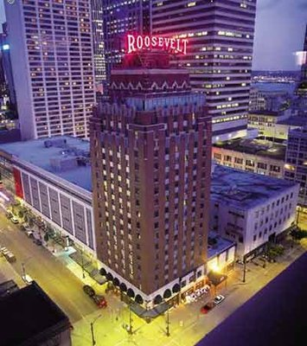
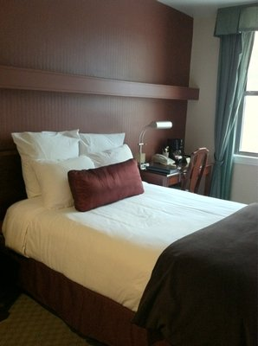

1531 7th Ave Seattle, WA 98101
(206) 621-1200
http://www.coasthotels.com/hotels/washington/seattle/the-roosevelt/rooms/

