Framework for Integrated Demand Response (DR) and Distributed Energy Resources (DER) Models

Version: Draft v1.0
Draft Release Date: September. 25th, 2009

Acknowledgements

Authors of this paper wish to thank NASEB, UCAIug OpenSG and its members to provide resources and support for this work. In alphabetical order, the following individuals and companies have made significant contributions to this document:

- Albert Chiu, PG&E, AKC6@pge.com
- Ali, Ipakchi, OATI, Ali.Ipakchi@oati.net
- Angela Chuang, EPRI, achuang@epri.com
- Bin Qiu, ESO-Global, Bin.Qiu@eso-global.com
- Dick Brooks, ISO-NE, rbrooks@iso-ne.com
- Edward Koch, Akuacom, ed@akuacom.com
- Joe Zhou, Xtensible Solutions, jzhou@xtensible.net
- Mary K. Zientara, Reliant, MZientara@reliant.com
- Phillip R. Precht, Constellation Energy, Phillip.R.Precht@Constellation.com
- Robert Burke, ISO-NE, rburke@iso-ne.com
- R. Scott Crowder III, GridPoint Inc, SCrowder@gridpoint.com

Document History
Revision History

Revision Number | Revision Date | Revision  By | Summary of Changes | Changes marked
0.1 | 9/2/2009 | Joe Zhou | Developed first draft outline of the document | No.
0.2 | 9/3/2009 | Joe Zhou | Outline updated and assignment of sections to team members | Yes
0.3 | 9/10/2009 | Joe Zhou, Ali, Ipakchi, Bin Qiu, Dick Brooks, Robert Burke, Scott Crowder, Mary Zientara, Albert Chiu | Content added to sections 1, 2 and 3. | No.
0.4 | 09/22/2009 | Joe Zhou, Ali, Ipakchi, Bin Qiu, Dick Brooks, Robert Burke, Scott Crowder, Mary Zientara, Albert Chiu, Ed Koch, Angela Chuang, Phil Precht. | Expanded content throughout the document. | No.
1.0 | 09/25/09 | Joe Zhou, Ali, Ipakchi, Bin Qiu, Dick Brooks, Robert Burke, Scott Crowder, Mary Zientara, Albert Chiu, Ed Koch, Angela Chuang, Phil Precht. | First complete draft of the document, available for NAESB Smart Grid Task Force review and comments. | No.
Contents
1. Executive Summary 7
2. Introduction 8
2.1 Purpose 9
2.2 Scope 10
2.3 Assumptions 10
3. Current and Future State of DR and DER 11
3.1 Overview of North America Electricity Wholesale and Retail Markets 11
3.2 DR Overview and Problem Statement 17
3.2.1 What is Demand Response? 17
3.2.2 Major Categories of Demand Response Programs 18
3.2.3 What is a Distributed Energy Resource? 21
3.3 Customer and Service Provider Profiles 23
3.3.1 Customer Profiles 23
3.3.2 Customer Energy Management 24
3.3.3 Service Providers 26
3.3.4 Modes of Interaction 26
4. DR and DER Business Models 28
4.1 Market Types, Domains, Business Entities, and Business Functions 28
4.1.1 Market Types 28
4.1.2 Domains 29
4.1.3 Business Entities 30
4.1.4 Business Functions 31
4.2 DR/DER Business Context 32
4.2.1 Regions with No Open Wholesale and Retail Market 32
4.2.2 Regions with No Wholesale Market but With Retail Competition 34
4.2.3 Regions with Wholesale Markets but No Retail Competition 36
4.2.4 Regions with Open Wholesale Market and Retail Competition 38
4.3 DR Use Case Classification 40
4.4 Use Case Cross Cutting Issues 41
4.5 High Level Business Requirements 41
5. Integrated DR and DER Architecture Considerations 43
5.1 Guiding Principles 43
5.2 Reference Architecture 45
6. Appendix 47
6.1 Demand Response Program Examples 47
6.1.1 Wholesale Market Type Programs - NYISO 47
6.1.2 Retail Type Programs - Baltimore Gas and Electric Company (BGE) 50
6.1.3 Central Registration Agent Type Programs - ERCOT 52
6.2 Reference Documents 54
6.3 Reference Materials 55
6.4 Abbreviations 55
6.5 Terms and Definitions 58
Figures & Tables
Figure 1 – US Electric Power Regulatory Structure 11
Figure 2 - ISO/RTOs in North America 12
Table 1 - Demand Response Participation in ISO Markets 13
Table 2 – Tariff Rate Structures for DR Purposes 16
Table 3 – Customer Incentive Based DR Programs Categorization 20
Table 4 – Customer Type DR Participation Characteristics 24
Figure 3 – Energy Management Activities within the Customer Domain (courtesy of DRRC, LBNL) 25
Figure 4 - Smart Grid Domains 29
Figure 5 - Business Context for No Open Market 32
Figure 6 – DR Information Flow for Regions with no Open Wholesale and Retail Market 33
Figure 7 - Business Context for Open Retail Market Only 34
Figure 8 – DR Information Flow for Regions with no Wholesale Market but Retail Competition 35
Figure 9 - Business Context for Open Wholesale Market Only 36
Figure 10 – DR Information Flow in Regions with Wholesale Markets but no Retail Competition 37
Figure 11 - Business Context for Open Wholesale and Retail market 38
Figure 12 – DR Information Flow for Regions with Wholesale Market and Retail Competition 39

Executive Summary

This document addresses the business objectives and context for standardizing control and pricing signals for Demand Response (DR) and Distributed Energy Resources (DER) as part of the Smart Grid implementation, which is called for by NIST Priority Action Plan 03 and 09. The NAESB Smart Grid Task Force and UCAIug OpenSG task forces took the responsibility of consolidating and developing DR use cases that provide requirements for developing DR control and pricing signal standards. The first step of use case development is this Framework for Integrated DR and DER Models that provides an overall business context.

The key subjects and findings of this document are:
- DR signals standardization must support all four market conditions, i.e. regions with or without either wholesale or retail open competition. It must also consider key differences that exist and will continue to exist in all four market types.
- Wholesale market DR and pricing signals have different characteristic than retail market DR and pricing signals, although commonality in format may be developed.
- Most customers (with a few exception of C&I customers) will not interact directly with wholesale market when it comes to DR and Pricing signals.
- Retail pricing models is complex due to the large variety of tariff rate structures that exist in both regulated and un-regulated markets. Attempts to standardize DR control and pricing signals must not hinder regulatory changes or market innovations when it comes to future tariff or pricing models.
- New business entities (Energy Service Providers, Curtailment Service Providers (DR Aggregators), Energy Information Service Providers) will play an increasing role in DR implementation.
- DER will play an increasingly important role in DR, yet tariff and/or pricing models that support DER’s role in DR are still in its infancy.
- Customer’s perspective and ability to react to DR control and pricing signals must be a key driver to the development of DR standards.

Overall, this framework document provides the necessary business context and reference architecture for the on-going standards development effort around Demand Response.

Introduction
To accelerate the development of standards for Smart Grid Interoperability, the National Institute of Standards and Technology (NIST) is working with all stakeholders of Smart Grid and has developed a set of Priority Action Plans (PAP). A number of PAPs (03, 04, and 09) are related to the use of Smart Grid technologies to enable Demand Response (DR) and integration of Distributed Energy Resources (DER) for DR purposes.

Specifically for PAP09, North America Energy Standards Board (NAESB) and UCA International Users Group (UCAIug) Open Smart Grid (OpenSG) subcommittee took the responsibility to collect, analyze, and consolidate use cases and develop Unified Modeling Language (UML) based use case models for Demand Response. Such responsibility now falls under the NASEB Smart Grid Task Force and UCAIug OpenSG SG-Systems task forces.

It is determined by the first joint meeting between NASEB Smart Grid Task Force (SGTF) and OpenSG in Dallas on September 2nd, 2009 that an overarching framework is needed to provide context and guidance for the subsequent business requirements and technical specification work for DR and DER integration. This is particularly needed at this point in time because:

- Demand Response touches all aspects of the Smart Grid domains and users, therefore its use cases must be developed from end-to-end, i.e. from generation to delivery to consumption.
- Distributed Energy Resources (DER) are relatively new to the power industry and where/how they could impact the deployment DR needs to be carefully examined.
- There are a number of existing bodies of work related to DR and pricing, and all of which have been successful in their own right. However, each of them has been focused on a particular market segment, and challenges remain when trying to combine these into a cohesive set of end-to-end use cases; especially when one takes into consideration differences between wholesale and retail markets and jurisdictions with or without open wholesale and/or retail competition.
- There is also lack of shared understanding and documented work on the transition and integration from wholesale to retail markets when it comes to DR and pricing models.

Therefore, it is the objective of this document to provide a contextual framework for Demand Response that includes how DER could support DR. Such framework will be used to govern and prioritize the subsequent use case and requirements analysis work for PAP9 and to provide reference to other relevant PAPs within the NIST roadmap. It will also serve as a business framework for relevant work within NAESB and UCAIug OpenSG task forces.

Purpose
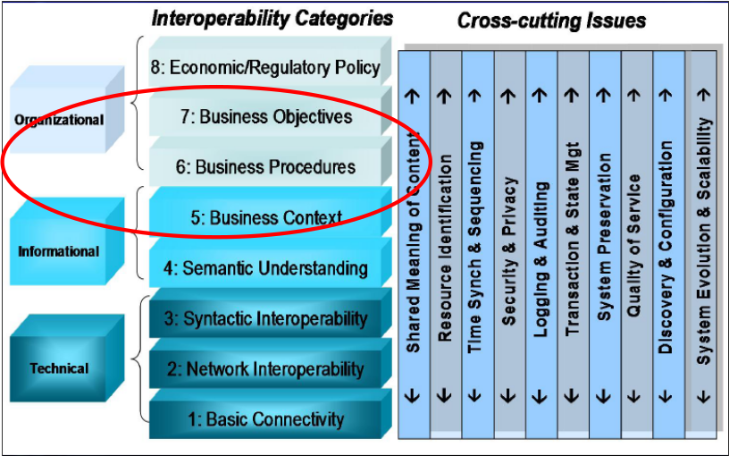
NIST Smart Grid Interoperability Roadmap leverages the GridWise Architecture Council (GWAC) interoperability framework, as illustrated in the figure on the right. This framework calls for the establishment of business objectives, procedures and context before technical interoperability standards can be established. To apply this framework to the development of interoperability standards for DR Signals, it is clear that the industry needs an overarching business framework to guide the development of technical standards, given the complexity and range of DR programs.

The purpose of this document is to provide standards developers with a context for understanding the range of scenarios which Demand Response programs and Distributed Energy Resources may be applied and implemented across the various electricity systems and jurisdictions in the United States of America with some overlaps to Canada. Each scenario will be documented using formal “use case” descriptions. A major objective in producing this document is to emphasize the importance of interoperability at all levels of the Gridwise Architecture Council Interoperability Framework.
Distributed Energy Resources are small, modular, energy generation and storage technologies that provide electric capacity or energy where it is needed. DER may be either connected to the local electric power grid (e.g. for voltage support) or isolated from the grid in stand-alone applications, such as part of a MicroGrid. However, for the purpose of this document, the scope of DER applications will be limited to the context of grid-connected DR use cases and does not include the other possible applications of DER.

Energy efficiency programs and DER programs have similar goals: reducing energy demand by using improved technology or control strategies. However, energy efficiency programs make permanent changes to the equipment or process they target; thus reducing energy consumption whenever the equipment or process operates. In contrast, DER programs make temporary changes in the way equipment or processes operate. These changes in operation are under active control by a human operator or automation system. This document and standard are focused only on DER programs.
Although gaps and/or requirements identified in this document and subsequent use case analysis effort may provide materials for future regulatory considerations that may result in new market policies at both wholesale and retail levels, this effort is not about making direct recommendations to create new products or services to enable Demand Response. This effort focuses exclusively on providing a framework to describe DR programs that are known to this industry today and in the near future, so that the relevant standards thereafter can readily support today’s needs and allow for a smooth transition into the Smart Grid of the future.

Scope
This document covers the current and future state of Demand Response integration and a framework for integrating logical components of the Demand Response to achieve its desired objectives.

This document is organized into five main sections, listed and described below.
- Section 1: Executive Summary
- Section 2: Introduction
- Section 3: Current and Future State of DR and DER
- Section 4: DR and DER Business Models
- Section 5: Integrated DR and DER Architecture Considerations
- Section 6: Appendix

Assumptions
The document is developed with the consideration of following key assumptions:
- The market focus of this framework is the power industry in United States of America with some overlaps to Canada, although much of the business models and practices may apply to other countries and markets.
- The scope of DER applications will be limited to the context of grid-connected DR use cases and does not include the other possible applications of DER.
- The focus of the framework is business level and abstracted models of DR and DER, not specific technologies that enable DR/DER implementation.

Current and Future State of DR and DER

Overview of North America Electricity Wholesale and Retail Markets
In the United States, the regulation of electric power services is divided between wholesale services and retail services. Wholesale services are regulated at the federal level by the Federal Energy Regulatory Commission (FERC), covering wholesale generation, inter-state transmission, and wholesale energy markets. The wholesale energy market structure, its products and prices, as well as the operation of independent system operators and regional transmission organizations (ISO/RTO) are subject to the FERC regulations. The exception to this is the Electric Reliability Council of Texas (ERCOT), which is regulated by Public Utility Commission of Texas.
The policies for ensuring the reliability of the transmission grid are established and enforced by the North American Electric Reliability Corporation (NERC) and its eight regional entities. This includes developing and enforcing reliability standards, e.g., scheduling interchange transactions etc.
Retail energy services, i.e., services provided directly to end-use energy customers are subject to state and regional regulations. Investor-owned utilities (IOUs) are regulated by the Public Utility Commission (PUC) of each state they provide services to. As a general rule, a PUC has the authority to establish the retail rates and tariff provisions (unless those services are competitive), oversee service reliability, approve plans for new energy facilities, such as generation resources and transmission and distribution lines, and establish standards, practices, and policies. Municipal and cooperative energy utilities, i.e., public utilities are typically regulated by the municipal governments and by boards made up of members of each cooperative, respectively. Municipal and cooperative utilities can elect to be subject to oversight by the regional PUC.

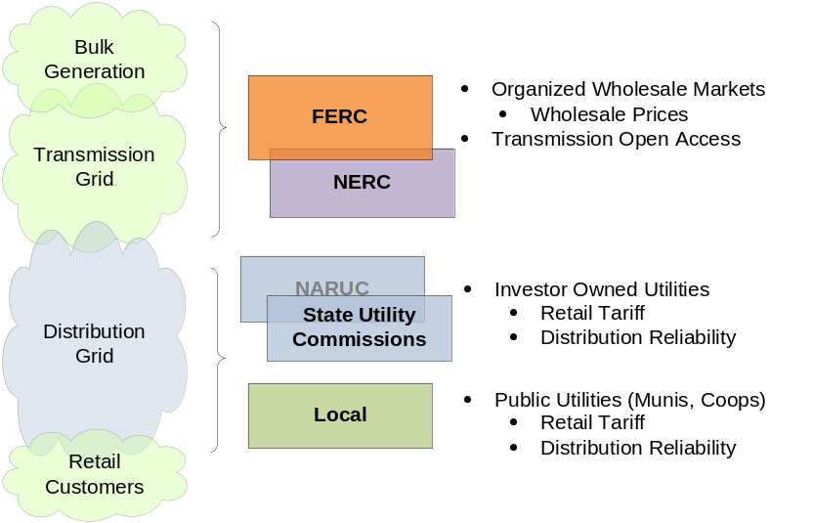
Figure 1 – US Electric Power Regulatory Structure

In the 1990s, as states and regions within the United States established wholesale competition for electricity, groups of utilities and their federal and state regulators began forming independent, unbiased transmission operators to ensure equal access to the power grid for new, non-utility competitors. Today, as shown in Figure 2, in the United States, seven Independent System Operators and Regional Transmission Organizations (ISO/RTOs) in the United States and two in Canada coordinate reliable power grid operations for two-thirds of its population and two-thirds of its electric generation,.
ISO/RTOs provide non-discriminatory transmission access and organized wholesale markets for electricity and ancillary services to facilitate competition among wholesale suppliers. The ISO/RTOs schedule the use of transmission lines and manage transmission congestion with locational pricing signals. They also provide for transactions settlement, billing and collections, and risk management.

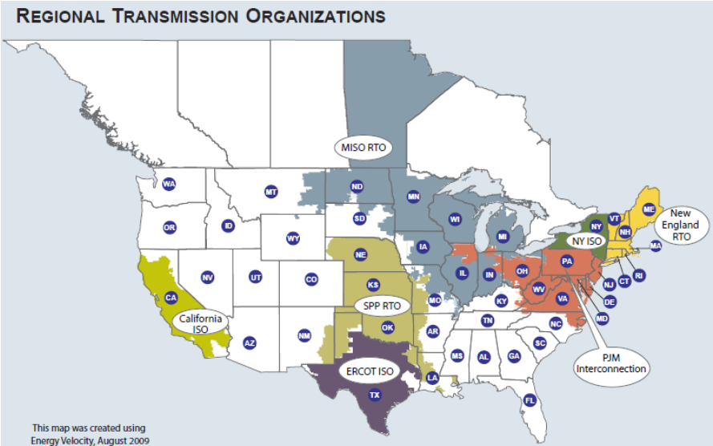

Figure 2 - ISO/RTOs in North America

The typical products scheduled and cleared by the organized wholesale markets (ISO/RTO) include day-ahead and real-time energy, ancillary services including reserves (spin and non-spin) and regulation, as well as capacity requirements.
ISO/RTOs also play an important role in development of Demand Response markets. ISO/RTO markets typically include demand side bidding, i.e., market participants are paid to reduce demand. Demand Response bids are very important during peak periods of electricity which is often cleaner and a more economical solution than building more power plants. Currently, most ISO/RTOs allow demand-side resources to participate in some of the available markets – See Table 1 below and Appendix 1.1 (IRC DR Matrix).

Table 1 - Demand Response Participation in ISO Markets
Product |  | ISO-NE | NYISO | PJM | MISO | ERCOT | CAISO | SPP
Capacity |  | RTDPR, RTEG, OP and SP | Installed Capacity Special Case Resources (Capacity Component) | Full Emergency Load Response (Capacity Component) | Load Modifying Resource | Emergency Interruptible Load Service
Energy | Day Ahead Energy | Day-Ahead Load Response Program for RTDRP & RTPR | Day-Ahead Demand Response Program | Economic Load Response | DRR-I, DRR-II |  | Participating Load Program | Variable Dispatch Demand Response
Energy | Real Time Energy | Real Time Price Response Program | Emergency Demand Response Program, SCR | Emergency Load Response - Energy Only | Emergency Demand Response
Ancillary  Services | Reserves | Demand Response Reserves Pilot | Demand Side Ancillary Services Program | Economic Load Response | DRR-I, DRR-II | LaaR / NSRS, RRS, CLR, UFR | Participating Load Program
Ancillary  Services | Regulation |  | Demand Side Ancillary Services Program | Economic Load Response | Demand Response Resource Type-II | Controllable Load Resources providing Regulation Service

The FERC Order 719-A issued on July 16, 2009, was aimed at improving the operation of organized wholesale electric markets, especially in the area of Demand Response and provision of ancillary services. The order seeks to improve wholesale markets by establishing a more forceful role for Demand Response by directing RTO/ISOs to:

- Permit aggregators to bid Demand Response on behalf of retail customers directly into the market, i.e., allow curtailment service providers to participate in wholesale markets
- Accept bids from Demand Response resources for ancillary services comparable to any other ancillary service capable resource, e.g., central generation.
- Allow Demand Response units to specify limits on frequency, duration, and the amount of their service in bids to provide ancillary services.
- Assess, through pilot projects, the technical feasibility and value to the market of using ancillary services from small Demand Response units.
- Study and report on reforms needed to eliminate barriers to Demand Response in energy markets.
On September 17, 2009, FERC laid the groundwork for further expanding the use of demand response in organized wholesale markets by issuing a Proposed Notice of Rulemaking (NOPR) to incorporate business practice standards adopted by NAESB for measuring and verifying the performance of demand response services. The standards - for energy services, capacity services, regulation services and reserve services - categorize these services, and require system operators to publish details of how they will measure and verify their performance.
The initial standards establish a template for a system operator to disclose how it measures the performance of the demand response services in how much they reduce electricity load, how long it takes for them to reach their load reduction goals, the length of time those load reductions were sustained and whether those measurements meet market operators' standards.
The NERC states that “Demand Response has an important role to play as we move into the carbon-free fast lane. Nearly 30 states over 4 provinces have Renewable Portfolio Standards in place in one form or another. Initiatives are also on the table in Washington and throughout the Canadian provinces to address climate change more specifically. Expectations are rising that the electric industry in North America will begin to reduce carbon emissions and integrate higher percentages of renewable resources into its generation mix over the coming years.
But renewable resources, especially variable generation, often need a “dancing partner,” a resource that can complement increasing penetration of wind and solar and provide operational flexibility to maintain reliability during the sharp down-ramps that can be experienced with these resources.
Demand Response has many qualities that make it particularly well-suited to play this role – and, indeed, we are already seeing it step on to the dance floor, so to speak. In addition to its ability to target peak demand growth, communications technologies have made the resource more dispatchable than ever before, in many cases available to operators in a matter of minutes.
In fact, Demand Response is increasingly being classified as non-spinning reserves and used as “ancillary services” by many utilities. Our data collection defined this as: demand-side resource displacing generation deployed as operating reserves and/or regulation. Use of Demand Response as spinning reserves indicates that operators are beginning to count on the resource with more certainty and that the programs are available to operators within strictly defined time-windows.”

In reference to the recent FERC report to Congress titled “A National Assessment of Demand Response Potential”, FERC Chairman Commissioner Jon Wellinghoff stated: “As the staff reported, barriers remain to achieving the Demand Response potential estimated in this report. We will be addressing those barriers in the second stage of fulfilling the charge given to us by Congress. Following this Assessment, FERC is required to develop a National Action Plan on Demand Response that, will: (1) identify requirements for technical assistance to the states to allow them to maximize the Demand Response, (2) develop or identify tools, information and other support materials for use by states, consumers, Demand Response providers and utilities, and (3) develop a national Demand Response communications program. FERC is then required, together with the Secretary of the Department of Energy, to submit to Congress a proposal to implement the Action Plan.”

End-use customers can be categorized into wholesale and retail customers. Wholesale customers, e.g., large industrial facilities, are directly connected to the transmission grid and are subject to wholesale markets and prices. Retail customers are served at distribution voltage levels, and are subject to retail tariffs that are regulated under state PUC or the regional regulatory authorities. A retail tariff establishes the prices paid for the services received, and is based on a variety of factors including wholesale prices, quality and type of service and costs associated with distribution grid infrastructure and operation.
In the retail market, many states have yet to permit retail competition. Even in those states where retail competition is permitted, some Distribution Companies continue to provide only regulated services. As a result, there are four distinct types of retail service being provided:
- Fully vertically integrated regulated distribution and energy where the Distribution Company owns the generation, supplies firm requirements to all its customers, and provides regulated distribution service.
- Vertically integrated regulated distribution and energy, but competitive supply permitted where, although the Distribution Company owns generation, third-party suppliers are permitted to supply customers within the Distribution Company’s service territory. The Distribution Company provides regulated distribution service. Obviously, this is a very rare situation.
- Divested generation and regulated distribution with no competitive supply where the Distribution Company has divested its generation, but purchases all the energy to provide full requirements to its customers while still providing regulated distribution service.
- Divested generation and fully open competitive supply where the Distribution Company has divested its generation, permits third-party suppliers to supply energy to customers, purchases energy and provides Provider of Last Resort service, and provides regulated distribution service.
Retail customers are typically categorized into Commercial and Industrial (C&I) and Residential customers classes. C&I customers are typically under a tariff rate schedule different than the residential customers. Regulators are usually reluctant to remove price protections for small customers. Multiple tariff rate schedules may be available for each customer class, including fixed, tiered, Time-based (e.g., Time-of-Use, Critical Peak Pricing, Peak Time Rebate, etc.), market-based (e.g., Dynamic tariff, real-time pricing, etc.), service-based (e.g., interruptible, etc.).
Electricity rate design process involves balancing multiple objectives, such as recovery of utility revenue requirements, fair apportionment of costs among customers etc. Electricity rate structures also influence customer energy consumption, and thus play an important role to encourage the adoption of Demand Response programs. Also, in support of Distributed Energy Resources (DER), various regions have adopted Net Metering and Feed-in Tariff to account for on-site generation and support deployment of distributed renewable resources. In addition, Standby Services have also been implemented to provide back-up for the generation and to encourage the installation of DER.
The main electricity tariff rates available in the regulated and de-regulated markets that can be used for Demand Response Programs are listed in Table 2. Note there might be additional rate structures that will apply to specific Distributed Energy Resources as more DER capabilities are implemented.
A retail electricity market exists when end-use customers can choose their supplier from competing electricity retailers, or in other words, have “direct access” to competing suppliers. In regions with retail competition, energy rates and prices paid by customers are determined through competitive market mechanics with agreed upon retail contracts. {Note, a table of retail contract types could be added}. Energy Service Providers in NYISO, defined various rate structures, such as the integrated variable energy rate products based on energy market prices (Day ahead or real time), Month or spot auction price, peak demand contribution, reserve margin, capacity cost, ancillary cost etc. The prices may vary for different zone, service classes or customer groups.

Table 2 – Tariff Rate Structures for DR Purposes
Tariff Rate Type | Target Customers | Description
Block Rate | C&I, Residential | A rate structure where per unit energy prices vary for each successive block of energy consumed.
Critical Peak Price (CPP) | C&I, Residential | A rate structure that includes critical peak periods to be designated by the utility. Unlike TOU rates, the critical peak periods are not designated in the tariff, but are designated on relatively short notice, up to a limited number of days per year.
Demand Rate | Mainly for C&I customers, Pilot for Residential customers | A rate structure that includes a per kW charge based on maximum demand for electricity served to the customer.
Day Ahead Market Rate (DAMP) | C&I, Residential | Rate structure that is similar to real time pricing, with the prices determined day ahead
Market Clearance Price for Energy (MCPE) | C&I, | The MCPE price for energy is a variable rate structure that allows for price changes every 15 minutes.  Note: MCPE is the bare bones price that Texas companies generally use to fashion a custom tailored contract when they are buying their energy in large blocks.
Peak Time Rebate (PTR) | C&I, Residential | Incentive rate in which the utility pays customers to reduce demand during peak periods on critical days
Real Time Rate (RTP) | C&I, | A rates structure in which prices can vary continuously over time. E.g. NYISO real time prices are calculated at five-minute intervals throughout the day based on generation and energy transaction bids that were offered to the NYISO.
Time of Use (TOU) Rate | C&I, Residential | A rate structure where the amount charged per unit (kWh or kW) varies according to the time of day of electricity consumption. Utilities can set up TOU rates based on Time of day, Seasons of the year, Holidays, etc. and include different tiers (such as On Peak, Off Peak, Mid Peak)
Variable Peak Pricing (VPP) | C&I  Residential | A rate structure that allows customers to purchase their generation supply from service provider at prices set on a daily basis, under the VPP program, the on-peak price for each weekday will be available the previous day.

.

DR Overview and Problem Statement

What is Demand Response?
Demand response (DR) is a dynamic change in electricity usage coordinated with power system or market conditions. The response or change in usage is facilitated through demand response programs designed to coordinate electricity use with electric system needs. From a grid operator’s perspective, demand response appears as a net reduction or increase in grid-supplied electric services. Demand response is achieved through application of a variety of demand response resource types. Resource types include distributed generation, dispatchable load, storage, and other resources that are capable of supporting a net change in grid-supplied power.
Although grid operators may also manage resources located along the distribution system or at substations, demand response (DR) more commonly involves customers changing their consumption of electricity in response to supply conditions. For example, demand response programs may encourage electricity customers to reduce their consumption at critical times or in response to market prices (and other scenarios outlined in section 3.3 of this document). Demand Response systems respond to explicit requests to alter consumption. Demand Response can involve actually curtailing power used or by starting or increasing the output of onsite generation which may or may not be connected in parallel with the grid.
Demand response programs often utilize mechanisms to encourage consumers to reduce demand, thereby reducing the peak demand for electricity. Since electrical systems are generally sized to support peak demand (plus a margin for forecasting error and unforeseen events), lowering peak demand reduces overall plant and capital cost investments. Depending on the configuration of generation capacity, however, demand response may also be used to increase demand (load) at times of high production and low demand. Some systems may thereby encourage energy storage during periods of low demand or prices and release of that energy during high demand or prices.
While both energy efficiency and Demand Response reduce electricity consumption, they are quite different. Energy efficiency describes a reduction in energy consumption (using less power) to perform the same tasks, on a continuous basis or whenever that task is performed. On the other hand, demand response resources can be coordinated in operational timeframes (e.g., day-ahead and day-of) to balance supply and demand, as needed to support the grid. For example, demand response schemes are implemented with large and small commercial as well as residential customers, often through the use of dedicated control systems to shed loads in response to a request by the Electric System Operator or Program Administrator (an ISO/RTO or local Distribution Company respectively), or market price conditions. Processes or specific equipment (lights, manufacturing or copy machines, air conditioning, etc.) are reduced according to a customer’s preplanned load prioritization scheme when specifically instructed to curtail the load. An alternative to reducing load at a facility is using onsite generation of electricity to supplement the power from the grid. Under conditions of tight electricity supply, Demand Response can significantly reduce the peak price and, in general, free up one MW of electricity for each MW of reduced consumption. Therefore, demand response which targets power reduction (measured in MW) is distinct from energy efficiency which targets energy conservation (measured in MWh).
In the organized markets (wholesale electricity markets), generally the end use customer does not participate directly in the market. An intermediary aggregates these end use customers and presents this aggregated capability to reduce consumption to the organized market. The Federal Energy Regulatory Commission (FERC) refers to these entities as Aggregators of Retail Customers (ARC), and these entities are also called curtailment service providers (CSP) or Demand Response provides (DRP) in the wholesale market place. Local distribution companies (LDC) may also aggregate retail customers for Demand Response and present these curtailments to the wholesale market. The ARC, CPS, DRP and LDC are wholesale market participants and may provide various services to the wholesale market based on the specific market rules.

Major Categories of Demand Response Programs
In retail markets, Demand Response programs can be described using a variety of characteristics (e.g., program objective, incentive structure, actuation method, trigger type, baseline, etc.). Some common examples of demand response programs, which vary by actuation method, include:

- Direct Load Control
- Guaranteed Load Drop
- Firm Service Level; and
- Price-directed Load Reduction

Direct Load Control programs entail the Program Administrator sending a signal to a control device on customer equipment which curtails or interrupts the equipment’s operation. In a Guaranteed Load Drop program, the customer contractually commits to reduce load by a specified amount (e.g. the customer agrees to reduce load by 100 MW upon notice). A Firm Service Level program is similar except the customer contracts to reduce Load to a specified level upon notice (e.g. reduce down to 200 MW). There are many types of Price-directed Load Reduction programs, but they all use changes in prices to encourage customers to reduce Load. Examples are Time-of-Use Rates, Critical Peak Pricing, Peak Time Rebate, etc.
DR is a dynamic change in electricity use coordinated with power system or market conditions. Measuring the change in usage may or may not be required, depending on the particular demand response program in question. Unlike energy efficiency, however, the quantity of demand response is more difficult to estimate. For energy efficiency improvements, such as the replacement of incandescent light bulbs with CFL equivalent light bulbs, the savings in usage can be calculated with reasonable assurance. However, Demand Response involves dynamically altering energy consumption. This can be done for example by reducing cooling levels, increasing temperatures set-points, adjusting brightness of light levels, or shutting off excess equipment (e.g., copiers or computer monitors, etc.), The amount of energy that would have been consumed “but for” such actions can only be estimated. This estimate is generally referred to as the customer Baseline, a critical billing determinant in Paid-for-Performance type demand response programs.
There are many different methods for developing customer Baselines. A summary of those methods used in the organized wholesale electricity markets can be found in North American Wholesale Electricity Demand Response Program Comparison. For the wholesale market, standards for the determination of Baselines are found in NAESB’s Wholesale Electric Demand Response Measurement and Verification Standards. For the retail market, standards are found in the Retail Electric Measurement & Verification (M&V) of Demand Response Programs Model Business Practices. Although baseline determination is not required for all types of demand response programs, ISO/RTO programs are generally designed to compensate demand response participants and therefore do require the calculation of baselines.
The ISO/RTOs operate wholesale electricity markets. The DR programs for the wholesale electricity markets can be grouped by program objective or type of response the program is designed to achieve, as follows:
- Price Response (e.g., Dynamic Pricing)
- Reliability Response (e.g., Emergency DR Programs)
- Both Price and Reliability Response (e.g., Ancillary Service)

Distribution/Retail companies operating within retail electricity markets tend to administer DR programs designed to achieve either price or reliability response. However, they may also operate Variable Service Subscription type programs designed to provide premium power or different levels of service by customer subscription, utilizing demand response. Some Variable Service Subscription type programs like Premium Power can be flexibly applied for price and reliability response.
ISO/RTO price response programs are currently designed to induce customers to alter electricity consumption during periods of extreme wholesale market prices. Exactly how periods of high wholesale market prices are defined can vary between markets, but once the high-price trigger is met and the window for interruption is established for reducing electricity consumption, price response participants’ reductions are measured. In general, price response is voluntary and customers are not penalized for inaction. However, they may face a higher cost of electricity if they do not curtail during a price response event.
Emergency response programs are designed to induce customers to reduce electricity usage at times when the bulk electric system or a local area is strained or experiencing a reliability event. Such conditions might occur during periods of extremely high loads or as the result of an unexpected loss of a large generating resource or transmission line. Emergency response is not activated for the purpose of affecting wholesale market energy prices, though such programs may have an effect on resulting wholesale prices. Some wholesale markets have specific rules for netting such effects of demand response on the wholesale market energy price for settlement purposes.
Ancillary services are services procured in wholesale electricity markets in addition to energy. Ancillary services can include 10 minute operating reserves (e.g., synchronize and non-synchronized, or spinning and non-spinning), other types of operating and replacement reserves, and Regulation Service. The specific rules for each of these types of ancillary services procured in competitive electricity markets are defined by the specific wholesale electric markets and are beyond the scope of this document.
Table 3 below categorizes the various types of demand response programs by the motivation for customer engagement used to incent participation. Under Alternative Pricing, rate structures that determine what customers pay for electric service are used to incent demand response. Under Paid for Performance, demand response programs are designed with provisions to pay customers for measured demand response during triggered events (i.e., performance). On the other hand, Public Appeals have also proven effective for inducing voluntary demand response, without financial exchange expected by the customer. Examples of Variable Service Subscriptions also can be found, in which customers are provided with a choice to subscribe to different levels of electric service. Physical delivery or enforcement of the subscribed level of service can involve automated demand response systems, particularly in operating programs with many customers engaged. Each of the program types listed in the table below have been implemented by regional system operators and retail electric utilities. However, in North America, there appears to be a lack of actual implementations of Priority Service, although this program type can be found discussed in the literature. Reference 15 and Section 3.1 describe each of the program types listed under the four major categories in the table.

Table 3 – Customer Incentive Based DR Programs Categorization

Alternative Pricing and Rate Structures  (customer pays more for lack of DR) | Paid for Performance  (customer paid for DR) | Public Cooperation  (no financial exchange for DR) | Variable Service Subscription  (more customer choice using DR)
TOU  Block Rate  Day-ahead market rate  Dynamic Pricing (CPP, RTP, VPP)  Demand Rates | Peak Time Rebate  Regional Operator Economic DR Programs  Demand Bidding for:  Forward Energy  Ancillary Service | Public Appeal for:  Peak Demand Conservation  Voluntary Demand Response (Day-ahead) | Demand Subscription Service  Demand Limiting
Market-clearing price for energy  Discounted Rate for:  Direct Load Control  Interruptible Load  Curtailable Load (FSL, GLD)  Dispatchable Standby Generation | Regional Operator Emergency DR Programs  Interruptible Load  Curtailable Load  Dispatchable Standby Generation  Direct Load Control | Voluntary emergency demand Response  Voluntary emergency standby generation  Pre-planned voluntary interruptible/ curtailable load  Rolling Blackout | Premium Power  Better-Served-for-Performance  (OBMC, PAP)  Priority Service

What is a Distributed Energy Resource?
Besides curtail able end-use loads, demand response resources include Distributed Energy Resources (DER) like distributed generation (DG), storage, and renewable energy resources (RES). Distributed Energy Resources (DER) refers to any energy source located along the distribution system that can produce electricity in coordination fashion in support of grid or market needs. This document addresses resources that can be controlled by the customer or the utility, and thus does not address weather dependent variable resources like PV nor wind generation. Examples of DER within the scope of this document include local battery storage, backup generators, and plug-in electric vehicles.

Customer level DER
Any demand response resource, including DER, located on customer premises (i.e., the customer side of the meter) can be referred to as a demand-side resource. The resource becomes formally recognized when a customer signs up for a specific DR or DER eligible rate or program with a utility or resource aggregator. The program may define one or more of the following:
- What devices or device classes will be controlled?
- Who will control them during an event; the customer or the utility/aggregator.
- How often and how long the duration of triggered event can be
- The maximum and minimum number of events allowed in a given period of time.
- The required response time.
- Minimum and maximum power delivered.
- Other measures
- The signaling protocol and message content.
- Whether or not the program allows emergency as well as pre-scheduled event execution.
Note: this document supports standards development and definition of signaling protocol and message content. This document does not address how to define or administer DER programs.

Plug-in Electric Vehicle DER
Plug-in Electric Vehicles (PEV) present the opportunity for DER whenever they are connected to a Smart Electric Vehicle Service Equipment (SEVSE) station. PEV is another example of a customer level DER resource, but it has unique characteristics to consider including:
- As mobile resources, PEVs can move around the distribution grid within one business’ territory.
- PEVs can also move between different business’ territories.
Note: This standard in concerned with communication and control of SEVSE stations from the premises, aggregator, and grid viewpoint. SAE 1772, SAE J2836, and the ISO/IEC electric vehicle standard groups are developing the standards for communication and control between the SEVSE and PEV.

Distribution level DER
Distribution level DER is concerned with aggregation and control of DER connected at the distribution system level. Scenarios covered include:
- Communicating forecasted availability and capability at various points in the distribution grid.
- Sending event control signals for events at various levels of the distribution grid.
- Communicating result information as an event executes and after completion of the event.
DER can be used to relieve congestion or overload condition on the distribution network. DER can be applied to support customers fed from a particular distribution node by relieving overload on a feeder of the distribution system without incurring the cost of dispatching a DER event across a whole transmission area. DER sited in substations to decrease peak demand can defer substation expansion.

Aggregated DER for Bulk System Support
Aggregating DER up to the bulk level allows DER to be managed as a Virtual Power Plant (VPP). VPPs are defined to contain a single DER program aggregated to the transmission area level. Using VPPs to manage DER has the advantage that VPPs have enough capacity that they can be treated similarly to central generation plants when doing system-wide planning.
Note: this document and standard is concerned with the definition of VPPs and signaling protocols. This document does not address how VPPs should be managed.

Customer and Service Provider Profiles
Within the NIST Smart Grid Conceptual Model there are two classes of entities that may interact with the Utility/ISO for the purposes of DR – Customers and Service Providers. Customers are those entities that consume energy and Service Providers are intermediaries between the Utility/ISO and the Customers that provide a range of services related to DR. When it comes with DR programs, some customers are voluntary while some are mandatory.

Customer Profiles
Customers can be divided into the following categories depending upon the amount of their consumption within their facilities:
- Large Commercial and Industrial (C&I)
- Small Commercial and Industrial
- Fleet PEV
- Residential
- Individual PEV

Large C&I Customers may participate in either wholesale or retail electricity markets and typically have the most sophisticated loads and technologies for controlling the loads within their facilities. Within Commercial facilities the main loads are typically used for the management of the facilities such as HVAC and lighting. In the case of Industrial customers the loads are typically related to manufacturing and process control.
Because of the amount of electricity being consumed by large C&I customers they are more likely to dedicate resources to the management of their consumption. This includes both personnel and equipment. In addition some businesses, such as large chain retailers, may have numerous facilities distributed across broad geographic regions, each dealing with a different electricity supplier. In these scenarios it is not uncommon for these businesses to outsource their facility management responsibilities to a third party that can provide economies of scale and centralized control across all their facilities.
On the other end of the spectrum are Residential Customers that represent relatively small and somewhat limited types of loads. They typically only participate in retail electricity markets and the types of DR programs that are currently most prevalent in the residential domain are direct load control programs such as AC cycling. Residential customers currently do not spend much in terms of either time or money to manage their electrical usage. This is likely to change as newer technologies such as AMI are deployed and standards are developed that facilitate lower cost equipment in the marketplace.
Small C&I Customers are varied and in some cases look more like Residential Customers while in others look more like Large C&I Customers.
PEV has a similar range of electricity consumption and sophistication of control. Fleet PEV operators may have 100s of high capacity PEVs with complex SEVSE systems at their depots. While owners of a small number of typical-sized PEVs will have relatively simple SEVSE, most will likely be at their residence.
Table 4 below shows the typical characteristics of each of these customer types across a number of dimensions that may affect their ability to participate in DR programs and tariffs.
Table 4 – Customer Type DR Participation Characteristics
Customer Type | Existing investment in energy management | Level of energy management expertise | Willingness to invest more in technology for energy management | Willingness to invest more time and/or personnel towards energy management
Large C&I | high | high | high | high
Small C&I | low-med | low-med | low-med | low-med
Residential | low | low | low | Low
Fleet PEV | Low | Low-high | High | High
Individual PEV | Low | Low | Med | low

Customer Energy Management
Figure 3 shows the spectrum of energy management activities within a Customer’s facility and how that relates to DR.
On the left are activities that are performed on a regular basis regardless of whether there are any interactions with a Utility/ISO and are not considered within the realm of DR. These include energy efficiency and management of daily peak usage to minimize their costs as part of a fixed TOU tariff.
Towards the right of the diagram are activities that include some sort of interaction with the grid and are within the realm of DR. This includes real-time pricing, scheduled DR responses such as day ahead DR, and ancillary services including real-time capacity management and frequency regulation.
The financial benefit to Customers of some programs or tariffs such as real-time pricing are only related to the savings they will get from optimizing their consumption against a dynamic rate. Other programs, such as ancillary services, may include an additional payment related to the customer explicitly modifying their load profile in some fashion.

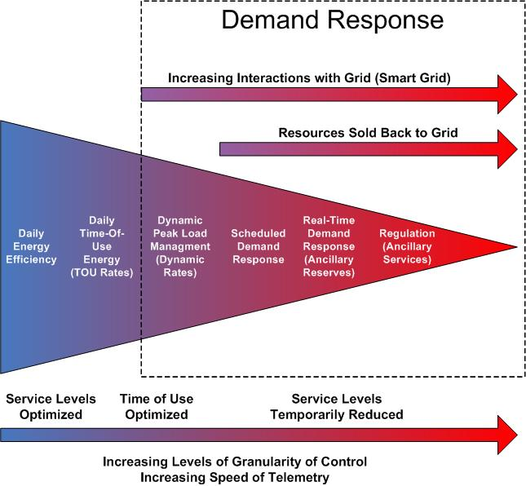
Figure 3 – Energy Management Activities within the Customer Domain (courtesy of DRRC, LBNL)

In general, the latency between the grid interaction and the load management decreases as you move to the right in the diagram while the level of control and instrumentation increases. For example there exist DR programs that notify Customers the day before a DR event and do not require any real time usage feedback during the event. At the other end of the spectrum frequency regulation requires responses of a few seconds from the time of notification and may require telemetry feedback to the ISO with very high sampling rates.
Customers manage their overall load profiles by managing their consumption and bringing DER resources on line. In general the more advanced notice that a Customer receives of an impending DR event the more opportunity they will have to deploy load shifting strategies by modifying the operations schedules or storing energy prior to the event and then using the stored energy during the DR event.
The ranges of control strategies used by customers to react to DR events are broad and depend upon the type of loads and DER at their disposal and the nature of the DR programs they are participating in. In some cases the Utility/ISO may dictate that the Customer’s loads and DER resources are controlled in a particular fashion using a “Direct Load Control” mechanism. In other cases the Customer will have complete latitude in determining how their loads and DER resources are controlled during a DR event and those strategies will be completely instantiated within the facilities control systems.

Service Providers
In general Service Providers are intermediaries between the Utility/ISO and Customers that mediate the interaction between those two parties. In many cases customers only participate in a DR program through an intermediary. This is can be due to a number of reasons including:
- Utility/ISO requires that participation is through an aggregator. This is often because the requirements on the size of the loads being managed form the Utility/ISO point of view dictate that they be of a certain size which is not met by individual facilities. This is especially true in the wholesale market.
- The administrative/financial commitments required to participate in a DR program are more than an individual business is willing to bear.
- The entity that owns the facility does not have the technical expertise or manpower available to enable and monitor their facilities performance during a DR event and are thus willing to outsource that to a third party. This is currently true in larger C&I facilities that hire third parties to manage their facilities, but will also become increasing true for residential customers as they acquire the technology that will enable them to participate in DR programs. In this case the third party may even be the Utility providing the type of services through AMI.

There are three types of Service Providers – Curtailment Service Providers, Energy Service providers, and Energy Information Service Providers.
Curtailment Service Providers (CSP) typically enter into agreements with the Utility/ISO in order to provide the required load profiles during a DR event. This includes aggregators that may aggregate the loads of numerous Customers in order to provide a response that contractually behaves as a single resource from the Utility/ISO point of view. In general all the Customer resources that are aggregated as part of a particular DR program are within the domain of the same Utility/ISO.
On the other hand Energy Resource Providers (ESP) enter into agreements with Customers for the overall management of their energy consumption of which participation in DR programs would be one aspect of that arrangement as well as energy efficiency. The type of agreements may span numerous facilities across wide geographic regions which entails interacting with different Utility/ISO’s.
Energy Information Service Providers (EISP) are an emerging class of service providers that primarily offer interfaces or portals for facility owners to obtain information about their energy usage. This includes information such as current prices as well as historical consumption. These energy information portals could range from web interfaces to some sort of specialized displays within the facility (e.g. in home displays (IHD), or thermostats). Larger C&I customers typically already have access to this type of information so it is anticipated that these services and information will be more relevant to the residential and small C&I customers as access to it emerges.

Modes of Interaction
Customers can participate in a wide range of DR programs. Some of these programs may be voluntary and not require any more interaction with the Utility/ISO than receiving a price signal. Others may require mandatory reductions and require additional interactions with the Utility/ISO to confirm that their load profile is behaving as expected. For example in the NYISO market the Emergency Demand Response Program (EDRP) is a voluntary load curtailment program focuses on large C & I (commercial and industrial) customers. Those customers receive compensation to reduce energy consumption when requested. On the other hand ICAP Special Case Resource (SCR) Program is a mandatory program to large C & I customers. When asked by the NYISO, those customers must curtail energy consumption.

There are a variety of ways in which a Utility/ISO may interact with customers:
- Via an intermediary that aggregates loads (CSP)
- Via an intermediary that manages facilities load profiles (ESP)
- Direct communication with the facility owner/manager (e.g. IHD, emails, phones calls, etc.)
- Communications with facility wide control systems (EMS)
- Direct communications with load or DER resources (e.g. direct load control, prices to devices, etc.)

When the interaction is via an intermediary, that intermediary then accepts responsibility for insuring the Customer’s load profile is affected in the required fashion. The intermediaries may use a variety of means to affect the changes in the load profiles of the Customers in their portfolio ranging from full automation to manual notifications such as emails, phone calls, etc,
In the case where communications is with a facility wide energy management system (EMS) the strategies for determining how to respond to the DR signals may be instantiated within the EMS. This gives the opportunity to Customer to determine how to use their loads and DER resources to affect their overall load profile.
It is possible that the Utility/ISO may interact directly with loads or DER resources, as in the case of price signals, in which the strategy for how the load or DER resources will respond during the DR event is instantiated within the load controller itself. The DR strategy in this case is typically specified by the Customer.
It is also possible that the Utility/ISO may directly control the load or DER resource and specifically specify its state during the DR event. This is referred to as direct load control and the strategy for how the load or DER responds during the DR event is instantiated at the Utility/ISO before the interaction with the load or DER resource takes place.

DR and DER Business Models

Market Types, Domains, Business Entities, and Business Functions
To understand the present and future impact of Demand Response to those that are affected by the implementation of Smart Grid, one must understand the current regulatory, market and business structure of the power industry and project with reasonable certainty its future. While we will not be able to predict exactly how the future would look like, we must develop strategies that would allow us to migrate from where we are today. In the following section, we will provide an overview of current US electric power industry market models, domains of Smart Grid as illustrated from the NIST Smart Grid Roadmap report, types of businesses that will likely to play key roles within the Smart Grid, and key functions that will need to be performed in order to deliver Demand Response.

Market Types
There are currently nine ISO/RTO organizations in North America, namely: Alberta ESO, Ontario IESO, California ISO, MISO RTO, SPP RTO, ERCOT ISO, NY ISO, New England RTO (ISO-NE), PJM Interconnection. While FERC is promoting Standard Market Design (SMD) among existing ISO/RTOs and encouraging other regions of the USA to establish wholesale markets, it is unclear when and how many new ISO/RTOs will emerge in the future. Furthermore, commonality in core market design elements exists in established markets, regional differences still exist when it comes to market design (Nodal vs. Zonal), price (LMP vs. LIP), settlement (two vs. one), transmission rights (financial vs. physical), and other services (capacity, ancillary, etc.)

At the retail level, there are 21 jurisdictions that have open retail market in North America, namely: Alberta Canada, Arizona, California, Connecticut, Delaware, Illinois, Maine, Maryland, Massachusetts, Michigan, New Hampshire, New Jersey, New York, Ohio, Ontario Canada, Oregon, Pennsylvania, Rhode Island, Texas, Virginia, Washington D.C.

Since there are some states that have no open wholesale and/or retail market, it is clear that we have four market types:
- Regions with no open wholesale and retail competition
- Regions with open wholesale market only
- Regions with open retail market only
- Regions with open wholesale and retail competition

Each market type has a different set of regulatory and market dynamics that present different requirements for Demand Response and distributed energy resources.

Domains
NIST Smart Grid Interoperability Standards interim roadmap identifies the conceptual model, see Figure 4.
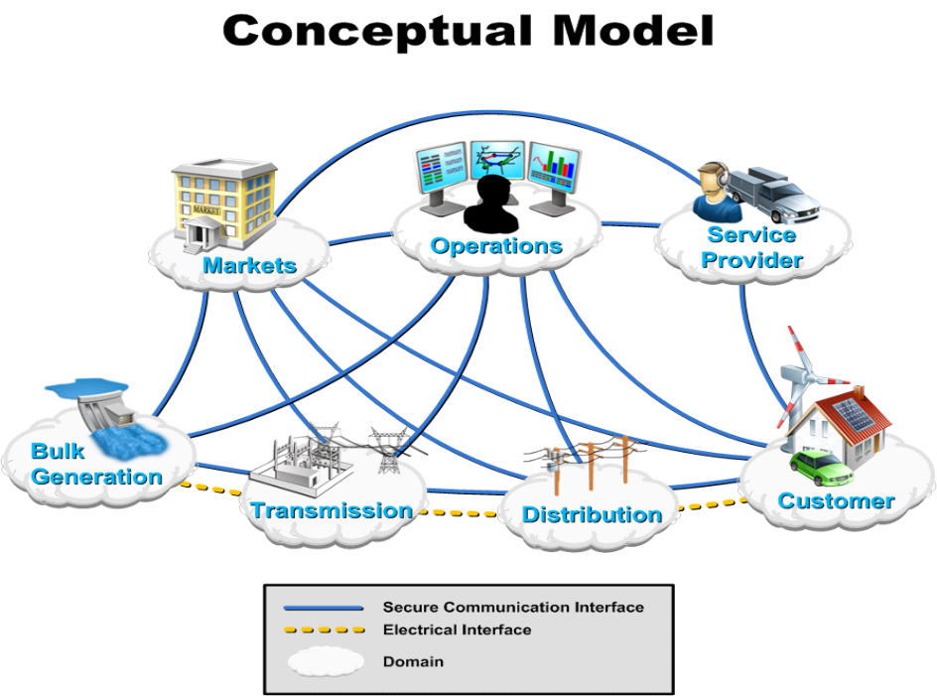

Figure 4 - Smart Grid Domains

The following table provides a modified view of domains of Smart Grid in order to fully support DR and DER business models.

Domain Name | Domain Description
Customers | Any Entity that takes gas and/or electric service for its own consumption. The consumers of electric power. Customers include small to large size commercial & industrial customers and residential customers.
Markets | Power market is a system for effecting the purchase and sale of electricity, using supply and demand to set the price.
Service Providers | An entity that provides electric services to a retail or end-use customer.
Operations | The management of generation, market, transmission, distribution and usage of the electric power.
Generation | The production of bulk electric power for industrial, residential, and rural use. It also includes power storage and distributed energy resources.
Transmission | . Electric power transmission is the bulk transfer of electrical energy, a process in the delivery of electricity to consumers.
Distribution | Electricity distribution is the final stage in the delivery of electricity to end users. A distribution system's network carries electricity from the transmission system and delivers it to consumers
Micro-grid | The local grid for distributed energy resources management and delivery.

Business Entities
The following table provides a list of business and sub-business entities that may participate in the DR use cases.

Business Entities | Sub-Business Entities
ISO/RTOs (Wholesale Market)
Balancing Authority
Regulated Utility
Regulated Utility | Merchant Operation
Regulated Utility | Transmission Operation
Regulated Utility | Distribution Operation
Regulated Utility | Load Service Operation
T&D Service Provider
T&D Service Provider | Transmission Operation
T&D Service Provider | Distribution Operation
Energy Service Providers (ESP)
Demand Curtailment Service Provider (CSP)
Energy Information Service Providers (EISP)
End-Use Consumer
End-Use Consumer | Large C&I
End-Use Consumer | Medium C&I
End-Use Consumer | Small C&I
End-Use Consumer | Residential
End-Use Consumer | Mobile (roaming customer)
End-Use Consumer | Fleet PEV Operator
Merchant Generator
Merchant Generator | Bulk/Aggregated Generation
Merchant Generator | Distributed Generation

Business Functions
The following table provides a list of business functions that may be affected by the DR use cases.

Business Functions | Description | Business Entities | Domains
Facility Energy Management and conservation. | Includes factory, building and others with demand greater than 20KW. | Large or Medium C&I Customers, | Customers
Premise Energy Management and conservation | Includes residential and small business with demand less than 20 KW. | Small C&I and Residential Customers | Customers
Resource and Load Balancing | Balancing resource supply with load demand at the bulk/wholesale level. It includes forecasted or emergency cases. | ISO/RTO, Vertically Integrated Utility | Operations, Transmission.
Power Trading & Settlement | Provides a market for trading and settlement electric power on long term, day-ahead and real time. | Merchant Generator, Large Customer, DR Aggregator, Regulated Utility, ESP. | Market
Load Serving and Control | Delivers reliable power services to end consumers. | Regulated Utility, T&D Service Provider. | Operations,  Generation,  Transmission, Distribution,
Customer Management | Manages the customer information, relationship and services. | Regulated Utility, ESP, DR Aggregator, EISP. | Customer, Operations, Service Providers
Resource Serving and Control | Provides and manages the resources that generate electricity. | Merchant Generator, Regulated utility, Large, Medium and Small Customer distributed generations. | Generation
Vehicle Energy Management | Smart charging at various geographic locations | Fleet and residential PEV owners | Customers

DR/DER Business Context

Regions with No Open Wholesale and Retail Market
Regions with no open wholesale and retail competition have regulated and/or vertically integrated utilities that provide all energy related services to end-use customers see Figure 5. DR and DER can still play a significant role in these regions as Smart Grid technologies are implemented. DR/DER will provide means to reduce long term generation peak capacity investment, increase reliability, and foster increased use of distributed renewable energy resources. What remains to be seen is how regulators of the regions will leverage DR/DER for the benefit of customers.
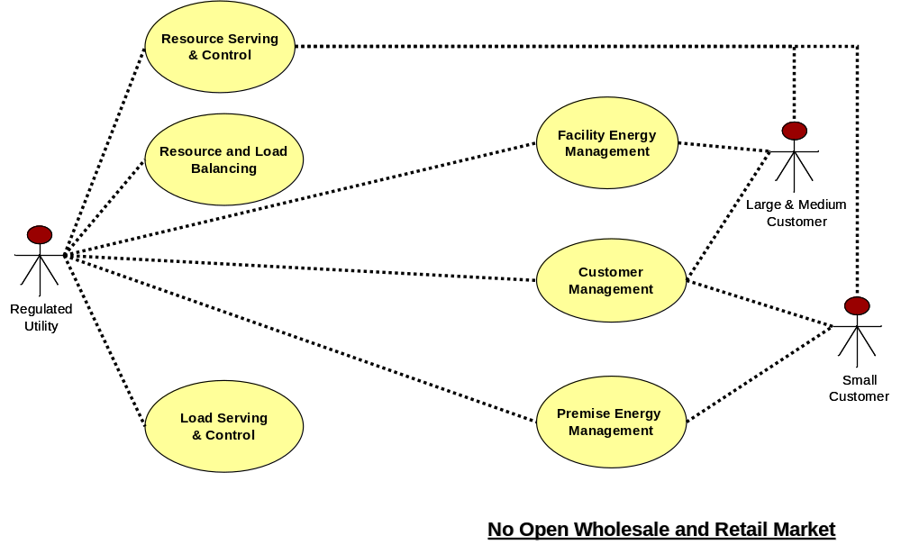

Figure 5 - Business Context for No Open Market

The following diagram, Figure 6, shows the typical information flows of DR implementation in such a region, where wholesale energy prices are not determined by open market, and retail price is determined by regulated tariff structure. To foster pricing related DR programs, these regions will need to find a way to introduce dynamic pricing based tariff to consumers. There will be a need for Energy Information Service Provider (EISP) to assist any utility based capabilities.
Within the utility environment, integration among the various operational entities will still occur, albeit they might not require integration between business to business in an all vertically integrated utility.
The key characteristics of this region for DR are:
- Utility responsible for all aspects of DR
- Need dynamic pricing tariff
- Less B2B integration between utility related entities
- Focus on consumer benefit using regulated mechanism

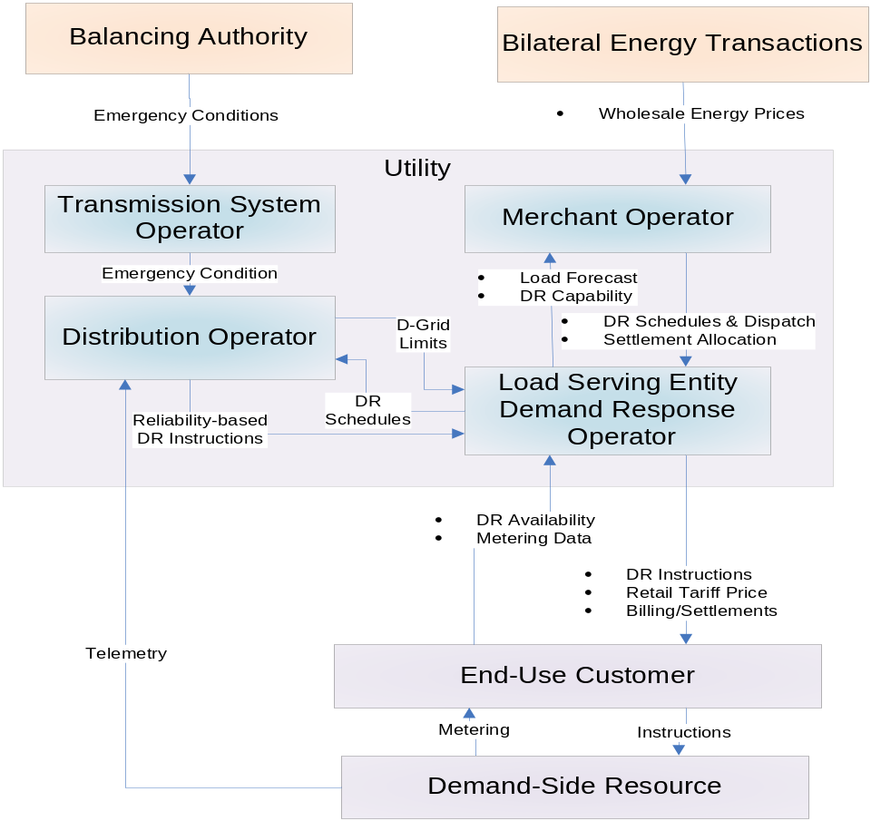

Figure 6 – DR Information Flow for Regions with no Open Wholesale and Retail Market

Regions with No Wholesale Market but With Retail Competition
Regions with no open wholesale and but have open retail competition will include the Energy Service Provider and/or Curtailment Service Provider (or DR Aggregator) to deal with end-use customers, see Figure 7. The introduction of ESPs provides a mechanism to introduce retail competition for both the price and services. ESPs will be allowed to created innovative products and services, and DR and DER will be a key mechanism to enable such innovation.
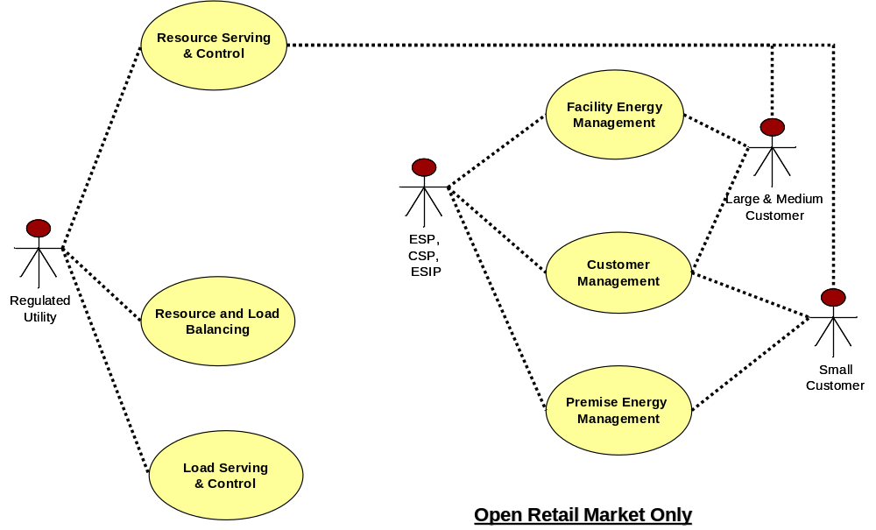

Figure 7 - Business Context for Open Retail Market Only

However, without open wholesale competition, the wholesale energy prices do not fully reflect the supply side of the picture, therefore limiting the ability for ESP/CSP to transfer the supply side price risk and reward to consumers. Figure 8 shows the typical information flow of DR implementation in such a region. Customers will have the ability to be represented by ESP/CSP for products and services that better match their needs.
The key characteristics of this region for DR are:
- ESP/CSP to customer DR interaction
- Innovative DR program and pricing structure
- B2B integration between utility and third party service providers (ESP, CSP, ESIP, etc.)
- Focus on consumer benefit using open retail competition

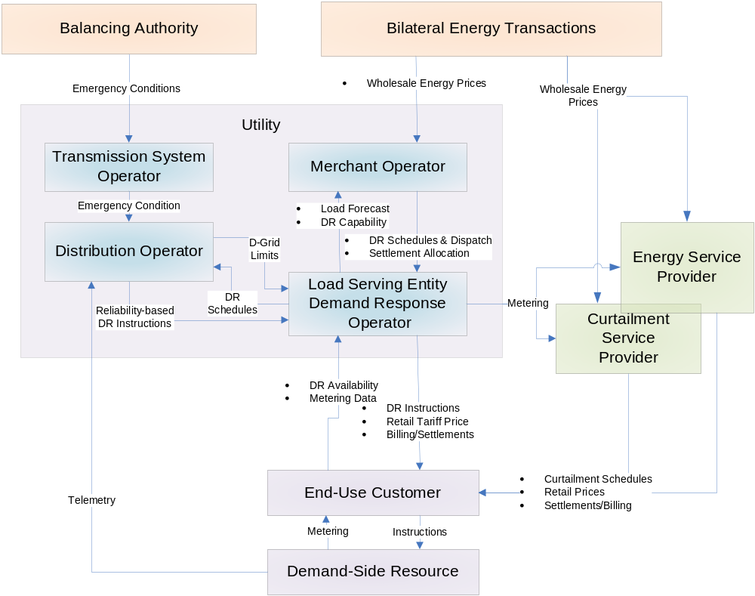

Figure 8 – DR Information Flow for Regions with no Wholesale Market but Retail Competition

Regions with Wholesale Markets but No Retail Competition
Regions with open wholesale and but no open retail competition will present a different set of challenges to DR/DER, see Figure 9. The open wholesale market provides the mechanism to see the supply side risk and reward of energy, yet the demand side is still regulated. Although many ISO/TROs in such a region are still progressively pursue Demand Response at the bulk power delivery level, the integration between the wholesale market level DR and the retail market level DR is still largely fragmented and manual in nature.

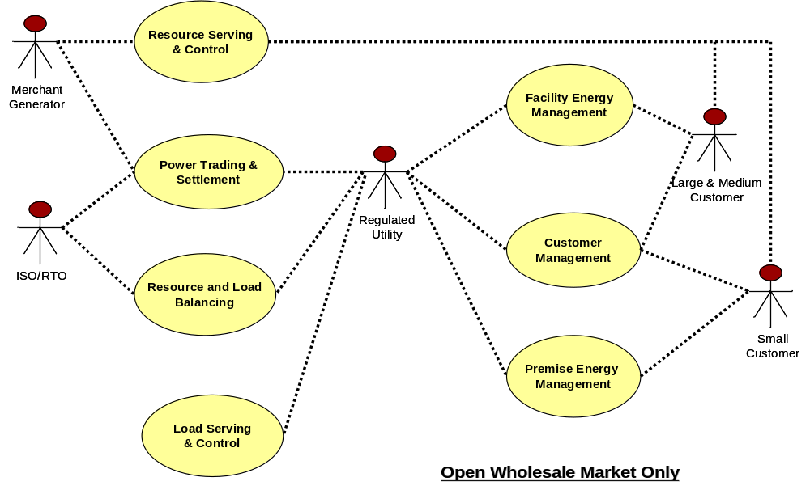

Figure 9 - Business Context for Open Wholesale Market Only

Figure 10 shows the typical information flow of DR implementation in such a region. There is still a strong need for Curtailment Service Providers in this case. The supply side investment is now determined more by the wholesale market, so aggregated DR capacity as resource will play a significant role in both long term capacity planning and peak pricing of the market.
The key characteristics of this region for DR are:
- Wholesale market price to a few large C&I customers to foster direct DR program participation
- Wholesale market price does not directly translate into retail tariff pricing, therefore limiting the power of DR with dynamic pricing model.
- B2B integration between ISO/RTO and utility operational entities
- Need dynamic pricing tariff
- Focus on consumer benefit using regulated mechanism

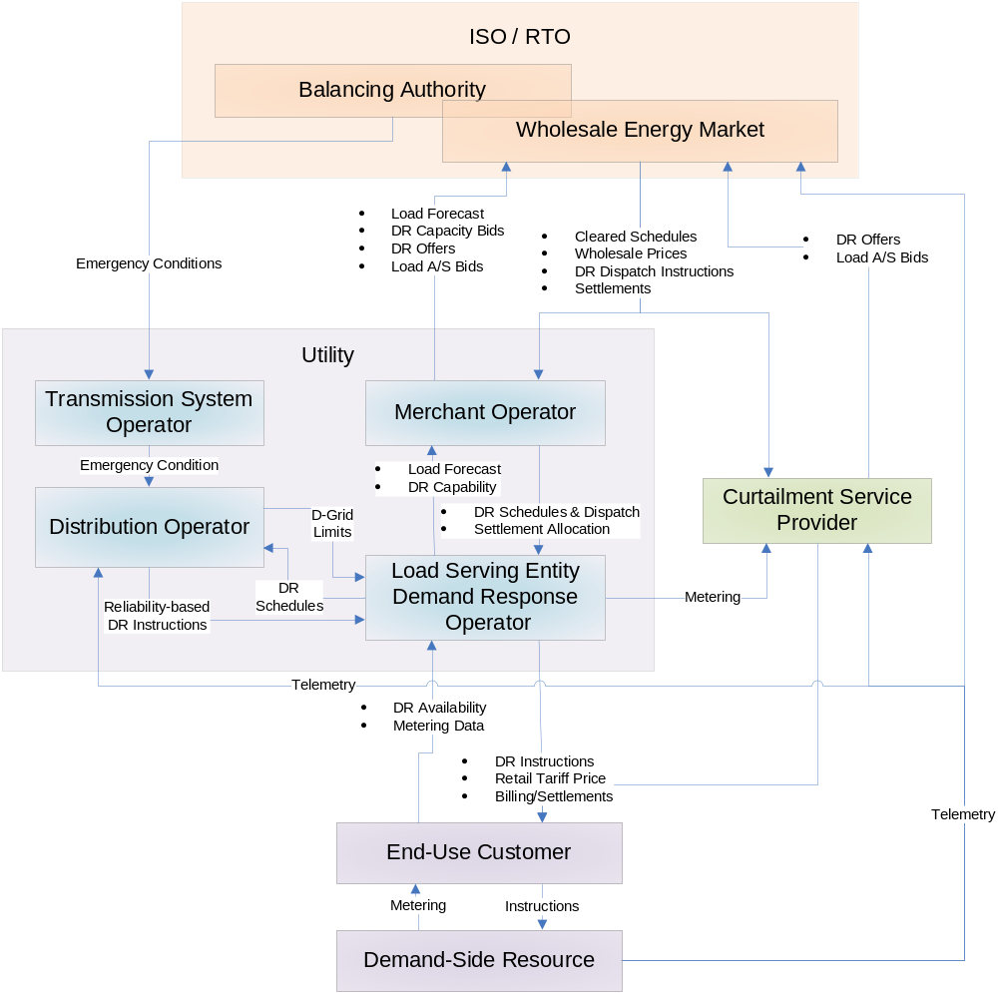

Figure 10 – DR Information Flow in Regions with Wholesale Markets but no Retail Competition

Regions with Open Wholesale Market and Retail Competition
As expected, regions with open wholesale and open retail competition present the most complex structure for DR, see Figure 11. This market structure will allow the market participants at both levels to see supply and demand in more real time. Such capabilities will potentially create more demand fluctuations (more dynamic and frequent response to DR control and/or pricing signals) which will require more sophisticated grid control and reliability management systems and tools.

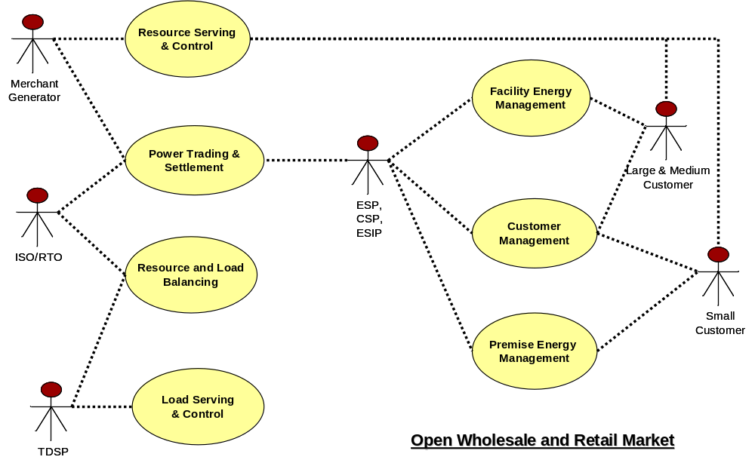

Figure 11 - Business Context for Open Wholesale and Retail market

Figure 12 shows the typical information flow of DR implementation in such a region.
The key characteristics of this region for DR are:
- Wholesale market price to increased number of C&I customers to foster direct DR program participation
- Wholesale market price may be better translated into retail pricing with ESP/CSP’s involvement.
- B2B integration between ISO/RTO and utility operational entities
- B2B integration between utility and third party service providers (ESP, CSP, ESIP, etc.)
- ESP/CSP to customer DR interaction
- Innovative DR program and pricing structure
- Focus on consumer benefit using open wholesale and retail competition

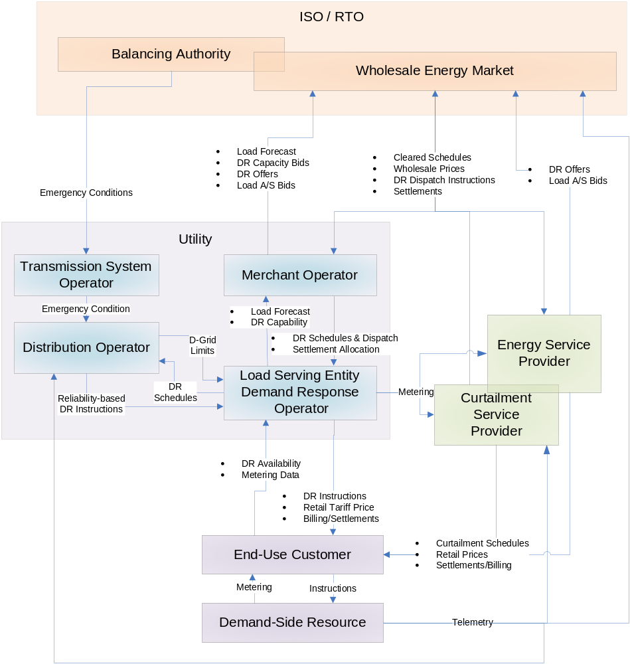

Figure 12 – DR Information Flow for Regions with Wholesale Market and Retail Competition

DR Use Case Classification
Right now, we have three dimensions to slice-dice the DR use cases:

- Four market types
- Regions with no open wholesale and retail competition
- Regions with open wholesale market only
- Regions with open retail market only
- Regions with open wholesale and retail competition
- Five DR program drivers
- Power Grid Reliability driven
  - Supply shortage (emergency)
  - Supply shortage (forecasted)
- Electricity Price driven (cost saving or profit making)
  - Distributed energy resources integration
  - Energy consumption shift or reduction
  - Peak Demand Reduction (for deregulated market)
- Ancillary Services (Can be driven by price or reliability)
  - Demand-side offers to supply services (status quo demand bidding scenario)
  - Demand-side bids to buy services (demand limiting scenario with demand subscriptions that recognize price for reliability distinct from price for energy)
- Asset management driven
  - Distribution Automation
  - Asset Management
- Environment driven
- Three DR operational phases
- DR Enrollment, Deployment and Configuration
- DR Operation
- DR Administration.

This classification will be used to guide and prioritize the subsequent use case development and consolidation work within NAESB Smart Grid Task Force to fulfill the NIST PAP10 objective. The first draft of the wholesale market DR use cases is attached in Appendix section 6.3 for reference.

Use Case Cross Cutting Issues
{Here are a few examples of cross cutting issues, more to come}

There are a number of cross cutting issues when it comes to standardize DR signals:
- Wholesale market to customer/LSEs versus retail market customers, can we or should establish one standard DR and pricing signals for all situations?
- Emergency situation: Is the emergency case caused by loss of generator or loss of tie line? Actually, in the emergency cases, the loads will be shed at substation level or transmission line level instead of at customer level, since the response time needs to be within hundreds of milliseconds to seconds. Should we standardize emergency load shedding, such as that of the ERCOT LaaR program?
- Coordination with AMI and HAN Network.
  - Load Curtailment at Meter Level (Using AMI Meter to manage the loads)
  - Load Curtailment at HAN Level (using HAN to manage the loads)
  - Load Curtailment at Individual Device Level.
  - Load Curtailment at the SEVSE.
- DR program security requirements:
  - Cyber security
  - Infrastructure security

High Level Business Requirements
{This is to describe near term and long terms goals of integrated DR and DER functionality, to ensure that we agree to and focus on designing towards near term goals without losing sight of future state and desires of Smart Grid}
{More high level business requirements will be flushed out as DR use case work progresses.}

Req. # | Name | Description
1 | Signaling | DR Program should provide secure, reliable communications with consumers for Demand Response operations
2 | Interoperability | DR program should utilize open, interoperable industry standard control and communication technologies to integrate with both common energy management and control systems that can conduct Demand Response activities
3 | Timing of Notification | Day ahead , day of or real time notification should be communicated to the end consumers for Demand Response activities
4 | Automatic Demand Response | The Demand Response program (analysis, notification, event, action, monitoring, verification, settlement) should be automatic.
5 | Businesses | Should cover businesses described in section 3.1.3
6 | Cyber Security
7 | Cover All Market Types
8 | ……
9

Integrated DR and DER Architecture Considerations

Guiding Principles
{Here is the initial set of guiding principles, more to come}

# | Name | Description | Rationale | Implication
1 | Scalability | The architecture should allow for the management of millions of customer premises devices | Scale-out, adding more low-cost machines, has proven to be superior to scale-up, using larger single machines, as a way to handle large loads. For example high traffic web sites use farms of low-cost machines to serve pages to millions of simultaneous web users. | Architecture should allow the solution to scale-out as more devices are added to DER programs.
2 | Actionable, testable, and transferable work products | Any work (artifacts) that are created can be used by the audience for this work, e.g. utilities, vendors, regulators, etc. There needs to be clear, explicit guidance for how to use the artifacts. There is an expectation that the work products are useful at lower levels of design | Such work products will promote market adoption, and minimize the cost and risk of adoption. Leverage open and best practices and establish repeatable processes, patterns, and template for all work products. | The use of common tools and methods will be fostered. Organizations that do not follow the use of the common tools and methods may have more difficulty implementing the artifacts.
3 | Platform Independence, Vendor Neutral | Requirements and design artifacts shall be platform independent. Implementation technologies shall be chosen due to its level of acceptance at the marketplace as open standards. | There is an expectation of differentiation and innovation in the marketplace. With greater dependence on a specific platform there may be less architectural flexibility. | To achieve both technical and semantic interoperability, certain lower level technologies will need to be chosen. For example, Web Services technology is widely used for integration, and UML is widely used for modeling.
4 | Secure | Architecture must incorporate latest secure computing techniques | The integrity of the electric grid and market depend on preventing unauthorized actors from manipulating the DER system. | Architecture must comply with the latest security guidance from the OASIS security committees, when it comes to Web Services security related implementation.
5 | Business driven architecture and design | Requirements and architecture patterns and designs of this effort shall be driven by real world business requirements of AMI. | This will ensure that recommended solutions deliver real and specific business requirements and benefits. | This will require a top down approach for driving DR deliverables, starting from business processes and functional requirements (use cases)
6 | Extensibility | This activity will prioritize functions with a focus on AMI functions, but does not preclude future extensions of the architecture; e.g. smart grid. Implementation of AMI will also vary from utility to utility. | Business requirements evolve over time; the location of business function may change.  This group recognizes that smart grid represents a set of business functions and that AMI is a subset of that capability. | This implies that technologies and methods chosen to develop the work products shall be easily extended to enhance and maintain them and their resulting implementations. And of course, be extended into new areas of business functionality.
8
9

Reference Architecture
Given the types of markets and DR programs exist today and in the near future, the follow reference architecture is developed to show generically how the key players of DR programs may interact with each other, see Figure 13 below.
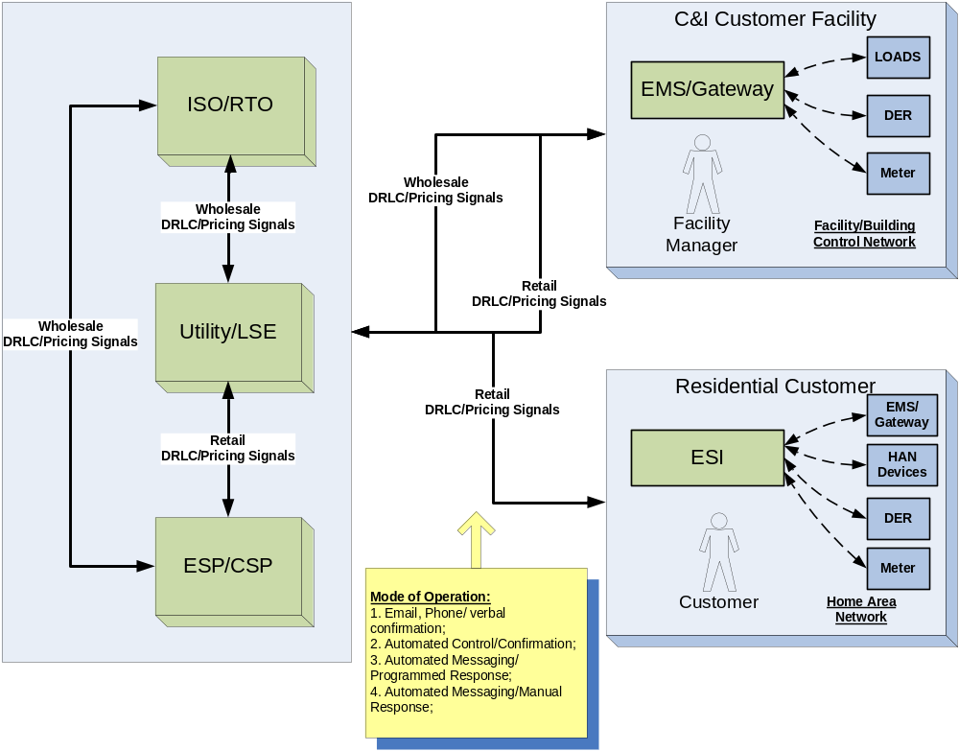
Figure 13 – DR Reference Architecture

At the wholesale level, there might be a few C&I customers that will interact directly with ISO/RTO, therefore receiving wholesale level DR Load Control or Pricing signals. Most other customers will interact with their utility or ESP/CSP for DR purpose to receive retail level DR Load Control or Pricing signals.
The technical model of operation for DR can be categorized as follows:
- E-mail or Phone notification with verbal confirmation between parties for a given DR event.
- Automated Load Control and Confirmation. Mostly through dedicated network, using IP network or paging network or AMI network to communicate control messages. Immediate feedback and confirmation is required.
- Automated Messaging/Programmed Response; used primary for broadcasting pricing signals that will be used for customers to respond automatically, i.e. control logics are programmed with a facility EMS or individual devices to take appropriate actions.
- Automated Messaging/Manual Response; used primarily for broadcasting pricing signals that will be used for customers to respond manually.

Security is a key concern for achieving reliable and desired effect of Demand Response. Since DR usually involves a number of business parties and a large number of customers, the risks associated with breached security on DR infrastructure is very high. Security in this case means that:
- Parties involved in any DR event will have to be authentically and authorized;
- Command/message exchanged between parties involved in any DR event will have to be secure from end to end.
- Results of the DR event execution will have to auditable.

Appendix

Demand Response Program Examples
There are a vast number of possible Demand Response programs that can be implemented. To demonstrate the range of programs that may be encountered, the following examples are provided. For all other ISO/RTO market and retail market DR programs, please refer to DOE and FERC reports, see section 6.2.

Wholesale Market Type Programs - NYISO
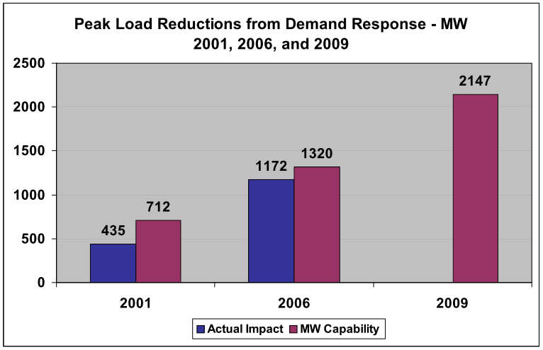
The New York ISO (Independent System Operator) is a federally regulated, non-profit corporation. It started its operation in 1999 to facilitate the restructuring of New York’s Electric industry. The NYISO operates the State’s bulk electricity grid and administers the State’s wholesale electricity markets including energy, reserves, regulation, ICAP (Installed Capacity), and Transmission Congestion Contracts TCC’s).
NYISO included its Demand Response and Energy Efficient resources since ISO inception. By year 2009, it has around 2147MW of Demand Response capacity.

Reliability Base Demand Response Programs
NYISO developed two Reliability Demand Response Programs, and NYISO controls activation. Those two programs began operation in May 2001. The purpose of those two programs is to provide Load reductions to supplement generation when operating reserves are forecast to be short or actual operating reserve deficiency.
- Emergency Demand Response Program (EDRP). EDRP is a voluntary Load curtailment program focuses on large C & I (commercial and industrial) customers. Those customers receive compensation to reduce energy consumption when requested.
- ICAP Special Case Resource (SCR) Program. SCR is a mandatory program to the signed large C & I customers who signed the contract to agree load shedding under the contract terms. When asked by the NYISO, those customers must curtail energy consumption.
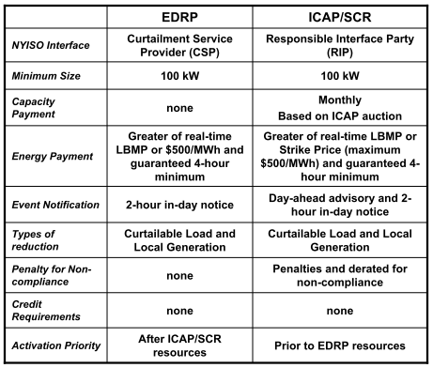

Economic based Demand Response Programs
NYISO also developed two Economic Demand Response programs for Resource (or Customer) to determine whether and when to participate the programs through bidding. The purpose of the economic based programs is to achieve Load reduction acting as and competing with generations.
- Day-Ahead Demand Response Program (DADRP). DADRP Program allows energy users to bid their load reductions into the Day-Ahead energy market as generators do. Offers determined to be economic are paid at the market clearing price. DADRP program was started in May 2001.
- Demand Side Ancillary Service Program (DSASP) started in June 2008.
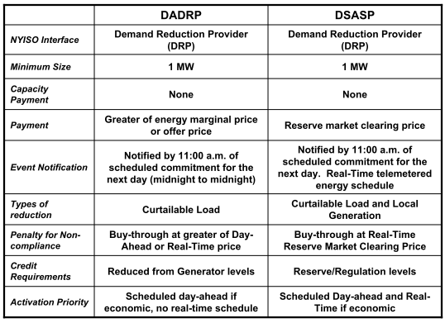

Demand Response Event and Notification
NYISO developed an automated notification system for EDRP and ICAP/SCR programs in 2003.
- When needed, NY ISO can issue a series of notification in support of the reliability based Demand Response programs. These notices can consist of different information such as general system information, system conditions, warnings of potential Load response events and activation notices. Those events are sub-zonal based.
- NYISO issues those notifications either by email and / or voice notification.
- In the case of both notice methods, each RIP/CSP must respond to the notice in one of two ways: by committing to participate in the event specified in the notification message along with the MWs to be committed, or by indicating that the resources will not be participating in the activity specified in the communication notice.
- NYISO will validate the committed amount with registered amount and sends warning message if the gap is greater than 10%.

Participations, Aggregation
Certain rules apply to the Demand Response Program participants:
- Customers with interruptible Loads:
  - Minimum of 100kW for EDRP program
  - Minimum of 100kW for ICAP/SCR program
  - Minimum of 1MW for DADRP program
- Customers with standby generators can participate in EDRP and ICAP/SCR programs subject to DEC regulations
- Customers with flexible operations and automated control systems. Minimum requirement is 1WM, with:
  - Real-time reserve (5-minute response)
  - Real-time regulation (6-second response)
- Smaller resources or small Load customers can be aggregated within a zone to participate different programs to meet the minimum requirements.
- Penalties may be applied to the participants who do not fulfill the contracted Demand reduction during the contract period (vary by programs)

Retail Type Programs - Baltimore Gas and Electric Company (BGE)
BGE is a combination gas and electric Distribution Company serving the central Maryland area. It traces its roots back to 1815 and is the oldest gas Distribution Company in the US. Both of BGE’s gas and electric service territories are competitive wholesale and retail markets. BGE has a long history of providing Demand Response and energy efficiency products and services to its customers.

Recently, the EmPOWER Maryland Act of 2008 was signed into law. This Act, among other energy reduction initiatives, set aggressive goals for the reduction of per capita energy consumption and Demand. BGE’s Smart Energy Savers ProgramSM was developed over a year prior to the enactment of EmPOWER Maryland and has become the foundation of BGE’s initiatives to comply with the law. Smart Energy SaversSM consists of four components:
- PeakRewardsSM – BGE’s residential Direct Load Control Demand Response program
- Energy Efficiency & Conservation
- Smart Energy Pricing for residential customers; and
- Smart Grid Strategy which includes Advanced Metering Infrastructure (AMI).
Under BGE’s PeakRewardsSM program, customers can choose either a programmable thermostat or a switch which allows BGE to cycle their air conditioning compressors on and off during periods of peak Demand. There are two typed of cycling events: (1) Emergency Cycling when regional Demand is very close to surpassing regional supply, and BGE is required by PJM to initiate cycling, and (2) Non-emergency Cycling where BGE may, on occasion, activate cycling when the wholesale price of electricity is very high. Communication with both the thermostats and the switches is accomplished remotely. Participants receive an annual incentive of $50, $75, or $100, and a one-time signing bonus of $50, $75, or $100, both depending on the customer’s choice for the level of cycling. The customer may choose 50%, 75%, or 100% cycling during an event. Customers have access to their thermostats or switches on a 24/7 basis through BGE’s PeakRewardsSM Online Access. Through PeakRewardsSM Online Access, customers can manage their thermostat settings, override non-emergency cycling events up to two times each year, and view their cycling history for each device installed. Registration for PeakRewardsSM may be accomplished online through BGE’s web site, or by calling a special telephone number.

BGE’s Smart Energy Pricing program is an example of a Price-directed Load Reduction program for residential customers. To make these programs viable, enabling technology is essential. BGE installed AMI meters on all participants. BGE conducted two seasonal pilots. During the first season, June through September 2008, BGE tested both Critical Peak Pricing and Peak Time rebate programs. In both pilots, a sample of customers were provided with an Energy Orb which began pulsing at 6:00 p.m. the day prior to an event and then glowed a steady red during the event. During the pilots, BGE has also placed telephone calls, e-mailed, texted, and even used Twitter to notify customers of an upcoming event. Under the Critical Peak Pricing program, a significantly higher price was charged for energy used during an event. To pass Public Service Commission acceptance, the program had to be revenue neutral to BGE. Consequently, the price charged during non-event periods was slightly reduced. The Peak Time Rebate program, on the other hand was a mirror-image of Critical Peak Pricing. Under this program, the Customer received a credit for the amount of energy recued during an event. Results showed that Peak Time Rebate was a more effective program. To determine if the results were sustainable, BGE conducted a second season pilot in 2009 for only the Peak Time Rebate program. Preliminary results are very favorable. Following a report to the Public Service Commission, and Commission acceptance, BGE anticipates rolling out the program to all customers.

BGE also has Demand Response programs for its non-residential customers. BGE offers these programs through its Rider 24. Large commercial and industrial customers who can reduce Loads on peak days can register their Load reduction capability with PJM through BGE. BGE has two options – an energy program and a capacity program.

In the energy program, customers voluntarily reduce energy Demands during periods of high real-time prices of electricity and receive credits on their electric distribution bills based on the amount of energy not taken, the real-time price of energy and the retail rate charged the customer by his retail supplier. The customer is under no obligation to reduce Loads.

In the capacity program, customers agree to reduce Loads upon request from BGE. This can occur up to 10 times each year, and each activation can last up to 6 hours. The requests for Load reductions originate from PJM. Customers receive credits based on the amount of Load reduction they commit to, and the credits are based on the prices in the PJM RPM capacity markets. These prices vary from year to year. BGE determines whether customers comply with their Load response registrations. Customers that do not comply with their Load response registrations receive penalties based on the kilowatts of non-compliance. Compliance is measured either during PJM-initiated Load response events or during tests of the Load response resources.

Customers can participate in the capacity program either by agreeing to drop to a specified amount (a Firm Service Level) or by agreeing to drop a certain amount (a Guaranteed Load Drop). Customers specify which method they want to use. Customers can achieve the Load drops either by curtailing operations, by using back-up generators or a combination of the two. Customers participating in the capacity program can also participate in the energy program. All participation in BGE’s commercial and industrial Load response activities is voluntary – no customers are mandated to participate. Customers must have interval meters in order to participate. Interval meters enable BGE to measure a customer’s use on an hourly basis.

Central Registration Agent Type Programs - ERCOT
The ERCOT region, located entirely in Texas, is a competitive wholesale market with portions of the region having open retail competition. The installed generating capacity of ERCOT is 80,076 MW and the record peak demand was 63,453 MW set in July 2009. In 1995, the Texas Legislature introduced competition into the state’s wholesale markets by allowing generation developers, not affiliated with investor-owned electric utilities (IOUs), to construct and operate generation facilities, providing them with non-discriminatory access to the transmission lines. In 2002, ERCOT opened to retail competition which satisfied the requirements of legislation passed by the Texas Legislature in 1999. This legislation unbundled the IOUs and created retail customer choice in the former IOU service territories located in ERCOT. The unregulated utilities in ERCOT (i.e. cooperatives and municipal electric utilities) were given the option to open up to retail competition; however, all but one has chosen not to open up to retail competition. In the competitive regions of ERCOT, separate companies provide retail, transmission & distribution, and generation services (see Figure below). Electric consumers now have multiple retail electric providers (REPs) and electric service plans to choose from and may switch providers at any time, limited only by a REP’s contractual provisions. Currently, there are 33 active REPs competing in the competitive areas of the ERCOT market serving 6.5 million customers.

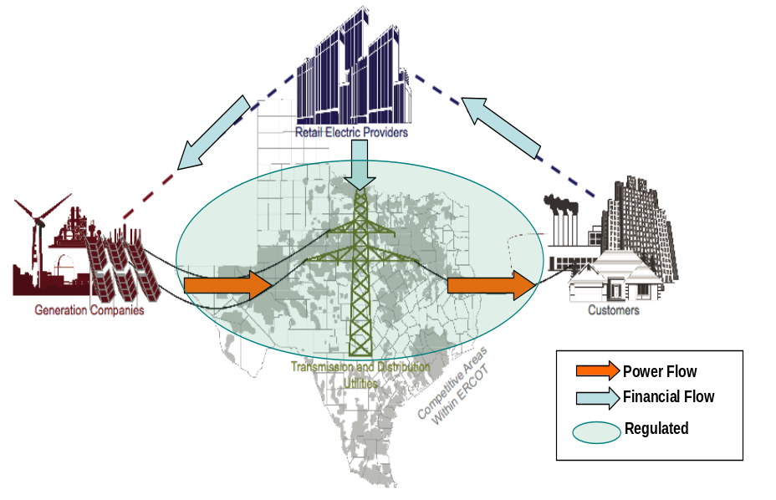

Demand Response in ERCOT
ERCOT has a long history of utilizing Demand Response provided by industrial, commercial and residential customers to help maintain system reliability. However, since the beginning of retail competition in ERCOT, Demand Response has been limited to only the largest of industrial and commercial consumers. One of the primary requirements to participate in the ERCOT Demand Response programs is a meter recording interval (15 minute) consumption data, which is needed for Measurement and Verification and the establishment of the minimum Baseline Load. There are three basic types of Demand Response programs currently in the ERCOT market. As customers do not have a direct relationship with ERCOT, they will contract with a REP in order to participate in one of these ERCOT programs. Also, since ERCOT is a competitive retail market, REPs cannot mandate that their customers participate in any program. REPs may offer these programs to customers as a competitive service, however, they are not required to offer these services.

- Loads Acting as a Resource (LaaR) – these Loads are typically very large industrial and commercial customers who must meet strict qualifying requirements to provide ancillary services such as responsive reserve (10 minute notice) and non-spin reserve (30 minute notice). In 2009, there were 137 LaaRs registered with ERCOT with a peak interruptible capacity of 2,121 MW. LaaRs will be curtailed during an electric grid emergency or when no other market solutions exist to solve certain operating problems. Loads providing ancillary services must bid in each day for the following day delivery through their Qualified Scheduling Entity (QSE) and are paid a capacity payment for each day they are selected to provide that ancillary service, regardless of whether the Load is actually curtailed. When a system emergency occurs, ERCOT will either automatically reduce Load controlled by high-set under-frequency relays or notify the Load’s QSE through a through verbal dispatch instruction to reduce Load within a specified period of time. The QSE will notify the customer.

- Emergency Interruptible Load Service (EILS) Service is provided by Loads willing to interrupt during an electric grid emergency in exchange for a capacity payment. ERCOT contracts for EILS through a request for proposal (RFP) process three times a year for terms of four months each. Aggregators are allowed to aggregate smaller Loads to supply the minimum 1 MW quantity. In the summer of 2009, a maximum of 375 MW was offered. This Load is interrupted in the last stages of a grid emergency, after LaaRs has been deployed but prior to firm Load shedding. When a system emergency occurs, ERCOT will notify the Load’s QSE to reduce Load within 10 minutes by a verbal dispatch instruction. The QSE will notify the customer.

3. Voluntary Load Response – this type of program is voluntary in that the REP does not formally offer the customer’s response to ERCOT and therefore the customer’s Load reduction will occur without interaction with ERCOT. Instead, this program is based on a customer’s independent decision to reduce consumption in response to a market price or other factors as set forth in a customer’s contract with the customer’s REP. Since this service is not recognized by ERCOT, it will not receive an ERCOT capacity payment nor will it be involuntarily curtailed during a gird emergency. The type of metering, communication, or curtailment requirements are set forth in the contract between the REP and customer. In ERCOT, the wholesale Market Clearing Price of Energy [MCPE] varies for every 15 minute interval of the day. If the customer has a meter recording interval consumption (15 minute), then typically MCPE can be used for the price paid for actual deployment of a resource’s energy (i.e. Load reduction or generation increase). The sharing of the benefits received from this type of service is negotiated in a bilateral agreement between the customer and REP.

Reference Documents
The following initiatives and documents are used as references for the development of this framework. The documents are available publically or made available to NASEB and/or UCAIug for the purpose of this work. The links to the documents publicly available on the Internet can be found here: http://www.naesb.org/smartgrid_doc.asp.

# | Name
1 | DOE report – Benefits of Demand Response in Electricity Markets and Recommendations for Achieving Them
2 | Harnessing the Power of Demand ------ How ISOs and RTOs Are Integrating Demand Response into Wholesale Electricity Markets
3 | Interim Report for NIST on Smart Grid Interoperability Standards Roadmap
4 | Open Automated Demand Response Communications Specification ( Version 1.0)
5 | DRACS Requirements FINAL V1.3
6 | DRACS Reference Architecture 1.1 FINAL
7 | MEASUREMENT & VERIFICATION (M&V) OF DEMAND RESPONSE PROGRAMS
8 | AMI-ENT Demand Response - Functional Requirements and Use Case Document v1.0
9 | UtilityAMI 2008 Home Area Network System Requirements Specification
10 | ZigBee+HomePlug MRD Home Area Network Use Cases
11 | ZigBee+HomePlug Smart Energy Profile - Marketing Requirements Document (MRD)
12 | DR M&V Standards Implementation Comparison
13 | ANSI C12 SC17 Standards (C12.18, C12.19, C12.21, C12.22, C12.23)
14 | Recommendation to the NAESB Executive Committee DSM-EE Subcommittee dated December 2, 2008 - Business Practices for Wholesale Electricity Demand Response
15 | Demand-side Integration in a Restructured Electric Power Industry – EPRI
16 | Interaction of Distributed Resources with Smart Grid – EPRI
17 | Load Participation in the ERCOT Market and Addendum
18 | Controllable Load Resource (CLR) Participation in the ERCOT Market
19 | Load Participation in the ERCOT Nodal Market

Reference Materials
IRC DR M&V Standards Implementation: 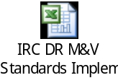
Wholesale Market DR Use Case: 
For most recent copy of the use case document and the UML model file in Enterprise Architect, please go to http://www.naesb.org/smart_grid_standards_strategies_development.asp

Abbreviations
The following table provides definitions for abbreviations used in this document.

Abbreviation | Definition
AMI | Advanced Metering Infrastructure
AMI - ENT | Advanced Metering Infrastructure - Enterprise
ANSI | American National Standard Institute
ANSI | American National Standards Institute
API | Application Programming Interface
ARC | Aggregator of Retail Customers
C & I | Commercial and Industrial
CFL | Compact Fluorescent Light
CPP | Critical Peak Price
CSP | Curtailment Service Provider
DADRP | Day Ahead Demand Response Program
DER | Distributed Energy Resources
DG | Distributed Generation
DOE | Department of Energy
DR | Demand Response
DRACS | Demand Response Analysis and Control System
DRAS | Demand Response Automation Server
DRP | Demand Response Provider
DSASP | Demand Side Ancillary Service Program
DSM-EE | Demand Side Management – Energy Efficiency
EDRP | Emergency Demand Response Program
EILS | Emergency Interruptible Load Service
ERCOT | Electric Reliability Council of Texas
ESO | Electric System Operator
ESP | Energy Service Provider
EV DER | Electric Vehicle Distributed Energy Resource
FERC | Federal Energy Regulatory Commission
GWAC | GridWise Architecture Council
HAN | Home Area Network
HVAC | Heating, Ventilation and Air Conditioning
IEC | International Electrotechnical Commission
IOU | Investor Owned Utilities
IRC | ISO RTO Council
ISO/RTO | Independent System Operator / Regional Transmission Organization
ISO-NE | Independent System Operator – New England
kW | Kilowatt
kWh | Kilowatt Hour
LaaR | Loads Acting as a Resource
LDC | Local Distribution Company
LIP | Locational Independent Price
LMP | Locational Marginal Pricing
LSE | Load Serving Entity
M&V | Measurement & Verification
MCPE | Market Clearing Price of Energy
MISO | Midwest ISO
MRD | Marketing Requirements Document
MW | Megawatt
MWH | Megawatt Hour
NAESB | North American Energy Standards Board
NERC | North American Electric Reliability Corporation
NIST | National Institute of Standards and Technology
NOC | Network Operating Center
NYISO | New York Independent System Operator
OASIS | Organization for the Advancement of Structured Information Standards
OpenADR | Open Automated Demand Response or Open Auto-DR
OpenSG | UCAlug Open Smart Grid
PAP | Priority Action Plan
PCT | Programmable Communicating Thermostat
PDC | Peak Day Credit
PEV | Plug-in Electric Vehicles
PJM | Pennsylvania – New Jersey – Maryland Interconnection
PUC | Public Utility Commission
PV | Photovoltaic
QES | Qualified Scheduling Entity
REP | Retail Electric Provider
RTP | Real-Time Pricing
SAE | Society of Automotive Engineers
SCR | ICAP Special Case Resource Program
SEVSE | Smart Electric Vehicle Service Equipment
SGTF | Smart Grid Task Force
SHA | Secure Hash Algorithm
SLA | Service Level Agreement
SMD | Smart Market Design
SOAP | Simple Object Access Protocol (XML protocol)
SPP | Southwest Power Pool
TLS | Transport Layer Security
TOU | Time Of Use
UCA | Utility Communication Architecture
UCAlug | UCA International Users Group
UI | User Interface
UIS | Utility Information System
UML | Unified Modeling Language
UML | Unified Modeling Language
VPP | Virtual Power Plant
WSDL | Web Services Description Language
XML | Extensible Markup Language

Terms and Definitions
The following table provides definitions for terms used in this document that may not be widely used or understood. Where there are definitions already provide by NAESB standards, those definitions are adopted here in this document. For additional definitions and acronyms, please refer to other relevant document from NASEB and/or UCAIug OpenSG task forces.
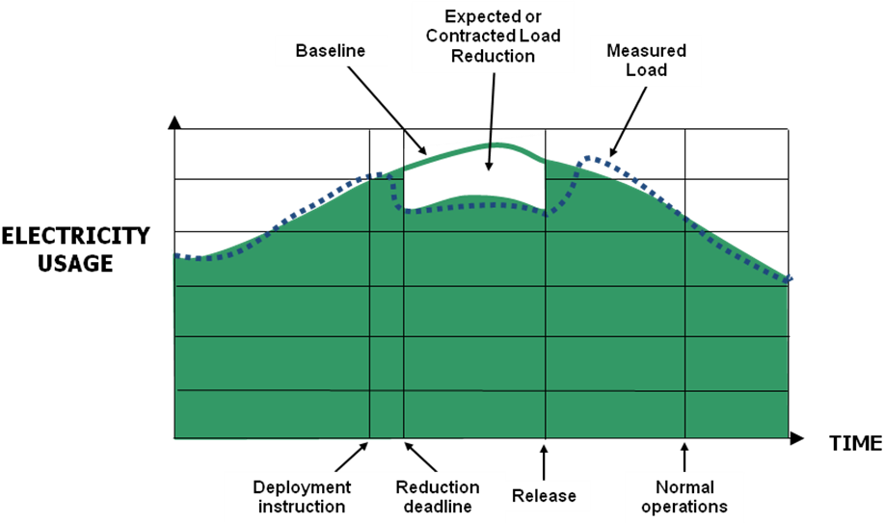
To assist the understanding of Demand Response related definition, these illustrations show the timing elements used to describe and the load impacts of DER events. Each term is defined below.
Source: Recommendations to the NAESB Executive Committee DSM-EE Subcommittee dated December 2, 2008
Figure 3 Timing Elements of DER Event

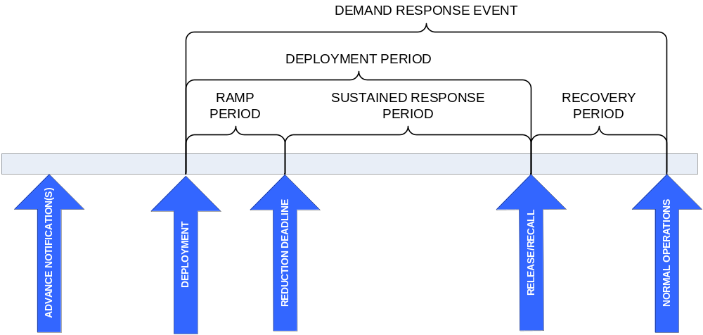

Source: Recommendations to the NAESB Executive Committee DSM-EE Subcommittee dated December 2, 2008
Figure 4 Impact of DER on Electric Usage

Table: Terms and Definitions
Term | Definition
Adjustment Window | The period of time prior to a Demand Response Event used for calculating a Baseline adjustment. (NAESB Definition)
Advanced Metering | Technology which allows two way communications between the Distribution Company and the meter. This communication enables the ability to analyze energy consumption resulting in more efficient Demand Response systems.
Advanced Metering Infrastructure (AMI) | The infrastructure built around Advanced Metering allowing the Distribution Company and consumer to communicate in real time with respect to energy consumption. Based on the information collected the Distribution Company is able to obtain an accurate reading of Demands, while consumers are able to modify their usage to save energy.
After-the-Fact Metering | Interval meter data separate from Telemetry that is used to measure Demand Response. May not apply to Demand Resources under Baseline Type II (Non-Interval Meter) for wholesale markets, or under Baseline using statistical sampling for retail markets. (NAESB Definitions combined)
Aggregated Demand Resource | A group of independent Load facilities that provide Demand Response services as a single Demand Resource.
Automated Meter Reading | A subcategory of AMI which allows for communication devices to transfer data from a meter to the Distribution Company or from a meter to the data management provider.
Baseline (*) See NAESB Retail Definition at end | A Baseline is an estimate of the electricity that would have been consumed by a Demand Resource in the absence of a Demand Response Event. The Baseline is compared to the actual metered electricity consumption during the Demand Response Event to determine the Demand Reduction Value. Depending on the type of Demand Response product or service, Baseline calculations may be performed in real-time or after-the-fact. The Grid Operator may offer multiple Baseline models and may assign a Demand Resource to a model based on the characteristics of the Demand Resource’s Load or allow the Demand Resource to choose a performance evaluation model consistent with its load characteristics from a predefined list. A baseline model is the simple or complex mathematical relationship found to exist between Baseline Window demand readings and Independent Variables. A baseline model is used to derive the Baseline Adjustments which are part of the Baseline, which in turn is used to compute the Demand Reduction Value. Independent variable is a parameter that is expected to change regularly and have a measureable impact on demand.
Baseline Adjustment | An adjustment that modifies the Baseline to reflect actual conditions immediately prior to or during a Demand Response Event to provide a better estimate of the energy the Demand Resource would have consumed but for the Demand Response Event. The adjustments may include but are not limited to weather conditions, near real time event facility Load, current Demand Resource operational information, or other parameters based on the System Operator’s or Program Administrator’s requirements for the wholesale or retail markets, respectively. (NAESB Definitions combined)
Baseline Type-I (Interval Metered) (*) Not Applicable for retail | A Baseline performance evaluation methodology based on a Demand Resource’s historical interval meter data which may also include other variables such as weather and calendar data.
Baseline Type-II (Non-Interval Metered) (*) Not Applicable for Retail | A Baseline performance evaluation methodology that uses statistical sampling to estimate the electricity consumption of an Aggregated Demand Resource where interval metering is not available on the entire population.
Baseline Window | The window of time preceding and optionally following, a Demand Response Event over which the electricity consumption data is collected for the purpose of establishing a Baseline. In the wholesale market, the applicability of this term is limited to Meter Before/Meter After, and Baseline Type-I and Type-II. (NAESB Definitions combined)
Budget | Some allowed amount of a VPPs parameters. For example if a VPP specifies that  - a customer may be ‘have up to 10 DER events /week  - a customer may be controlled up to 15 hrs/wk  - and there are 500 customers in the VPP,  then the VPP’s total budget is 5,000 customer-events and 7500 hrs per week. Budgets are complex objects; they contain one value for each VPP parameter.
Business Intelligence | A term describing the extraction and presentation of data to provide business value.
Business Service Provider (*) A term like this usually refers to a Party, not software | Software delivered over the internet as web services. The platform for integrating these web services is the enterprise service bus.
Capacity Service | A type of Demand Response service in which Demand Resources are obligated over a defined period of time to be available to provide Demand Response upon deployment by the System Operator or the Program Administrator in wholesale and retail markets, respectively.
Cost | Amount of a VPP parameter expended to execute a DR or DG. For example turning off a water heater for 2 hrs would cost 1 ‘hit + 2 hrs for a VPP that was defined by number of hits and total hours controlled.
Customer Result | Aggregate of all device results for a given customer taking into account program rules. For example of a VPP included both water heaters(2kW load) and pool pumps (3 kW load) and both devices were turned off for 15 minutes the results would be 5 kW for a cost of 1 hit + 0.25 hrs.
Customer schedule | Schedule for all devices by interval: targets in device-power.
Daily Consumption | The amount of energy a customer uses in a 24 hour period. This information is used to drive business intelligence solutions.
Demand | The rate at which electric energy is delivered to or by a system or part of a system, generally expressed in kilowatts or megawatts, at a given instant or averaged over any designated interval of time; and the rate at which energy is being used by the customer (NERC and NAESB Definition).
Demand Billing | That portion of a customer’s bill related to energy Demand. This is often based on peak Demand or some other Demand related measurement.
Demand Interval | The interval of time between Demand queries to the meter. This is typically in 15, 30, and 60 minute intervals.
Demand Reduction Value | Quantity of reduced electrical consumption by a Demand Resource, expressed as MW or MWh. (NAESB Definition)
Demand Resource | A Load or aggregation of Loads capable of measurably and verifiably providing Demand Response. (NAESB Definition)
Demand Response | Changes in electric use by demand-side resources from their normal consumption patterns in response to changes in the price of electricity, or to incentives designed to induce lower electricity use at times of high cost periods or when system reliability is jeopardized. (NAESB Definition)
Demand Response Program | An agreement between customer and utility that states that the customer agrees to allow the utility to manage their energy consumption when the utility deems necessary. Often times this result in the utility increasing or reducing energy distribution based on supply based metrics. Demand response mechanisms typical operate in on or off whereas dynamic response mechanisms may passively curtail energy usage as the mechanism senses stress on the grid.
Demand Response Provider | The Entity that is responsible for delivering Demand reductions from Demand Resources (NAESB Retail Definition)
Distributed Energy Resource | Small, modular, energy generation and storage technologies that provide electric capacity or energy at the distribution level of the grid.
DER Availability | Amount of load decrease caused by dispatching a DER event to only DR Assets that meet DR program constraints. For example, if a DR program specifies that no more than 3 DER events can be dispatched to any customer. If a customer 1 has already participated in 3 events when a 4th DER event is dispatched, the capability of customer 1 is no longer available to the VPP defined by that program.
DER Capability | Maximum amount of load decrease caused by dispatching a DER event to all DR Assets enrolled in a DR program.
Device Result | Realized Value delivered by a device and cost for an event by interval. Expressed as power and cost. For example turning off a water heater with a 2kW load for 15 minutes when it was predicted to be on would deliver 2kW at a cost of 1 hit + 0.25 hrs. Value must take coincidence factor into account.
Device-level power | Electrical power as measured at the consuming device. Note: Demand reduction at the device (DRd) results in a reduction of Demand at the generator (DRg) = (1+TL)DRd where TL is the transmission loss.
Distributed Generation | Electricity generation from small energy sources allowing for more efficient energy distribution. This approach allows for energy to be generated closer to the source of the consumption which reduces the distance the generated energy has to travel.
Energy Data Acquisition | Obtaining meter data by way of handheld devices. Essentially a non automated meter reading typically administered by a Distribution Company worker.
Energy Data Management | Analyzing meter data for consumption by backend systems. Often times these back end systems will measure Load, calculate Demand Response, billing intervals, etc.
Energy Service | A type of Demand Response service in which Demand Resources are compensated solely based on their performance during a Demand Response Event. (NAESB Definition)
Enterprise Resource Planning | Integrating all back and front office data and process into one unified enterprise system.
ESB | Enterprise Service Bus. The ESB provides the features necessary for a service oriented architecture implementation by providing a place to host all of the web services.
EVSE | Electric Vehicle Service Equipment: simple charging station for PEV. It may have remote on/off control to determine the timing of PEV charging.
Forecast Device Availability | A forward prediction of how much DR or DG is available for a VPP after applying the VPP rules to the predicted device capacity. Expressed as power and cost. If there is no event scheduled then forecast and cost are 0 by definition.
Forecast VPP Availability | Aggregation for all Forecast Device Availabilities in a given VPP that meet the VPP rules. Expressed as power and cost. Power may be either device-level or generation-level.
Generation-level power | Electrical power as measured at the generation plant.
Highly-Variable Load | A Load with a fluctuating or unpredictable electricity consumption pattern. (NAESB Definition)
IEC | The International Electrotechnical Commission (IEC). The IEC TC57 maintains an electric Distribution Company focused information model called CIM (Common information model).
IEC 61968 | International standards for Energy Distribution Managements Systems, respectively, specify a Common Information Model (CIM) for Distribution Company data exchange, Applications Programming Interfaces (API) for application integration (GID), and XML messaging standards.
Load | An end-use device or customer that receives power from the electric system (NERC and NAESB Definition).
Load Shedding | Reducing a customer's Demand in order to maintain integrity of the grid. Load shedding in Distribution Company operations, is monitoring electric usage continuously (usually by automated instrumentation) and shutting down certain pre-arranged electric loads or devices if a certain upper threshold of electric usage is approached.
Logical Data Model | A representation of an organization's data based upon entities and attributes of those entities. A logical data model is often a logical representation of a business' integration or business requirements.
Maximum Base Load | A performance evaluation methodology based solely on a Demand Resource’s ability to reduce to a Firm Service level, regardless of its electricity consumption or Demand at Deployment. (NAESB Retail Definition)
Meter Before/ Meter After | A performance evaluation methodology where electricity Demand over a prescribed period of time prior to Deployment is compared to similar readings during the Sustained Response Period. (NAESB Definition)
Meter Bus (M-bus) | Allows for the interconnecting of many different Distribution Company measuring units (i.e. gas, electric, water, etc.) The M-Bus acts as the central station for these different utilities to communicate with.
Meter Data Management | A system for storing, processing, consuming and analyzing large quantities of meter data.
Meter Data Recording Interval | The time between electricity meter consumption recordings. (NAESB Definition)
Metering Date Reporting Deadline | The maximum allowed time from the end of a Demand Response Event (Normal Operations) to the time when meter data is required to be submitted for performance evaluation and settlement. The Meter Data Reporting Deadline may be either relative (a number of hours/days after Normal Operations) or fixed (a fixed calendar time, such as end-of-month). (NAESB Definition)
Metering Generator Output | A performance evaluation methodology in which the Demand Reduction Value is based on the output of the generation asset, used when a generation asset is located behind the Demand Resource’s revenue meter. (NAESB Definition)
Partner schedule | Schedule of DER targets and budgets for a partner’s customers by VPP, segment, and interval, target in device-power
Performance Window | The period of time in a Demand Response Event analyzed by the System Operator or Program Administrator to measure and verify the Demand Reduction Value for a Demand Resource. (NAESB Definition)
Predicted Device Capacity | A forward prediction of how much DR or DG a device could produce in a given interval if it was placed under event control e.g. ‘hit’. The capacity should be the difference between the predicted Load if not controlled and if under event control. If there is no event scheduled, then by definition the predicted device capacity is 0. Value must take coincidence factor into account.
Ramp Rate | The rate, expressed in megawatts per minute, that a generator changes its output. (NERC Definition) OR  The rate, expressed in megawatts per minute, that a generator changes its output or a Demand Resource changes its Load. (NAESB Definition)
Real Time Metering | Meter readings taken almost in real time to allow for adjustments to be made as the energy market fluctuates.
Realized Value | The amount of power realized from a DER event (nega or mega). The realized value is the difference between the predicted device load if not controlled and the measured load while under event control.
Regulation Service | A type of Demand Response service in which a Demand Resource increases and decreases Load in response to real-time signals from the System Operator or Program Administrator. Demand Resources providing Regulation Service are subject to dispatch continuously during a commitment period. Provision of Regulation Service does not correlate to Demand Response Event timelines, deadlines and durations. (NAESB Definition)
Reserve Service | A type of Demand Response service in which Demand Resources are obligated to be available to provide Demand reduction upon deployment by the System Operator, based on reserve capacity requirements that are established to meet applicable reliability standards.
Schedule | As appropriate such as pricing programs a schedule would show / publish specific pricing time (e.g. TOU is 8:00-1:00, CPP is 1:00-5:00, etc.)
Segment schedule | Schedule of DER targets and budgets by VPP, feeder section, and interval, target in device-power
SEVSE | Smart Electric Vehicle Service Equipment: smart charging station for PEV. SEVSE provides bi-directional communication between the PEV and grid. This allows DER systems to control charging to deliver DR, frequency regulation, and other ancillary services to the grid.
SLA | Service Level Agreement: the part of a service contract where the level of the services are agreed upon between two systems.
Smart Grid | The term smart grid represents the digital upgrade of our distribution and long distance transmission grid allowing for increased energy efficiency as well as a boost in optimization of current systems.
Smart Meters | Meters with extra functionality that allow for more accurate and useful meter readings. This extra functionality allows the meter to collect usage data and transmit this data back to the utility over a network.
SOA | Service oriented architecture - The concept of grouping business functionality around business processes. These services are than packaged as interoperable services. A SOA architecture allows for the transmission of data between multiple systems as they participate in multiple business processes.
SOAP | Simple Object Access Protocol (XML protocol) - A protocol for exchanging xml messages for web services in a service oriented architecture implementation.
Supervisory Control and Data Acquisition (SCADA) | SCADA systems monitor and control the electric power generation, transmission, and distribution.
System Operator | A System Operator is a Balancing Authority, Transmission Operator, or Reliability Coordinator whose responsibility is to monitor and control an electric system in real time (based on NERC definition). The System Operator is responsible for initiating Advance Notifications, Deployment, and Release/Recall instructions.
Target Reduction | The requested power (nega or mega watt) for an event. Device-level targets result from applying grid state loss factors to generation-level targets.
Telemetry | Real-time continuous communication between a Demand Resource or Demand Response Provider and the System Operator or Program Administrator. (NAESB Definitions combined)
Telemetry Interval | The time unit between communications between a Demand Resource or Demand Response Provider and a System Operator.
Transmission Area schedule | Schedule of DER generation targets and budgets by VPP, zone, and interval, target in generation-power
UML | Unified Modeling Language is a general purpose modeling language commonly used for object/data modeling.
Utility Sub Metering | An implementation that allows for a multi tenant property to bill tenants for individual energy usage. This is most commonly implemented in apartments and condominiums.
Validation, Editing and Estimation (VEE) | The process of taking raw meter data and performing validation and, as necessary, editing and estimation of corrupt or missing data, to create validated data.  The process of confirming the accuracy of raw meter data and, if necessary, replacing corrupt or missing data. (NAESB Retail Definition)  (VEE guidelines are published in the Edison Electric Institute’s Uniform Business Practices for Unbundled Electricity Metering, Volume Two, Published 12/05/00, http://www.naesb.org/REQ/req_form.asp).
Virtual Power Plant (VPP) | Specific DER program applied to the homes and businesses within a given electrical transmission area.
VPP Result | Aggregate for all Customer results taking into account VPP rules. VPP results can be expressed in either device-level power or generation-level power.
WSDL | Web Services Description Language is a xml format used to describe web services and the messages that interface with the web services.
XML | Extensible Markup Language – general purpose markup language for creating custom mark-up languages.
XSD | A description describing a specific xml document focusing primarily on the restraints and structure of that xml document.

http://collaborate.nist.gov/twiki-sggrid/bin/view/_SmartGridInterimRoadmap/PriorityActionPlans
Interoperability is the capability of two or more networks, systems, devices, applications, or components to share and readily use information securely and effectively with little or no inconvenience to the user. The characteristics of interoperability as set forth in the GridWise® Interoperability Context- Setting Framework? are (1) exchange of meaningful, actionable information between two or more systems across organizational boundaries, (2) a shared understanding of the exchanged information, (3) an agreed expectation for the response to the information exchange, and (4) a requisite quality of service: reliability, fidelity, and security. The result of interoperability is that interfaces, systems, and devices are capable of being integrated, scalable, adaptable, and upgradable and utilize open standards to promote competitive technology and to avoid stranded investments. Interoperability can only be achieved if there is a seamless, end-to-end coordination and exchange of data between many organizations, interfaces, systems, and devices resulting in behavior changing information given to the consumer.
Originally developed by Ivar Jacobson; a summary of the approach is available at: http://www.ibm.com/developerworks/rational/library/5383.html
Definition of DER provided by the Department of Energy, http://www1.eere.energy.gov/femp/pdfs/31570.pdf
See Appendix section 6.1 for a description of the ERCOT market
The Value of Independent Regional Grid Operators - a report by the ISO/RTO Council, November 2005
In the United States, ISOs are single-state or multiple-state entities established under Order 888 of the Federal Energy Regulatory Commission. RTOs perform similar or expanded services across a multi-state area, and have been approved by the FERC as meeting the requirements of FERC Orders 2000 and 2001.
http://www.ferc.gov/whats-new/comm-meet/2009/071609/E-1.pdf
http://www.ferc.gov/whats-new/comm-meet/2009/091709/E-1.pdf
http://www.nerc.com/page.php?cid=4%7C53%7C56
FERC Report – A National Assessment of Demand Response Potential – June 19, 2009
The document is available for download from the ISO RTO Council web site at URL http://www.isorto.org/site/c.jhKQIZPBImE/b.2604461/k.6151/Documents_and_Issues.htm
Variable Service Subscription type demand response programs are described in http://www.smartgrid.epri.com/pdfs/Demand-side%20Integration%20in%20a%20Restructured%20Electric%20Power%20Industry.pdf
Investment is low only because of the immaturity of the market. Standards for SEVSE communication both between the grid and between the PEV will speed investment in this segment.
Fleet operators are very sophisticated with how they manage fuel consumption. For example several large package delivery services plot routes to minimize left turns and thus save millions of gallons of fuel per year. It is not hard to imagine that they will leverage this expertise to optimize total energy consumption of their PEV fleets.
PEV owners show that they are interested in energy and environmental issues. They may be willing to invest in a SEVSE to optimize their PEV performance instead of using a simple outlet for charging.
Source: Report to NIST on Smart Grid Interoperability Standards Roadmap (2009)

